66ա

June, 2016

Contract No. AID-111-C-12-00001
This report is made possible by the support of the American people through the United States Agency for International Development (USAID). The contents of this report are the sole responsibility of Deloitte Consulting LLP and its implementing partners and do not necessarily reflect the views of USAID or the United States Government.

FUNCTIONAL DESCRIPTION OF
HUMAN RESOURCE MANAGEMENT INFORMATION SYSTEM (HRMIS) OF THE RA STATE REVENUE COMMITTEE

TAX REFORM PROJECT (TRP)

ՆԱԽԱԳԻԾ
Authors

Date | Document version | Description of the document review | Author of the document
 | V1 | First Draft

Date of approval | Approved version | The role of approving officer | Approving Officer

Contents
1 Introduction 10
2 Description of the Human Resource Management Information System 10
2.1 The Objective of the System 10
2.2 System Approach 10
2.3 System Framework 11
2.3.1 Labor Resource Module 11
2.3.2 Organization Structure and Position Management Module 16
2.3.3 Vacation Management Module 18
2.3.4 Business Trip Management Module 28
2.3.5 Internal Transfers Management Module 33
2.3.6 Contract Management Module 37
2.3.7 Probation Period Management Module 41
2.3.8 Employee Separation Administration Module 43
2.3.9 Cadre Reserve Module 46
2.3.10 Candidate Pool Module 49
2.3.11 Recruitment and Selection Module 49
3 Functional Requirements 56
3.1 Main Information Submission Forms of the System 56
3.2 The User Roles and Accessibility to the System 57
3.3 Labor Resource Module Implementation 58
3․3․1 Labor Resource List Module 59
3․3․2 Labor Resource Advanced Search Module 63
3․3․3 Employee Personal Data View Module 70
3․3․4 Appointing to a Position Module 98
3․3․5 Contract Extension Module 105
3․3․6․ Personal Data Editing Module 107
3.4 Organization Structure and Position Management Module Implementation 127
3․4․1 Organization Structure Administration Module 128
3․4․2 The SRC Staff List Administration Module 136
3.5 Vacation Management Module Implementation 159
3․5․1 Vacation Application Creation Module 160
3․5․2 Vacation Administration Module 169
3․5․3 Vacation Schedule Creation Module 177
3.6 Implementation of Business Trip Administration Module 180
3․6․1 Business Trip Requests and Certificates 180
3․6․2 Business Trip Administration Module 188
3.7 Implementation of Internal Transfers Module 195
3․7․1 Rotation Administration Module 196
3․7․2 Internal Transfers Administration Module 203
3.8 Implementation of Probation Administration Module 213
3․8․1 Probation Administration Module 214
3․8․2 Probation Documents Creation Module 221
3.9 Implementation of Employee Separation Administration Module 226
3․9․1 Employee Separation Administration Module 228
3․9․2 Separation Documents Generation Module 238
3.10 Administration 246
3.11 Implementation of Cadre Reserve Module 251
3.11.1 Cadre Reserve/Candidate Pool List Module 252
3.12 Implementation of Candidate Pool Module 257
3.12.1 Candidate data completion module 258
3.13 Implementation of Selection and Recruitment Module 271
3․13.1 Recruitment Process Launch Sub-Module 273
3․13. 2 Application Registration and Respond Submodule 287
3․13. 3 Final Selection and Appointment Sub-module 312
4 Infrastructure, Implementation and Resource Requirements 317
4.1 Implementation Requirements 317
4.2 Existing Implementation Methodology Infrastructure at SRC 317

Diagrams
Diagram 1. HRMIS structure and module links 10
Diagram 2. Labor resource. Registering new employee 11
Diagram 3. Personal data modifications 12
Diagram 4. Appointing the SRC employee to a position 13
Diagram 5. Separation of employee from position 14
Diagram 6. Organization structure administration 15
Diagram 7. Staff list administration 16
Diagram 8. Schedule administration process 18
Diagram 9. Granting annual vacation 19
Diagram 10. Vacation granted based on a medical certificate for incapacity 20
Diagram 11. Vacation to be granted for the care for up to 3 year old child 22
Diagram 12. Vacation granted for fulfilling State or social obligations 24
Diagram 13. Procedure of granting educational vacation 25
Diagram 14. Procedure of granting unpaid vacation 26
Diagram 15. Preparing business trip request 28
Diagram 16. Business trip approval and formation 29
Diagram 17. Business trip; going to and returning from business trip 30
Diagram 18. International business trip 31
Diagram 19. Rotation of officers 32
Diagram 20. Demotion of employee to a lower position 33
Diagram 21. Changes of employee position due to staff reduction 34
Diagram 22. Employee promotion 35
Diagram 23. Preparation of contract 36
Diagram 24. Preparation of draft decree and approval of necessary documents 38
Diagram 25. Contract extension/end 39
Diagram 26. Appointing probation period and its supervisor 40
Diagram 27. Evaluation of the probation period results 41
Diagram 28. Separation based on employee’s personal application 42
Diagram 29. Separation upon availability of appropriate grounds 44
Diagram 30. Process of registering in Cadre Reserve 45
Diagram 31․ Process of using Cadre reserve 46
Diagram 32․ Deregistration of a person from Cadre reserve 47
Diagram 33․ Process of personal data registration 48
Diagram 34․ Process of recruitment approval 49
Diagram 35․ Launching recruitment process 50
Diagram 36․ Process of application registration and answering stage 51
Diagram 37․ Permission to participate in competition 53
Diagram 38․ Final selection and appointment 54

Tables
Table 1. Labor resource list 59
Table 2. Labor resource advanced search 64
Table 3. Employee personal data view and editing 72
Table 4. Position selection 97
Table 5. Appointing to a position 100
Table 6. Contract extension form 104
Table 7. Employee family composition editing/adding page 106
Table 8. Editing/adding page for data on employee’s serving in security forces 107
Table 9․ Employee education data editing/adding page 108
Table 10. Computer skills data editing/adding 109
Table 11. Editing window for knowledge of languages 110
Table 12. Employee experience data editing/adding window 111
Table 13. Employee ranks data block editing/adding 111
Table 14. Editing/adding page for data on employee’s incentives 113
Table 15. Editing/adding page for the information on employee’s fines 115
Table 16. Editing/adding page for information on the employee research papers/inventions 117
Table 17. Editing/adding page for information on employee’s involvement in elective bodies 118
Table 18. Editing/adding page for information on employee’s State awards 118
Table 19. Editing page for information on the employee’s Learning 119
Table 20. Editing page for information on the employee training 120
Table 21. Editing page for information on the employee’s attestation 121
Table 22. Editing page for the data on the positions held by employee within the system 123
Table 23. Editing/adding page for employee involvement in commissions 124
Table 24. Organization structure administration 128
Table 256. Page to create/view/edit the structural unit 131
Table 26. Staff list administration form 135
Table 27. Position creation/view/edition 141
Table 28. Editing/adding page for the data on duties and rights 150
Table 29. Edit/add official duties 151
Table 30. Competency data editing/adding 151
Table 31. Editing/adding of data on communication inside/outside the organization 152
Table 32. Selection of person to be appointed to a vacant position 153
Table 33. Links of the position types and groups and the positions 155
Table 34. Vacation application form 163
Table 35. Vacation application administration form 169
Table 36. Vacation schedule completion form 176
Table 37. Business trip request and certificate creation/view page 181
Table 38. Employees’ business trip administration 188
Table 39. Rotation adminisitration 194
Table 40. Rotation scheme selection page 200
Table 41. Transfers administration 202
Table 42. Demotion justification form 208
Table 43. Promotion documents view page 210
Table 44. Probation administration form 213
Table 45. Probation supervisor selection form 217
Table 46. Probation report form 220
Table 47. Probation memo form 221
Table 48. Probation conclusion form 223
Table 49. Form of employee list with grounds for separation 227
Table 50. Separation document list view form 233
Table 51. Employee separation application and decree generation/view form 238
Table 52. Separation document page 242
Table 53. Administration page 246
Table 54․ Cadre reserve/Candidate pool list 250
Table 55․ Cadre reserve documents view 254
Table 56․ Candidate registration in the pool: alerts 256
Table 57․ Candidate registration in the pool: personal data page 258
Table 58․ Candidate registration in the pool: education data 261
Table 59․ Candidate registration in the pool: work experience 264
Table 60․ Candidate registration in the pool: service in RA Armed Forces 266
Table 61․ Candidate registration in the pool: CV and other documents 268
Table 62․ List of SRC vacant positions 272
Table 63․ Recruitment request 275
Table 64․ Candidate selection form 276
Table 65․ Candidate selection/Recuitment application approval: SCR Chairman form 278
Table 66․ Competition announcement creation form 281
Table 67․ Competition view form 286
Table 68․ Form for attaching Commission decision 291
Table 69․ Filling in application: alerts 293
Table 70․ Application completion: selection for vacancy 293
Table 71․ Application completion: personal data page 295
Table 72․ Application completion: education data 298
Table 73․ Application completion: work experience 301
Table 74․ Application completion: service in RA Armed Forces 303
Table 75․ Application completion: medical certificates 305
Table 76․ Application completion: attached documents 306
Table 77․ Competition result view 308
Figures
Fig. 1. Labor resource list 58
Fig. 2. Labor resource advanced search 62
Fig. 3. Employee personal data view form in the state of the data sections closed 70
Fig. 4․ Employee data view form 70
Fig. 5․ Appointment of person to position. Position selection 96
Fig. 6․ Appointing to a position 99
Fig. 7․ Contract extension 104
Fig. 8․ Employee family composition data editing/adding page 106
Fig. 9․ Editing/adding page for data on employee’s duty in special services of the RA 107
Fig. 10. Employee education data editing/adding page 108
Fig. 11․ Employee computer skills data editing/adding page 109
Fig. 12. Editing page for employee’s command of language data 110
Fig. 13. Employee experience data editing/adding page 110
Fig. 14. Editing/adding page for data on employee ranks 111
Fig. 15. Editing/adding page for data on employee incentives 113
Fig. 16. Editing/adding page for the information on employee’s fines 115
Fig. 17. Editing/adding page for information on the employee’s research papers/inventions 116
Fig. 18. Editing/adding page for data on employee’s involvement in elective bodies 117
Fig. 19. Editing/adding page for data on employee’s State awards 118
Fig. 20. Editing page for information on the employee’s Learning 119
Fig. 21. Editing page for information on the employee’s training 119
Fig. 22. Editing page for information on the employee’s attestation 120
Fig. 23. Positions held within the system 123
Fig. 24. Involvement in commissions 124
Fig. 25. Organization structure administration 127
Fig. 26. Example of organization structure tree reporting 128
Fig. 27. Page to view/edit the structural unit data/create a new structural unit 131
Fig. 28. Staff list administration 135
Fig. 29. Position creation/edition/view 140
Fig. 30. Position passport data modification 150
Fig. 31. Selection of person to be appointed to a vacant position 153
Fig. 32. Links of the position types and groups and the positions 155
Fig. 33. Application on granting vacation/return from vacation 162
Fig. 34. Vacation application 162
Fig. 35. Application on return from vacation 163
Fig. 36. Vacation application administration 168
Fig. 37. Vacation decree report 168
Fig. 38. Report of decree on return from vacation 169
Fig. 39. Entering vacation schedule 176
Fig. 40. Business trip request, decree and certificate creation form 180
Fig. 41. Business trip request report 181
Fig. 42. Business trip certificate report 181
Fig. 43. Business trip administration 187
Fig. 44. Business trip decree report form 188
Fig. 45. Rotation administration 194
Fig. 46. Automatic rotation scheme generation page 199
Fig. 47. Internal transfers adminsitration 202
Fig. 48. Demotion justification form 208
Fig. 49. Promotion form 209
Fig. 50. Report on promotion recommendation document 210
Fig. 51. Probation administration form 213
Fig. 52. Probation supervisor selection form 217
Fig. 53. Probation report form 219
Fig. 54. Printable probation report form 219
Fig. 55. Probation memo form 221
Fig. 56. Report on probation memo 221
Fig. 57. Probation conclusion form 223
Fig. 58. Report on probation conclusion 223
Fig. 59. List of employees with grounds for separation 227
Fig. 60. Separation document view list 232
Fig. 61. Separation application/decree 237
Fig. 62. Separation application report 237
Fig. 63. Employee separation decree report 238
Fig. 64. Separation document 242
Fig. 65. Separation document report 242
Fig. 66. Administration 245
Fig. 67․ Cadre reserve/Candidate pool list 250
Fig. 68․ Cadre reserve documents view 253
Fig. 69․ Candidate registration in the pool: alerts 256
Fig. 70․ Candidate registration in the pool: personal data 258
Fig. 71․ Candidate registration in the pool: education data block 261
Fig. 72․ Candidate registration in the pool: work experience 264
Fig. 73․ Candidate registration in the pool: service in RA Armed Forces 266
Fig. 74․ Candidate registration in the pool: CV and other documents 268
Fig. 75․ List of SRC vacant positions 272
Fig. 76․ Recruitment request 275
Fig. 77․ Candidate selection form 275
Fig. 78․ Candidate selection/Recuitment application approval: SCR Chairman form 277
Fig. 79․ Competition announcement creation form 281
Fig. 80․ Competition announcement report 284
Fig. 81․ Competition view form 286
Fig. 82․ Form for attaching Commission decision 291
Fig. 83․ Police inquiry 292
Fig. 84․ Filling in application: alerts 292
Fig. 85․ Application completion: selection for vacancy 293
Fig. 86․ Application completion: personal data 294
Fig. 87․ Application completion: education data block 298
Fig. 88․ Application completion: work experience 301
Fig. 89․ Application completion: service in RA Armed Forces 303
Fig. 90․ Application completion: medical certificates 305
Fig. 91․ Application completion: attached documents 306
Fig. 92․ Competition result view 308
Fig. 93․ Report on test or interview schedule 312
Fig. 94․ Final competition report: decision on considering the competition completed 313
Fig. 95․ Final competition report: decision on recognizing the winner 313
Fig. 96․ Final competition report: conclusion on the decision to recognize winner 313

Introduction
This document defines the main functional requirements for the Human Resource Management Information System (HRMIS) modules of the State Revenue Committee of the Republic of Armenia (SRC). It constitutes the basis for development of the HRMIS software module.
HRMIS software should be flexible and should provide possibilities:
- to change business process workflow schemas
- to dynamicly create/modify business objects such as organizational units, job positions, personal datas, business processes, business actions.
- to generate forms dynamicly for input, search, view and editing of business objects.

Using this document as a guide, software developers due to the flexible built-in instruments of the system, should create databases and a program tool ensuring the automation of the procedures described herein. This document will be treated as the basis of the quality assurance (testing) for the final introduction of automated HRMIS.

Description of the Human Resource Management Information System
The management procedures currently implemented at the SRC Personnel Management Department (PMD) are mainly based on non-automated manual, paper-based procedures. In the case of similar process, features, such as centralized information collection, automated notifications on operations requiring intervention, automated report creation required in course of data management, etc., are lacking. In view of the methodology defined in this document, all the possible procedures implemented at the PMD should be automated. Producing standard reports based on the data available in the system also should be ensured.

HRMIS should be developed as a dynamic platform, with build in easy to use instruments, which allows to localize and create specialized HR solutions. HRMIS should be very flexible and allow to easily make changes, define data structure and modify visual forms with build-in instruments by using metadata. Metadata should be described in XML files.

HRMIS stores in metadata:

business objects and structure

build-in input, search, view, edit forms

workflow schemas

Metadatas should be created by HRMIS built-in editors

The Objective of the System
The purpose of the HRMIS is to enable saving, processing and analyzing the information about all the SRC employees that is contained in the database, without regard to the type of service (e.g. tax officer, customs officer, civil servant, persons engaged in civil work and maintenance). Information technologies are used for the purpose of automating the process and increasing the efficiency of the labor resource management, as well as tracking the labor resource indicators system to assist in managerial decision making in the SRC Human Resources (HR) management.
The main objectives of the system are:
- Create Labor Resource Database;
- Create a software tool for Human Resource Management;
- Create a Notifications System;
- Data exchange with the current software systems;
- Compile standard and ad hoc reports;
- Increase the efficiency of the labor resource management.

System Approach
In fact, the HRMIS is a tool for collection of information on the SRC labor resource and implementation of functions required in the HR context, which reflects the data and activities of each staff member and the whole period of his/her labor activity (from applying for recruitment to the discharge from position (separation) and post-employment relations). The system represents a group of special modules serving the purposes of running the employee data, performing HR functions and producing reports.

HR systems contains big count of business objects and fields. During the explotation of the system, HR managers always needs to add new fileds, new subobjects and do some modification in data structure. Sometimes HR managers needs to add new subtypes for organizational units, positions, employee description records, business actions, but more usually needs to add new fields and sub object with “one-to-many” relationship with HR basic objects. That is why it is very efficient to have flexible system which will allow easylly do this modifications by super administrator without additional software development.

System Framework
HRMIS core shoud consist: static modules, metadata editors, metadata compiler and interpretator, modules which are working based on metadata. HRMIS flexible instruments should allow:
- Dynamicly declare specific organizational units, positions, business roles, personal datas, business processes, business actions, other descriptor objects and their special properties. It also should allow to create semantic structure of interconnected objects, to compile metadata and, as a result, creates tables, stores metadata and structure in database.
- To automatically generate input, search, view and edit forms for objects that are inherited from organizational unit, staff, person, role, personal data, business process, business action. HRMIS instruments assure input, search, view and editing of object data through generated forms.
- To create workflows that are defined for business processes and to modify schemas.

The structure of the HRMIS is displayed in Diagram 1, in which separate units are dynamically built in the system via special editors.. This operational process starts with creation of organization structure units via the organization structure and positions management module. Subsequently, the name list of positions is created for each structural unit. In parallel, by using the Labor Resource Module, the personnel file data of employees are entered, after which employee is being appointed to the position held by him/her. In the course of managing the personnel file of employee, the procedures regarding probation period, vacation, business trips, position transfer administration and separation are implemented via appropriate modules. Recruitment procedures are implemented through “Recruitment and Selection” module. In the course of recruitment, “Cadre Reserve” and “Candidate Pool” modules are used for the purpose of the candidate selection. Once candidate is selected and appointed to a position, he/she is displayed in “Labor Resource” Module as a new employee. All processes in these modules should be described and modified by HRMIS workflow-building flexible editors.
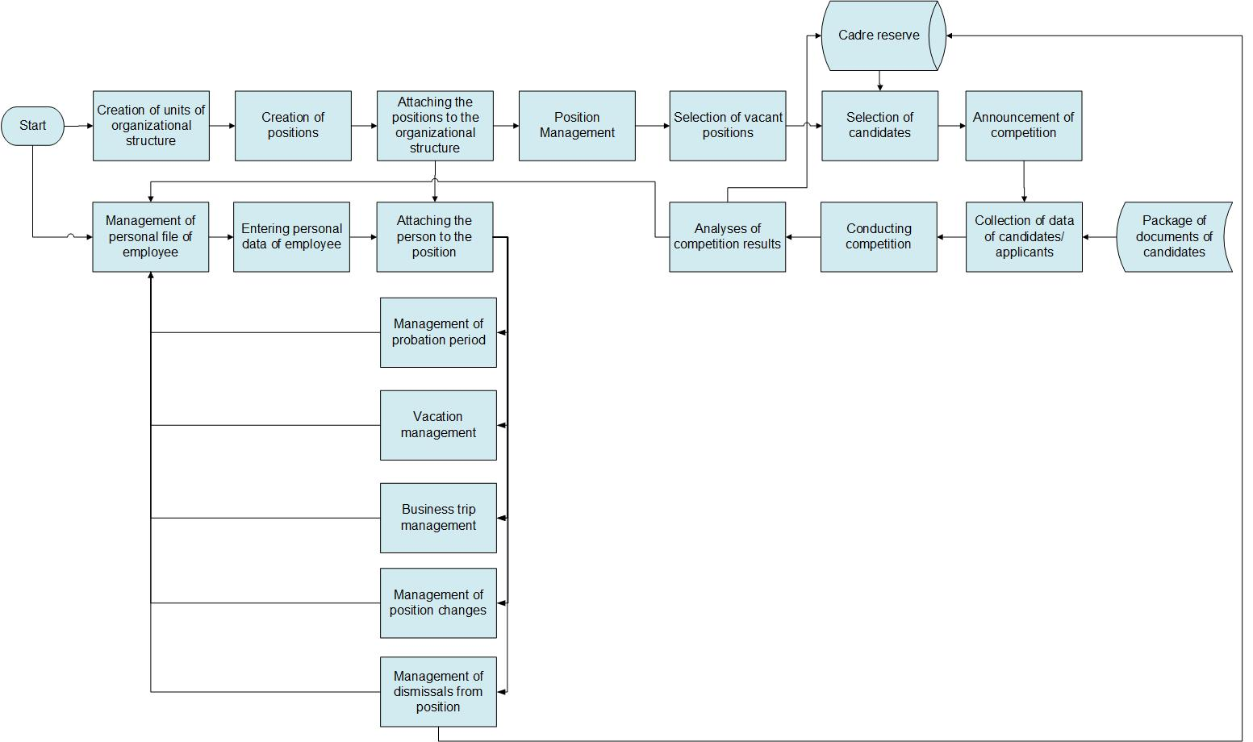
Diagram 1. HRMIS structure and module links
The workflows implemented in the modules that are reflected in the diagram are described in Sub-sections 2.3.1 – 2.3.11 of this document. The workflows defined by these sub-sections should be built by using the HRMIS build-in editor. With the help of instruments that provide system flexibility, it must allow to modify the process, define new fields, and modify visual forms. The numberings of the descriptions of diagrams that are presented in the sub-sections do not reflect the sequence of the steps in the diagram, but rather present the sequence of the workflow.
Below we will describe details for each module that should be configured in HRMIS framework.

Labor Resource Module
The sequence of the procedures implemented in the Labor Resource Module after the commencement of the employment relations with employee and/or signing the contract is presented in Diagram 2 for the data entry. The procedures implemented in case of changes in the personal data are presented in Diagram 3.

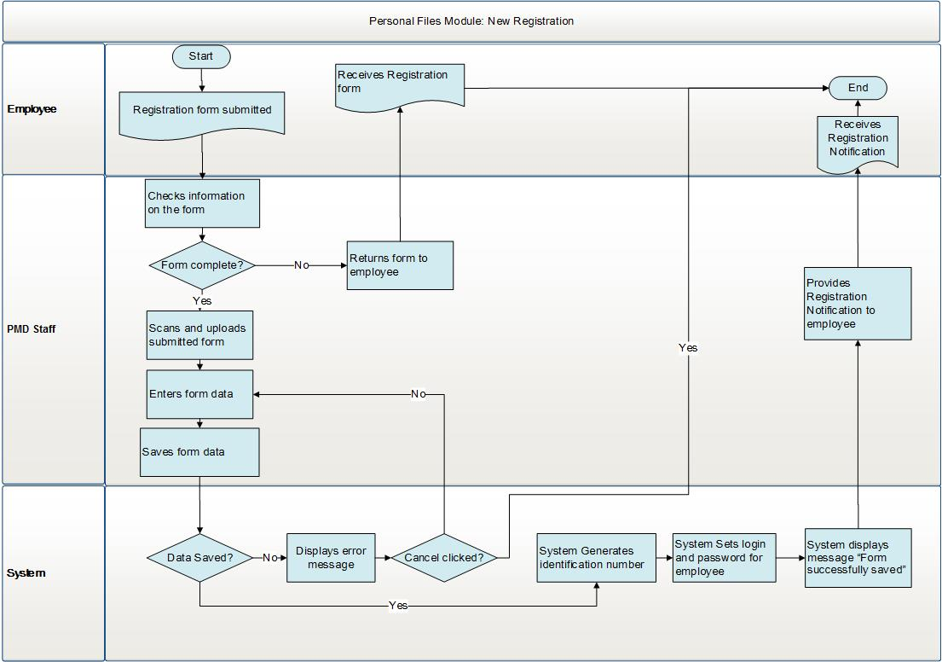
Diagram 2. Labor resource. Registering new employee
The sequence of the process steps is as follows:
- Officer of respective PMD division receives from a new employee the documents required to make registration.
- PMD officer conducts document checks.
- In case there are no mistakes, a transition to Step 5 takes place.
- In case there are mistakes, the documents are sent back to the new employee to make adjustments.
- PMD officer enters the required data in the form.
- PMD officer saves the data.
- The system saves the data and, in case there are no mistakes, a transition to Step 11 takes place.
- In case there are mistakes, the system displays an error message.
- The process ends when clicking “Cancel” button in the error message.
- If not, go to Step 5.
- An identification number is generated for employee.
- Login name and password are generated for employee.
- The system displays “Data saved” message.
- A notification on registration is sent to employee.

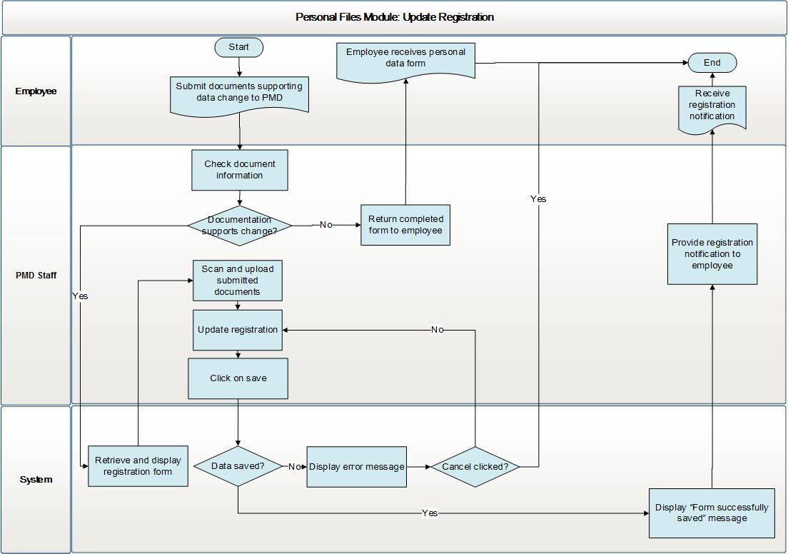
Diagram 3. Personal data modifications

The following actions are performed, in the event there are changes in the personal data:
- Employee provides to the PMD officer documents verifying the changes in the personal data.
- PMD officer conducts the document inspection.
- In case there are no mistakes, go to Step 5.
- In case there are mistakes, the documents are sent back to employee to make adjustments.
- PMD officer enters the required data in the form.
- PMD officer saves the data.
- The system saves the data, and in case there are no mistakes, go to Step 11.
- In case there are mistakes, the system displays an error message.
- The process ends when clicking on “Cancel” button in the error message.
- If not, go to Step 5.
- The system displays “Data saved” message.
- A notification on registration is sent to employee.
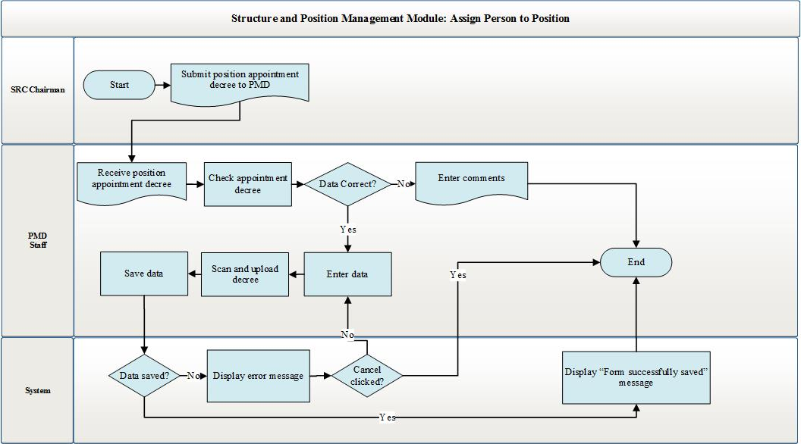
Diagram 4. Appointing the SRC employee to a position
Appointing person to a position and separating him/her from the position are conducted via this module. The process of appointing the SRC employees to a position is presented in Diagram 4.
The process is carried out in the following decree:
- PMD officer receives the decree on appointing the employee to a position, as approved by the Chairman of the RA SRC (hereinafter, Chairman).
- PMD officer checks the accuracy of the decree.
- In case there are no mistakes, go to Step 5.
- In case there are mistakes, comments are to be entered in the system and the decree is not being registered in the system.
- Employee of respective PMD division finds in the system the employee stated in the decree and his/her position.
- Employee of respective PMD division completes the fields in the form for appoining the person to a post.
- Officer of respective PMD division clicks on “Save” button.
- The system saves the data.
- The system saves the data, and in case there are no mistakes, a transition to Step 12 takes place.
- In case there are mistakes, the system displays an error message.
- The process ends when clicking “Cancel” button in the error message.
- If not, go to Step 6.
- The system shows “Data saved” message.
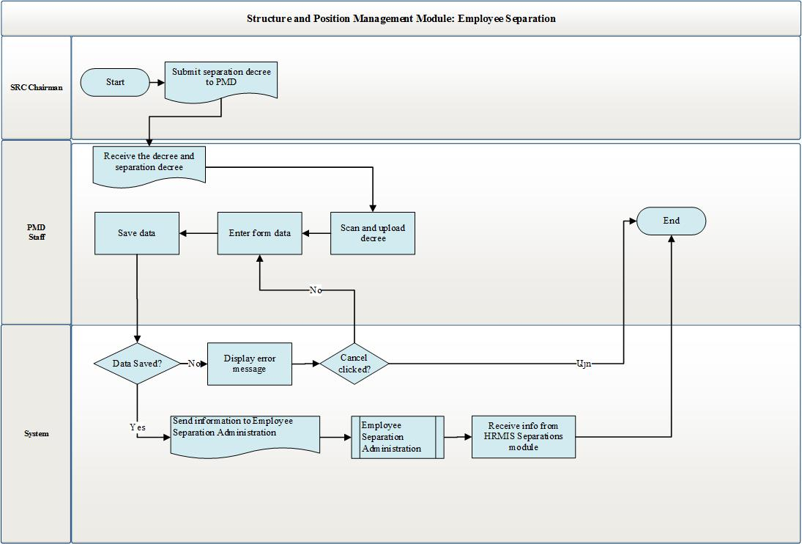
Diagram 5. Separation of employee from position
The process of separation of person from position for the SRC employees is presented in Diagram 5։
It is performed in the following decree:
- PMD officer receives grounds for the separation of employee from position and the separation decree of the employee being signed by the Chairman.
- The PMD officer finds the employee stated in the decree in the system.
- Employee of a respective PMD division completes the information required for the separation of person from position.
- PMD officer clickes on“Save” button.
- The system saves the date, and in case there are no mistakes, a transition to Step 10 takes place.
- In case there are mistakes, the system displays an error message.
- The process ends when clicking on “Cancel” button in the error message.
- If not, go to Step 4.
- The data are transferred to the HRMIS “ Employee Separation Administration” Module.
- The operations required for the separation process are implemented in “Employee Separation Administration” Module.
- The system receives a reply from “ Employee Separation Administration” Module regarding the process results.

Organization Structure and Position Management Module
The sequence of the processes implemented in this module in course of administering the organization structure is presented in Diagram 6.
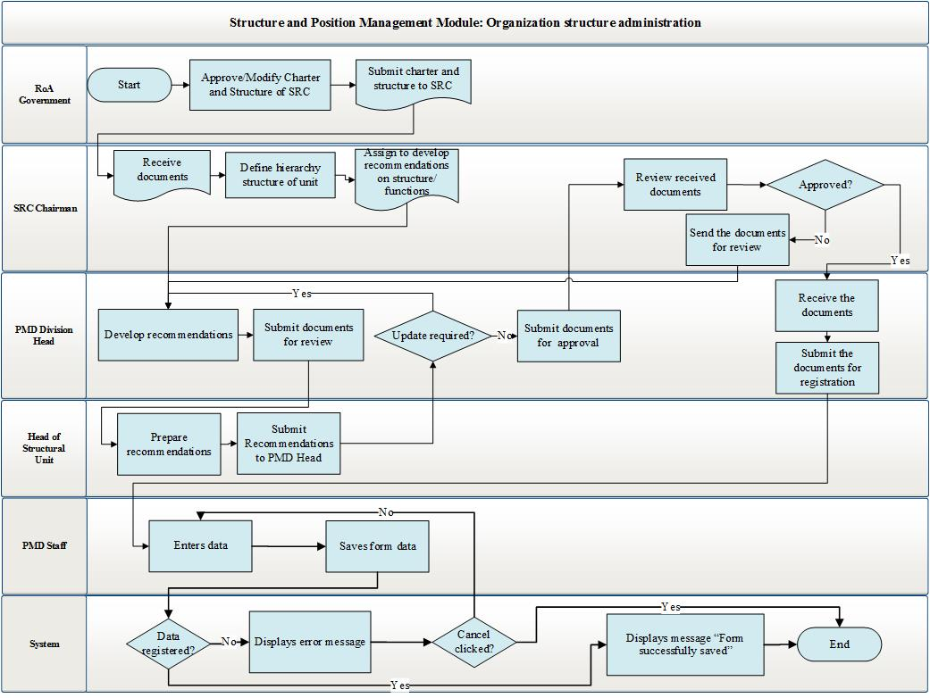
Diagram 6. Organization structure administration

It is implemented in the following decree:
- The RA Government shall approve the SRC Charter and structure.
- The RA Government sends the SRC Charter and structure to the SRC Chairman.
- The SRC Charman defines the work distribution among his/her deputies and assigns the Head of the PMD and the head of organizational units to submit recommendations on the functions and the structure of structural units.
- The heads of structural units shall submit to the Head of the PMD the drafts of the functions of their units by coordinating those with their respective supervisors.
- Receiving instructions from the Chairman and coordinating those with appropriate officials, the PMD Head summarizes and edits the documents, as well as produces draft decree of the SRC Chairman on approving such functions.
- The PMD Head submits the draft decree for approval by the Chairman.
- The SRC Chaiman considers the documents, and in case if amendments are required, sends those to the PMD Head. A transition to Step 5 takes place.
- Upon approval, the SRC Chairman sends the documents to the PMD Head.
- The PMD Head receives the documents and sends them to the PMD officer for the purpose of making the registration.
- The PMD officer makes necessary registrations on each structural unit in the system.
- The PMD officer clickes on “Save” button, and the system registers the information.
- In case there are mistakes, the system displays an error message.
- The process ends when clicking on “Cancel” button in the error message.
- In case another button is clicked, a transition to Step 10 takes place.
- In case there are no mistakes in the process of registration, the system shows “Information registered” message.
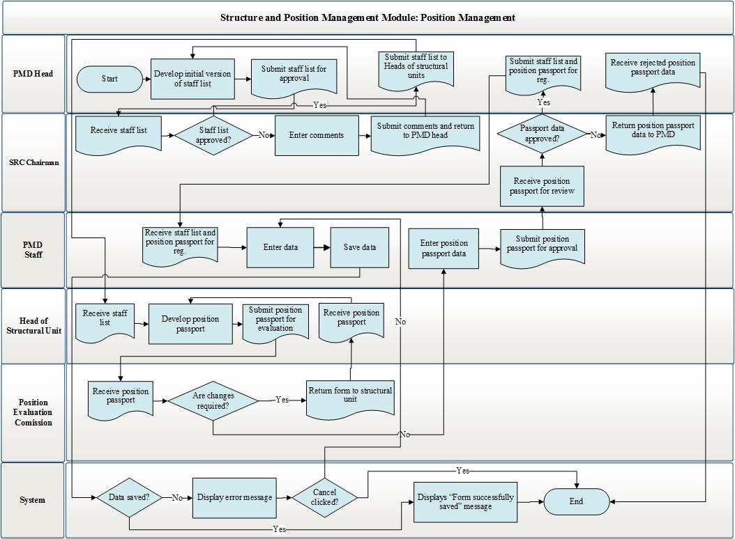
Diagram 7. Staff list administration
This module is envisaged also for carrying out the SRC staff list administration. The sequence of the procedures implemented in course of the staff list administration is presented in Diagram 7. It is implemented in the following decree:
- The PMD Head produces the staff list.
- The PMD Head sends the staff list for the approval by the Chairman
- Upon approval, the SRC Chairman sends the approved staff list to the PMD Head for the purpose of attaching the position descriptions.
- If not approved, the SRC Chairman sends the staff list to the review by the PMD Head.
- Heads of structural units develop the draft of each position description.
- Position description is to be sent for evaluation by the Position Evaluation Commission.
- In consequence of such evaluation, the protocol of job evaluation is sent to the PMD.
- In case there is a need to make amendments in the draft position description, the draft position description is to be sent to the head of structural unit, and a transition to Step 5 takes place. If not, go to Step 9.
- The PMD officer sends the position description and evaluation protocol for the approval by the Chairman.
- The Chaiman considers the position description, and either approves or rejects it. If approved, a transition to Step 11 takes place. If rejected, go to Step 5.
- The approved position description and staff list are sent to the PMD officer for being registered in the system.
- Officer of a respective PMD division enters the required data in the position creation form.
- Officer of a respective PMD division clickes on “Save” button.
- The system registers the information.
- In case there are mistakes, the system displays an error message.
- The process ends when clicking on “Cancel” button in the error message.
- In case another button is clicked, a transition to Step 12 takes place.
- In case there are no errors in course of registration, the system displays “Information recorded” message.

Vacation Management Module
In the Vacation Management Module, the processes of vacation planning and vacation granting are performed. In the vacation granting module, the processes of vacation granting for annual (minimum, extended and additional), pregnancy and maternity, temporary incapacity, educational, unpaid vacation, the care for up to 3-year-old child and fulfilling State/social obligations are carried out. The workflows implemented in this module are presented below.
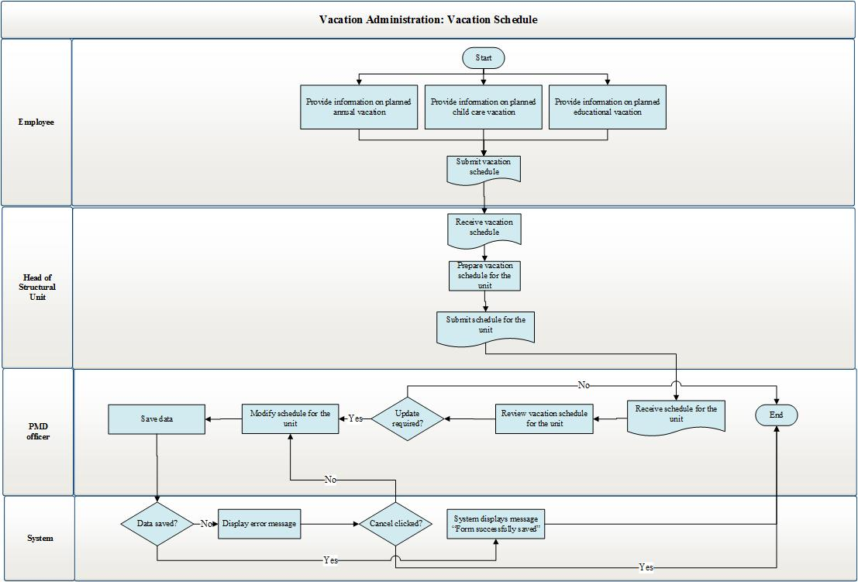
Diagram 8. Schedule administration process
The vacation schedule administration process is as follows:
It is implemented in the following decree:
- Employees provide to the heads of their structural unit’s information on the timeframes for going on an annual vacation, vacation of the care for up to 3-year-old child and educational vacation through the current year.
- Heads of structural units verify the information on their employees’ planned vacations through the current year. As necessary, they instruct their employees to make changes in the entered data.
- Based on the information received from employees, officer of the PMD Division conducts collations, comparisons and analysis in respect to the schedule available.
The processes of granting vacations as performed in the given module is implemented by the type of granted vacation.
The process implemented in terms of annual vacation is described in Diagram 9.

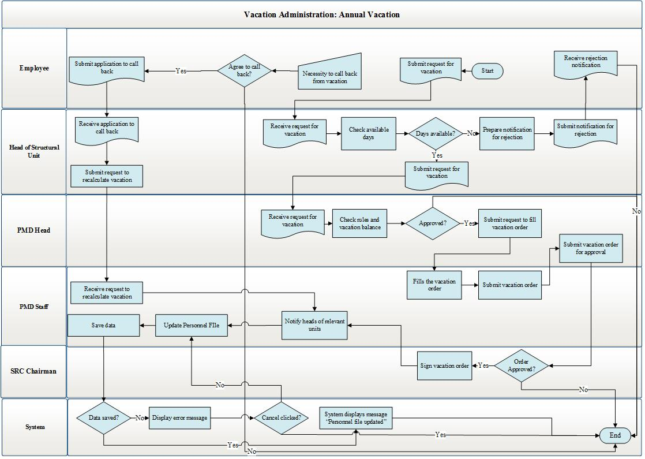
Diagram 9. Granting annual vacation
The process of granting annual vacation shall be performed as follows:
- To go on an annual vacation, employee should complete the annual vacation application form.
- In course of filling the vacation days while completing the application, the system makes a comparison between the accrued vacation days of the particular employee and the vacation days filled in the application. The calculation mechanism of accrued vacation days is described in the Vacation Application Creation module in Section 3.5.1. After completing and signing the application, it is to be sent for the approval by the head of unit.
- Head of the structural unit checks the application, and upon approval, he/she approves the application. Transition to Step 4 takes place. If not approved, the application is rejected, and a transition to Step 1 takes place.
- The application shall be sent to the PMD division.
- The PMD Head considers the compliance of the application with the vacation rules and provisions as prescribed in the legislation, and makes a decision on setting the application in motion. If rejected, a transition to Step 1 takes place. In case of approval, officer of a respective PMD division is assigned to produce draft decree on granting vacation.
- Officer of respective PMD Division produces draft decree on granting vacation to the employee, which is to be sent to the head of the PMD division.
- Head of the PMD division considers the received draft decree, and in case there are no mistakes, he/she sends it for the signature by the SRC Chairman. In case there are mistakes, it is to be returned to respective PMD division, and a transition to Step 6 takes place.
- The SRC Chairman signs the decree on granting vacation to the employee. In case the decree is signed, it should be sent to officer of the PMD division, who attaches the signed decree to the employee’s personnel file.
- Officer of respective PMD division notifies the particular employee of the approval of the decree.
- The employee is given an opportunity to go on vacation.
The process of vacations granted on the basis of medical certificate for pregnancy and maternity, as well as sickness or temporary incapacity for work is presented in Diagram 10.

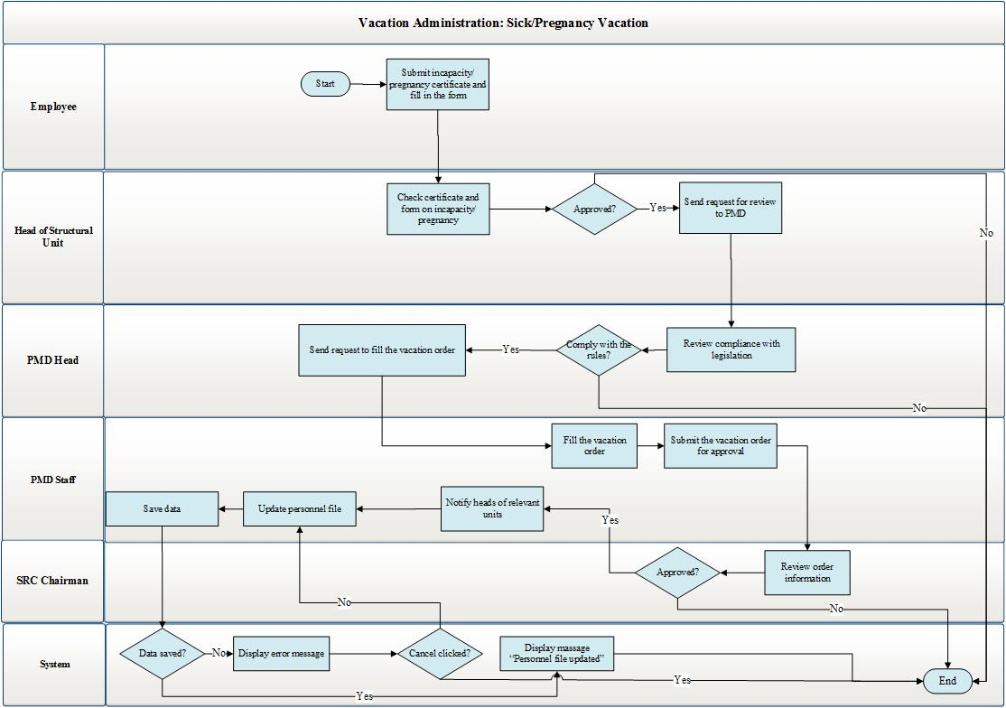
Diagram 10. Vacation granted based on a medical certificate for incapacity
When taking a pregnancy and maternity vacation, the position of the person going on such vacation shall be noted in “Organization structure and Positions Management” Module as “Temporarily Vacant”. The status of such employee becomes “Temporarily Inactive”. For the position in question within the given unit in “Organization structure and Positions Management” and “Labor Resource” modules, an opportunity is created to assign a contract holder of “Replacement” type. Where the employee returns from pregnancy and maternity vacation, the position of the returned employee becomes “Enabled”. The status of employee becomes “Active”. In regard to the employee appointed to a contract-based position, the date of the end of the contract is recorded. This date shall be equal to the date of return of the employee from the pregnancy and maternity vacation.
The process of granting vacation on the basis of the medical certificate for temporary incapacity should be implemented as follows:
- To go on vacation based on the medical certificate for temporary incapacity, employee shall complete an appropriate form and send such form and the copy of the medical certificate for incapacity for the approval by the head of structural division.
- While filling the timeframe in the medical certificate for temporary incapacity, when medical certificate for sickness and temporary incapacity is used, the system performs check of the days of incapacity for work in relation to the particular employee in compliance with the following procedure described in “3.5.1 Vacation Application Creation Module”. In case the medical certificate is rejected, a transition to Step 1 takes place. In case the medical certificate for incapacity is approved, it shall be sent to a relevant PMD division.
- Upon the assignment by the PMD Head, an appropriate PMD division considers the compliance of the medical certificate with the requirements of the legislation and the accuracy of the completed form, and the PMD Head makes a decision on setting it in motion. In case it is rejected, a transition to Step 1 takes place. If approved, the PMD Head assigns to an appropriate PMD division to produce a draft decree on granting vacation. Decree should be produced only in case of pregnancy and maternity vacation. In case of a vacation granted given the medical certificate for sickness and incapacity, a transition to Step 8 takes place.
- In case of a vacation granted in connection with pregnancy and maternity, officer of respective PMD division produces draft decree on granting vacation to such employee, which is to be sent to the PMD Head.
- The PMD Head considers the decree and, in case there are no mistakes, he/she sends it to the SRC Chairman for signature. In case there are mistakes in the decree, the latter is to be returned to the respective PMD division, and a transition to Step 5 takes place.
- The SRC Chairman makes a decision on granting vacation to the particular employee. If approved, he/she should sign the decree. The signed decree is sent, through the PMD head, to employee of respective division, who attaches the signed decree to the personnel file of such employee.
- Officer of a respective PMD division registers the incapacity certificate in the system.
- Officer of a respective PMD division informs the head of the appropriate structural division about the approval of the decree.
- The employee is be given an opportunity to go on vacation.

The scheme of the procedures for vacations granted for the care for up to 3 year old child is presented in Diagram 11.

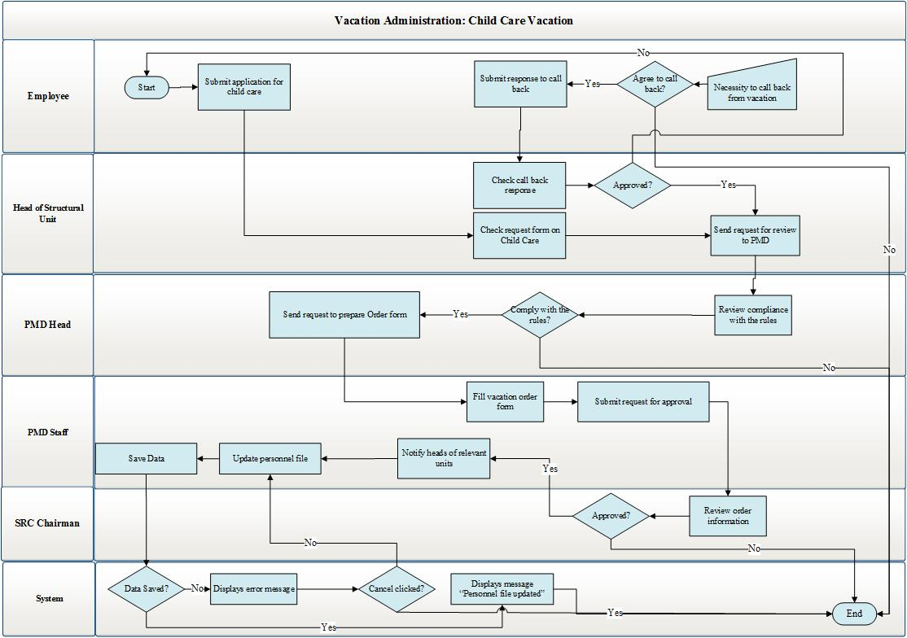
Diagram 11. Vacation to be granted for the care for up to 3 year old child
When taking a vacation for the care for up to 3-year-old child, the position of person going on vacation is to be noted as “Temporarily vacant”. The status of such employee becomes “Temporarily inactive”. For the position in question within the given unit in “Organization structure and Positions Management” and “Labor Resource” modules, an opportunity is created to assign a contract holder of “Replacement” type. When employee comes back from the vacation for the care for up to 3-year-old child, the position of the returned employee becomes “Enabled. The status of employees become “Active”. For an employee appointed to the contract-based position, the date of the end of the contract is recorded. This date shall be equal to the date when the employee comes back from the vacation of the care for up to 3-year-old child. The procedure of granting vacation shall be carried out as follows:
- To go on vacation for the care for up to 3-year-old child, employee completes an appropriate application form.
- While entering the application timing, the system performs check of the vacation days of the employee in question by the following procedure. At the wish of mother (stepmother), father (stepfather) or guardian of the family, a childcare vacation shall be granted before the child turns 3. The vacation shall be taken in full or in part. After entering the data in the application, it is to be signed and sent for approval.
- Head of the division of the employee receives the application and makes a decision on approving or rejecting the completed application.
- Head of the division approves the application, which is to be sent to a respective PMD division, and a transition to Step 5 takes place.
- The PMD Head verifies the compliance of the application with the requirements of legislation and makes a decision on setting it in motion. If rejected, the application is sent to the employee, and transition to Step 1 takes place. Where approved, an officer of a respective PMD division is assigned by the head of the division to produce a decree on granting vacation to the employee.
- Officer of a respective PMD division produces the decree on granting a vacation to the employee. The decree is sent to the Head of the PMD Division.
- The Head of the PMD division considers the decree and, in case there are no mistakes, it is to be sent to the SRC Chairmen for approval. If the decree is not approved, a transition to Step 6 takes place.
- The SRC Chairman considers the decree on granting vacation to the employee. If approved, the decree is to be sent to officer of a respective PMD division, who attaches the decree to the personnel file of the employee.
- Officer of an appropriate PMD division informs the head of the respective division about the approval of the decree.
- The employee is given an opportunity to go on vacation.
While being on vacation granted for the care for up to 3-year-old child, the employee should have an opportunity to come back from the vacation before its due time. To that end, he/she should enter into the system and complete an application on coming back from the vacation prematurely. In case the decree on premature return is approved, the status of the position held by the employee becomes “Enabled. The employee’s status becomes “Active”. The system enters the date of the end of the contract of the employee appointed to the particular position during the time of having “Temporarily vacant” status, which should be equal to the date of return from the vacation of the employee being on vacation for the care for up to 3-year-old child.
- The employee completes an application on premature return from the vacation.
- The application is sent for the approval by his/her direct supervisor.
- The direct supervisor of the employee either approves or rejects the application. If approved, the application is to be sent to the PMD, and a transition to Step 14 takes place. If rejected, proceed to Step 11.
- After the application has been considerd by the PMD Head, it should be either approved or rejected.
- In case the application is rejected, it is to be sent back to the employee, and a transition to Step 11 takes place. In case it is approved, the PMD Head assigns an appropriate PMD division to produce draft decree on behalf of the SRC Chairman on the return from the vacation.
- Officer of an appropriate PMD division produces the decree on returning from the vacation. The decree is to be sent, by his/her direct supervisor, to the PMD Head.
- The PMD Head considers the decree, and in case there are no mistakes, he/she sends it for the approval by the SRC Chairman. In case there are mistakes, the decree is to be sent to an appropriate PMD Division, and a transition to Step 15 takes place.
- The SRC Chairman receives the decree, makes a decision and either approves or rejects the decree on the premature return of the employee from the vacation. If approved, the decree is sent to officer of a respective PMD division, who attaches it to the personnel file of the employee.
- Officer of an appropriate PMD division informs the head of appropriate unit and the employee who has filled the application about the approval of the decree.
- The employee is given an opportunity to come back from the vacation on the day stated in the application.
The scheme of the procedures of the vacation granted for fulfilling State or social obligations is presented in Diagram 12.

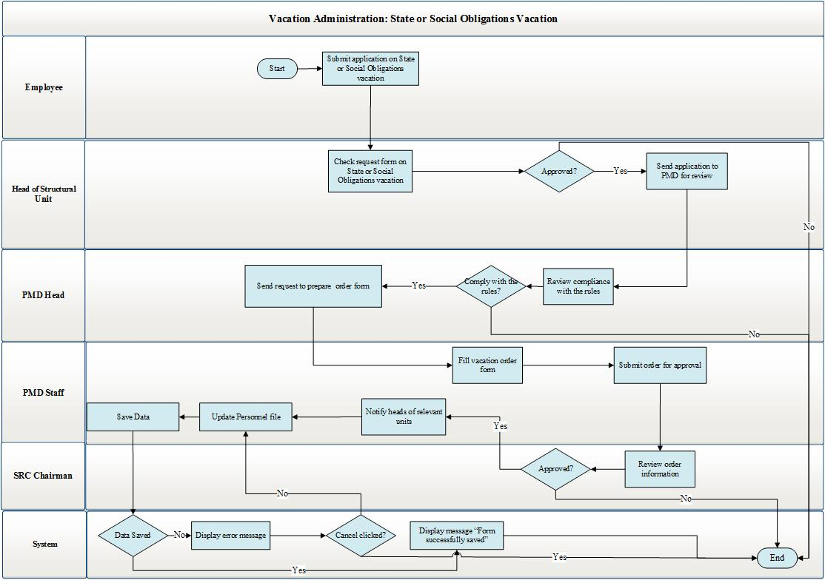
Diagram 12. Vacation granted for fulfilling State or social obligations
This procedure is implemented as follows:
- To go on a vacation granted for fulfillment of state or social obligations, employee completes an appropriate application form and attaches the copies of documents constituting the reason for granting such vacation to the form.
- While entering the application timing, the system performs check of the vacation days of the employee in question. The application is signed and sent to the PMD division for approval.
- The PMD Head verifies the compliance of the application with the requirements of the legislation, and makes a decision on setting the request in motion. In case the application is rejected, it is to be sent back to the employee, and a transition to Step 1 takes place. Where approved, the Head of the PMD instructs respective PMD division to produce a decree on granting vacation to the employee.
- Head of respective PMD division instructs officer to produce the decree on granting a vacation to the employee. The PMD officer produces the decree on granting vacation and sends it to the head of the PMD division.
- Head the PMD division verifies the decree, and in case there are no mistakes, sends it, for the approval by the SRC Chairman. In case there are mistakes, the decree is sent back to the appropriate PMD division, and a transition to Step 4 takes place.
- The SRC Chairman makes a decision on approving or rejecting the decree on granting vacation to the employee. In case of approval, the decree is to be signed and sent to the PMD, and a transition to Step 7 takes place. In case of rejection, the decree is sent back to the PMD, and transition to Step 4 takes place.
- Officer of a respective PMD division attaches the signed decree to the appropriate module of the HRMIS.
- Officer of the respective PMD division informs the head of the appropriate unit and the employee filling the application about the approval of the decree.
- The employee is be given an opportunity to go on vacation.

The scheme of the procedures for educational vacation is presented in Diagram 13.

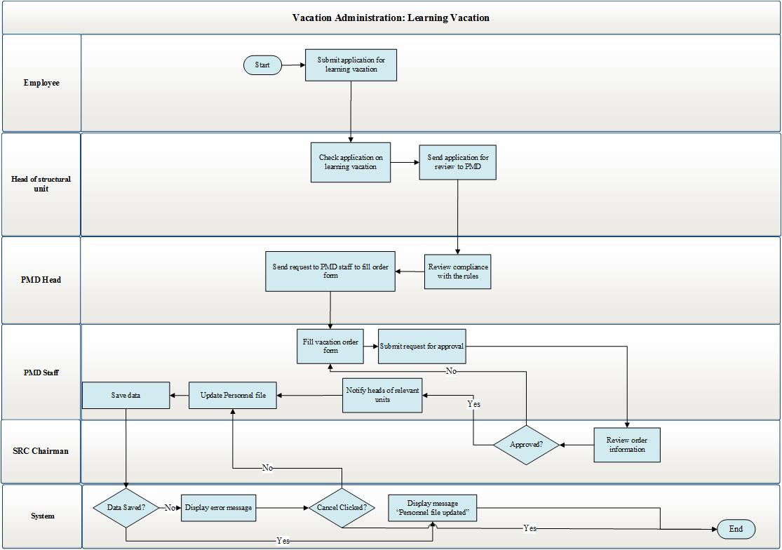
Diagram 13. Procedure of granting educational vacation
The procedure of graning educational vacation is implemented as follows:
- To go on an educational vacation, employee completes an appropriate application form and attachas to it the copy of the document issued by the educational institution.
- The fields of the application are to be filled. It is to be signed and sent for the approval by the head of unit.
- The head of the unit receives the application, approves and sends it to the PMD.
- The PMD Head approves the application and assigns an appropriate PMD division to set the application in motion.
- Officer of respective PMD division produces the decree on granting vacation to the employee. The decree is to be sent to the Head of the PMD.
- The PMD Head verifies the decree and, in case there are no mistakes, sends the decree for the signature by SRC Chairman, and a transition to Step 7 takes place. In case there are mistakes in the decree, the decree is to be sent back to the PMD division and a transition to Step 5 takes place.
- The SRC Chairman either approves or rejects the decree on granting vacation to the employee. In case of approval, the decree is to be sent to officer of respective PMD division, who attaches the application to the personnel file of the employee. In case of rejection, the decree shall be sent back to the PMD division and transition to Step 4 takes place.
- Officer of respective PMD division informs the head of the respective unit about the approval of the decree.
- The employee is given an opportunity to go on vacation.
The scheme of the procedure for unpaid vacation is presented in Diagram 14.
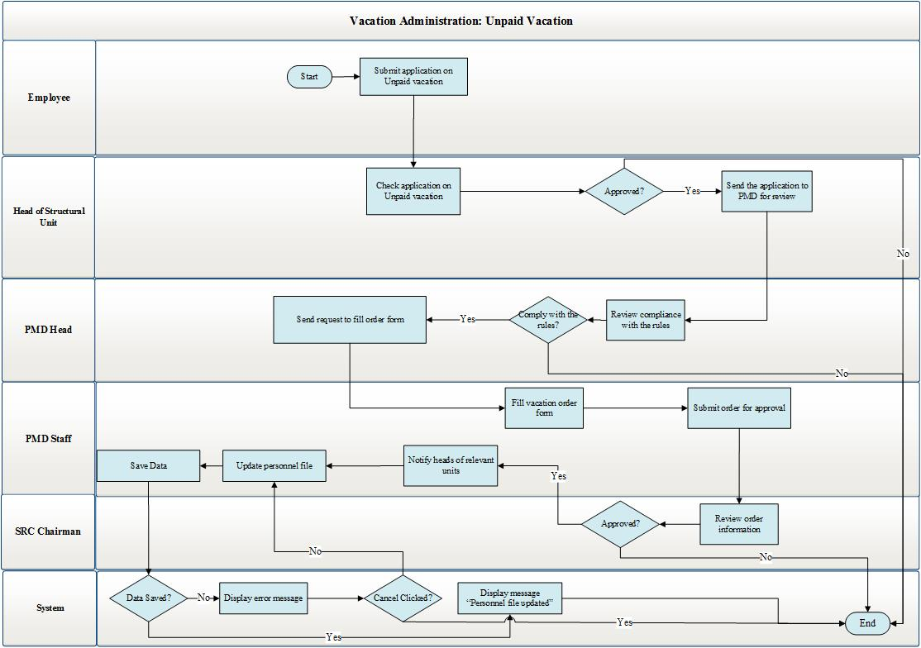
Diagram 14. Procedure of granting unpaid vacation
The procedure of granting unpaid vacation is performed as follows:
- To go on an unpaid vacation, employee should complete an appropriate application form.
- In course of entering the timing in the application, the system performs check of the employee’s vacation days by the principle described in “3.5.1 Vacation Application Creation Module”.
- The head of unit receives the employee’s application form.
- The head of unit makes a decision either on approving or rejecting the application form. In case of approval, the application form is sent to the respective PMD division for setting the application form in motion, and a transition to Step 5 takes place. In case of rejection, the application form is to be sent back to the employee, and a transition to Step 4 takes place.
- The PMD Head verifies the compliance of the application form with the requirements of the legislation, and makes a decision on setting the application form in motion. In case of rejection, a transition to Step 1 takes place. In case of approval, the PMD Head assigns the officer of division to produce a draft decree on granting vacation to the employee.
- Officer of a respective PMD division produces the decree on granting vacation to the employee. The decree is to be sent to the head of the PMD division.
- The head of the PMD division should verify the decree. In case there are no mistakes, the head of PMD division sends the decree for the approval by the SRC Chairman. In case there are mistakes, the decree is to be returned to an appropriate PMD Division, and a transition to Step 6 takes place.
- The SRC Chairman receives the decree and makes a decision either on approving or rejecting the decree. In case of approval, it is to be sent to the officer of a respective PMD division, who attaches the approved decree to the personnel file of the employee. In case the decree is not signed, it is returned to the PMD division, and a transition to Step 6 takes place.
- Officer of a respective PMD division informs the head of appropriate unit and the employee about the approval of the decree.
- The employee is given an opportunity to go on vacation.

Business Trip Management Module
The sequence of the procedures carried out in the business trip administration module is presented in Diagrams 15-18. Diagram 15 presents the process of creating Business trip request, Diagram 16 – the process of creating Business Trip Decree and Certificate, Diagram 17 – the processes occurring in course of going to business trip and returning from the business trip, and Diagram 18 – the processes occurring in case of business trips abroad.

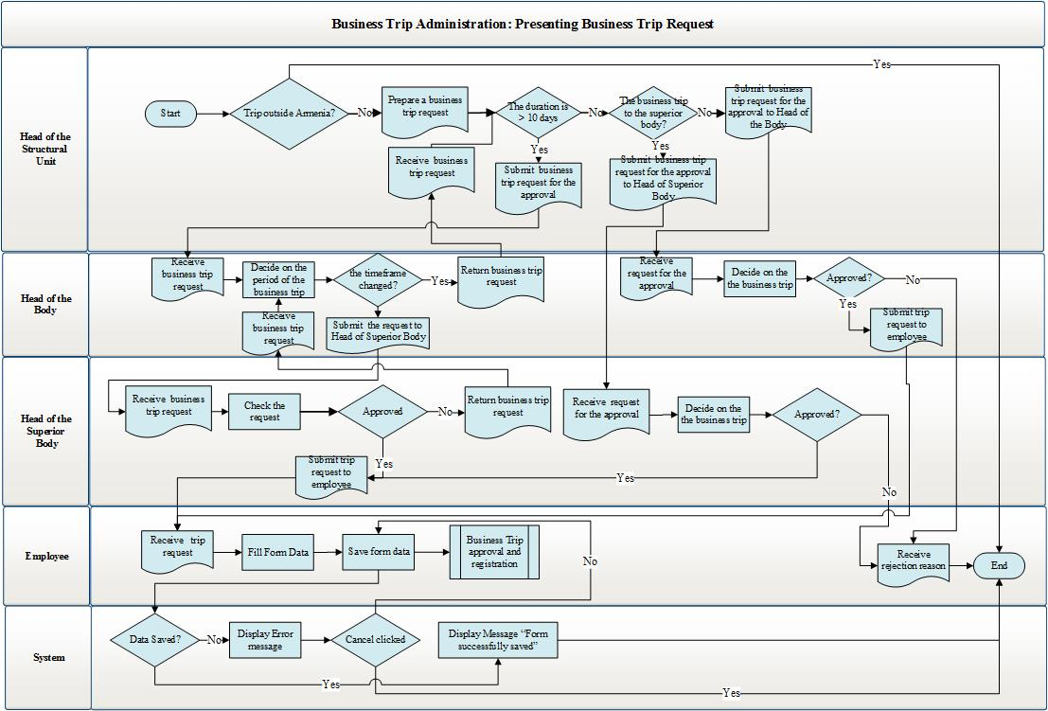
Diagram 15. Preparing business trip request
The Business trip request is prepared in the following decree:
- Employee fills the memo and sends it to the head of unit for approval.
- The head of unit considers the request. In case the request is rejected, it is to be sent back to the employee. In case of approval, proceed to Step 3.
- In case the employee is from the staff of the superior body, or if the business trip timeframe exceeds 10 days or the employee is being sent on a business trip to the superior body, then the completed Business trip request is to be sent to the head of superior body for the approval, and a transition to Step 3 takes place. If the employee is from the staff of territorial body or if the business trip timeframe is less than 10 days or the employee is not sent on a business trip to the superior body, the request is to be sent for the approval by the territorial body, which employee is the seconded person, and a transition to Step 4 takes place. TI, Customs and Customs Points are treated as territorial bodies.
- Head of the superior body considers the request. In case of rejection, it shall be sent back to the head of the unit. Upon approval, the process proceeds to “Business trip approval and formation” phase.
- The head of territorial body considers the Business trip request, and in case of agreement, he/she approves it and the process proceeds to “Business trip approval and formation” phase. In case of rejection, it is sent back to the head of the unit, which employee is the seconded person, and a transition to Step 2 takes place.
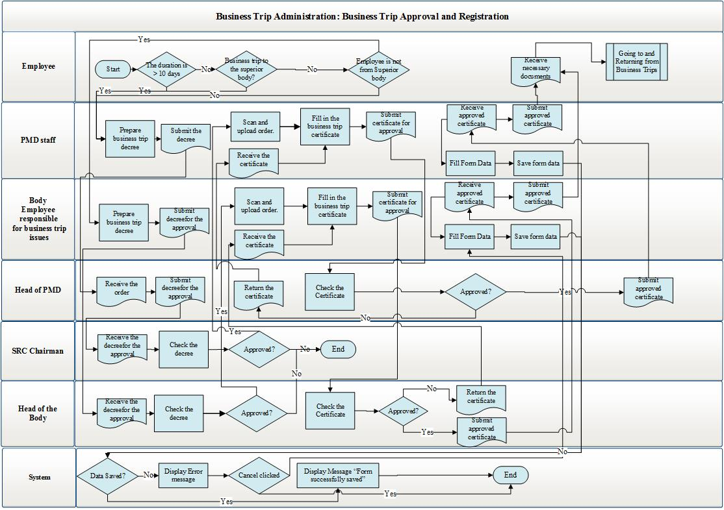
Diagram 16. Business trip approval and formation
Creation of the business trip decree and certificate on the basis of the Business trip request is carried out by the following workflow:
- In case the employee is treated as staff of the territorial body and the business trip lasts for less than 10 days, and the employee is not sent on a business trip to the superior body, then the filled request should be considered by the head of the territorial body. In case if one of the stated conditions are not satisfied, the request should be considered by the head of the superior body.
- Upon approval, the head of superior body or territorial body signs the request, and the officer of the territorial body in charge of business trip issues or the officer of an appropriate PMD division should be assigned to prepare draft business trip decree.
- The PMD officer or officer in charge of business trip issues prepares draft business trip decree and sends the decree to the PMD Head or the head of the territorial body.
- The PMD Head receives the decree and sends it for the approval by the SRC Chairman.
- The SRC Chairman or the head of the territorial body receives the decree and makes a decision on setting the business trip in motion. Upon approval, the Chairman or the head of territorial body signs the decree, which is to be sent to an appropriate PMD division or the officer of the territorial body in charge of business trip issues; it is assigned to prepare and fill the business trip certificate, and a transition to Step 6 takes place. In case of rejection, it is sent back to the PMD, and transition to Step 3 takes place.
- Officer of the PMD division or the officer of the territorial body in charge of business trips prepares business trip certificate, fills and delivers it to the employee (the signature of the head of competent unit should be put to the front side of the business trip certificate and is validated with seal (for business trips of the employees from the superior body); on the reverse side of the certificate, an annotation is made about going on a business trip destination and returning from the business trip destination to the main workplace, signed by heads of appropriate units (business trip destination unit and the unit of the person being sent on a business trip) and validated with the seals of appropriate units).
- The employee sent on a business trip is issued a certificate, following which the employee is given an opportunity to go on the business trip.
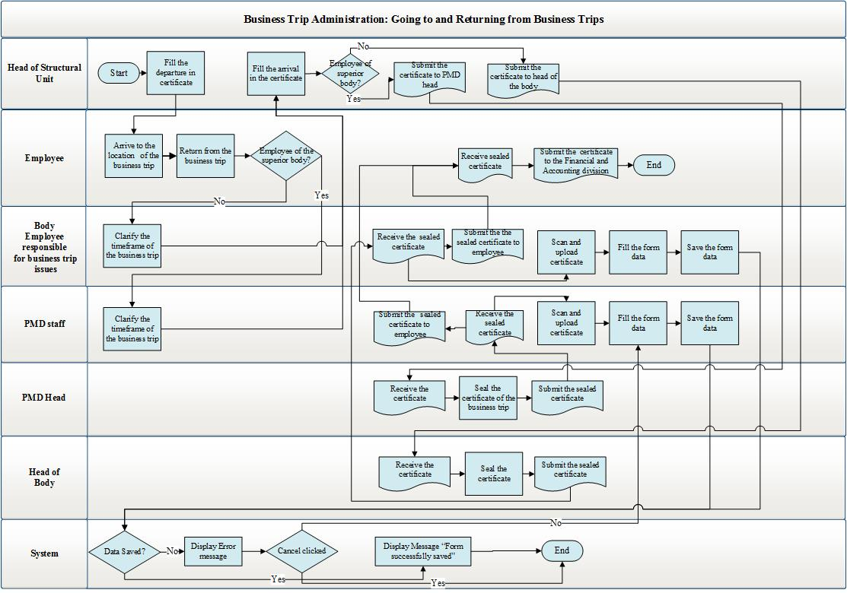
Diagram 17. Business trip; going to and returning from business trip
The processes of going to and returning from business trip are carried out as follows:
- Head of the division of the person to be sent on a business trip signs in the departure section of the business trip certificate.
- The employee arrives to the business trip destination.
- After accomplishing the works in the business trip destination, the officer of the business trip destination in charge of business trips signs in the return section of the business trip certificate.
- After returning from the business trip, the PMD officer, provided the employee sent on a business trip is from superior body, or the officer in charge of business trips of the territorial body, provided the employee is from the territorial body, shall adjust the timing of the business trip.
- The head of unit approves the return of the employee from the business trip in the certificate.
- If the employee sent on a business trip is from the superior body, the certificate is to be sent to the Head of the PMD, and if he/she is an employee of the territorial unit, the certificate is to be sent to the head of the territorial unit.
- The PMD Head or the head of the territorial body should seal the certificate and return it to the officer of an appropriate PMD division or the officer from the territorial body being in charge of business trips.
- The officer of an appropriate PMD division or the officer from the territorial body being in charge of business trips issues the sealed certificate to the employee.
- The employee files the certificate to the Finance and Accounting Department.
- The process is over.

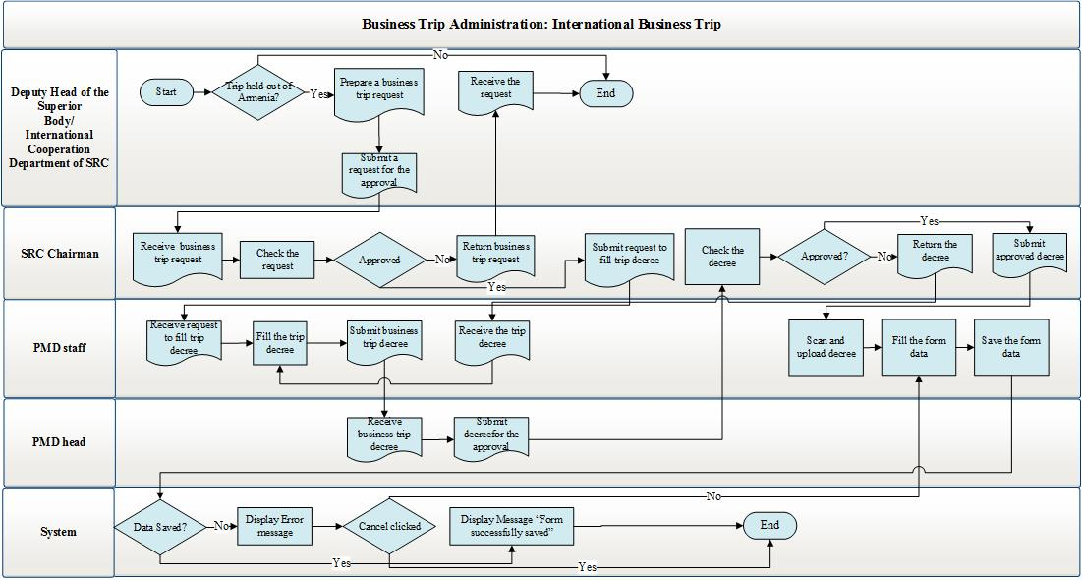
Diagram 18. International business trip
The processes performed for international business trips are as follows:
- Officer of the International Cooperation Department fills a request, addressed to the head of the superior body, with the view to sending a respective employee on a business trip with a prior agreement reached with the deputy head coordinating the superior body or the head of unit. Thereafter, the Business trip request of such employee is submitted for the approval by the Chairman.
- After the Business trip request is considered by the head of the superior body, he/she either approves or rejects it. Upon approval, the head of the superior body assigns the PMD to prepare a draft business trip decree. In case of rejection, the request is returned to the person that has filed the request, and a transition to Step 1 takes place.
- PMD officer prepares the business trip decree, which is to be sent to the Head of the PMD.
- The PMD Head submits the business trip decree for the approval by the SRC Chairman.
- The Chairman approves the decree.
“Business Trip Management” module under “Functional Requirements” Chapter presents the forms used in these phases, as well as the description of their fields and the operation rationale.

Internal Transfers Management Module
The processas occurring in the Internal Transfers Module are described in Diagrams 19-22.
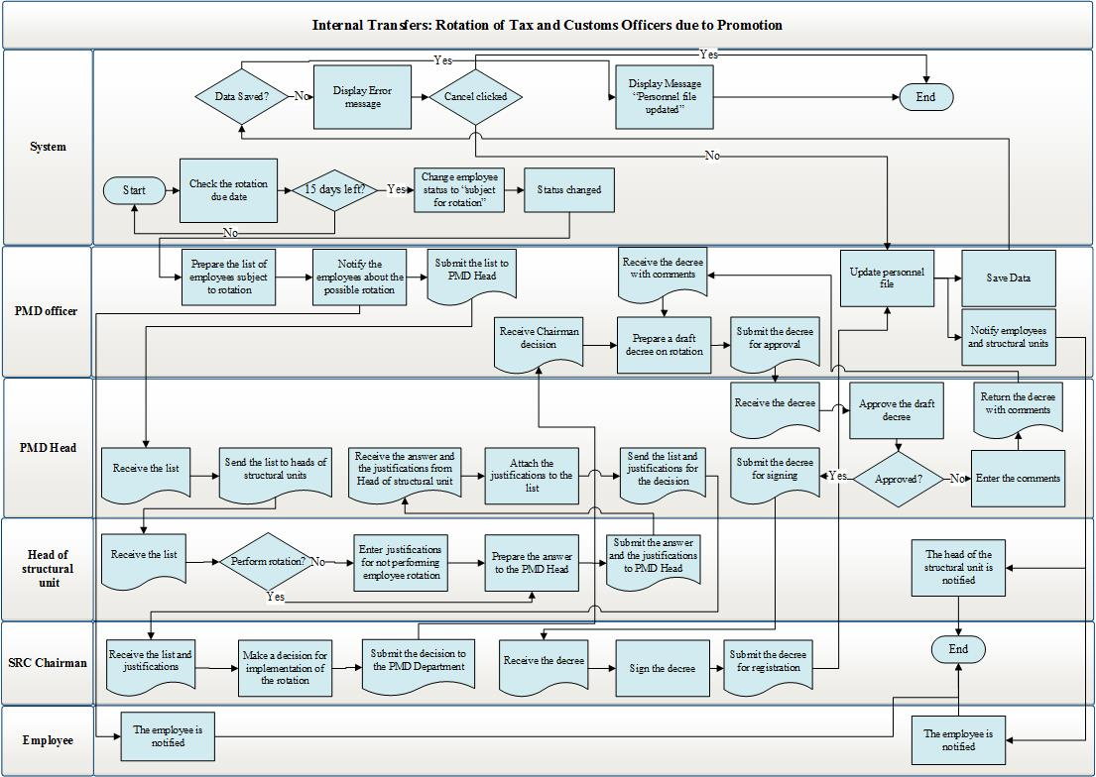
Diagram 19. Rotation of officers
The rotation process is carried out as follows. The basis for rotation is expiration of at least consecutive two-year working phase among persons holding relevant positions as per the Government decision. The positions subject to rotation should be checked through the “Subject to rotation” field displayed in “Create Position” form under the description of “Labor Resource” Module. Positions subject to rotation are described in 3.4.2 The SRC Staff List Administration Module description.
The rotation process is carried out in the following decree:
- The list of employees that have worked for at least two years in their recent position is compiled for appropriate positions.
- As a result of considering the list, the head of unit may submit a proposal of not conducting rotation for an employee. In case there are justifications available for not conducting rotation for any employee, a recommendation document for not implementing rotation is to be filled and sent to the PMD. For customs officer, it is allowed to fill only one recommendation document.
- The list of person’s subject to rotation is to be considered by the Head of the PMD; the PMD Head produces a rotation scheme, and sends the scheme and the recommendation documents on not implementing rotation to the Chairman with the view to making a decision on employee’s subject to rotation.
- The Chairman considers the list and makes a decision on either conducting or not conducting a rotation with regard to a particular person. In case of agreeing on the recommendation documents on not conducting rotation, the rotation of the particular employee shall not be carried out. In case of agreeing with the rotation scheme, the Chairman approves it and assigns the PMD to prepare draft decree on conducting such rotation.
- Officer of an appropriate PMD division prepares the decree for conducting employees rotation, which is to be sent to the PMD Head.
- The PMD Head submits the decree for the approval by the Chairman.
- The Chairman approves the decree and sends it to an appropriate PMD division.
- Officer of an appropriate PMD division registers the decree in the personnel file of the employee and notifies the employee and the head of the unit of conducting rotation.
Demotion is carried out based on “demotion” conclusion as a result of official investigation and attestation.
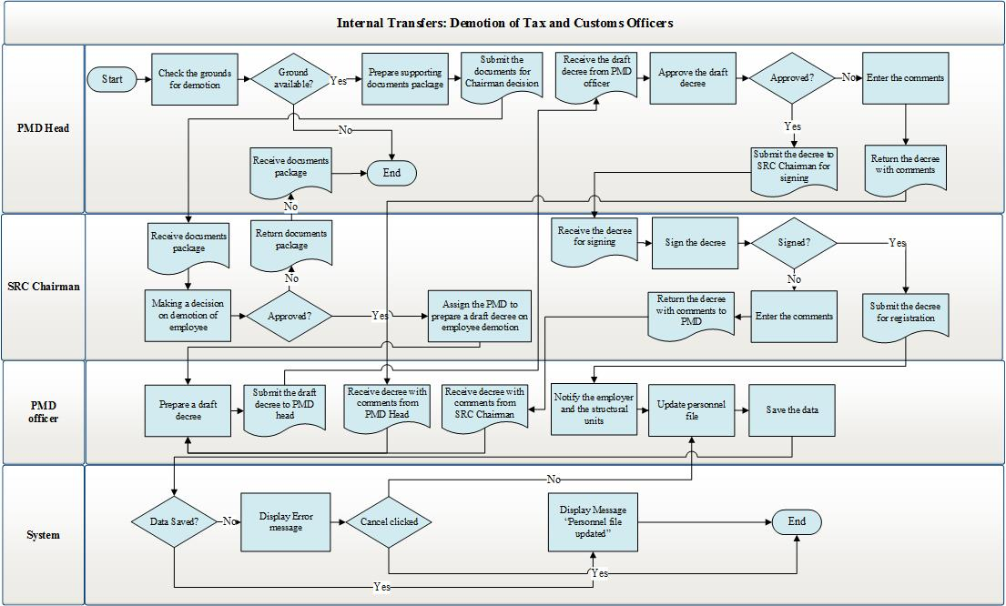
Diagram 20. Demotion of employee to a lower position
Demotion of employee to a lower position is carried out as follows:
- The reasons for demotion to a lower position are to be checked.
- Upon availability of any reason, the PMD Head receives the document underlying the demotion and sends it to the Chairman for consideration.
- The Chairman considers the conclusion and makes a decision on demotion of the employee to a lower position.
- Once the decision on demotion is made by the Chairman, he assigns the PMD to prepare a draft decree on demotion. In case a decision is made on dismissing the employee from office, it is to be carried out by the workflows of “Employee Separation Administration” Module. In case of rejection, the process ends.
- Officer of respective PMD division prepares the decree, which is to be sent to the Head of the PMD.
- The PMD Head submits the decree for the approval by the Chairman.
- The Chairman signs the decree, which is to be sent to respective PMD division.
- Officer of respective PMD division registers the decree in the personnel file, and notifies the employee and the head of unit.
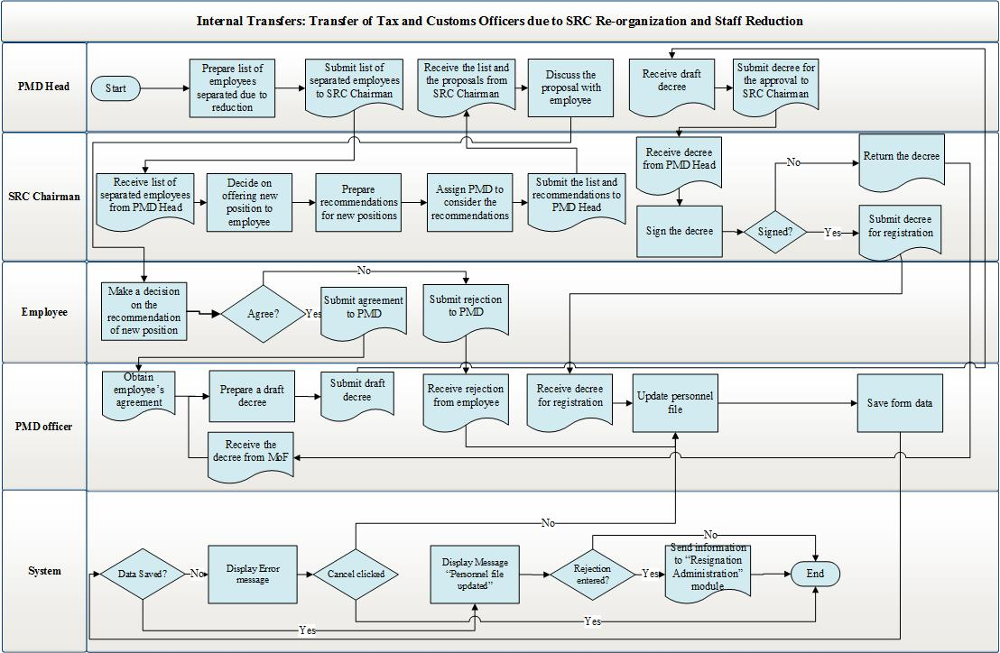
Diagram 21. Changes of employee position due to staff reduction
Change of officer’s position due to staff reduction is carried out as follows:
- The PMD Head compiles the list of employees to be dismissed from office due to staff reduction and sends it to the Chairman.
- The Chairman makes a decision on proposing a new position to the employee subject to reduction. In such case, the proposals should be prepared and sent to the Head of the PMD.
- The PMD Head receives the proposals and discusses those with the staff.
- If agreed by the employee, officer of respective PMD division is assigned to prepare draft decree on appointing the employee to a new position. In case of rejection, the process ends.
- Officer of respective PMD division creates an decree, which is to be sent to the Head of the PMD.
- The PMD Head submits the decree for the approval by the Chairman.
- The Chairman signs the decree, which is to be sent to an appropriate PMD Department.
- Officer of an appropriate PMD division registers the decree in the personnel file, and notifies the employee and the head of the unit.

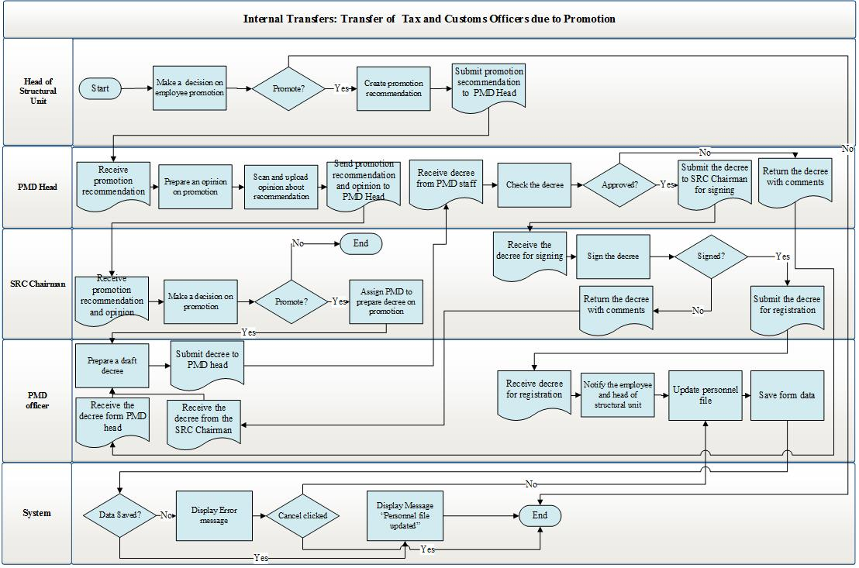
Diagram 22. Employee promotion
Position promotion in case of Career Promotion is implemented through a recommendation document. Career promotion is carried out as follows:
- For the purpose of employee position promotion, the head of unit prepares a promotion recommendation document and sends it to the PMD Head.
- The PMD Head considers the documents, attaches his/her opinion on such promotion and sends the package to the Chairman.
- The Chairman considers the documents. Upon approval, he instructs the PMD to prepare a decree on appointing the employee to a new position. In case of rejection, the process ends.
- Officer of the PMD division creates draft decree and sends it to the PMD Head.
- The PMD Head submits the decree for the signature by the SRC Chairman.
- The Chairman signs the decree and sends it to an appropriate PMD division.
- Officer of an appropriate PMD division registers the decree in the employee’s personnel file and notifies the head of unit and the employee.
See below the description of the forms used in these phases and the fields displayed therin, as well as the rationale of their operation.

Contract Management Module
The processes occurring in the Contract Module are described in Diagrams 23-25.
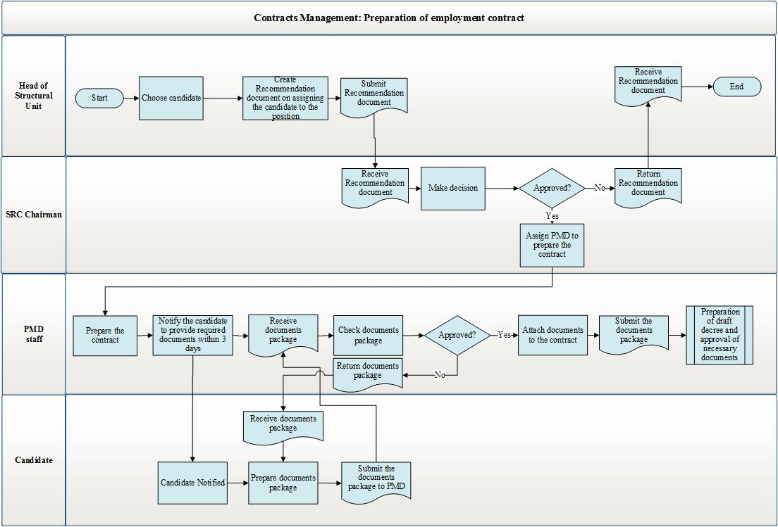
Diagram 23. Preparation of contract
The process of preparing contracts is performed as follows:
- Selection of a candidate is made from “Candidate Pool” or “Cadre Reserve” modules to hold the contract-based position.
- To appoint the candidate to the position, a recommendation document should be prepared by the head of respective unit or the direct supervisor.
- The Chairman makes a decision on appointing the candidate to the position.
- Upon approval, the SRC Chairman assigns the PMD to prepare a contract. In case of rejection, a transition to Step 1 takes place.
- Officer of the PMD division prepares the contract for appointing the particular candidate to the position in question and notifies the candidate of providing the package of all necessary documents within a 3-day period.
- The candidate prepares and submits to the PMD the document package, which shall contain:
- identification document;
- employment record book (save for those being recruited for the first time), social security card or a reference on not having social security card and/or the public servant number or a reference on not having public servant number;
- certificate of education or any required qualification, if, according to the employment legislation, the job is contingent on a certain education or vocational training;
- health certificate (health book), provided the employment contract is concluded for such jobs that require initial and regular medical examination, as well as in the event of entering into an employment contract with citizens under eighteen. The list of such jobs and the form of certificate (health book) shall be defined by the Government of the Republic of Armenia.
- other documents being stipulated in the law and other normative legal acts;
- when hiring for a job, it shall be prohibited to request such documents that are not provided for under the law or other normative legal acts.
- Officer of a respective PMD division shall conduct the document package inspection. In case there are no mistakes, a transition to Step 8 takes place. In case of identifying mistakes or submitting not the full document package, the latter shall be returned to the candidate, and a transition to Step 6 takes place.
- Officer of an appropriate PMD division prepares the contract and attaches the received documents to the contract.
- Transition to “Preparation of draft decree and approval of necessary documents” workflow takes place.

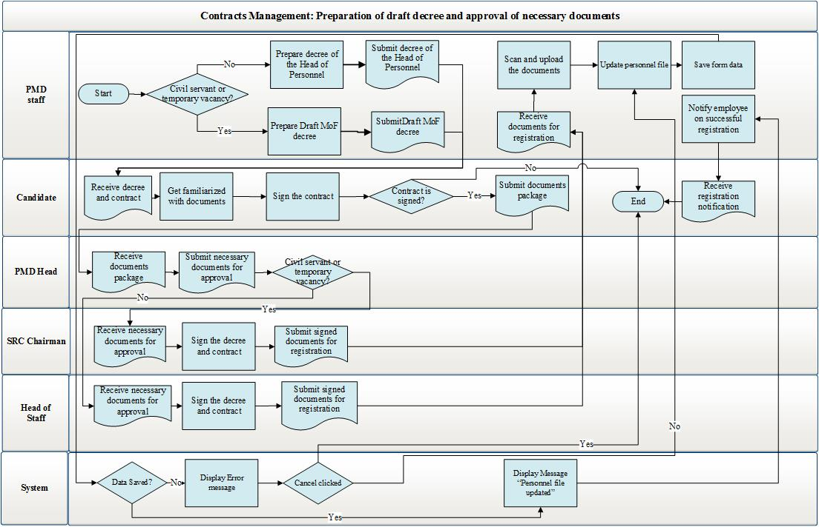
Diagram 24. Preparation of draft decree and approval of necessary documents
Preparation of draft decree and approval of necessary documents are performed as follows:
- Officer of the PMD division prepares an decree on appointing a particular person to a position. If the position is temporarily vacant or is envisaged for performing civil works, then the decree of the Chairman shall be prepared. If the position is for performing technical works, then the decree of the Head of Staff shall be prepared. The contract and the decree shall be sent to the candidate for being familiarized with it.
- Employee gets familiarized with the decree and signs the contract. In case it is not signed, the process is ended.
- After the contract is signed by the employee, the Decree and the Contract are to be signed by the Chairman or the Head of Staff pursuant to the cases referred to in Step 1. Once the document package is signed, it is to be sent to the PMD to be attached to the personnel file, and a transition to Step 4 takes place. Otherwise, the process should be over.
- Officer of a respective PMD division attaches the documents to the personnel file and notifies the candidate and the head of unit of being appointed to the position.
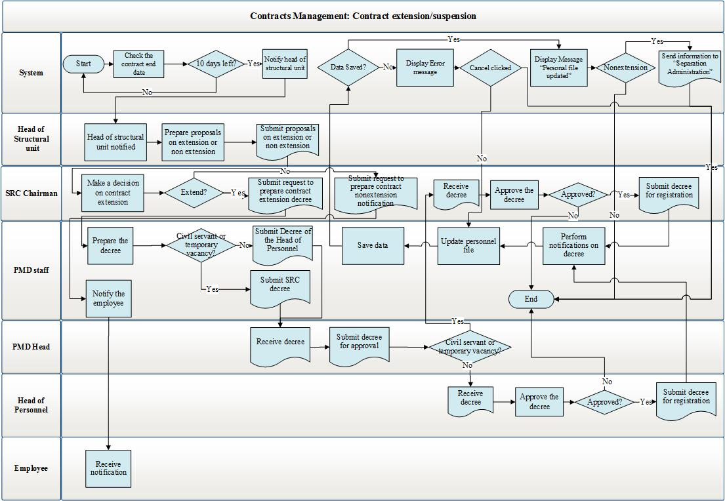
Diagram 25. Contract extension/end
Contract extension is performed by the following process:
- 10 days before the end of contract, the head of unit notifies of the end of the subordinate employee’s contract.
- Head of unit makes a decision on extension or non-extension of the contract. A proposal is to be prepared and submitted to the Chairman.
- The Chairman makes a decision on extension or non-extension of the contract. The Chairman assigns the PMD to prepare an appropriate draft decree.
- Officer of a respective PMD division prepares the decree on extension or non-extension of the contract. Where the position is temporarily vacant or is envisaged for performing civil works, decree of the Chairman is to be prepared. In case the position is for performing technical works, decree of the Head of Staff is to be prepared. After the decree has been prepared, it is to be sent for the signature by the Chairman or the Head of Staff.
- The Chairman or the Head of Staff shall sign the decree, which is to be sent to an appropriate PMD division to be attached to the personnel file.
- Officer of a respective PMD division receives the decree, and based on it extends or terminates the contract. Officer of a respective PMD division notifies the contractual-based employee of extension or non-extension of the contract.

Probation Period Management Module
The processes occurring in the probation and adaptation module are described in Diagrams 26-28. The probation and adaptation process is implemented as follows. In case a person is appointed to a new position, the duration of his/her probation is to be determined by the process described in Diagram 26. Thereafter, the probation and adaptation phase is implemented by the workflow described in Diagram 27. At the end of the probation, the probation period of the employee is to be evaluated through the process presented in Diagram 28.
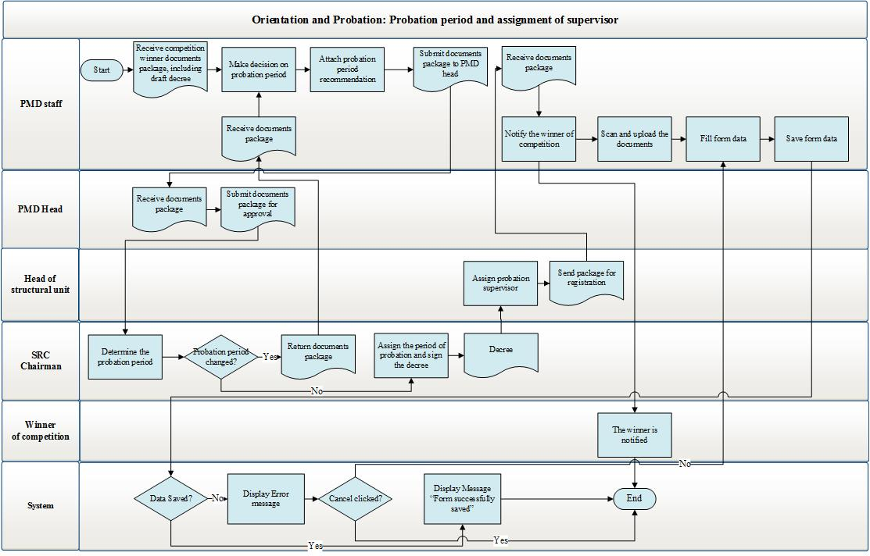
Diagram 26. Appointing probation period and its supervisor

The probation period selection process is performed in the following decree:
- Officer of a respective PMD division receives the document package of person recently appointed to a position, including the draft decree.
- Officer of PMD proposes the duration of the probation period, which is to be sent to the PMD Head. The probation period cannot be more than 6 months.
- The PMD Head considers the proposal and sends it for the approval by the Chairman.
- The Chairman determines the probation period. In case it fails to conform to the PMD proposal, the probation period should be changed.
- The Chairman determines and approves the probation period, signs the decree, subsequently sending the document package to respective PMD division to make records. The processes related to the decree are described in “2.3.1 Labor Resource Module Workflows” section herein.
- Within a two-day period after appointing the person to a position for tax or customs service with a probation period, the head of an appropriate unit of tax or customs authority shall appoint a supervisor for the probation period from among the experienced employees of the same unit.
- Officer of an appropriate PMD division receives the document package and attaches the package to the employee’s personnel file.
- The employee should be notified of the probation period.
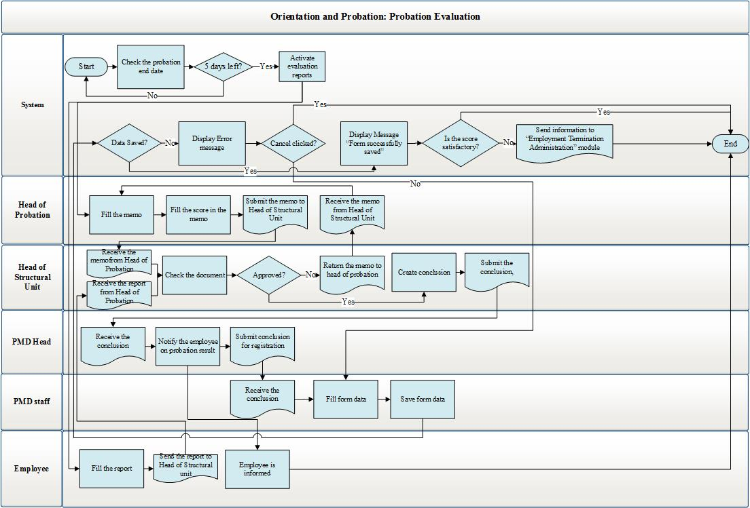
Diagram 27. Evaluation of the probation period results
- Evaluation of the probation period is implemented in the following decree: the system performs check of the expiration of the probation period, and if less than 5 days are left until the end of the probation, the employee on probation shall be notified via the system on the need of preparing a report on the probation period. The supervisor of the probation is notified through the system of the need of preparing a memo.
Person fills the report and sends it to the head of unit.
- The supervisor of the probation period fills the memo and evaluates the probation with “Satisfactory” or “Unsatisfactory”, and sends it to the head of unit.
- The head of unit receives the documents package and prepares a conclusion on the probation evaluation, where he/she evaluates the probation period with “Satisfactory” or “Unsatisfactory”.
- The head of unit sends the conclusion to the PMD Head.
- The PMD Head receives the conclusion and considers it. In case of “Satisfactory”, the employee is deemed to pass the probation, and the PMD Head sends the documents to respective PMD division for making records and notifications. In case of being “Unsatisfactory”, the PMD Head assigns an officer of respective PMD division to perform the separation process.
- Officer of respective PMD division receives the documents and performs the required actions.

Employee Separation Administration Module
The processes in the Separation Module are described in Diagrams 29-30. The reason for separation can be an employee separation application written by employee, or availability of any reason for separation.
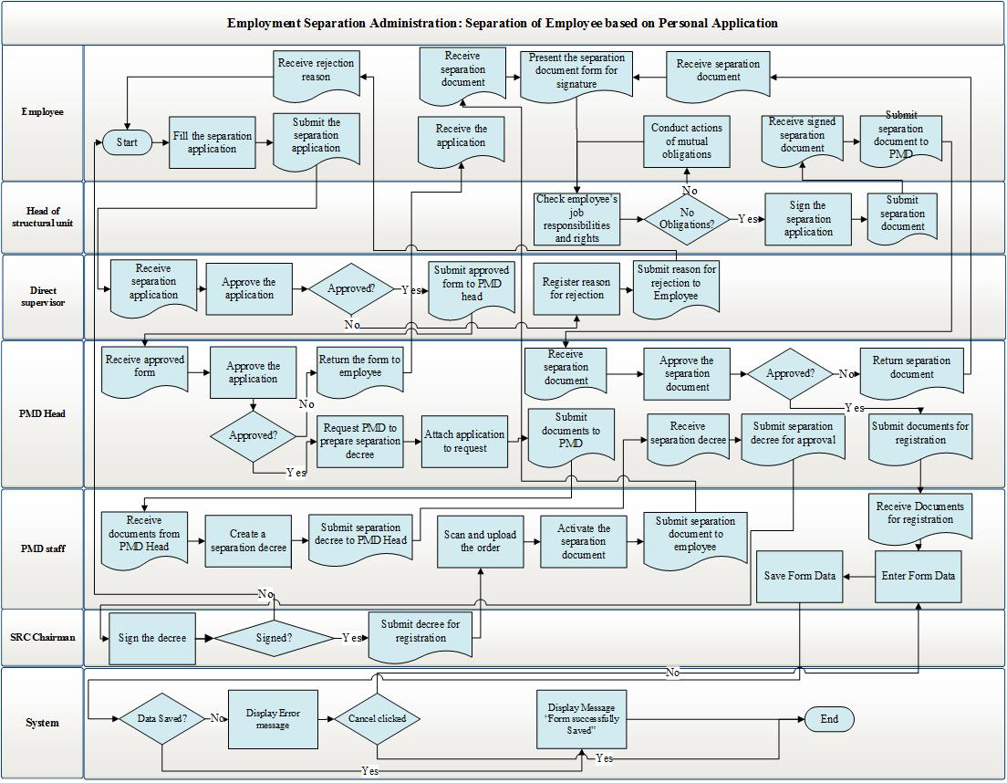
Diagram 28. Separation based on employee’s personal application
The process of separation based on employee separation application is presented in Diagram 29.
It is performed in the following decree:
- Employee completes and signs the employee separation application form. The employee separation application shall be sent to the direct supervisor for approval.
- The direct supervisor considers the employee separation application and approves or rejects it. In case of rejection, the process proceeds back to Step 1. Upon approval, the separation application is sent for the approval by the head of unit, and the process proceeds to the next step.
- The head of unit considers the employee separation application and either approves or rejects it. In case of rejection, the process proceeds back to Step 1. In case of approval, the separation application is sent for the approval by the Head of the PMD, and the process proceeds to the next step.
- The PMD Head receives the approved separation application. The PMD Head considers the separation application and once again approves or rejects it. Upon approval, an appropriate PMD division shall be assigned to prepare draft decree on separation, and the process proceeds to the next phase. In case of rejection, the process proceeds back to Step 1.
- Officer of respective PMD division receives the task, prepares draft separation decree, which is to be sent to the PMD Head for his/her consideration.
- After receiving, the PMD Head considers the draft decree and sends it for the approval by the Chairman.
- The Chairman considers the draft decree and approves or rejects it. In case of rejection, the process proceeds back to Step 1. In case of approval, the decree is sent to respective PMD division, and transition to the next step takes place.
- Officer of respective PMD division receives the decree and attaches it to the employee’s personnel file.
- Officer of respective PMD division issues the employee separation sheet to the employee.
- The employee issues the employee separation sheet to the heads of the units stated therein for the signature.
- In case there are no mutual obligations, the heads of units sign the employee separation sheet.
- In case the signatures of the heads of all involved units are available, the employee submits the employee separation sheet to the PMD Head.
- The PMD Head checks the employee separation sheet. In case there are mistakes, it is returned to the employee, and a transition to Step 9 takes place. In case there are no mistakes, the PMD Head signs the employee separation sheet and delivers it to respective PMD division to make records.
- Officer of PMD division receives the employee separation sheet and attaches it to the personnel file.
- Officer of the PMD division submits the decree and the employee separation sheet to the Accounting and Financial Analysis Department.
- Officer of respective PMD division fills the employment record book and provides it to the employee.
Upon availability of other grounds for separation, the process takes place in the same manner, save for the above Points 1-5, which are the following in this particular case:
- Officer of respective PMD division checks the availability of other grounds for separation in regard to the employee.
- Upon availability of another ground, officer of respective PMD division prepares draft separation decree. Thereafter, the draft separation decree and the document constituting the ground are submitted to the Head of the PMD.
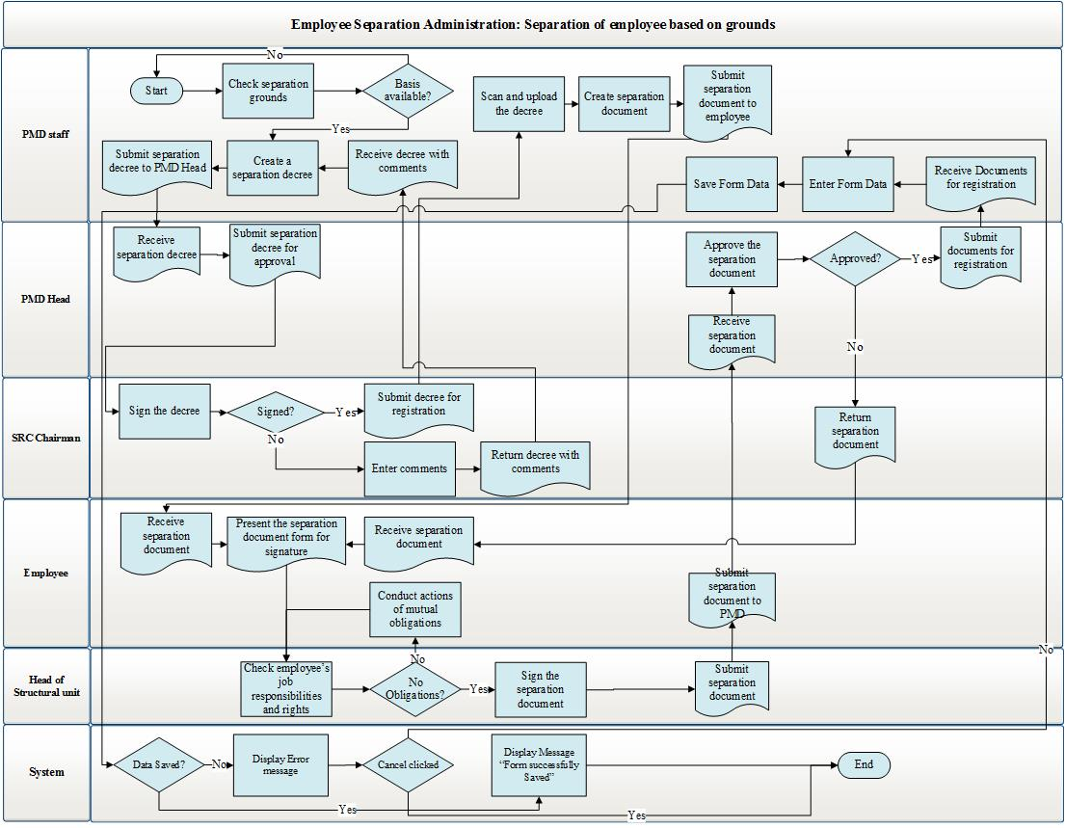
Diagram 29. Separation upon availability of appropriate grounds

Cadre Reserve Module
The sequence of processes implemented in Cadre reserve, from registering employee in Cadre reserve to deregistering, is pictured in Diagram 30-32. The process of registering in Cadre reserve is described in Diagram 30.

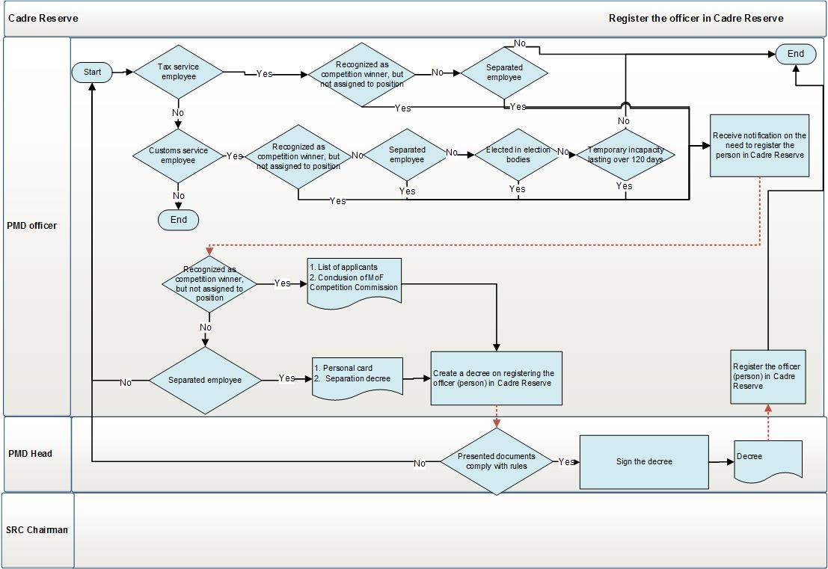

Diagram 30. Process of registering in Cadre Reserve

It is implemented in the following sequence:
      - Checks are made with the tax or customs officer on availability of grounds for registering in Cadre reserve.
      - When such grounds are missing, the process is finalized. If there are grounds, the PMD officer prepares the required forms and the Decree of SRC Chairman.
      - The PMD Head sends the documents to the SRC Chairman for approval.
      - SRC Chairman makes a decision on registering or not registering the given person in Cadre reserve.
      - In the case of positive decision, s/he signs and approves the Decree. Moving to step 8.
      - In the case of negative decision, the process is over. The package of documents is sent to PMD.
      - In case no decision is made, the officer (person) is, within 5 day’s time, automatically registered in Cadre Reserve.
      - The officer of respective PMD sub-division makes necessary registrations and the person’s data are registered in Cadre reserve.
The process of Cadre Reserve application is described in Diagram 30.

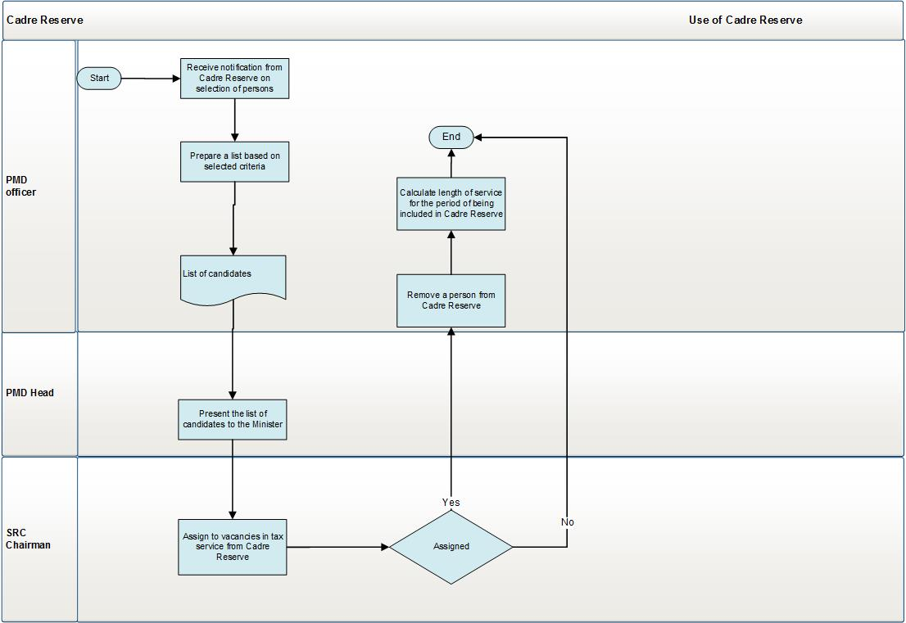
Diagram 31․ Process of using Cadre reserve

To identify data from Cadre reserve, prepare candidate list if necessary and to fill vacant positions, the following process shall take place in the manner described below:

      - PMD officer refines the list based on certain criteria and saves it.
      - Saved list is sent to the PMD Head.
      - PMD Head checks the list and submits to the Chairman.
      - SRC Chairman, upon his/her wish, makes a selection of candidate from the list.
      - When selection is made, the selected person is appointed to the position as per the existing procedure.
      - Appointed person shall be removed from Cadre reserve.

The process of removing a person from Cadre reserve is described in the Diagram below:
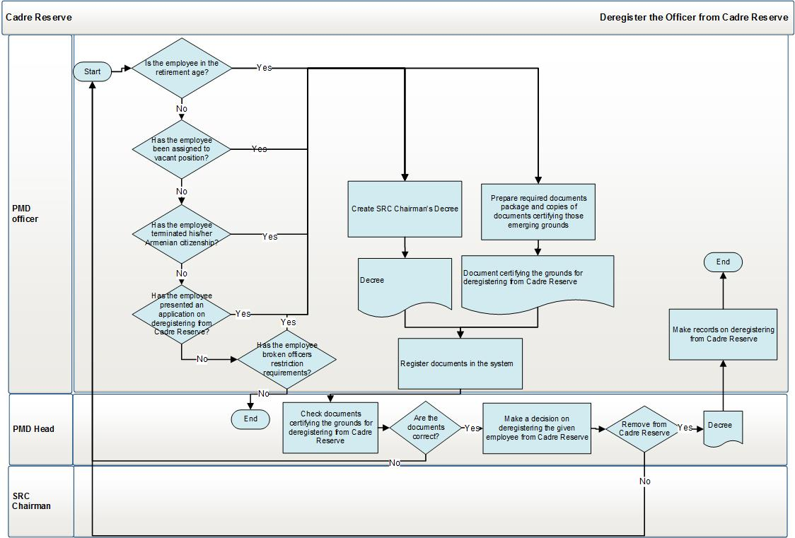
Diagram 32․ Deregistration of a person from Cadre reserve
Deregistration process is implemented through the principle presented in Diagram 32.

- Officer of respective PMD sub-division receives the documents serving as grounds for deregistration.
- PMD officer registers the documents data in the relevant document package for particular person.
- PMD officer creates the deregistration decree and sends documents package, including draft decree to the PMD Head.
- Head of respective PMD checks the documents and approves them. In that case, the package is sent to PMD Head and afterwards to the SRC Chairman. In the case of rejection, the process is over.
- In the case of approval, the package of documents is sent to respective PMD sub-division.
- When rejected, the process is over.
- Officer of respective PMD sub-division registers necessary documents in the system and removes the person from Cadre reserve.

Candidate Pool Module
The process of registering candidates in Candidate pool is described in Diagram 33.

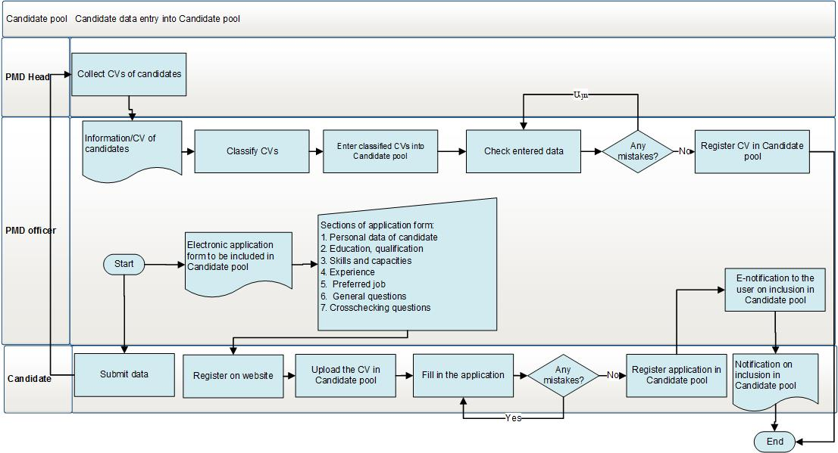
Diagram 33․ Process of personal data registration

The process is carried out in the following sequence։ data entry is done from two sources; first one is the CVs collected by the PMD officer, second is the online CVs. In the Jobs page of the SRC website the vacancy announcements are posted and a link to fill in online CVs. The actions are performed as follows:
When registering forms online:
- The candidate logs into the system.
- The candidate fills in the application form fields.
- The candidate saves the application.
- The candidate receives notification on inclusion in Candidate pool.

In case the PMD officer enters data, s/he shall:
- Collect CVs from candidates.
- Categorize the collected CVs.
- Enter Candidate pool module.
- Enter CV data through module forms.
Register entered data in Candidate pool.

Recruitment and Selection Module
The process of recruitment and selection is implemented in several stages:
- Approval of recruitment.
- Launching the recruitment process.
- Registration and answering the applications.
- Permission to participate in the competition.
- Final selection and appointment to position.
- Make a decision on considering the competition finished.
- Submit a conclusion on winning candidates to the SRC Chairman.
The sequence of processes done in the stage of recruitment approval is presented in Diagram 34.

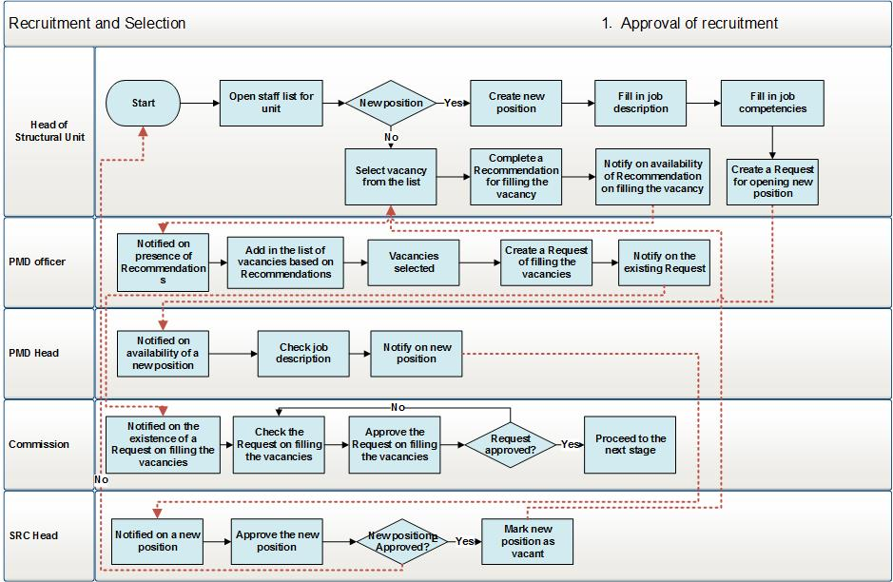
Diagram 34․ Process of recruitment approval

It is implemented in the following sequence:

      - The unit head performs selection of vacancies available in his/her unit for recruitment purposes. If the position is not available, then a new position is created through “SRC staff list administration”, and is shifted to step 5.
      - The unit head creates recruitment request for filling in selected positions.
      - The request is sent to the SRC Chairman (provided the unit is not coordinated by the Deputy Chairman of SRC) through the Head of Personnel and PMD Head to respective sub-division.
      - The officer of respective PMD sub-division receives the request and based on that makes a recruitment inquiry. Moves to step 7.
      - If new position is created, then the PMD Head or officer checks the position description, after which the documents package is sent to SRC Chairman.
      - SRC Chairman approves or rejects the new position after the review of document package. In the case of rejection the process ends, if approved, it is entered into the system and is displayed in the list of vacancies of the unit. The recruitment request for the given vacancy is once again enabled. Moving to step 1.
      - After the recruitment request is created, it is sent to the Attestation and Competition Commission members (hereafter referred to as Commission). The Commission reviews the positions mentioned in the request together will all the relevant documents, including the position description, requests and position evaluation. As soon as the Commission members review everything, they either approve or reject the given recruitment inquiry. In the case of approval, the next stage starts. In the case of rejection, a move to step 1 is made.

The recruitment process starts in the following sequence։

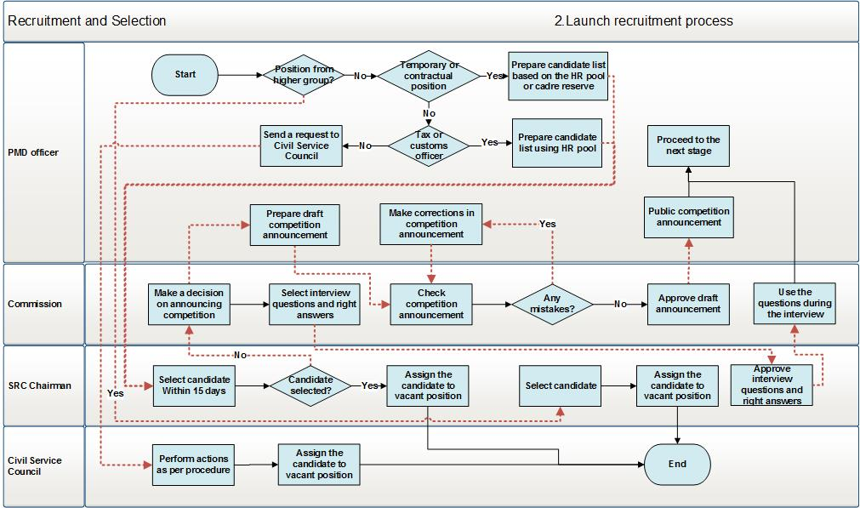
Diagram 35․ Launching recruitment process
It is implemented in the following sequence:

- The respective PMD sub-division employee reviews the list of positions available in the recruitment inquiry approved by the Commission.
- If the vacancy is for temporary or contractual employee, then the respective PMD sub-division employee prepares list of candidates using the PMD pool and Cadre reserve. These lists are included in the staff pool.
- If the vacancy is for tax or customs officers, then the respective PMD sub-division employee prepares list of candidates using the list of tax, customs, civil servants, or persons occupying discretionary positions, as well as the Cadre reserve.
- The ready list of candidates should be sent to the SRC Chairman and s/he makes a selection within 15 day’s period. If s/he fails to do so within the defined period, a move to step 5 is made. In case the selection is made, the selected person shall be appointed to the vacancy and the process ends.
- The Commission makes a decision on running the competition. The Commission members make random selection of test and interview questions and prepare respective list of interview and test questions.
- At least one month prior to the competition, the SRC Chairman shall approve the interview questions and correct answers.
- The tests should be taken no earlier than within one month’s time after its approval.
- If the Commission makes a decision to run the competition, the respective PMD sub-division officer is notified and s/he shall prepare the draft competition announcement.
- The draft competition announcement shall be discussed by the Commission. In the case of errors, the process recesses to step 8 and the respective PMD sub-division officer makes changes to the text. If no errors are found, the Commission approves the final announcement.
- The respective PMD sub-division officer is notified about the approved announcement, who then implements all necessary processes to make the announcement and all attached documents public.
- The moment when the process is made final becomes the start of the next stage.

In the stage of application collection, registration and responding, the applications and other documents are received from citizens and checked, the RA Police makes conviction background checks of the applicants. The implemented processes are described in Diagram 36.

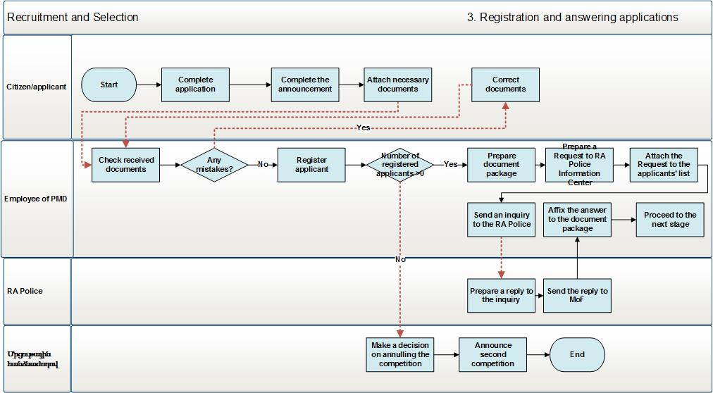
Diagram 36․ Process of application registration and answering stage
The process takes place in the following order:
- The applicant logs in the SRC website to complete the application. It is also necessary to enable the PMD to fill in the application if the applicant visits SRC.
- The applicant completed the application using the options mentioned in the above-mentioned clause.
- The applicant attaches other necessary documents to the filled documents, including:
      - Passport copy, PSN (or social card) copy;
      - Copy of higher education diploma;
      - Certificates and diplomas of professional trainings;
      - Certificate(s) to assert that s/he doest’t suffer from any of the deseases states in the list of diseases hindering the implementation of official duties and powers, in case s/he is appointed to tax or customs office (RA Government Decrees №1583-N of 03.10.2001 and №1655-N of 17.10.2002);
- Male applicants shall present also the copy of military service book or the copy of any replacement temporary and military unit attachment certificate (if available);
- Two photos of 3 x 4 cm
- The PMD officer is notified on the availability of document package sent by the applicant and checks the package of received document and completed forms. In case errors are found, the process moves to clause 2, if none are found, the process shifts to clause 5.
- A notification on detected errors is sent to the applicant’s e-mail and/or phone call, and necessary changes is made possible to introduce in the documents and forms sent by the applicant. After the corrections, the process shifts to clause 4.
- The PMD officer asserts the accuracy of documents presented by the applicant.
- If the number of registered applications is higher than 0, then the process movest o clause 9, if it 0, then clause 8.
- The Commission fills in the decision form on not holding the competition, which is later on registered by the PMD in the system. After that the competition is considered to be not held and the process is ends.
- The PMD officer prepares the document package received from all applicants.
- The PMD officer fills in an inquiry to send to the Infromation Center of the RA Police (hereinafter – RA Police).
- The PMD officer sends the completed inquiries signed by the PMD Head to the RA Police.
- After the reply is received from the RA Police, it is automatically attached to the applicant’s document package.
- The process moves to the next sub-stage “Permission to participate in competition”.

In the stage of permission to participate in competition the decisions to permit the applicants participate in the competition are made, the lists of permitted and prohibited persons are prepared, the competition schedule is developed, as well as the respective decree is prepared and published. The sequence of the processes at this stage is presented in Diagram 37.

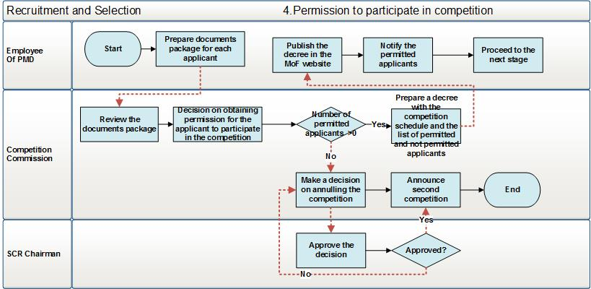
Diagram 37․ Permission to participate in competition

It is implemented the following sequence:
- PMD officer prepares document package for each applicant attached to the reply from the RA Police on conviction.
- Competition Commission reviews document package of each applicant.
- Competition Commission makes a decision on permitting or not permitting the applicant to participate the competition.
- If the number of applicants participating in the competition is higher than 0, then the Competition Commission prepares a decision containing the competition schedule, list of persons permitted to participate in the competition and the list of not permitted applicants. The process proceeds to clause 4.
- If the number of applicants allowed to participate in the competition is equal to 0, then the Competition makes a decision on considering the competition as not held and the process ends.
- PMD sub-division officer posts the list of persons permitted to participate in the competition on the SRC official website.
- PMD sub-division officer notifies the permitted persons on participating in the competition.
- The process proceeds to the next stage.

At the stage of final selection and appointment, the testing and interviewing process are implemented, as well as the selection and appointment of the winning applicant. The sequence of processes at this stage are described in Diagram 38.

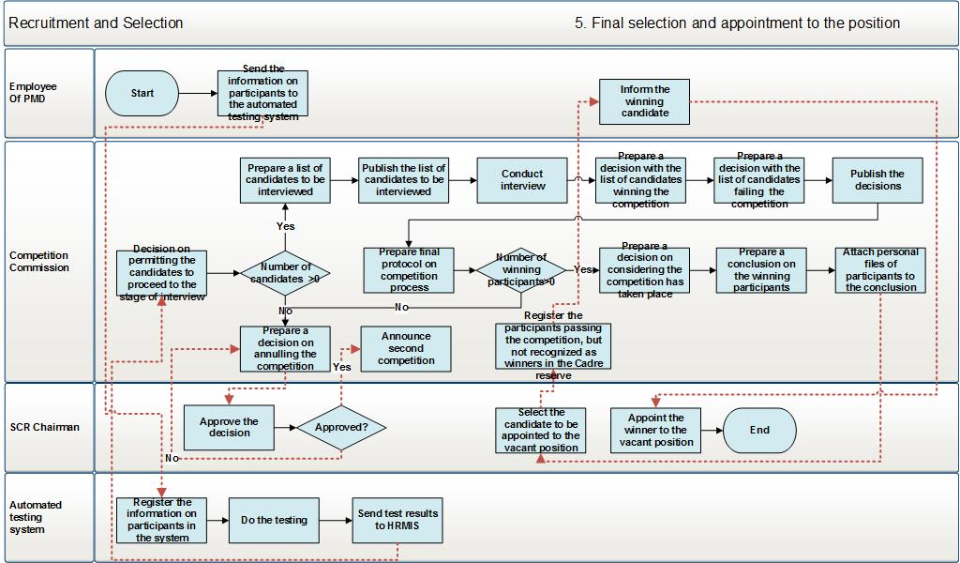
Diagram 38․ Final selection and appointment

It is performed in the following logic:
- PMD officer prepares necessary information on participants and sends it to authomated test system. The test system is sent the name, surname, paternal name, PSN, passport dat of the applicant, as well as the name and date of the competition, and the vacant position.
- After the test ends, the scores of applicants are sent to the HRMIS Recruitment and selection module.
- Based on the information obtained from the automated test system, the Competition Commission makes a decision on allowing the applicants to pass the interview. For positions with customs service the minimum score is 90% and for tax service – 80%.
- If none of the participants earned sufficient test scores to pass the interview, then the Competition Commission makes a decision on not recognizing a winner in the result of competition, and submits it immediately to the SRC Chairman.
- If the number of permitted participants is higher than 0, then the Competition Commission prepares the list of participants for interview.
- Competition Commission publishes the list of participants to be interviewed.
- Competition Commission conducts the interviews.
- After the interview a voting is held in the following principle – 5 questions are selected. To answer each question, the member of Commission selects one of the three possible options: a) full answer –scores 2 – 20%; b) partial – scores 1 – 10%, c) not answered – scores 0 - 0%. If the total score of the given applicant is higher than 75%, then the Commission member is considered to have voted for that applicant, if lower than 75%, then it is – against. The applicant who received more than half of the votes of Commission members is considered to have passed the test.
- A decision is prepared with the list of winning participants, including their test and interview scores and total scores.
- A decision is prepared with the list of not winning participants, including their test and interview scores and total scores.
- Both decisions are published.
- The summary protocol of competition process is prepared.
- If the number of winning participants is equal to 0, then the competitions is considered to be not held and the process ends.
- If the winning participants’ number is higher than 0, then a decision on considering the competition to be held shall be prepared.
- The conclusion is attached to the personal files of participants and the document package is sent to the SRC Chairman.
- The SRC Chairman is informed about the competition being held, and receives the document package prepared during the previous stage.
- The SRC Chairman selects one of the winning participants to appoint to the vacant position.
- Other participants of the competition not recognized as a winner are then registered in Cadre reserve.
- The winning participant is sent a notification about winning.
- The winning participant is appointed to the given vacant position.

Functional Requirements
This section contains the functional requirements for the HRMIS modules. The description of the requirements is necessary to make sure that the developed system meets the user needs.

Main Information Submission Forms of the System
The HRMIS should be introduced taking into account previously defined requirements, which will ensure proper system operation. Information in the HRMIS module is presented in the pages of the following type:
- Data view page, which constitutes a page of a table oriented view with search options in it, helping a system user to search in the table and, which would afford an opportunity to sort the presented data by any field and create a new record in the table. In the table, the data are initially sorted by the date of modifications made in the row in descending decree.
- Detailed data view page, which is enabled when clicking “View” button. It displays grouped data and has data editing option.
The HRMIS Data View Page should have information search option, enabling the user to find, without any difficulty, the required information from the list. Information search parameters are contingent on the content of data stated in the list. When creating a new document or form, there should be an option to conduct intermediate savings of document and in case of complete saving of the document edition – to conduct its complete registration in the database.
In all modules, it is necessary to have a data modification tracking system, which in case of modification of any field value by user, would register the field name, the previous field value, the modified value, the user data, including name, the name of the computer used to login the system, IP address, the MAC (Media Access Control) address of the network card, the date, hour, minute and second of making such modification, as well as to have a page to view these data, perform search and export data therein.
It is necessary to create an option, so that it would be possible to export in various formats (.doc, .xls, .xml, .pdf) each data displayed in the system and presented in a table oriented view. It is also necessary to have a special report creation module, which would enable to compile any report by using all the fields presented in this module, thus creating the template for such report and saving it in the system. It is also necessary to have standard report forms in the system.
Module objects, forms and schemas described in the chapters from 3.3 to 3.13 should be built by HRMIS system configuration modules described in 2.3.12

The User Roles and Accessibility to the System
The HRMIS accessibility and safety are based on the roles management system. The role (the function performed by user) determines the environments, transactions and pages (screens), where user can login and/or make modifications. The HRMIS roles represent the main tool for HRMIS safety and process management.
The HRMIS roles management must be supervised by a responsible person. Roles management should enable the responsible person to create and assign appropriate roles to various users, and conduct the audit for the use of the roles.
There should be a special user called “Super Administrator” who has an opportunity to use system configuration module described in 2.3.12.
In the roles management module, it should be an option to provide, in a centralized manner, the required permits and to track the successful course of the processes, which will enable to verify modifications in various tables of the HRMIS. Supervision of the centralized roles will also enable to verify, in a centralized manner, the exchange of information with various external systems (Taxpayer 3, Automated Testing System, etc.).
The system for user creation, roles creation and accesses management should be based on and regulated by the roles and accesses regulation system of “Taxpayer 3” system.
The roles are provided by functional modules (staff management, organization structure and positions, recruitment and selection, etc.).
The main system users can be classified in the following groups:
- Super Administrator who configures the system, declares objects, builds forms, draws workflow schemas, defines other user groups, provides them with functionality.
- Users, who are responsible for the approval of probation, rotation, separation processes, vacation, business trips, probation, appointment to a position, change of position, dismissing from office of the employees of their subordination, and control of the processes performed in the HRMIS - Chairman, Head of Personnel.
- Users who are responsible for the control of the data of the employees of their subordination that are registered in the HRMIS, approval of applications and memos on vacation, business trip and separation processes, creation of recommendation documents for not conducting rotation and for promotion, and verification of the actions performed with the employees of their subordination in the HRMIS – heads of units.
- Users who are the main employees of the system and are responsible for registration and modification of employees’ personal data, registration, modification and control of information in relation to the organization structure and positions, registration of decrees in the HRMIS for vacation, business trip and separation processes, verification of the reasons for separation regarding the employees in the separation process, conducting analysis based on the data being registered in the HRMIS – PMD employees.
- Users, who are responsible for providing personal data, performing operations to adjust the data where there are modifications in the personal data, creation of vacation applications, Business trip requests, producing reports on probation, producing employee separation application – SRC employees.

Labor Resource Module Implementation
This sub-module enables to view and edit the data registered in the employees’ personal files, as well as to produce reports for the purpose of conducting analysis with such data. The system should ensure the following functionality:
- Create a login opportunity for a new employee by providing him/her a login name and password. This process shall be conducted via the tool created based on the roles and accesses regulation system of “Taxpayer 3” program. After generating login name and password for a new employee, a notification shall be sent to the business email of the particular employee, which should contain the login name and password with annotation of the login name and password.

- Create a data page for a new employee, for which the employee should provide preliminary information, particularly PSN, passport data, etc. After creation of the data page for the new employee, “Employee registered” message containing the registered data related to the new employee are to be sent on the business email address of the head of unit.

- Edit/view the employee data. Employee data can be edited only if the data of the particular block fails to receive information from other HRMIS modules. In case the employee data are modified, a letter with “Employee Personal Data Update” text is sent on the business email address of that employee for the notification purpose.

- Create reports for the purpose of analyzing the data available in personnel files. Such reports are:
- The list of the whole staff in alphabetic order;
- Notifications and notes on the birthdays (date of birth, years of employment, e.g. 10, 15, 20 years, etc.) of employees;
- Number of employees by various types of service and management levels, position groups, subgroups, service terms within the SRC, servicing to citizens (for example, employees of the taxpayer service centers), persons engaged in general or corporative functions (HRM, finances, legal, IT, public relations, etc.), possessing special knowledge or skills, disability, etc.
- Sex-age composition of the labor force by types of services and management levels, organizational units, geography, etc.
- The number of employees of retirement age expressed in percent’s; for example, throughout the next X years;
- The number of those who have been separated from the office; i.e. the ratio of the number of the separated persons in a particular period of time and the average number of labor force, expressed in percent;
- The number of those being dismissed from office, i.e. the ratio of the people being dismissed over a particular period of time and the average number of labor force, expressed in percent;
- The average duration of holding position; e.g. the average duration of service in X sector or in the position or the unit is Y years.
- The average duration of the service term at the SRC; e.g. employees stay with the SRC on average for X years;
- Staff turnover, i.e. the number of employees that have withdrawn the SRC over a certain period of time divided on the average number of labor force in the same period of time, expressed in percent;
- Level of stabilitiy (maintenance), i.e. the number of employees in a certain period of time that used to continue to work for the SRC, expressed in percent;
- The scores collected by tax and customs officers as per efficiency report and training (education) results prior to attestation;
- Personal card of employee.
- After receiving the relevant basis (decree on being appointed to position), assign the employee to the relevant position;
The link of the labor resource management module to other HRMIS modules is presented in Diagram 1. The labor resource management module is organized into the following sub-modules:
- Labor resource list module;
- Labor resource advanced search module;
- Personal data view module;
- Appointing to a position module;
- Contract extension module;
- Personal data editing module;
See below the description of these modules.

3․3․1 Labor Resource List Module
This sub-module of the system enables to view the list of the SRC staff and perform searches of the SRC employees. It constitutes a sub-module of the HRMIS and is accessible to the senior management and the PMD employees in terms of viewing all the SRC employee data. The PMD employees have also an opportunity to add new records and edit the data displayed in this module. For the head of unit, the module enables to view only the unit employees. The key functionalities of the Labor Resource List module are as follows:
- View the SRC employee list and perform searches therein by various criteria;
- This list displays tax and customs officers, contractual employees and those employed under civil contracts. Only present and former SRC employees will be seen in the lists.
- Register a new employee by clicking on “New employee” button.
- Send notifications in case there are changes in the employee data or status. A message with “Employee Personal Data Update” or “Status Change” text is sent on the business email address of employee.
See below the view form for the labor resource list and the description of each of its fields.
Fig. 1. Labor resource list
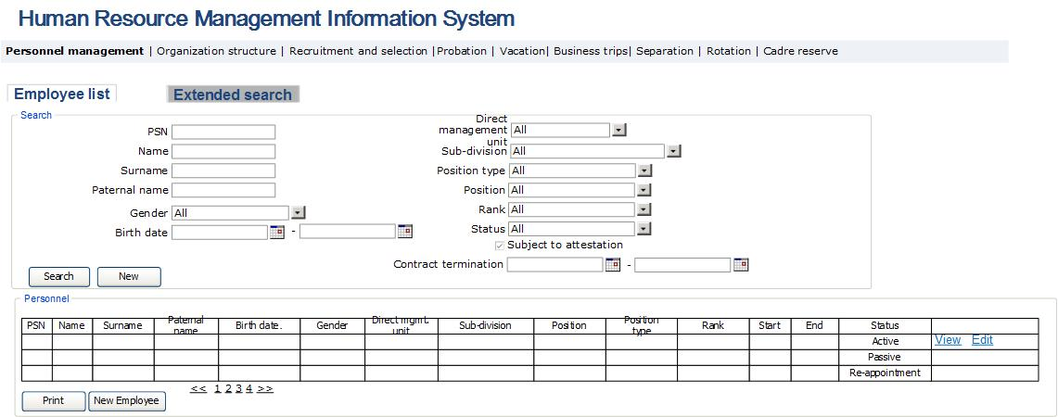

Table 1. Labor resource list
Field | Type | Attributes |  | Initial value |  |  | Description
Search section
PSN of employee | Text Box |  | Not mandatory |  | All | Defines the field of employee PSN.
First name of employee | Text Box |  | Not mandatory |  | All | Defines the field of employee name.
Surname of employee | Text Box |  | Not mandatory |  | All | Defines the field of employee surname.
Paternal name of employee |  |  | Not mandatory |  | All | Defines the field of employee’s paternal name.
Gender | Dropdown |  | Not mandatory |  | All | Defines the field of employee gender.  Potential values:  - All  - Male  - Female
Birth date | Calendar box |  | Not mandatory |  |  | Defines the range of employee’s birth date.
Direct management unit | Dropdown |  | Not mandatory |  |  | Defines direct management unit of employee’s position. It constitutes a list of SRC structural units and value “All”.
Sub-division | Dropdown |  | Not mandatory |  |  | Defines sub-division of employee’s position. It constitutes a list of SRC structural units and value “All”.
Position type | Dropdown |  | Not mandatory |  |  | Defines the list of SRC positon types. Potential values:  - All  - Discretionary positions  - Tax service  - Customs service  - Civil service  - Civil service contract-based  - Contract-based
Position | Dropdown |  | Not mandatory |  |  | Defines the list of position of employee and value “All”.
Rank | Dropdown |  | Not mandatory |  |  | Defines the list of ranks of employees and value “All”.
Status | Dropdown |  | Not mandatory |  |  | Defines employee’s status. Potential values:  - All  - Active  - Passive  - Temporarily active  - Temporarily passive  - Re-assignment  Currently working employees have the status of “Active”.  Employing not working at that moment have the status of “Passive”. Employees attached to the type of “Replacement” contract-based employee, have the status of “Temporarily active”.  Employees on “Maternity” and “Child care” type of vacation, have the status of “Temporarily passive”.  The status “Re-appointment” is attached to the following employees:  - Not separated from employment, but their position status is “Inactive” due to expiry of their sub-division activity;  - Not separated from employment, but another employee has been appointed to their position and conseqently they are not attached to any position at that moment.
Subject to attestation | Checkbox |  | Not mandatory |  |  | Defines employees subject to attestation. The selection is done as follows:  - Tax officers whose last attestation date and the current date is >= 3 years, and  - Customs officers whose new position appointment date or last attestation date is >= 3 years
Contract end | Calendar box |  | Not mandatory |  |  | Defines contract end date. The field is entered as a range.
Find | Button |  |  |  |  | Perform search
New Search | Button |  |  |  |  | To set the fields of search to the initial value
Table
PSN of employee | Column |  |  |  |  | Displays the field of employee PSN.
Name of employee | Column |  |  |  |  | Displays the field of employee name.
Surname of employee | Column |  |  |  |  | Displays the field of employee surname.
Paternal name of employee | Column |  |  |  |  | Displays the field of employee’s paternal name.
Gender | Column |  |  |  |  | Displays the field of employee gender.  Potential values:  - All  - Male  - Female
Date of birth | Column |  |  |  |  | Displays the range of employee’s birth date.
Direct management unit | Column |  |  |  |  | Displays direct management unit of employee’s position.
Division | Column |  |  |  |  | Displays sub-division of employee’s position.
Position | Column |  |  |  |  | Displays the position of employee.
Position type | Column |  |  |  |  | Displays the last position occupied by employee.
Rank | Column |  |  |  |  | Displays current rank of employee.
Start | Column |  |  |  |  | In the case of contract-based employee, the field displays start date of contract. In other cases, the field displays the date of appointment to the current position.
End | Column |  |  |  |  | In the case of contract-based employee, the field displays end date of contract. In other cases, the field displays the date of separation from current position.
Status | Column |  |  |  |  | Displays employee’s status.
Edit | Button |  |  |  |  | By pressing the button, the system displays display page of the mentioned employee’s data (Table 4) in edit option.
View | Button |  |  |  |  | By pressing the button the data view window of the given employee is opened on the top of the table of the same page.
Print | Button |  |  |  |  | Exports data, shown in the table into .xlsx format.
New employee | Button |  |  |  |  | To make a record of a new employee in the human resources database for the persons whose data are not yet available in the system and who do not have a personal data page in the system. The button is available only for PMD department employees. Clicking the button opens the form, described in Table 4.

3․3․2 Labor Resource Advanced Search Module
This sub-module of the system enables to perform advanced search of the SRC employees. It constitutes a sub-module of the HRMIS and is accessible to the senior management and the PMD Head in terms of viewing the data of all the SRC employees, and to the PMD employees – to view the data of the employees working for units being serviced by the former. For the head of unit, the module enables to view only the employees of that unit.
The main functionalities of the Labor Resource Advanced Search Module are: this sub-module enables to perform complex searches of the SRC employees by various criteria and to export Excel.
See below the labor resource advanced search form and description of each of its fields.
Fig. 2. Labor resource advanced search
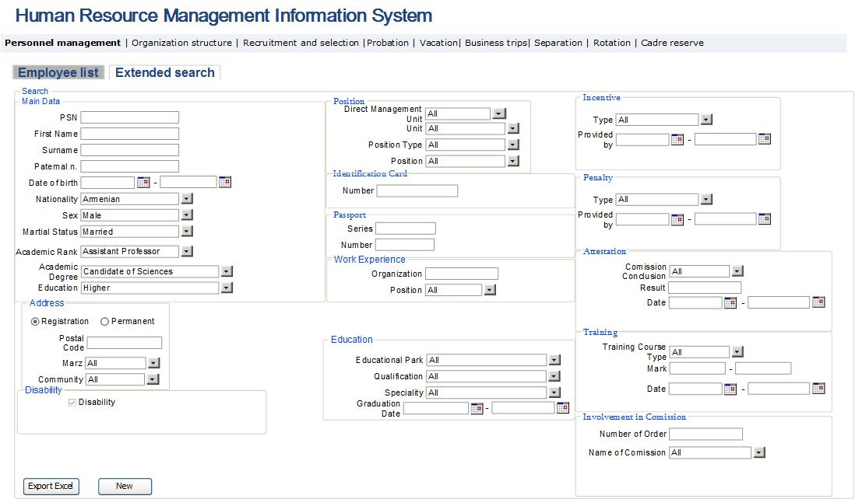

Table 2. Labor resource advanced search
Field |  | Type | Attributes |  | Initial value |  | Description
Search Sector
Main Data
PSN |  | Text Box | Not mandatory |  | All |  | Defines the employee’s Public Services Number.
First name |  | Text Box | Not mandatory |  | All |  | Defines employee’s name field.
Surname |  | Text Box | Not mandatory |  | All |  | Defines employee’s surname field.
Paternal name |  | Text Box | Not mandatory |  | All |  | Defines employee’s paternal name field.
Date of birth |  | Calendar box | Not mandatory |  |  |  | Defines employee’s date of birth.
Nationality | Dropdown |  | Not mandatory |  |  | Defines employee’s nationality; the nationality list and “All” value are displayed in the field.
Sex |  | Dropdown | Not mandatory |  | All |  | Defines employee’s sex field.  Potential values:  - All  - Male  - Female
Family status |  | Drop Down | Not mandatory |  |  |  | Defines employee’s family status. Potential values:  - All  - Married  - Single  - Divorced
Academic rank |  | Drop Down | Not mandatory |  |  |  | Defines employee’s academic rank. Potential values:  - All  - Assistant Professor  - Professor  - Academician
Academic degree |  | Drop Down | Not mandatory |  |  |  | Defines employee’s academic degree. Potential values:  - All  - Specialist with degree  - Bachelor  - Masters  - Candidate of Science  - Doctor of Science
Education |  | Drop Down | Not mandatory |  |  |  | Defines employee’s education qualification degree. Potential values:  - All  - Specialist  - Specialist with degree  - Bachelor  - Masters  - Researcher  - PhD applicant  - Graduate  - PhD student
Address section
Registration |  | Radio button | Not mandatory |  |  |  | Once this field is checked, the search is performed in the personal data “registration address” data section.
Actual |  | Radio button | Not mandatory |  |  |  | Once this field is checked, the search is performed in the personal data “actual address” data section.
Postal code |  | Text Box | Not mandatory |  |  |  | Defines the postal code of the employee’s address.
Marz |  | Dropdown | Not mandatory |  |  |  | Defines the marz or the City of Yerevan of the employee’s address. Potential values:  - All  - Aragatsotn  - Ararat  - Armavir  - Gegharquniq  - Yerevan  - Lori  - Kotayk  - Shirak  - Syunik  - Vayots Dzor  - Tavush
Community |  | Dropdown | Not mandatory |  |  |  | Defines the community of the employee address; the content of the list is attributable to the selected marz. Community list is registered pursuant to the Law of the Republic of Armenia “On Administrative-Territorial Division of the RA”.
Disability
Disability |  | Checkbox | Not mandatory |  |  |  | Defines the availability of employee disability.
Position
Direct Management Unit |  | Dropdown | Not mandatory |  | All |  | Defines the direct management unit regarding the position held by employees. It constitutes the list of the SRC structural units and “All” value.
Unit |  | Dropdown | Not mandatory |  | All |  | Defines the unit in regard to the position held by employee. It constitutes the list of the SRC units and “All” value.
Position type |  | Dropdown | Not mandatory |  |  |  | Defines the list of the SRC position types.  Potential values:  - All  - Discretionary positions  - Tax Service  - Customs Service  - Civil service  - Those performing civil works  - Contract-based
Position |  | Dropdown | Not mandatory |  |  |  | Defines the name list of the employees’ positions and “All” value.
Identification card
Number |  | Text box | Not mandatory |  |  |  | Defines the identification card number.
Passport
Series |  | Text box | Not mandatory |  |  |  | Defines the Passport series.
Number |  | Text box | Not mandatory |  |  |  | Defines the Passport number.
Work experience
Organization |  | Text Box | Not mandatory |  |  |  | Defines the name of organization
Position |  | Drop Down | Not mandatory |  |  |  | Defines the position held. The field displays the position names entered into the system and “All” value.
Education
Educational park |  | Drop Down | Not mandatory |  |  |  | Defines the name of the educational institution. It covers the list of educational institutions, as well as “All” value.
Qualification |  | Drop Down | Not mandatory |  |  |  | Defines the qualification acquired by the employee in the particular educational institution. Potential values: by the list of specialties and qualifications of the RA vocational education, as well as “All” value
Specialty |  | Drop down |  |  |  |  | Defines the main specialty acquired by employee in the particular educational institution. Potential values: by the list of specialties and qualifications of the RA vocational education, as well as “All” value
End |  | Calendar Box |  |  |  |  | Defines the date of graduating from the particular educational institution. The field is entered by the range.
Incentive
Type |  | Drop down | Not mandatory |  |  |  | Defines the type of incentive granted to employee. Potential values:  - All  - Disciplinary penalty removed  - Money reward  - Souvenir  - Salary increase  - Expressing gratitude by the Head of Tax and Customs authority or the head of superior body.  - Rewarding special rank and (or) rank.  - Awarding “Exemplary Tax Officer of the Republic of Armenia” Medal  - In case of “Removing disciplinary penalty ” incentive, after its registration, the disciplinary penalty effective for the particular employee shall be removed. The date of such incentive shall be stated as the date of the sanction termination.  - Expressing gratitude  - Money reward  - Souvenir reward  - Being awarded the diploma from the superior customs authority  - Preliminary removal of disciplinary penalty  - Granting additional paid vacation  - Special service rank granted preliminarily  - Granting a rank one degree higher than the highest special rank attributable to the position held.  - Awarding “High performer of Customs Service” and “Honorary Customs Officer of the Republic of Armenia” medals.
Issued |  | Calendar Box | Not mandatory |  |  |  | Sets the date of the granted incentive. The field is displayed by the range.
Penalty
Type |  | Drop down | Not mandatory |  |  |  | Defines the type of penalty imposed on employee. Potential values:  - All  - Verbal reprimand  - Disciplinary record  - Rank lowering  - Being held liable for damages;  - Position lowering from the held position  - Separation from the service
Imposed on |  | Calendar Box | Not mandatory |  |  |  | Sets the date when the penalty has been imposed. The field is displayed by the range.
Attestation
Conclusion by the Commission |  | Drop Down | Not mandatory |  |  |  | Defines the conclusion by the Commission regarding the particular attestation. Potential values:  - All  - Attested  - Send to undergo training
Result |  | Text box | Not mandatory |  |  |  | Defines the attestation result, expressed in percent units.
Date |  | Calendar Box | Not mandatory |  |  |  | Defines the date of attestation. The field shall be entered by the range.
Training
Type of training course |  | Drop down | Not mandatory |  |  |  | The field defines the type of the employee training course. The field displays the types of training courses entered in the system and “All” value.
Date |  | Calendar box | Not mandatory |  |  |  | The field sets the date of the employee training course. The field should be entered by the range.
Grade |  | Text box | Not mandatory |  |  |  | The field defines the grade received by the employee as a result of the training course. The field shall be entered by the range.
Involvement in commissions
Decree number |  | Text box | Not mandatory |  |  |  | Defines the decree number of the employee’s involvement in the commission.
Name of commission |  | Drop Down | Not mandatory |  |  |  | Defines the commission, where the employee is involved. The list is displayed from the directory entered in “Management” Module.
Export Excel |  | Button |  |  |  |  | Clicking on the button, the search result is exported in Excel format. Data should be exported in Excel file by all the parameters described in this module.
New |  | Button |  |  |  |  | Define search fields with their initial values.

3․3․3 Employee Personal Data View Module
This sub-module of the system enables to view and make changes in the SRC employee personal data. It constitutes a sub-module of the HRMIS and is accessible to the senior management on the part related to them with an option of only viewing the data of all the SRC employees; to the PMD employees – with options to view, add and modify data of all employees. For the head of unit, the module enables to view only the employees of the given unit. Regarding the SRC employees, this module is accessible with an option to view the data. Where logging in the system, the view page of own personal data is displayed to user. The main functionalities of the employee personal data view module are:
- View the main data of the SRC employee. With regard to the PMD employees, this module enables to make changes in the personal data.
- This module enables the SRC employee to create an application on vacation, Business trip request, employee separation application, probation period report, to track the process of granting vacation and business trip through status modification.
- This module enables an officer of the PMD division to create a link between employee and the position held by him/her by clicking “Appoint to Position” button, in case if the decree on being appointed to position is in place.
- The system should send notifications to the business email address of such employee, in case there are the employee data or status modification in the given module. The content of email shall be as follows:
- “Employee Personal Data Update”, in the event there is personal data modification, including appointment to a post;
- “Status Modification, in the event there is status modification.
- In case if less than 5 days are left until the date when the social package can be used, a notification is to be sent to the business email of the employee of an appropriate PMD division reading “[XX] For employee holding PSN, the option of making use of the social package must be enabled on [the date of making use of the social package]”.
Add, Edit, delete operations in this module shall be accessible only to the PMD officers.
See below the employee personal data view module form, description of its fields and the link with the module data block and other HRMIS modules.

Fig. 3. Employee personal data view form in the state of the data sections closed
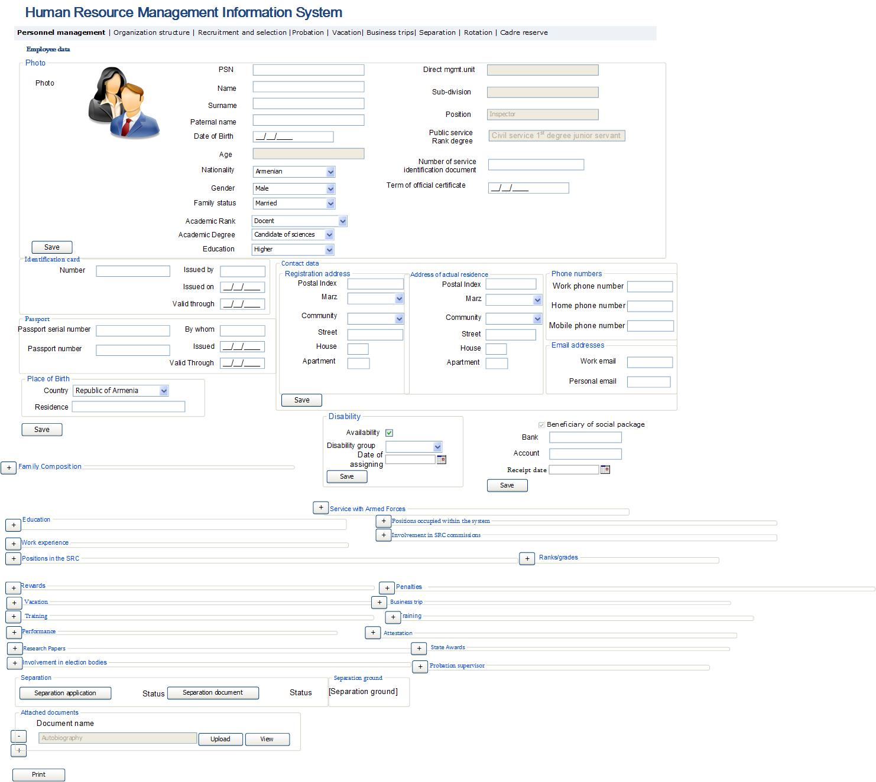

Fig. 4․ Employee data view form
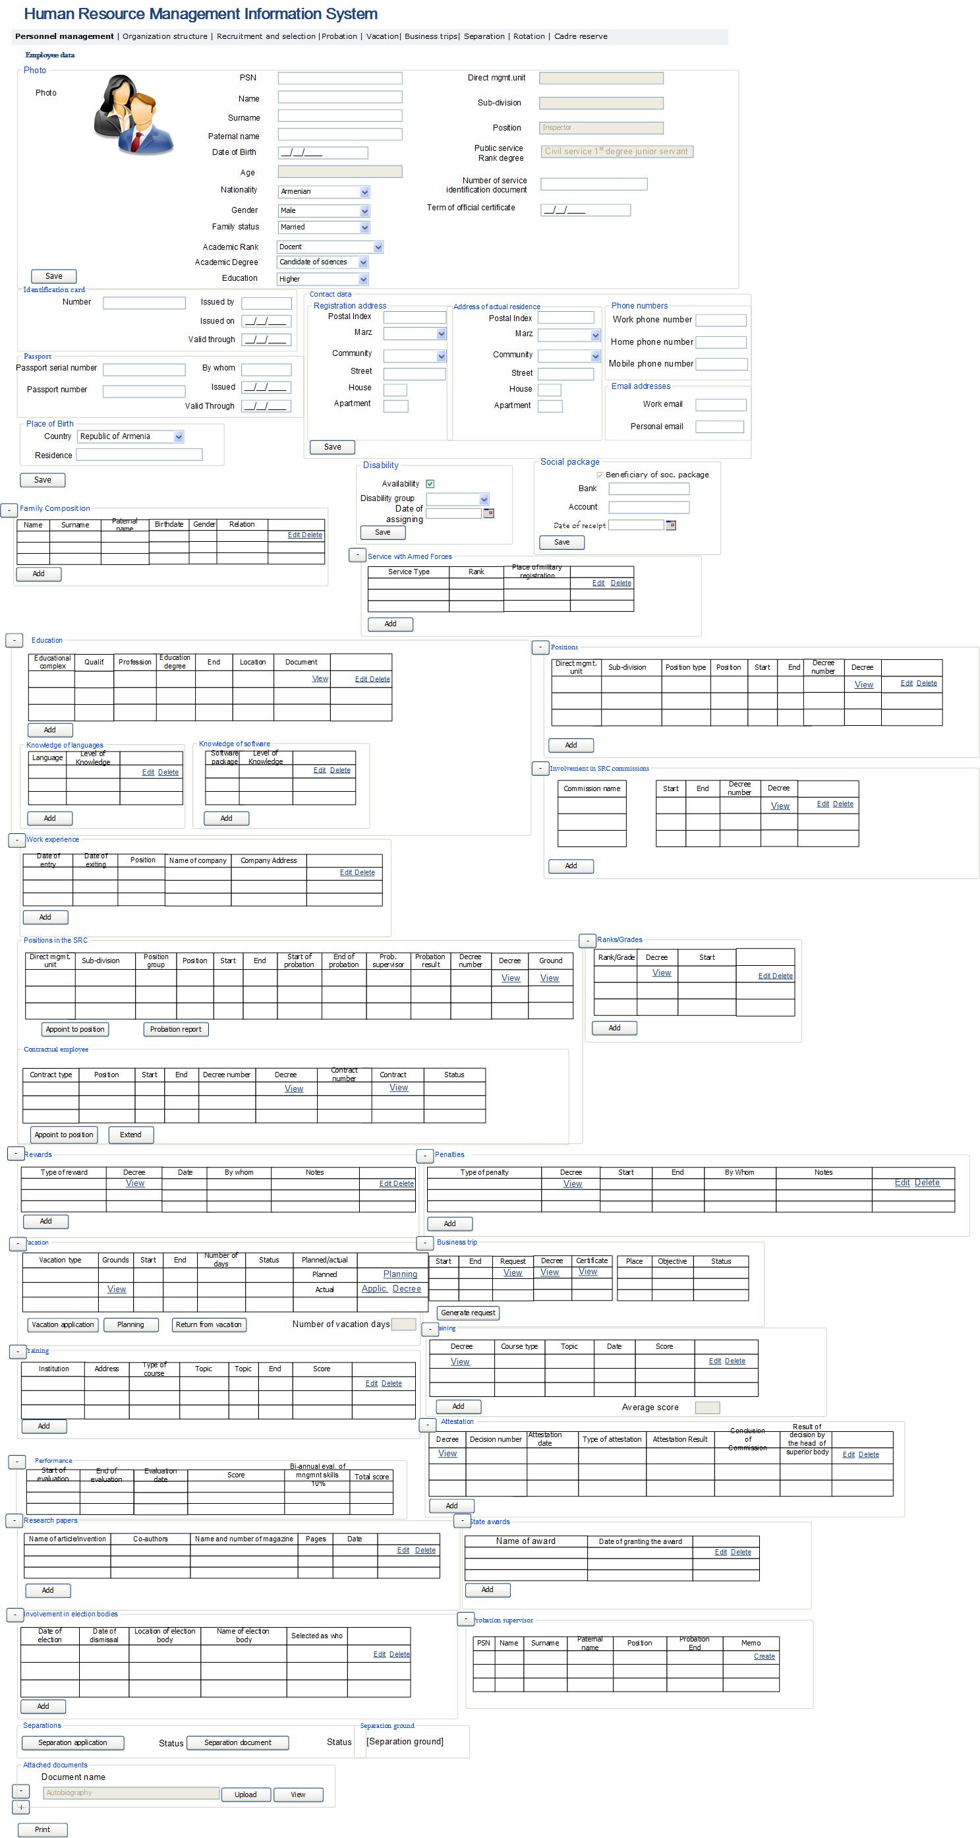
For Table 3 see Table 4.
Table 3. Employee personal data view and editing
Field | Type |  | Attributes |  |  |  | Initial value |  |  |  | Description
Personal data window
Block of main data
PSN of employee | Text Box |  | Disabled |  |  |  |  |  |  |  | Displays the field of employee PSN.
Photo | Image box |  | Disabled |  |  |  |  |  |  |  | Displays the photo of employee.
Name of employee | Text Box |  | Disabled |  |  |  |  |  |  |  | Displays the name of employee.
Surname of employee | Text Box |  | Disabled |  |  |  |  |  |  |  | Displays the last name of employee.
Paternal name of employee | Text Box |  | Disabled |  |  |  |  |  |  |  | Displays paternal name of employee.
Date of birth of employee | Calendar Box |  | Disabled |  |  |  |  |  |  |  | Displays date of birth of employee.
Age of employee | Text Box  Disabled |  | Disabled |  |  |  |  |  |  |  | Calculation field: displays the age of the employee.
Nationality | Dropdown |  | Disabled |  |  |  |  |  |  |  | Displays the nationality of the employee, defines the list of nationalities.
Gender | Dropdown |  | Disabled |  |  |  |  |  |  |  | Displays the gender of the employee.  Potential values:  - Male  - Female
Marital status | Dropdown |  | Disabled |  |  |  |  |  |  |  | Displays the marital status of the employee  Potential values:  - Married  - Single  - Divorced
Academic rank | Dropdown |  | Disabled |  |  |  |  |  |  |  | Displays the academic rank of the employee. Potential values:  - Associate professor  - Professor  - Academician
Academic degree | Dropdown |  | Disabled |  |  |  |  |  |  |  | Displays the academic degree of the employee. Potential values:  - Specialist with diploma  - Bachelor degree  - Master’s degree  - Ph.D. Candidate  - Ph.D. / Doctor of Philosophy
Education | Dropdown |  | Disabled |  |  |  |  |  |  |  | Displays employee’s edication. Potential values:  - Secondary  - Vocational  - Higher  - Post-graduate
Direct management unit | Text box |  | Disabled |  |  |  |  |  |  |  | Displays the direct management unit of employee’s position.
Sub-division | Text box |  | Disabled |  |  |  |  |  |  |  | Displays the sub-division of employee’s position.
Position | Text box |  | Disabled |  |  |  |  |  |  |  | Displays the most recent position of the employee. The possible values are inserted from the list of position titles.
Rank of public service | Тext box |  | Disabled |  |  |  |  |  |  |  | Displays the rank of the public service of the employee. Potential values according to the Law on Civil Service are:  - 1st class State Counselor (Advisor) of the Civil Service  - 2nd class State Counselor of the Civil Service  - 3rd class State Counselor of the Civil Service  - 1st class Counselor of the Civil Service  - 2nd class Counselor of the Civil Service  - 3rd class Counselor of the Civil Service  - 1st class Leading officer of the Civil Service  - 2nd class Leading officer of the Civil Service  - 3rd class Leading officer of the Civil Service  - 1st class Junior officer of the Civil Service  - 2nd class Junior officer of the Civil Service  - 3 ^{rd} class Junior officer of the Civil Service
Term of official certificate | Calendar box |  | Disabled |  |  |  |  |  |  |  | Displays the term of official certificate of the employee.
Number of official certificate | Text box |  | Disabled |  |  |  |  |  |  |  | Displays the number of official certificate of the employee.
Save | Button |  |  |  |  |  |  |  |  |  | Pressing the button saves data changes in the main data block
Data block on the list of personal identification documents
Identification card
Public Service Number | Text box |  | Disabled |  |  |  |  |  |  |  | Displays the public service number of employee.
Authority that issued the document | Text box |  | Disabled |  |  |  |  |  |  |  | Displays the authority that issued the document.
Date of issue | Calendar box |  | Disabled |  |  |  |  |  |  |  | Displays the date of issue of the document.
Date of expiry | Calendar box |  | Disabled |  |  |  |  |  |  |  | Displays the date of expiry of the document.
Passport
Series | Text box |  | Disabled |  |  |  |  |  |  |  | Displays the series of the personal identification document.
Number | Text box |  | Disabled |  |  |  |  |  |  |  | Displays the number of personal identification document.
Authority that issued the document | Text box |  | Disabled |  |  |  |  |  |  |  | Displays the authority that issued the document.
Date of issue | Calendar box |  | Disabled |  |  |  |  |  |  |  | Displays the date of issue of the document.
Date of expiry | Calendar box |  | Disabled |  |  |  |  |  |  |  | Displays the date of expiry of the document.
Place of birth data sub-group
Country | Dropdown |  | Mandatory |  |  |  |  |  | The country of birth is displayed in this field.  Potential values: List of countries
Location | Text Box |  | Mandatory |  |  |  |  |  | The birth place of employee is displayed in this field.
Save | Button |  |  |  |  |  |  |  | Saves all changes made in all existing fields of the given data block.
Block of data of contact information of the employee
Postal Index | Text Box |  | Disabled |  |  |  |  |  |  |  | Displays the postal index of the registration address of the employee
Marz | Dropdown |  | Disabled |  |  |  |  |  |  |  | Displays the Marz of registration address of the employee. Potential values:  - Aragatsotn  - Ararat  - Armavir  - Gegharkunik  - Yerevan  - Lori  - Kotayk  - Shirak  - Syunik  - Vayots Dzor  - Tavush
Community | Dropdown |  | Disabled |  |  |  |  |  |  |  | Displays the community of the registration address of the employee. The content of the list depends on the selected Marz. The list of communities is registered according to the RA Law on Administrative-territorial division of the Republic of Armenia.
Street | Text Box |  | Disabled |  |  |  |  |  |  |  | Displays the street of the employee's registration address.
Home | Text Box |  | Disabled |  |  |  |  |  |  |  | Displays the number of the house of employee's registration address
Apartment | Text Box |  | Disabled |  |  |  |  |  |  |  | Displays the number of apartment of employee's registration address.
Subgroup of data on employee's residence as registered
Postal Index | Text Box |  | Disabled |  |  |  |  |  |  |  | Displays the postal index of employee's residence as registered.
Marz (Region) | Dropdown |  | Disabled |  |  |  |  |  |  |  | Displays the Marz of employee's residence of registration.  Potential values:  - Aragatsotn  - Ararat  - Armavir  - Gegharkunik  - Yerevan  - Lori  - Kotayk  - Shirak  - Syunik  - Vayots Dzor  - Tavush
Community | Dropdown |  | Disabled |  |  |  |  |  |  |  | Displays the community of the employee's residence as registered. The list of communities is registered according to the RA Law On Administrative-territorial division of the Republic of Armenia.
Street | Text Box |  | Disabled |  |  |  |  |  |  |  | Displays the street of employee's residence as registered.
Home | Text Box |  | Disabled |  |  |  |  |  |  |  | Displays the number of house of employee's residence as registered.
Apartment | Text Box |  | Disabled |  |  |  |  |  |  |  | Displays the number of apartment of employee's residence as registered
Subgroup of data of employee's phone numbers
Work place telephone number | Text Box |  | Disabled |  |  |  |  |  |  |  | Displays the work place telephone number of the employee.
Home telephone number | Text Box |  | Disabled |  |  |  |  |  |  |  | Displays the home telephone number of the employee.
Mobile phone number | Text Box |  | Disabled |  |  |  |  |  |  |  | Displays the mobile phone number of the employee.
Subgroup of data of e-mail addresses of the employee
Work place e-mail address | Text Box |  | Disabled |  |  |  |  |  |  |  | Displays the work place e-mail address of the employee.
Personal e-mail ad | Text Box |  | Disabled |  |  |  |  |  |  |  | Displays the personal e-mail address of the employee.
Block of data on family composition
First name | Column |  |  |  |  |  |  |  |  |  | Displays the name of employee's family member.
Surname | Column |  |  |  |  |  |  |  |  |  | Displays surname of employee's family member.
Paternal name | Column |  |  |  |  |  |  |  |  |  | Displays the paternal name of employee's family member.
Date of birth | Column |  |  |  |  |  |  |  |  |  | Displays the date of birth of employee's family member.
Relationship | Column |  |  |  |  |  |  |  |  |  | Displays the relationship of employee's family member. Potential values:  - Wife  - Husband  - Child  - Mother  - Father
Gender | Column |  |  |  |  |  |  |  |  |  | Displays the gender of the family member of employee. Potential values:  - Male  - Female
Edit | Button |  |  |  |  |  |  |  |  |  | Opens the given data block or the marked line in the data block in the editing mode, as a separate window described in Table 8 and Fig.8.
Add | Button |  |  |  |  |  |  |  |  |  | Opens the window of adding new data in the given data block described in Table 8 and Fig.8.
Delete | Button |  |  |  |  |  |  |  |  |  | By pressing the button, a dialogue box opens reading “Are you sure you want to delete the data?” In case of pressing ‘Yes’ button, the row is removed.
Subgroup of data on disability
Disability | Check box |  | Disabled |  |  |  |  |  |  |  | Displays whether the employee has a disability.
Category of disability (selected list) | Dropdown |  | Disabled |  |  |  |  |  |  |  | Displays the category of disability of the employee in case it exists. Potential values:  - 1st category  - 2nd category  - 3rd category
Date of getting category | Calendar Box |  | Disabled |  |  |  |  |  |  |  | Displays the date of obtaining category of disability.
Save | Button |  |  |  |  |  |  |  | Saves all changes made in all existing fields of the given data block.
Social package data sub-group
Social package beneficiary | Check box |  |  |  |  |  |  |  |  |  | By selecting the field, the option of entering data in that block is activated. The given field is active only for “tax and customs officer” type of positions.
Bank | Text box |  |  |  |  |  |  |  |  |  | Displays the name of the bank servicing the account for using social package.
Account | Text box |  |  |  |  |  |  |  |  |  | Displays the bank account number designed for using the social package.
Date of receipt | Calendar box |  | Disabled |  |  |  | Recruitment date+6 months |  |  |  | Displays the potential start date of using the social package. The field automatically displays the start date of using the social package. The calculation is done in the following way: recruitment date of new employee in SRC system+6 months. When only 5 days are left to the termination of the mentioned period, the respective PMD officer received notification on the need to activate the social package for particular employee. If the position change takes place within the system, no calculation of dates is performed.
Save | Button |  |  |  |  |  |  |  | Saves all changes made in all existing fields of the given data block.
Data section on the service in the RA enforcement services
Main table
Type of service | Column |  |  |  |  |  |  |  |  |  | Displays the type of special service that the employee has provided. Potential values:  - Police service  - National Security Service  - Military service
Rank | Column |  |  |  |  |  |  |  |  |  | Displays the rank of the employee who has provided special service. Potential values:  - Subaltern  - Senior Subaltern  - Junior Lieutenant  - Lieutenant  - Senior Lieutenant  - Captain  - Major  - Deputy Colonel  - Colonel  - Major-General  - Lieutenant-General  - Lieutenant-Colonel
Place of military registration | Column |  |  |  |  |  |  |  |  |  | The field displays the place of the military registration of the employee.
Edit | Button |  |  |  |  |  |  |  |  |  | Opens the given data block or the marked line in the data block in the editing mode, as a separate window described in Table 9 and Fig.9.
Add | Button |  |  |  |  |  |  |  |  |  | Opens the window of adding new data in the given data block described in Table 9 and Fig.9.
Delete | Button |  |  |  |  |  |  |  |  |  | By pressing the button, a dialogue box opens reading “Are you sure you want to delete the data?” In case of pressing ‘Yes’ button, the row is removed.
Data block on Education of the employee.
Table of education of the employee
Educational institution | Column |  |  |  |  |  |  |  |  |  | Displays the name of educational institution. Includes the list of educational institutions.
Qualification | Column |  |  |  |  |  |  |  |  |  | Displays the qualification that the employee has obtained in the given educational institution. The possible values: in accordance to the list of the Professions and Qualifications of the RA higher education.
Profession | Column |  |  |  |  |  |  |  |  |  | Displays the profession that the employee has obtained in the given educational institution. The possible values are set according to the list of the Professions and Qualifications of the RA higher education.
Academic degree | Column |  |  |  |  |  |  |  |  |  | Displays the employee’s Academic degree obtained in the given educational institution. Potential values:  - Specialist holding a diploma  - Bachelor’s degree  - Master’s degree  - Ph.D. Candidate  - Ph.D. / Doctor of philosophy
Graduation | Column |  |  |  |  |  |  |  |  |  | Displays the date of graduation from the given educational institution.
Place | Column |  |  |  |  |  |  |  |  |  | Displays the address of the given educational institution.
Document | Column |  |  |  |  |  |  |  |  |  | Displays the document certifying the given education in pdf format. By pressing the button, the given document opens in view template.
Edit | Button |  |  |  |  |  |  |  |  |  | Opens the given data block or the marked line in the data block in the editing mode, as a separate window described in Table 10 and Fig.10.
Add | Button |  |  |  |  |  |  |  |  |  | Opens the window of adding new data in the given data block described in Table 10 and Fig.10.
Delete | Button |  |  |  |  |  |  |  |  |  | By pressing the button, a dialogue box opens reading “Are you sure you want to delete the data?” In case of pressing ‘Yes’ button, the row is removed.
Language knowledge subgroup
Language | Column |  |  |  |  |  |  |  |  |  | Presents the required language consisting of the following points:  - Armenian  - Russian  - English  - Other
Degree of knowledge | Column |  |  |  |  |  |  |  |  |  | The level of mastering the appropriate language is entered. Potential values:  - Basic  - Intermediate  - Proficient
Edit | Button |  |  |  |  |  |  |  |  |  | Opens the given data block or the marked line in the data block in the editing mode, as a separate window described in Table 12 and Fig.12.
Add | Button |  |  |  |  |  |  |  |  |  | Opens the window of adding new data in the given data block described in Table 12 and Fig.12.
Delete | Button |  |  |  |  |  |  |  |  |  | By pressing the button, a dialogue box opens reading “Are you sure you want to delete the data?” In case of pressing ‘Yes’ button, the row is removed.
Computer literacy subgroup
Computer skills | Column |  |  |  |  |  |  |  |  |  | Displays the list of software packages the employee has mastered
Degree of knowledge | Column |  |  |  |  |  |  |  |  |  | The level of mastering the appropriate software is entered.  Potential values:  - Basic  - Intermediate  - Profound
Edit | Button |  |  |  |  |  |  |  |  |  | Opens the given data block or the marked line in the data block in the editing mode, as a separate window described in Table 11 and Fig.11.
Add | Button |  |  |  |  |  |  |  |  |  | Opens the window of adding new data in the given data block described in Table 11 and Fig.11.
Delete | Button |  |  |  |  |  |  |  |  |  | By pressing the button, a dialogue box opens reading “Are you sure you want to delete the data?” In case of pressing ‘Yes’ button, the row is removed.
Work experience data block
Date of entry | Column |  |  |  |  |  |  |  |  |  | Displays the date of recruitment in the given company.
Date of separation | Column |  |  |  |  |  |  |  |  |  | Displays the date of separation from the given company.
Position | Column |  |  |  |  |  |  |  |  |  | Displays the position of given job.
The name of company | Column |  |  |  |  |  |  |  |  |  | Displays the name of given company.
Place of company | Column |  |  |  |  |  |  |  |  |  | Displays the place of given company.
Edit | Button |  |  |  |  |  |  |  |  |  | Opens the given data block or the marked line in the data block in the editing mode, as a separate window described in Table 13 and Fig.13.
Add | Button |  |  |  |  |  |  |  |  |  | Opens the window of adding new data in the given data block described in Table 13 and Fig.13.
Delete | Button |  |  |  |  |  |  |  |  |  | By pressing the button, a dialogue box opens reading “Are you sure you want to delete the data?” In case of pressing ‘Yes’ button, the row is removed.
The data block of employee’s positions within the system
Direct management unit | Column |  |  |  |  |  |  |  |  |  |  |  | Displays the direct management unit of employee’s current position.
Sub-division | Column |  |  |  |  |  |  |  |  |  |  |  | Displays the sub-division of employee’s current position.
Position type | Column |  |  |  |  |  |  |  |  |  |  |  | Displays the type of employee’s particular position.
Position | Column |  |  |  |  |  |  |  |  |  | The field displays the name of employee’s current position.
Start | Column |  |  |  |  |  |  |  |  |  | The field displays employee’s date of appointment to the given position.
End | Column |  |  |  |  |  |  |  |  |  | The field displays employee’s date of separation.
The number of decree | Column |  |  |  |  |  |  |  |  |  | The field displays the number of decree of employee’s appointment to the given position.
Decree | Column |  |  |  |  |  |  |  |  |  |  |  | The field displays the file of decree on appointment to the particular position. By pressing the button, the decree view page opens in pdf format.
Edit | Button |  |  |  |  |  |  |  |  |  | Opens the given data block or the marked line in the data block in the editing mode, as a separate window described in Table 23 and Fig.23.
Add | Button |  |  |  |  |  |  |  |  |  | Opens the window of adding new data in the given data block described in Table 23 and Fig.23.
Delete | Button |  |  |  |  |  |  |  |  |  | By pressing the button, a dialogue box opens reading “Are you sure you want to delete the data?” In case of pressing ‘Yes’ button, the row is removed.
Involvement in SRC Commissions
Commission name | Column |  |  |  |  |  |  |  |  | Displays the commission, where the employee is involved.
Start | Column |  |  |  |  |  |  |  |  | Displays the date of appointing the employee to the given commission.
End | Column |  |  |  |  |  |  |  |  | Displays the date when employee exited the given commission.
Decree number | Column |  |  |  |  |  |  |  |  | Displays the decree number of the employee’s involvement in the commission.
Decree | Column |  |  |  |  |  |  |  |  | Displays the decree file on assigning to the given commission. By pressing the button, the decree view form opens in pdf format.
Edit | Button |  |  |  |  |  |  |  |  |  | Opens the given data block or the marked line in the data block in the editing mode, as a separate window described in Table 23a and Fig.23a.
Add | Button |  |  |  |  |  |  |  |  |  | Opens the window of adding new data in the given data block described in Table 23a and Fig.23a.
Delete | Button |  |  |  |  |  |  |  |  |  | By pressing the button, a dialogue box opens reading “Are you sure you want to delete the data?” In case of pressing ‘Yes’ button, the row is removed.
The data block of employee’s positions within SRC
Table of positions within SRC
Direct management unit | Column |  |  |  |  |  |  |  |  |  |  |  | Displays the direct management unit of employee’s current position.
Sub-division | Column |  |  |  |  |  |  |  |  |  |  |  | Displays the sub-division of employee’s current position.
Position type | Column |  |  |  |  |  |  |  |  |  |  |  | Displays the type of employee’s particular position.
Group of position | Column |  |  |  |  |  |  |  |  |  | The field displays the given position group of employee.
Position | Column |  |  |  |  |  |  |  |  |  | The field displays the name of the employee’s given position.
Start | Column |  |  |  |  |  |  |  |  |  | The field displays employee’s date of appointment to the given position.
End | Column |  |  |  |  |  |  |  |  |  | The field displays employee’s date of separation.
Start of probation period | Column |  |  |  |  |  |  |  |  |  | The field displays the start date of probation period of employee’s appointment to the given position.
End of probation period | Column |  |  |  |  |  |  |  |  |  | The field displays the date of completion of probation period of employee for the given position.
Probation supervisor | Column |  |  |  |  |  |  |  |  |  | The field displays the name, surname and paternal name of probation supervisor.
Result of probation period | Column |  |  |  |  |  |  |  |  |  | The field displays the result of probation period of employee for the given position. Potential values:  - Satisfactory  - Unsatisfactory
The number of decree | Column |  |  |  |  |  |  |  |  |  | The field displays the number of decree of employee’s appointment to the given position.
Decree | Column |  |  |  |  |  |  |  |  |  | The field displays the decree on appointing to the given position in pdf format.
Ground | Column |  |  |  |  |  |  |  |  |  | The field displays the document supporting the appointment to the given position in the case of changing the position.
Appoint to position | Column |  |  |  |  |  |  |  |  |  | By pressing the button, the window of appointment to the position opens, which is described in Table 5.
Probation report | Column |  |  |  |  |  |  |  |  |  | By pressing the button, the probation report entry form opens, which is described in the “Probation documents” module. The button is activated when less than 5 days is left to the end of probation.
Data block on contractual employees
Contract type | Column |  |  |  |  |  |  |  |  |  |  | The field displays the type of particular position of employee: Potential values:  - Term contract  - Replacement  - Fixed-term contract  In case the employees on “Replacement” type of contract are appointed to the given position, their status becomes “Temporarily active”.  For employees on “Term contract” type of contract, it is mandatory to enter the field “Contract expiry” (Fig. 7, Table 7).  In the case of “Fixed-term contract” it is not obligatory to enter the field “Contract expiry”.
Position | Column |  |  |  |  |  |  |  |  |  |  | The field displays the name of employee’s current position.
Start | Column |  |  |  |  |  |  |  |  |  |  | The field displays the date of appointing the employee to the particular position.
End | Column |  |  |  |  |  |  |  |  |  |  | The field displays the date of separating the employee from the particular position.
Decree number | Column |  |  |  |  |  |  |  |  |  |  | The field displays the number of decree on appointing to particular position.
Decree | Column |  |  |  |  |  |  |  |  |  |  | By pressing the button, the decree view form opens in pdf format.
Contract number | Column |  |  |  |  |  |  |  |  |  |  | The field displays the number of decree on appointment.
Contract | Column |  |  |  |  |  |  |  |  |  |  | By pressing the button, the contract on appointing to the given position described in “Contract Administration” in pdf format.
Status | Column |  |  |  |  |  |  |  |  |  |  | The field displays contract status. Potential values:  - Active  - Subject to consideration  - Completed  Those contracts which will be terminated in less than 15 days, have the status of “Subject to consideration”.  Those contracts which date is lower than the current one, have the status of “Completed”.  Those contracts which termination date is 15 days ahead of current date have the status of “Active”.
Appoint to position |  |  |  | Button |  |  |  |  |  |  |  | By pressing the button, the form for attaching the employee to the contractual position opens, which is described in Table 5 and Figure 5. The “Type of position” form described in Table 5 displays only the “Contractual” positions. When generating “Replacement” type of contract, the employee status becomes “Temporarily active”. The status of employee on Child care or Maternity type of vacation is “Temporarily passive”.
Extend |  |  |  | Button |  |  |  |  |  |  |  | The button activates if less than 15 days is left to the termination of contract. By pressing the button, the contract renewal form opens, which is described in Table 8 and Fig. 8. In case the contract is not renewed, after the contract expiry it receives the status of “Completed”. The “Vacant” field mentioned in the contract is assigned “Yes” value. It enables to appoint another employee to the same position.
Data block of Ranks
Rank | Column |  |  |  |  |  |  |  |  |  | Displays the rank of the employee: The possible values for tax service are:  - State Counselor of the Tax service of the Republic of Armenia  - 1st class State Counselor of the Tax service of the Republic of Armenia  - 2nd class State Counselor of the Tax service of the Republic of Armenia  - 3rd class State Counselor of the Tax service of the Republic of Armenia
- 1st class Senior Counselor of the Tax service of the Republic of Armenia
- 2nd class Senior Counselor of the Tax service of the Republic of Armenia
- 3rd class Senior Counselor of the Tax service of the Republic of Armenia,
- 1st class Counselor of the Tax service of the Republic of Armenia,
- 2nd class Senior Counselor of the Tax service of the Republic of Armenia
- 3rd class Senior Counselor of the Tax service of the Republic of Armenia
- For the Civil Service:
- 1st class State Counselor of the Civil Service
- 2nd class State Counselor of the Civil Service
- 3rd class State Counselor of the Civil Service
- 1st class Counselor of the Civil Service
- 2nd class Counselor of the Civil Service
- 3rd class Counselor of the Civil Service
- 1st class Leading officer of the Civil Service
- 2nd class Leading officer of the Civil Service
- 3rd class Leading officer of the Civil Service
- 1st class Junior officer of the Civil Service
- 2nd class Junior officer of the Civil Service
- 3rd class Junior officer of the Civil Service
- For the Customs Service :
- Customs Service Major-General
- Customs Service Colonel
- Customs Service Deputy Colonel
- Customs Service Major
- Customs Service Captain
- Customs Service Senior Lieutenant
- Customs Service Lieutenant
- Customs Service Junior Lieutenant
Decree | Column |  |  |  |  |  |  |  |  |  | Displays the decree of awarding the given rank to the employee in pdf format.
Start | Column |  |  |  |  |  |  |  |  |  | Displays the date of awarding the given rank to the employee.
End | Column |  |  |  |  |  |  |  |  |  | Displays the date of completion of the decree of awarding the given rank to the employee.
Edit | Button |  |  |  |  |  |  |  |  |  | Opens the given data block or the marked line in the data block in the editing mode, as a separate window described in Table 14 and Fig. 14.
Add | Button |  |  |  |  |  |  |  |  |  | Opens the window of adding new data in the given data block described in Table 14 and Fig. 14.
Delete | Button |  |  |  |  |  |  |  |  |  | By pressing the button, a dialogue box opens reading “Are you sure you want to delete the data?” In case of pressing ‘Yes’ button, the row is removed.
Awards / disciplinary penalties data block
Awards chart/diagram
Type of award | Column |  |  |  |  |  |  |  |  |  | Displays the type of award granted to the employee.  Potential values for Tax officers:  - Removing disciplinary penalty  - Monetary award  - Souvenir  - Salary increase  - Announcement of gratitude by the Head of superior body  - Grant special and/or class rank  - Award with a medal of “Exemplary Tax Officer of the Republic of Armenia”  For Customs officers:  - Announcement of gratitude  - Monetary award  - Souvenir  - Diploma of superior Customs body  - Early removal of disciplinary penalty  - Provision of additional paid vacation  - Grant special and/or class rank  - Award one class higher than entitled rank  - Award with a medal  In the case of granting “Removal of disciplinary penalty, the penalty active for the given employee is removed. The end date of disciplinary penalty is deemed as the start date of the award.
Decree | Column |  |  |  |  |  |  |  |  |  | Displays the decree for the given award in pdf format.
Date | Column |  |  |  |  |  |  |  |  |  | Displays the date of granting the award.
By whom | Column |  |  |  |  |  |  |  |  |  | Displays who the award was issued by. Possible values are the positions listed in the SRC staff list.
Notes | Column |  |  |  |  |  |  |  |  |  | Displays notes on award.
Edit | Button |  |  |  |  |  |  |  |  |  | Opens the given data block or the marked line in the data block in the editing mode, as a separate window described in Table 15 and Fig. 15.
Add | Button |  |  |  |  |  |  |  |  |  | Opens the window of adding new data in the given data block described in Table 15 and Fig. 15.
Delete | Button |  |  |  |  |  |  |  |  |  | By pressing the button, a dialogue box opens reading “Are you sure you want to delete the data?” In case of pressing ‘Yes’ button, the row is removed.
Disciplinary penalties chart
Type of penalty | Column |  |  |  |  |  |  |  |  |  | Displays type of disciplinary penalty of employee. Potential values are:  - Verbal reprimand  - Written reprimand  - Demotion  - Application of pecuniary responsibility  - Demotion from the current position  - Dismissal from tax service  The maximum validity period of the penalty is one year.
Decree | Column |  |  |  |  |  |  |  |  |  | Displays Decree of the given disciplinary penalty in pdf format.
Start | Column |  |  |  |  |  |  |  |  |  | Displays the date of disciplinary penalty.
End |  |  |  |  |  |  | Start date + 1 year |  |  |  | Displays the end date of disciplinary penalty.
By whom | Column |  |  |  |  |  |  |  |  |  | Displays who issued the disciplinary penalty. Potential values are the staff list positions of the SRC.
Notes | Column |  |  |  |  |  |  |  |  |  | Displays notes on disciplinary penalty
Edit | Button |  |  |  |  |  |  |  |  |  | Opens the given data block or the marked line in the data block in the editing mode, as a separate window described in Table 16 and Fig. 16.
Add | Button |  |  |  |  |  |  |  |  |  | Opens the window of adding new data in the given data block described in Table 16 and Fig. 16.
Delete | Button |  |  |  |  |  |  |  |  |  | By pressing the button, a dialogue box opens reading “Are you sure you want to delete the data?” In case of pressing ‘Yes’ button, the row is removed.
Data block on Vacation
Vacation table
Type of vacation | Column |  |  |  |  |  |  |  |  |  | Displays the type of vacation provided to the employee. Potential values:  - Annual vacation  - Targeted vacation for maternity leave  - Targeted vacation/ childcare for a chid up to three years  - Targeted vacation educational  - Targeted vacation provided for the performance of official or public duties  - Targeted vacation: non-paid  - Temporary disability and disease
Grounds | Column |  |  |  |  |  |  |  |  |  | Displays the justication document in pdf format if available.
Start | Column |  |  |  |  |  |  |  |  |  | Displays the date of providing vacation
End | Column |  |  |  |  |  |  |  |  |  | Displays the end date of vacation.
Days | Column |  |  |  |  |  |  |  |  |  | Displays the number of days of provided vacation.
Status | Column |  |  |  |  |  |  |  |  |  | Displays the status of vacation request. The statuses are described in Vacation Management module.
Planned/Actual vacation | Column |  |  |  |  |  |  |  |  |  | Displays whether the vacation is planned or actual. Potential values:  - Planned  - Actual
Planning | Column |  |  |  |  |  |  |  |  |  | Displays vacation planning form described in Fig. 39 and Table 37.
Application | Column |  |  |  |  |  |  |  |  |  | Displays vacation application form described in Fig. 32 and Table 34.
Decree | Column |  |  |  |  |  |  |  |  |  | Displays vacation decree form described in Fig. 36 in the case of “Vacation Decree” and in Fig. 37 in the case of “Return from Vacation” decree.
Number of vacation days | Text box |  |  |  |  |  |  |  |  |  | Displays the remaining vacation days.
Vacation application | Button |  |  |  |  |  |  |  |  |  | Displays the vacation application form described in vacation application generation module, Fig. 32 and Table 34.
Vacation planning | Button |  |  |  |  |  |  |  |  |  | By pressing the button, the form displayed in Fig. 38 and Table 36 opens for entering the planned vacation data.
Return from vacation | Button |  |  |  |  |  |  |  |  |  | The button is active only within the period of Child care type of vacation. By pressing the button, the form of Return from Vacation opens, which is described in Fig. 32 and Table 34 of the section “Vacation Administration module”. The date of application is displayed in the column “Start”.
Employee’s business trips, table
Start | Column |  |  |  |  |  |  |  |  |  | This field displays the date when the employee left for business trip.
End | Column |  |  |  |  |  |  |  |  |  | This field displays the date when the employee returned from business trip.
Business trip request | Column |  |  |  |  |  |  |  |  |  | This field displays the business trip request.
Decree | Column |  |  |  |  |  |  |  |  |  | By pressing the button, the given decree view form opens in the case of attaching the signed decree in the “Business trip administration” module.
Certificate | Column |  |  |  |  |  |  |  |  |  | This field displays the business trip certificate, which is described in Fig. 41.
Location | Column |  |  |  |  |  |  |  |  |  | The field displays the location of business trip.
Objective | Column |  |  |  |  |  |  |  |  |  | This field displays the objective of business trip.
Status | Column |  |  |  |  |  |  |  |  |  | This field displays the status of business trip progress. The statuses are described in “Business Trip Administration” module.
New Request | Button |  | Text box |  |  |  |  |  |  |  | Pressing this button shows Business trip request entering form, described in “Business Trips Administration” module in Fig. 39 and Table 37
Learning data block
Name of institution | Column |  |  |  |  |  |  |  |  |  | This field displays the name of institution organizing employees’ learning.
Address of institution | Column |  |  |  |  |  |  |  |  |  | This field displays the address of institution organizing employees’ learning.
Type of course | Column |  |  |  |  |  |  |  |  |  | This field displays employee’s course type.
Course topic | Column |  |  |  |  |  |  |  |  |  | This field displays employee’s course topic.
Start | Column |  |  |  |  |  |  |  |  |  | This field displays the start date of employees’ course.
End | Column |  |  |  |  |  |  |  |  |  | This field displays the end date of employees’ course.
Score | Column |  |  |  |  |  |  |  |  |  | This field displays the employee’s score of course.
Edit | Button |  |  |  |  |  |  |  |  |  | Opens the given data block or the marked line in the data block in the editing mode, as a separate window described in Table 20 and Fig. 20.
Add | Button |  |  |  |  |  |  |  |  |  | Opens the window of adding new data in the given data block described in Table 20 and Fig. 20.
Delete | Button |  |  |  |  |  |  |  |  |  | By pressing the button, a dialogue box opens reading “Are you sure you want to delete the data?” In case of pressing ‘Yes’ button, the row is removed.
Training data block
Decree | Column |  |  |  |  |  |  |  |  |  | This field displays the decree for organizing the training.
Type of training course | Column |  |  |  |  |  |  |  |  |  | This field displays employee’s training course type.
Course topic | Column |  |  |  |  |  |  |  |  |  | This field displays employee’s training course topic.
Date | Column |  |  |  |  |  |  |  |  |  | This field displays the date of employees’ training course.
Score | Column |  |  |  |  |  |  |  |  |  | This field displays the employee’s score of the training course.
Edit | Button |  |  |  |  |  |  |  |  |  | Opens the given data block or the marked line in the data block in the editing mode, as a separate window described in Table 21 and Fig. 21.
Add | Button |  |  |  |  |  |  |  |  |  | Opens the window of adding new data in the given data block described in Table 21 and Fig. 21.
Delete | Button |  |  |  |  |  |  |  |  |  | By pressing the button, a dialogue box opens reading “Are you sure you want to delete the data?” In case of pressing ‘Yes’ button, the row is removed.
Attestation table
Decision | Column |  |  |  |  |  |  |  |  |  | Displays the attestation Decision in pdf format.
Decision number | Column |  |  |  |  |  |  |  |  |  | Displays the attestation Decision number.
Attestation date | Column |  |  |  |  |  |  |  |  |  | Displays the attestation date.
Attestation type | Column |  |  |  |  |  |  |  |  |  | Displays the attestation type. Potential values:  - Document-based  - Testing and interview
Attestation result | Column |  |  |  |  |  |  |  |  |  | Displays the result of that attestation in percentages.
Conclusion of Commission | Column |  |  |  |  |  |  |  |  |  | Displays the conclusion of the Commission on the given attestation. Potential values:  - Attested  - Send for training
Result of the decision | Column |  |  |  |  |  |  |  |  |  | Displays the result of the superior body on the result of the given attestation.  Potential values:  - Attested  - Send for training  - Demotion  - Rank increase  - Rank decrease  - Dismiss from work
Edit | Button |  |  |  |  |  |  |  |  |  | Opens the given data block or the marked line in the data block in the editing mode, as a separate window described in Table 22 and Fig. 22.
Add | Button |  |  |  |  |  |  |  |  |  | Opens the window of adding new data in the given data block described in Table 22 and Fig. 22.
Delete | Button |  |  |  |  |  |  |  |  |  | By pressing the button, a dialogue box opens reading “Are you sure you want to delete the data?” In case of pressing ‘Yes’ button, the row is removed.
Performance evaluation data block
Start of evaluation | Column |  |  |  |  |  |  |  |  |  | Displays start date of evaluation.
End of evaluation | Column |  |  |  |  |  |  |  |  |  | Displays end date of evaluation.
Date of evaluation | Column |  |  |  |  |  |  |  |  |  | Displays evaluation date.
Score | Column |  |  |  |  |  |  |  |  |  | Displays average weighted mark earned in the result of evaluation for six months. The data should be displayed from Mulberry system.
10% of the semestrial mark for managerial skills | Column |  |  |  |  |  |  |  |  |  | Displays semestrial mark earned in the result of managerial skills evaluation. The data should be displayed from Mulberry system.
Total score | Column |  |  |  |  |  |  |  |  |  | Displays the total score earned in the result of evaluation. The data should be displayed from Mulberry system.
Research papers/inventions data block
Name of article/invention | Column |  |  |  |  |  |  |  |  |  | Displays the name of the article or invention.
Co-authors | Column |  |  |  |  |  |  |  |  |  | Displays co-authors of the article or invention.
Name and number of magazine | Column |  |  |  |  |  |  |  |  |  | Displays the name and number of magazine containing the article.
Pages | Column |  |  |  |  |  |  |  |  |  | Displays the pages where the article is published.
Date | Column |  |  |  |  |  |  |  |  |  | Displays the date of publishing the work.
Edit | Button |  |  |  |  |  |  |  |  |  | Opens the given data block or the marked line in the data block in the editing mode, as a separate window described in Table 17 and Fig. 17.
Add | Button |  |  |  |  |  |  |  |  |  | Opens the window of adding new data in the given data block described in Table 17 and Fig. 17.
Delete | Button |  |  |  |  |  |  |  |  |  | By pressing the button, a dialogue box opens reading “Are you sure you want to delete the data?” In case of pressing ‘Yes’ button, the row is removed.
State awards/prizes data block
Name of award | Column |  |  |  |  |  |  |  |  |  | Displays the state award granted to the employees.
Date of granting the award | Column |  |  |  |  |  |  |  |  |  | Displays the date of receiving the given award.
Edit | Button |  |  |  |  |  |  |  |  |  | Opens the given data block or the marked line in the data block in the editing mode, as a separate window described in Table 19 and Fig. 19.
Add | Button |  |  |  |  |  |  |  |  |  | Opens the window of adding new data in the given data block described in Table 19 and Fig. 19.
Delete | Button |  |  |  |  |  |  |  |  |  | By pressing the button, a dialogue box opens reading “Are you sure you want to delete the data?” In case of pressing ‘Yes’ button, the row is removed.
Involvement in election bodies data block
Election date | Column |  |  |  |  |  |  |  |  |  | Displays the date of being selected in the given election body.
Exit date | Column |  |  |  |  |  |  |  |  |  | Displays the date of exit from election body.
Location of election body | Column |  |  |  |  |  |  |  |  |  | Displays the location of the given election body.
Name of election body | Column |  |  |  |  |  |  |  |  |  | Displays the name of the given election body.
Position | Column |  |  |  |  |  |  |  |  |  | Displays as what the employee was elected as.
Edit | Button |  |  |  |  |  |  |  |  |  | Opens the given data block or the marked line in the data block in the editing mode, as a separate window described in Table 18 and Fig. 18.
Add | Button |  |  |  |  |  |  |  |  |  | Opens the window of adding new data in the given data block described in Table 18 and Fig. 18.
Delete | Button |  |  |  |  |  |  |  |  |  | By pressing the button, a dialogue box opens reading “Are you sure you want to delete the data?” In case of pressing ‘Yes’ button, the row is removed.
Probation supervisor: Data block activates as the employee is assigned a supervisor in “Probation administration” module
PSN | Column |  |  |  |  |  |  |  |  |  |  |  |  | The field displays the PSN of employee appointed as probation supervisor.
First name | Column |  |  |  |  |  |  |  |  |  |  |  |  | The field displays the name of employee appointed as probation supervisor.
Surname | Column |  |  |  |  |  |  |  |  |  |  |  |  | The field displays surname of employee appointed as probation supervisor.
Paternal name | Column |  |  |  |  |  |  |  |  |  |  |  |  | The field displays paternal name of employee appointed as probation supervisor.
Position | Column |  |  |  |  |  |  |  |  |  |  |  |  | The field displays position of employee appointed as probation supervisor.
Probation end | Column |  |  |  |  |  |  |  |  |  |  |  |  | The field displays end date of probation.
Probation memo | Column |  |  |  |  |  |  |  |  |  |  |  |  | The field displays probation memo filed by probation supervisor. The button activates when only 5 or less days are left for probation termination. By pressing the button the probation memo form opens, which is described in “Probation documents” module.
Separations
Separation application | Button |  |  |  |  |  |  |  |  |  |  |  |  | Opens the window described in Separation Administration module Table 51 and Fig. 59.
Separation document | Button |  |  |  |  |  |  |  |  |  |  |  |  | Opens the window described in Separation Administration module Table 52 and Fig. 63.
Separation grounds | Label |  |  |  |  |  |  |  |  |  |  |  |  | Displays separation ground for particular employee if available.
Attached documents
+ | Button |  |  |  |  |  |  |  |  |  |  |  |  | Adds new line in the given section.  On the added line the given button is named “-”, which is removed when the inquiry on deleting the line is answered positively.
- | Button |  |  |  |  |  |  |  |  |  |  |  |  | By pressing the button, a delete request window opens which if answered positively, is deleted.
Document name | Text Box |  |  |  |  |  |  |  |  |  |  |  |  | Displays document name.
Upload | Button |  |  |  |  |  |  |  |  |  |  |  |  | Opens document upload page.
View | Button |  |  |  |  |  |  |  |  |  |  |  |  | Opens uploaded document view page.
Print | Button |  |  |  |  |  |  |  |  |  |  |  |  | By pressing the button, to print the data on the page.

3․3․4 Appointing to a Position Module
This sub-module of the system enables to assign the SRC employees to the positions held by them. It constitutes a sub-module of the HRMIS and is accessible only to the PMD employees with options to view all the employees and all the positions and assigning the employee to the position. The main functionalities of the appointing to a position module are:
- Perform any required position search. After performing the search, click “Select” button and the data required for appointing the checked employee to a particular position is entered.
- Where employee is appointed to a position, “Employee Personal Data Update” message is sent on the business email addresses of the employee and the head of his/her unit.
- If there is another employee already appointed to the selected position, then in the event of appointing a new employee to that position, the termination period for holding that position shall be entered for the former employee and the latter stops being assigned to any position. His/her status is changed into “Reappointment” status.
- In case the employee has not been dismissed from office, whereas the status of the position held by him/her is “Inactive”, the status of such employee shall be changed into “Reappointment” status.
- In the event contract-based type positions are assigned to “Replacement” type position, the employee status shall become “Temporarily Active”.
- Contract Number and Contract File fields are displayed for all position types, save for Tax Service Position type.

Fig. 5․ Appointment of person to position. Position selection
Table 4. Position selection
Field |  |  | Type | Attributes |  | Initial Value | Description
Search Sector
Direct management unit |  | Text box |  | Not mandatory |  |  | The field defines the direct management unit of the searched position.
Unit |  | Text box |  | Not mandatory |  |  | The field defines the unit of the searched position.
Position type |  | Text box |  | Not mandatory |  |  | The field defines the position type of searched person.  Potential values:  - All  - Discretionary positions  - Tax Service  - Customs Service  - Civil Service  - Those performing civil work  - Contract-based
Position group |  | Text box |  | Not mandatory |  |  | The field defines the position group for the searched person. Potential values are:  - Top positions in Tax Service  - Chief position in Tax Service  - Leading position in Tax Service  - Junior position in Tax Service  - Top position in Customs Service  - Chief position in Customs Service  - Leading position in Customs Service  - Junior position in Customs Service  - List of civil service subgroups  - List of contract-based position types
Position |  | Text box |  | Not mandatory |  |  | The field defines the searched position.
Position Code |  | Text box |  | Not mandatory |  |  | The field defines the position code of searched person.
Search |  | Button |  |  |  |  | Perform search.
New |  | Button |  |  |  |  | Bring the search fields to their initial values.
Table of Positions
Direct management unit | Column |  |  |  |  |  | Field displays the direct management unit, to which the particular position is subordinate.
Unit | Column |  |  |  |  |  | Field displays the unit, within which the position is placed.
Position type |  | Column |  |  |  |  | Filed displays the types of the position in question.  Potential values:  - Discretionary positions  - Tax Service  - Customs Service  - Civil Service  - Those engaged in civil works  - Contract-based
Position group |  | Column |  |  |  |  | Field displays the particular position group. Potential values:  - Top positions in Tax Service  - Chief position Tax Service  - Leading position in Tax Service  - Junior position in Tax Service  - Top position in Customs Service  - Chief position in Customs Service  - Leading position in Customs Service  - Junior position in Customs Service  - List of civil service subgroups  - List of contractual position types
Position name |  | Column |  |  |  |  | Field displays the names of positions
Position code |  | Column |  |  |  |  | Field displays the position code with the following structure:  [sequential number of Tax/Customs Service]-[sequential number of department] - [sequential number of division] - [sequential number in the division staff list]
Superior position |  | Column |  |  |  |  | Field displays the name of position being superior in respect to the given position
Select |  | Button |  |  |  |  | Button is enabled when selecting any position in the table. By clicking on the button, the page for appointing to the position described in Table 6 and Fig. 6 opens.
Person’s data section
PSN |  | Column |  |  |  |  | Field displays person’s PSN.
First name |  | Column |  |  |  |  | Field displays the person’s first name.
Surname |  | Column |  |  |  |  | Field displays person’s surname.
Paternal name |  | Column |  |  |  |  | Field displays person’s paternal name.

Fig. 6․ Appointing to a position

Table 5. Appointing to a position
Field |  | Type | Attributes |  | Initial value | Description
Main Window
Direct management unit | Text box |  |  | Disabled |  | Field displays direct management unit, to which the state position is subordinate.
Unit | Text box |  |  | Disabled |  | Field displays the unit, where the stated position is placed.
Position |  | Text Box | Disabled |  |  | Field displays the name of the selected position.
Person’s N. S. P. |  | Text Box | Disabled |  |  | Field displays person’s name, surname and paternal name.
PSP |  | Text Box | Disabled |  |  | Field displays person’s public service number.
Date of being appointed to a position |  | Calendar Box |  |  |  | The date, when person has been appointed to the position is entered in the field.
Decree number |  | Text Box |  |  |  | The number of the decree on appointing person to a position is entered in the field.
Probation |  | Drop down |  |  |  | Probation period is entered in the field. Potential values are:  - Not available  - 1 month  - 2 months  - 3 months  - 4 months  - 5 months  - 6 months  The field is not displayed for “Contract-based” type positions.
Ground for change of position |  | Label |  |  |  | Field displays the ground for promotion or demotion, which is entered in “Internal transfers module”.  Potential values:  - Not available  - Official investigation with “Demotion” conclusion  - “The attestation result does not conform to the position held”  - Reduction  - Recommendation document on promotion  The field is not displayed for “Contract-based” type positions.
Ground |  | Label |  |  |  | Field displays the document constituting the ground for change of position.
View |  | Button |  |  |  | Clicking on the button, the page view of the attached file constituting the reason for change of position opens in pdf format. The field is not displayed for “Contract-based” type positions.
Upload |  | Button |  |  |  | Clicking on the button, the upload window of the file constituting the reason for demotion opens in pdf format. The field is not displayed for “Contract-based” type positions.
Decree file |  | Label |  |  |  | The field displays the file of the decree on being appointed to the position.
View |  | Button |  |  |  | Clicking on the button, the page view of the attached decree file opens in pdf format.
Upload |  | Button |  |  |  | Clicking on the button, the upload page of the attached decree file opens in pdf format.
Date of end |  | Calendar Box |  |  |  | The date of the end of the contract is entered in the field.
Contract number |  | Text Box |  |  |  | The number of the employee contract of the being appointed to the position is entered in the field.
View |  | Button |  |  |  | Clicking on the button, the page view of the attached file of the signed contract opens.
Upload |  | Button |  |  |  | Clicking on the button, the upload page of the attached signed contract file opens in pdf format.
Contract- based position type |  | Label |  |  |  | Field displays the type of contract of the particular employee. Potential values:  - Term contract  - Replacement  - Open-end contract  The status of the employees assigned to “Replacement” contract type becomes “Temporarily active”. In other cases, the status becomes “Active”. The field is displayed only with regard to “Contract-based” type positions.
Recommendation document |  | Label |  |  |  | The field displays the employee’s recommendation document for being appointed to a contract- based position. The field is active only for “contract-based” type positions.
View |  | Button |  |  |  | Clicking on the button, the view page for the attached recommendation document file opens in pdf format. The field is active only for “contract-based” type positions.
Upload |  | Button |  |  |  | Clicking on the button, the upload page of attached recommendation document file opens in pdf format. The field is active only for “contract-based” type positions.
Appoint to a position |  | Button |  |  |  | By Clicking on the button, the position in question is assigned to the checked person. Where the particular person is at that time assigned to another position, then when being appointed to a new position, the end of the period of his/her employment in the previous position should be the date of being appointed to a new position. “Vacant” field of the previous position acquires “Yes” value. Regarding “contract-based” type position, when saving while being assigned to another position, the date of the end of the contract is to be entered for the previous contract, which is equal to the date of the Start of the new contract. The status of the previous contract becomes “Ended”.  If the selected position is not vacant, then in case of appointing a new employee to that position, the date of the end of holding the position that is equal to the date of appointing the new employee to the position should be entered for the former employee, and that employee discontinues being assigned to any position. His/her status becomes “Reappointment”. After the operations are completed, the employee is assigned to the new position.

3․3․5 Contract Extension Module
This sub-module of the system enables to extend the contracts of the SRC contract-based employees. It constitutes a sub-module of the HRMIS and is accessible only to PMD employees with options to view all contractual employees and all contract-based positions, and to extend the contract-based employment terms. This operation is enabled, in case the condition of having less than five working days remained until the end of contract is satisfied. The main functionalities of the employee contract extension module are:
- Perform the extension of the required contract term and uploading of the decree pertaining thereto in the system. The date of the end of the previous contract is to be automatically installed as the date of the Start of the term of such contract.
- Where the contract is extended, “Employee Personal Data Update” message is sent on the business email addresses of the employee and the head of his/her unit.
- Where the contract is not extended, a new row displaying that employee is added in “Employee Separation Administration” module; in the “Separation Ground” field of that module, “Ended Contract Term” value is stated. “Employee Personal Data Update” message is sent on the business email addresses of the employee and the head of his/her unit.
- In case 5 working days are left until the end of the contract term, a notification reading, “5 working days are left till the end of your employment contract term” shall be sent on the business email address of such employee.
Fig. 7․ Contract extension
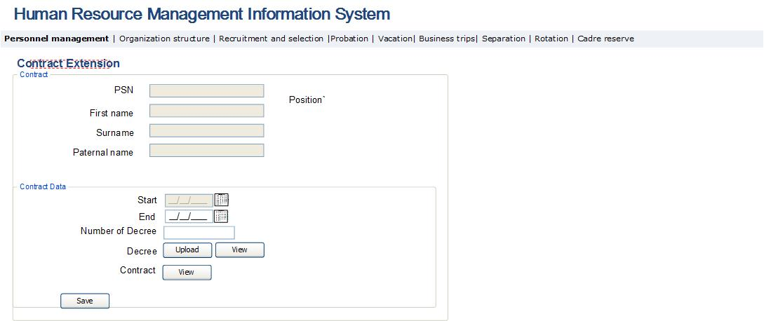

Table 6. Contract extension form
Field | Type | Attributes | Initial value | Description
Main Window
Position | Label |  |  | Field displays the name, direct management unit and unit of the selected contract- based position.
First name | Text Box | Disabled |  | Field displays person’s first name.
Surname | Text Box | Disabled |  | Field displays person’s surname.
Paternal name | Text Box | Disabled |  | Field displays person’s paternal name.
PSN | Text Box | Disabled |  | Field displays person’s public service number.
Start | Calendar Box | Disabled | Date of the end of the previous contract | Field displays the date of the Start of person’s contract
End | Calendar Box |  |  | Date of the contract end as stated in decree is entered in the field.
Contract | Label |  |  | The field displays the employment contract entered into with the employee, which, where being extended, is the same as the contract uploaded in the system for the same employee to the same position for the previous period.
View | Button |  |  | Clicking on the button, the page view for the signed contract file opens in pdf format
Decree | Label |  |  | Field displays the decree on extension of the contract in question for the particular employee.
Decree number | Text box |  |  | The number of the decree on the contract extension is entered in the field.
View | Button |  |  | Clicking on the button, the view page for the attached decree file opens in pdf format.
Upload | Button |  |  | Clicking on the button, the upload page for the attached decree file opens in pdf format.
Save | Button |  |  | Clicking on the button, changes made in the form are saved. In “Contract-based job” table, a row for the new contract is entered for the employee.

3․3․6․ Personal Data Editing Module
This sub-module of the system enables to view and make changes in the personal data of the SRC employees. It constitutes a HRMIS sub-module and is accessible to the PMD Department employees with options to view, add and change the data of all employees. The main functionalities of the employee data editing module are:
- This module enables the PMD employees to make changes in the personal data.
- In case of making changes or adding a new row and saving the data, “Employee Personal Data Update” notification is sent on the business email address of the employee, whose data have been modified.
See below the Employee Data Modification Module forms and description of their fields.
Fig. 8․ Employee family composition data editing/adding page
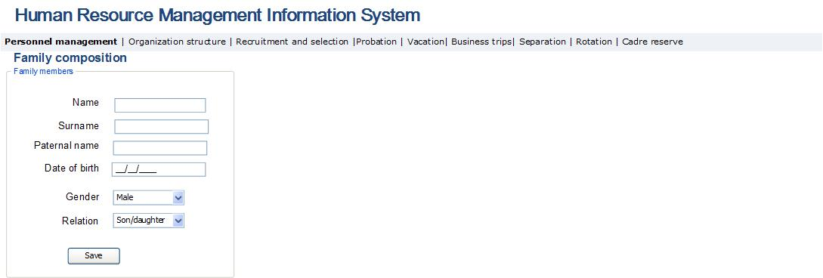
Table 7. Employee family composition editing/adding page
Field | Type | Attributes | Initial value | Description
Family composition data block
First name | Text Box |  |  | The name of employee’s family member is entered.
Surname | Text Box |  |  | The surname of employee’s family member is entered.
Paternal name | Text Box |  |  | The paternal name of employee’s family member is entered.
Birth date | Calendar Box |  |  | The birth date of employee’s family member is entered.
Relationship | Dropdown |  |  | The relationship of family member with employee is entered.  Potential values:  - Wife  - Husband  - Child  - Mother  - Father  - Sister  - Brother
Gender | Dropdown |  |  | The gender of employee’s family member is entered. Potential values:  - Male  - Female
Save | Button |  |  | Saves all changes made in all existing fields of the given data block. In the result, a new line is added to the family composition of employee data view module. If the line is edited, then the data of edited line is updated.

Fig. 9․ Editing/adding page for data on employee’s duty in special services of the RA
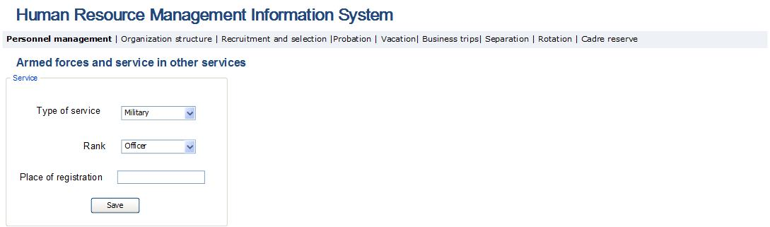

Table 8. Editing/adding page for data on employee’s serving in security forces
Field | Type | Attributes | Initial value | Description
Data block on service in enforcement body
Type of service | Drop Down |  |  | Displays the type of employee’s special service. Potential values:  - Police Service  - National Security Service  - Military Service
Rank | Drop Down |  |  | Displays the special rank of the employee: Potential values:  - Warrant Officer  - Senior Warrant Officer  - Junior Lieutenant  - Lieutenant  - Senior Lieutenant  - Captain  - Major  - Lieutenant Colonel  - Colonel  - Major General  - General-Lieutenant  - General-Colonel
Place of military registration | Text Box |  |  | This field displays the place of employee’s military registration.
Save | Button |  |  | Saves all changes made in all existing fields of the given data block. In the result, a new line is added to the enforcement bodies data view block. If the line is edited, then the data of edited line is updated.

Fig. 10. Employee education data editing/adding page
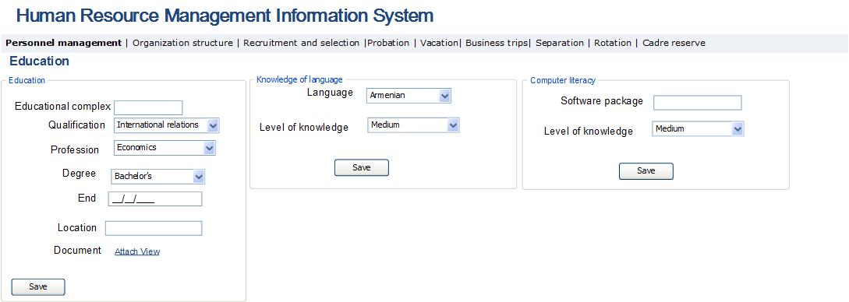

Table 9․ Employee education data editing/adding page
Field | Type | Attributes | Initial value | Description
Table of education of the employee
Educational institution | Text Box |  |  | Displays the name of educational institution. Includes the list of educational institutions.
Qualification | Dropdown |  |  | Displays the qualification that the employee has obtained in the given educational institution. Potential values:  In accordance to the list of the Professions and Qualifications of the RA higher education.
Profession | Dropdown |  |  | Displays primary profession that the employee has obtained in the given educational institution. Potential values  are set according to the list of the Professions and Qualifications of the RA higher education.
Academic degree | Dropdown |  |  | Displays the employee’s Academic degree obtained in the given educational institution. Potential values:  - Specialist holding a diploma  - Bachelor’s degree  - Master’s degree  - Ph.D. Candidate  - Ph.D. / Doctor of Science
End | Calendar Box |  |  | Displays the graduation date of the educational institution.
Location | Text Box |  |  | Displays the address of the educational institution.
Document | Text Box |  |  | The field displays/uploads the document certifying the particular education in pdf format.
Document upload | Button |  |  | By pressing the button, the window for uploading the document certifying the particular education opens in pdf format.
Document view |  |  |  | By pressing the button, the window for viewing the document certifying the particular education opens in pdf format.
Save | Button |  |  | Saves all changes made in all existing fields of the given data block. In the result, a new line is added to the education data block. If the line is edited, then the data of edited line is updated.

Fig. 11․ Employee computer skills data editing/adding page

Table 10. Computer skills data editing/adding
Field | Type |  | Attributes | Initial value | Description
Computer literacy subgroup
Computer skills | Text Box |  |  |  | The name of required software package that employee masters is entered.
Degree of knowledge |  | Text Box |  |  | The level of mastering appropriate package is entered.  Potential values:  - Basic  - Intermediate  - Proficient
Save |  | Button |  |  | Saves all changes made in all existing fields of the given data block. In the result, a new line is added to the computer literacy sub-group. If the line is edited, then the data of edited line is updated.

Fig. 12. Editing page for employee’s command of language data

Table 11. Editing window for knowledge of languages
Field | Type |  | Attributes | Initial value | Description
Language knowledge subgroup
Language |  | Text box |  |  | Presents the required language consisting of the following points:  - Armenian  - Russian  - English  - Other
Degree of knowledge |  | Text Box |  |  | The level of mastering the appropriate language is entered. Potential values:  - Basic  - Intermediate  - Proficient
Save |  | Button |  |  | Saves all changes made in all existing fields of the given data block. In the result, a new line is added to the language data block. If the line is edited, then the data of edited line is updated.

Fig. 13. Employee experience data editing/adding page
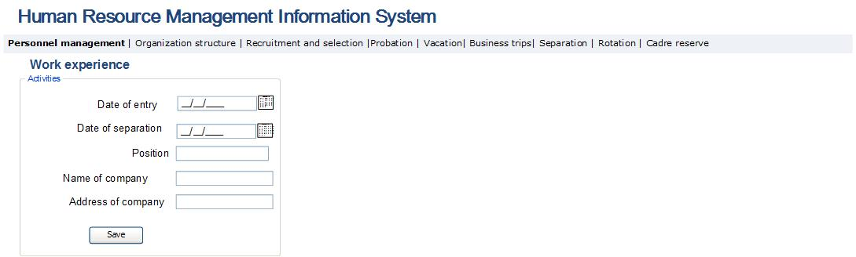

Table 12. Employee experience data editing/adding window
Field | Type | Attributes | Initial value | Description
Editing work experience data
Date of entry | Calendar box |  |  | The date of entry to the given company is entered.
Date of exit | Calendar box |  |  | The date of exiting from the given company is entered.
Position | Text Box |  |  | The position of the given job is entered.
The name of company | Text Box |  |  | The name of company is entered.
The address of company | Text box; multi-line |  |  | The address of company is entered.
Save | Button |  |  | Saves all changes made in all existing fields of the given data block. In the result, a new line is added to the work experience data block. If the line is edited, then the data of edited line is updated.

Fig. 14. Editing/adding page for data on employee ranks
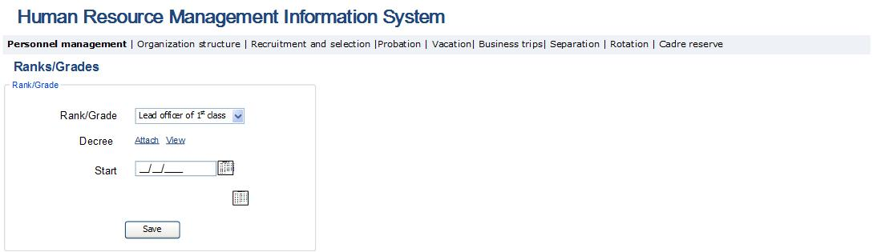

Table 13. Employee ranks data block editing/adding
Field | Type | Attributes | Initial value | Description
Ranks editing data block
Rank | Dropdown |  |  | The rank of employee is entered.  Potential values for Customs service are:  - Customs Service Major-General  - Customs Service Colonel  - Customs Service Deputy Colonel  - Customs Service Major  - Customs Service Captain  - Customs Service Senior Lieutenant  - Customs Service Lieutenant  - Customs Service Junior Lieutenant  For Tax service are:  - 1st class State Counselor of the Tax service of the Republic of Armenia  - 2ND class State Counselor of the Tax service of the Republic of Armenia  - 3^{rd.} class State Counselor of the Tax service of the Republic of Armenia  - 1^{set} class Senior Counselor of the Tax service of the Republic of Armenia  - 2ND class Senior Counselor of the Tax service of the Republic of Armenia  - 3^{rd.} class Senior Counselor of the Tax service of the Republic of Armenia,  - 1^{set} class Counselor of the Tax service of the Republic of Armenia,  - 2ND class Senior Counselor of the Tax service of the Republic of Armenia  - 3rd class Senior Counselor of the Tax service of the Republic of Armenia  For the Civil Service:  - 1^{set} class State Counselor of the Civil Service  - 2ND class State Counselor of the Civil Service  - 3^{rd.} class State Counselor of the Civil Service  - 1^{set} class Counselor of the Civil Service  - 2nd class Counselor of the Civil Service  - 3rd class Counselor of the Civil Service  - 1st class Leading officer of the Civil Service  - 2nd class Leading officer of the Civil Service  - 3rd class Leading officer of the Civil Service  - 1st class Junior officer of the Civil Service  - 2nd class Junior officer of the Civil Service  - 3rd class Junior officer of the Civil Service
Decree | Button |  |  | The decree on awarding the given rank to the employee is entered in pdf format.
Start | Calendar box |  |  | The date of awarding the given rank to the employee is entered.
Save | Button |  |  | Saves all changes made in all existing fields of the given data block. In the result, a new line is added to the ranks data block. If the line is edited, then the data of edited line is updated.

Fig. 15. Editing/adding page for data on employee incentives
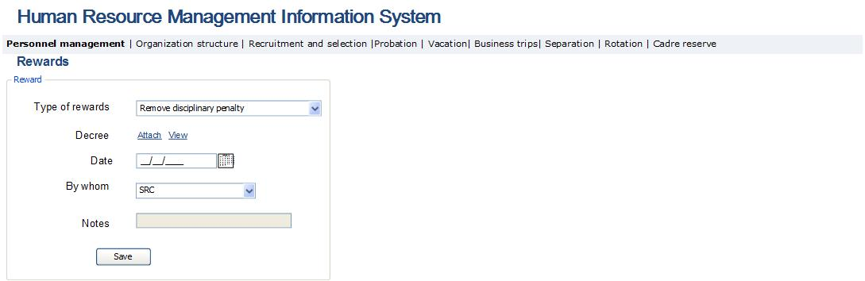
Table 14. Editing/adding page for data on employee’s incentives
Field | Type | Attributes | Initial value | Description
Incentives data block
Type of incentive | Drop down |  |  | The type of incentive awarded to the employee is entered. Potential values:  For Tax officers:  - Releasing from disciplinary penalty  - Financial rewards  - Souvenir  - Salary increase  - Gratitude expressed by the Head of Tax or Customs Body, or superior body  - Out-of-turn granting of special and/or grade rank  - Rewarding with the Model Tax Officer’s medal of the Republic of Armenia  For Customs officers:  - Announcement of gratitude  - Monetary award  - Souvenir  - Diploma of superior Customs body  - Early removal of disciplinary penalty  - Provision of additional paid vacation  - Out-of-turn granting of special and/or class rank  - Award one class higher than entitled rank  - Award with a medal  In the case of granting “Removal of disciplinary penalty, the penalty active for the given employee is removed. The end date of disciplinary penalty is deemed as the start date of the award.
Decree | Label |  |  | The Decree of the given incentive is entered in pdf format.
Attach | Button |  |  | By pressing the button, the window for attaching the given incentive in pdf format opens.
View | Button |  |  | By pressing the button, the window for viewing the given incentive in pdf format opens.
Date | Calendar box |  |  | The date of issued incentive is entered.
By whom | Dropdown |  |  | The issuer of the incentive is entered. Potential values: Position in the SRC staff list.
Notes | Text Box |  |  | Notes on the incentive are entered.
Save | Button |  |  | Saves all changes made in all existing fields of the given data block. In the result, a new line is added to the rewards data block. If the line is edited, then the data of edited line is updated.

Fig. 16. Editing/adding page for the information on employee’s fines
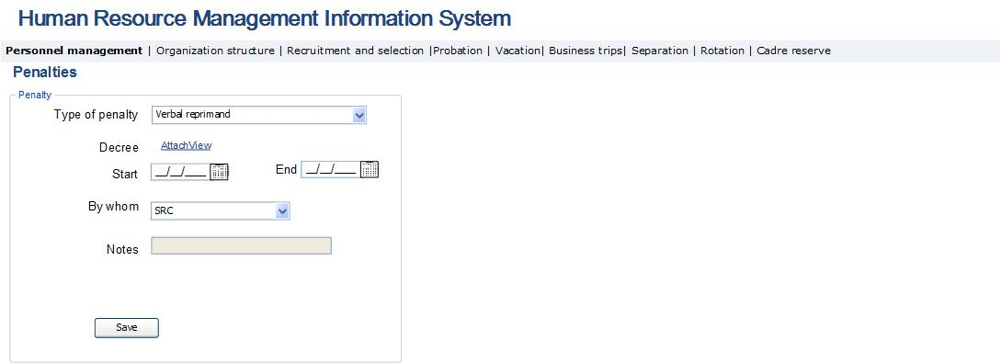

Table 15. Editing/adding page for the information on employee’s fines
Field | Type | Attributes | Initial value | Description
Editing disciplinary penalties
Type of penalty | Drop Down |  |  | The type of disciplinary penalty is entered. Potential values:  - Verbal reprimand  - Written reprimand  - Decrease rank  - Financial liability  - Demotion from the position held  - Separation from the tax service  Maximum period of penalty is 1 year.  When “Demotion” type of penalty is registered in the system, a new line with the particular employee’s data is added in the table of “Internal transfer administration” form of “Internal transfers” module, where the ground for demotion is mentioned “Disciplinary penalty”.  When “Separation from tax service” disciplinary penalty is registered in the table “List of employees with separation grounds” of “Separation administration” module, a new line displaying the particular employee is added to that table, where the ground for separation is marked as “Disciplinary penalty – separation from service”.
Decree | Text Box |  |  | The decree for the given disciplinary penalty is entered in pdf format.
Attach | Button |  |  | By pressing the button, the window for attaching the given penalty in pdf format opens.
View | Button |  |  | By pressing the button, the window for viewing the given penalty in pdf format opens.
Start date | Calendar box |  |  | The start date of exercising the given disciplinary penalty is entered.
End date | Calendar box |  | Start date +1 year | The end date of assigning the given disciplinary penalty is entered. The maximum period is 1 year from its exercise.
From whom | Drop Down |  |  | The unit issuing the disciplinary penalty is entered. Potential values: Positions of the staff list of the SRC.
Notes | Text Box |  |  | Notes on disciplinary penalty is entered.
Save | Button |  |  | Saves all changes made in all existing fields of the given data block. In the result, a new line is added to the incentives data block. If the line is edited, then the data of edited line is updated.

Fig. 17. Editing/adding page for information on the employee’s research papers/inventions
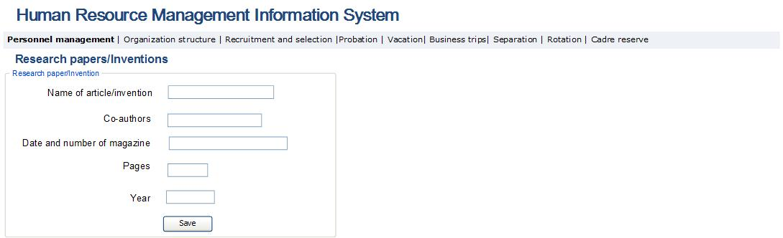

Table 16. Editing/adding page for information on the employee research papers/inventions
Field | Type | Attributes | Initial value | Description
Editing research papers/inventions
Name of article/invention | Text box |  |  | The name of article or invention is entered.
Co-authors | Text Box |  |  | The co-authors of article or invention is entered.
Name and number of magazine | Text box; multi-line |  |  | The name and number of the magazine containing the article or invention is entered.
Pages | Text Box |  |  | The pages of the magazine containing the article is entered.
Year | Text box |  |  | The Year of publishing the paper is entered.
Save | Button |  |  | Saves all changes made in all existing fields of the given data block. In the result, a new line is added to the research papers data block. If the line is edited, then the data of edited line is updated.

Fig. 18. Editing/adding page for data on employee’s involvement in elective bodies
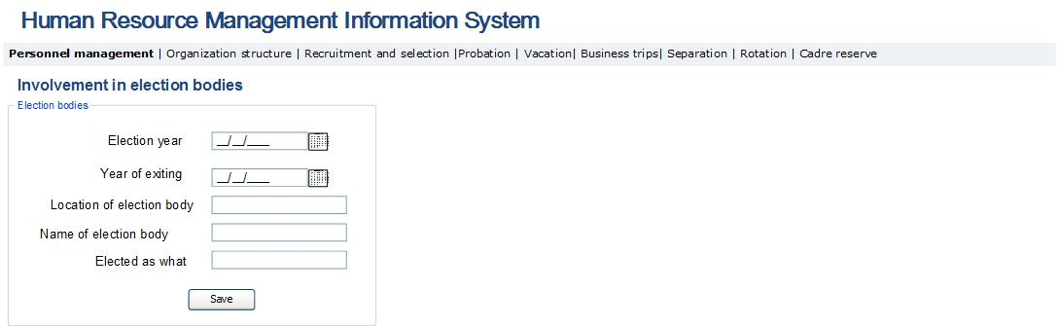
Table 17. Editing/adding page for information on employee’s involvement in elective bodies
Field | Type | Attributes | Initial value | Description
Editing the Involvement in election bodies data block
Election date | Calendar box |  |  | The date of being selected in the given election body is entered.
Exit date | Calendar box |  |  | The date of exiting from election body is entered.
Location of election body | Text box; multi-line |  |  | The location of the given election body is entered.
Name of election body | Text Box |  |  | The name of the given of election body is entered.
Position | Text Box |  |  | The position occupied by the employee in the result of selection is entered.
Save | Button |  |  | Saves all changes made in all existing fields of the given data block. In the result, a new line is added to the election bodies’ data block. If the line is edited, then the data of edited line is updated.

Fig. 19. Editing/adding page for data on employee’s State awards
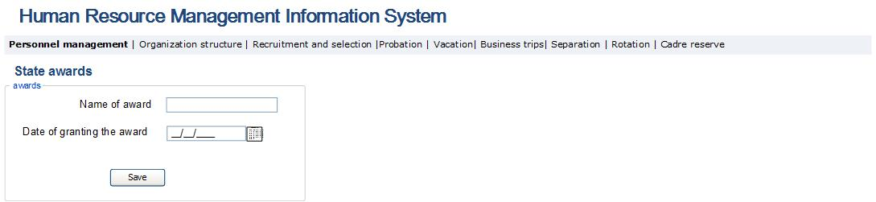

Table 18. Editing/adding page for information on employee’s State awards
Field | Type | Attributes | Initial value | Description
Editing state awards/prizes data
Name of award | Text Box |  |  | The state award granted to the employee is entered.
Date of granting the award | Calendar box |  |  | The date of receiving the given award is entered.
Save | Button |  |  | Saves all changes made in all existing fields of the given data block. In the result, a new line is added to the state awards data block. If the line is edited, then the data of edited line is updated.

Fig. 20. Editing page for information on the employee’s Learning
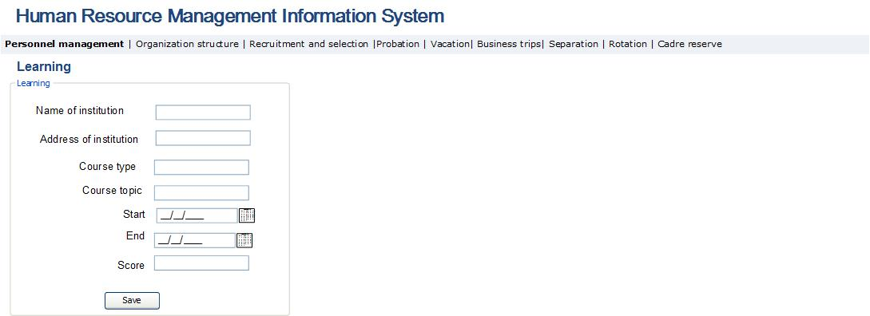
Table 19. Editing page for information on the employee’s Learning
Field | Type | Attributes | Initial value | Description
Learning/attestation data block
Name of institution | Text box |  |  | This field displays the name of institution organizing employees’ learning.
Address of institution | Text box |  |  | This field displays the address of institution organizing employees’ learning.
Type of course | Text box |  |  | This field displays the type of course of employee.
Course topic | Text box |  |  | This field displays the topic of employee’s course.
Start | Calendar box |  |  | This field displays the start date of employees’ course.
End | Calendar box |  |  | This field displays the end date of employees’ course.
Score | Text box |  |  | This field displays the employee’s score of course.
Save | Button |  |  | Saves all changes made in all existing fields of the given data block. In the result, a new line is added to the learning data block. If the line is edited, then the data of edited line is updated.

Fig. 21. Editing page for information on the employee’s training
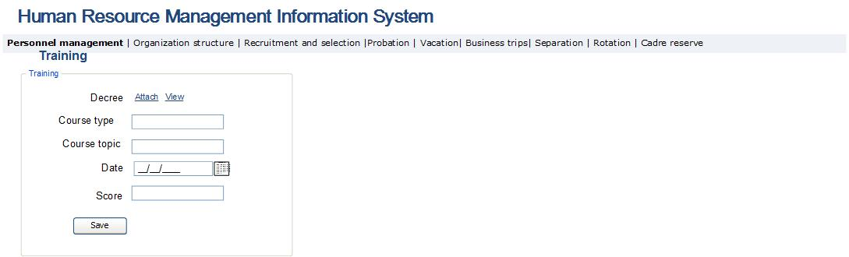
Table 20. Editing page for information on the employee training
Field | Type | Attributes | Initial value | Description
Training data block
Decree | Label |  |  | The decree for implementing employee’s training is entered in pdf format.
Attach | Button |  |  | By pressing the button, the window for attaching the given decree in pdf format opens.
View | Button |  |  | By pressing the button, the window for viewing the given decree in pdf format opens.
Type of training course | Text box |  |  | This field displays the type of training course of employee.
Training course topic | Text box |  |  | This field displays the topic of employee’s training course.
Date | Calendar box |  |  | This field displays the date of employees’ training course.
Score | Text box |  |  | This field displays the employee’s score of training course.
Save | Button |  |  | Saves all changes made in all existing fields of the given data block. In the result, a new line is added to the training data block. If the line is edited, then the data of edited line is updated.

Fig. 22. Editing page for information on the employee’s attestation
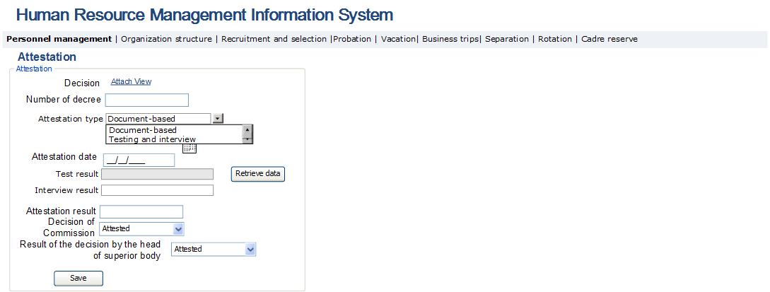
Table 21. Editing page for information on the employee’s attestation
Field | Type | Attributes | Initial value | Description
Editing attestation data
Decision | Text Box |  |  | The decision for implementing employee’s attestation is entered in pdf format.
Attach | Button |  |  | By pressing the button, the window for attaching the given decision in pdf format opens.
View | Button |  |  | By pressing the button, the window for viewing the given decision in pdf format opens.
Decision number | Text box |  |  | The attestation Decision number is entered.
Attestation type | Drop down |  |  | The type of attestation is entered in the field. Potential values:  - Document-based  - Testing and interview  In the case of document-based attestation only the Attestation result field is displayed.
Attestation date | Text box |  |  | Displays the attestation date.
Test result | Text box |  |  | Displays the result of attestation test in percentages. The field is displayed only when the “Testing and Interview” attestation type is selected.
Retrieve data | Button |  |  | By pressing the button, the system makes data inquiry to the automated attestation system. By sending the attestation date and employee’s PSN, the test results are retrieved and entered in “Test result” field.
Interview result |  |  |  | The result of interview is entered in the field in percentages. The field is displayed only when the “Testing and Interview” attestation type is selected.
Attestation result | Text box |  |  | Displays the result of given attestation in percentages. In the case of “Testing and Interview” attestation type, the average scion of test and interview is automatically entered in the field. In the case of document-based attestation, attestation result is entered in the field.
Conclusion of Commission | Text box |  |  | Displays the conclusion of the Commission on the given attestation. Potential values:  - Attested  - Send for training
Result of the decision of superior body | Text box |  |  | Displays the result of the superior body on the result of the given attestation.  Potential values:  - Attested  - Send for training  - Demotion  - Rank increase  - Rank decrease  - Separate from work  If the decision on “Demotion” is registered, a new line on the particular employee is added in the “Internal transfer administration” form table of “Internal transfer” module. The basis “Attestation result” for changing the position is registered for that line.  When the decision “Separate from work” is registered, a new line on the particular employee is added to the “List of empoyees with separation grounds” form table of “Separation administration” module. The separation ground for that line is “Attestation result”.
Save | Button |  |  | Saves all changes made in all existing fields of the given data block. In the result, a new line is added to the attestation data block. If the line is edited, then the data of edited line is updated.

Fig. 23. Positions held within the system
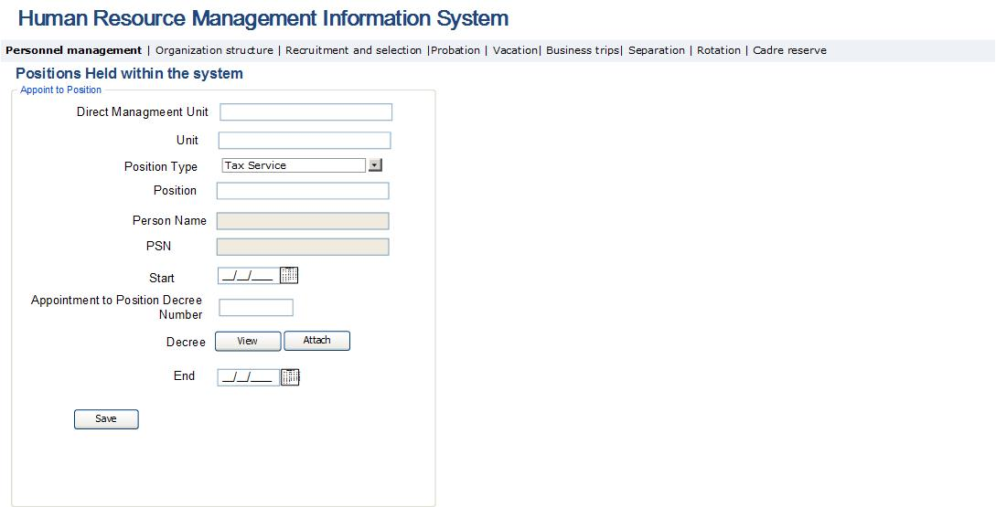

Table 22. Editing page for the data on the positions held by employee within the system
Field | Type | Attributes | Initial Value | Description
Editing block for the data on position held inside the system
Direct management unit | Text Box |  |  | Direct management unit of the particular position of employee is entered in the field.
Unit | Text Box | Text Box |  | Unit of the particular position of employee is entered in the field.
Position type | Drop Down |  |  | Particular postion type of employee is entered in the field. Potential values:  - Discretionary positions  - Tax Service  - Customs Service  - Civil service  - Those engaged in civil works  - Contractual
Position | Text Box |  |  | Name of the particular position of employee is entered in the field.
Start | Calendar box |  |  | The date of the employee being appointed to the particular position is entered in the field.
End | Calendar box |  |  | Date of the employee being separated from the particular position is entered in the field.
Decree number | Text box |  |  | Number of decree on the employee being appointed to the particular position is entered in the field.
Decree file | Column |  |  | Decree file of being appointed to the particular position is entered in the field.
Attach | Button |  |  | Clicking on the button, attachment page for the decree file on being appointed to the position opens in pdf format.
View | Button |  |  | Clicking on the button, the view page for the decree file on being appointed to the position opens in pdf format.

Fig. 24. Involvement in commissions
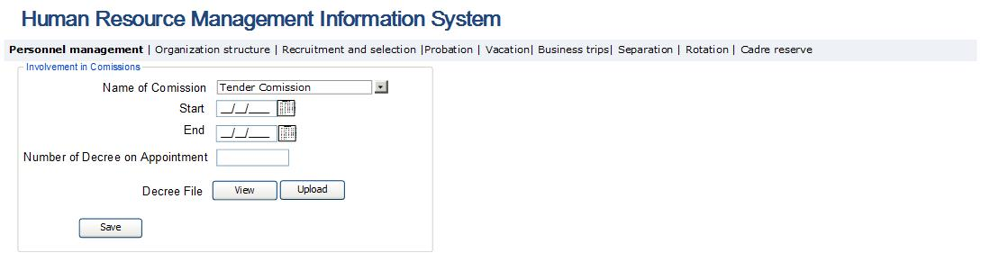

Table 23. Editing/adding page for employee involvement in commissions
Field | Type | Attributes | Initial Value | Description
Involvement in commission
Name of the commission | Drop Down |  |  | The name of the commission, where the employee is involved is entered in the field. Potential values of such field are taken from the commissions list, which is entered in “Management” module.
Start | Calendar box |  |  | The date of appointing of the employee to the commission is entered in the field.
End | Calendar box |  |  | The date, when the employee withdraws from the commission is entered in the field.
Decree number | Text box |  |  | Number of the decree on appointing the employee to the commission is entered in the field.
Decree file | Label |  |  | File of the decree on appointing the employee to the commission is entered in the field.
Attach | Button |  |  | Clicking on the button, the attachment page for the decree file on appointment to the commission opens in pdf format.
View | Button |  |  | Clicking on the button, the view page for the decree file on appointment to the commission opens in pdf format.

Organization Structure and Position Management Module Implementation
This sub-module enables to create, view, edit structural units and positions, the links between them, as well as to create reports for conducting analysis on the basis of such data. It constitutes a sub-module of the HRMIS and is accessible to the senior management and the PMD employees in terms of viewing the data on all the SRC structural units and positions. The PMD employees are also enabled to add new records and edit the data displayed in this module. The module enables the head of unit to view only the structure and positions of that unit.
The main functionalities of “Organization Structure and Positions Management” module are:
- Create a new structural unit and position, for which an employee of respective PMD division shall be provided with information for the purpose of creating structural unit or position; for example, the decree on creating structural unit and the functions thereof, recommendation document on creating position passport and the position.
- Edit/View the data on structural unit and position. Such data can be edited only if those are not entered in the main data block. In case when it is necessary to make modifications in the main data block, the structural unit or position requiring modification should be made inactive by entering the date of the end of activity. Subsequently, it is necessary to create a new structural unit or position with new data. In case if the structural unit data are modified or a structural unit is created, notification with “Unit created” or “Modifications made in the data of your unit” text is sent on the business email address of the head of unit.
- Create reports for the purpose of analyzing the data available in the module. Examples of such reports are:
- Management hierarchy in the diagrammatic and hierarchical mannar:
- Employee data by positions (staff list)
- Position descriptions list
- Report on vacant positions
- Report on active positions
- Report on inactive positions
- Report on filled positions
- Report on planned position
- Report on another characteristics of position
- Occupational level of position.
- After receiving appropriate reasons (decree on being appointed to position), assign the employee to the relevant position.

Organization structure and positions management module is organized into the following two sub-modules:
- Organization structure administration module, where the SRC organization structure is defined, determined, organized and edited.
- The SRC staff list administration module, where the SRC staff list administration process and positions descriptions administration process are performed.

3․4․1 Organization Structure Administration Module
This sub-module of the system enables to view the list of the SRC structural units and perform their searches. It constitutes a sub-module of the HRMIS and is accessible to the senior management and the PMD employees in terms of viewing the data on all the SRC structural units. PMD employees have also an opportunity to add new records and to edit the data displayed in this module. The module enables the head of unit to view only the unit employees. The main functionalities of the organization structure administration module are:
- View the list of the SRC structural units and perform searches therein by various criteria.
- Create a new structural unit by clicking on the “New Structural Unit” button. By clicking on “New subordinate unit” button, structure constituting the subordinate unit for the checked structural unit is created. Such operation is accessible only to the PMD employees. Where creating a structural unit, a notification reading “Structural unit created” is sent on the business email address of the head of unit.
- Make changes in the structural unit data. The structural unit data can be edited only if they are not entered in the main data block. In case there is a need to make changes in the main data block, the structural unit requiring modification should be made inactive by entering the date of the end of activity. Consequently, the structural unit is given “Inactive” status. Thereafter, it would be necessary to create a new structural unit with new data. Where the structural unit data are changed, “Modifications are made in data of your unit” notification or message is sent on the business email address of the head of unit.
- Send notifications in case if structural unit data or status modifications are made. In case of data modifications, “Unit created” or “Modifications are made in data of your unit” message is sent on the business email address of the head of that structural unit.
The following forms are envisaged for the purpose of performing the above operations.

Fig. 25. Organization structure administration
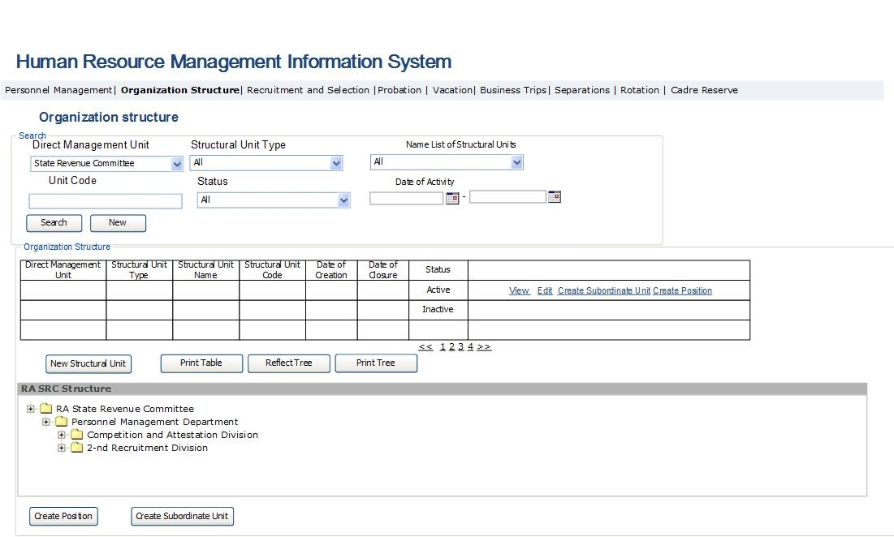

Fig. 26. Example of organization structure tree reporting
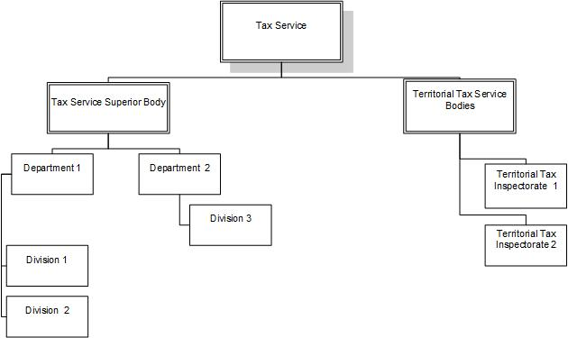

Table 24. Organization structure administration
Field | Type | Attributes | Initial value | Description
Search Section
Direct management unit | Dropdown | Not mandatory | All | Defines the direct management unit of the SRC structural unit.
Type of structural unit | Dropdown | Not mandatory | All | Defines the list of the SRC structural unit types pertaining to the direct management unit stated in the previous point. Potential values:  - All  - Superior tax authority  - Superior customs authority  - Territorial body  - Territorial tax inspection  - Taxpayer Service Center  - Department  - Division  - Customs point  - Customs house
Name list of structural units | Drop down | Not mandatory |  | Defines the name of the SRC structural unit. Potential values:  - All  - Name list of the SRC structural units
Structural unit code | Text Box | Not mandatory |  | Defines the SRC structural unit code.
Status | Drop down | Not mandatory | Active | Defines the status of the SRC structural unit. Potential values:  - All  - Active  - Inactive  “Active” status pertains to the units that are active at that moment. “Inactive” status pertains to the structural units that are inactive at that moment.
Date of activity | Calendar box | Not mandatory | Active | Defines the date of activity of the SRC structural unit. The date is defined in the range.
Search | Button |  |  | Clicking on the button, search is performed in the below table by checked indicators.
New | Button |  |  | Bring the search fields to the initial values.
Structural units table
Direct management unit | Column |  |  | Field displays the direct management unit of structural unit.
Type of structural unit | Column |  |  | Field displays the type of structural unit. Potential values are:  - Headquarters  - Territorial body  - Territorial Tax Inspectorate  - Taxpayer Service Center  - Department  - Division  - Customs point  - Custom-House
Name of structural unit | Column |  |  | Field displays the name of the structural unit.
Structural unit code | Column |  |  | Field displays the code of the checked structural unit. The code is the sequential number of structural unit in the unit’s list of the direct management unit.
Date of creation | Column |  |  | Field displays the date of creation of the particular structural unit.
Date of closure | Column |  |  | Field displays the date of termination of activity of the given structural unit.
Status | Column |  |  | Field displays the status of the checked structural unit. Potential values are:  - Active  - Inactive  “Active” status pertains to the units that are active at that moment. “Inactive” status pertains to the structural units that are inactive at that moment.
New structural unit | Button |  |  | Opens the form for creation of a structural unit that is on the same level as the checked unit (Table 25). In case the data entered in the form are saved, the structural unit is added in the table as a new row.
Create a subordinate unit | Button |  |  | Opens the form for creation of a unit deemed as a subordinate unit for the checked structural unit (Table 24). The structural unit of the checked row in the table is displayed as a direct management unit in the form when clicking on the button. If the data entered in the form as described in Table 24 are saved, the structural unit is added in the table as a new row.
View | Button |  |  | Opens the form to view the checked structural unit (Table 24) in view mode, with suspended fields, without editing option.
Edit | Button |  |  | Opens the form to edit the checked structural unit. When editing, the main data block fields of the structural unit are not active. The button is accessible only to the PMD employees.
Print the tree | Button |  |  | Opens the report displaying the structure of the checked structural unit and its substructures with diagrammatic view (Fig.. 25). It is necessary to create an option for placing the diagram in the SRC website.
Print the table | Button |  |  | Clicking on the button, the rows checked in the table are exported from the system with file view in xls formate.
Reflect the tree | Button |  |  | Clicking on the button, the SRC structure opens at the button of the page with the view of tree.
Create a position | Button |  |  | Clicking on the button, the window, described in Table 26, for creatin a new position in the checked structural unit opens.

Fig. 27. Page to view/edit the structural unit data/create a new structural unit
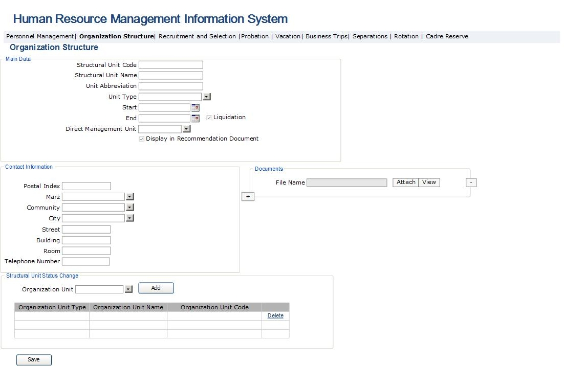

Table 256. Page to create/view/edit the structural unit
Field | Type |  | Attributes |  | Initial value |  |  |  |  | Description
Main data block
Structural unit code |  | Text box |  |  |  |  |  |  | Field presents the code of the checked structural unit.
Name of structural unit |  | Text box |  |  |  |  |  |  | Field presents the name of structural unit.
Abbreviation of structural unit |  | Text Box |  |  |  |  |  |  | Field presents the abbreviation of the structural unit.
Type of structural unit |  | Text box |  |  |  |  |  |  | Field presents the type of structural unit. Potential values are:  - Headquarters  - Territorial body  - Territorial tax inspection  - Taxpayer Service Center  - Department  - Division  - Customs point  - Custom house
Start date |  | Calendar Box |  |  |  |  |  |  | Field presents the date of creation of the particular structural unit.
End date |  | Calendar Box |  |  |  | Disabled |  |  | Field presents the end date of the activity of the particular structural unit. This field is enabled after “Termination” field is checked.
Termination |  | Check box |  |  |  |  |  |  | By enabling the field, an opportunity is created to enter the end date.
Direct management unit |  | Drop down |  |  |  |  |  |  | Field displays the direct management unit of the checked structural unit. Potential values are the names of entered structural units.
Display in separation sheet |  | Check box |  |  |  |  |  |  | In case this field is checked, the particular structural unit is displayed in “Separation sheet” form of the employee separation sheet creation module, and “employee separation sheet” page under dismissed employee management module becomes accessible to the head of such structural unit.
Save |  | Button |  |  |  |  |  |  | Clicking on the button, modifications made in the given form are saved. The form is closed, and the created or modified structural unit is displayed in the form described in Table 24. Organizational units checked in “Organizational unit status modification” sector gain “Inactive” status. As the inactivation period, the date of creation of organizational unit is placed. As the end of the activation period of subordinate units of the checked organizational units, the date of establishment of the newly created organizational unit is automatically entered, and their status is changed into “Inactive” value. The status of all positions assigned to the structural units with “Inactive” status also becomes “Inactive”, and for them the end date of activation, identical to the date of creation of the new structural unit, is entered. The status of employees assigned to such positions becomes “Reappointment”. The status is displayed in “Labor Resource” Module.
Print |  | Button |  |  |  |  |  |  | Clicking on the button, the window displaying the position description in doc format opens.
Structural unit address data block
Postal code |  | Text Box |  |  |  |  |  |  | Displays the postal code of the registration address of the structural unit.
Marz |  | Dropdown |  |  |  |  |  |  | Displays the marz of registration address the structural unit and the City of Yerevan; Potential values are:  - Aragatsotn  - Ararat  - Armavir  - Gegharquniq  - Yerevan  - Lori  - Kotayk  - Shirak  - Syunik  - Vayots Dzor  - Tavush
Community |  | Dropdown |  |  |  |  |  |  | Displays the community of the structural unit registration address, and the content of the list depends on the selected marz. The list of community is registered pursuant to the Law of the Republic of Armenia “On Administrative-Territorial Division of the RA”.
Street |  | Text Box |  |  |  |  |  |  | Displays the street of registration address of the structural unit.
Document data block
File name |  | Text box |  |  |  |  |  |  | The field displays the file name of the document on creation of the particular structural unit. Such documents are:  - Decision and decree on creation of structural unit.  - The functions of the structural unit.
+ |  | List box |  |  |  |  |  |  | Adds a field for attachment of a new document on creation of the particular structural unit.
- |  | Button |  |  |  |  |  |  | Removes a field for attachment of a new document on creation of the particular structural unit.
Attach |  | Button |  |  |  |  |  |  | Clicking on the button, window to attach the document on creation of a new structural unit in pdf format opens.
View |  | Button |  |  |  |  |  |  | Clicking on the button, window to view the particular document opens.
Structural unit status modification
Organizational unit |  | Drop Down |  |  |  |  |  |  | Structural units that should become inactive when creating the particular unit are selected in the field. The field is active only in case of creation of a new structural unit.
Add |  | Button |  |  |  |  |  |  | Adds the structural unit checked in “Organizational Unit” field in the list of organizational units. The button is active only when creating a new structural unit.
List of structural units
Structural unit code |  | Column |  |  |  |  |  |  | Field presents the code of such structural unit, which will become inactive when creating a new structural unit. The field is active only in case a new structural unit is created.
Name of structural unit |  | Column |  |  |  |  |  |  | Field presents the name of such structural unit, which will become inactive when creating a new structural unit. The field is active only in case a new structural unit is created.
Structural unit type |  | Column |  |  |  |  |  |  | Field presents the type of the structural unit, which will become inactive, when creating a new structural unit. Potential values are:  - Headquarters  - Territorial body  - Territorial Tax Inspectorate  - Taxpayer Service Center  - Department  - Division  - Customs point  - Customs House  Field is active only when creating a new structural unit.
Delete |  | Column |  |  |  |  |  |  | Removes the given row from the list, when a positive answer is given to the question on removing the row. The field is active only when creating a new structural unit.

3․4․2 The SRC Staff List Administration Module
This sub-module of the system enables to view the list of the SRC positions and to perform their searches. It constitutes a sub-module of the HRMIS and is accessible to the senior management and the PMD employees in terms of viewing the data on all the SRC positions. The PMD employees can also add new records and edit the data displayed in this module. The module enables the head of unit to view only the positions of such unit.
The main functionalities of the staff list administration module are:
- View the SRC positions list and perform searches therein by various criteria.
- Create a new structural unit by clicking on “Create position” button. Such operation is accessible only to the PMD employees. When creating a position, a notification reading “Position created” is sent on the business email address of the head of unit.
- Make position changes. The position data can be edited only if those are not entered in the main data block. If there is a need to make changes in the main data block, then the position requiring modification should be made inactive by entering the end date of the activity. Consequently, the position gains “Inactive” status. Thereafter, it is necessary to create a new position with new data. In case of modifying the position data, a notification or message reading “Modification is made in the data of your unit position” is sent on the business email address of the head of unit.
- Send notifications, in case if there is a data or status modification. In case of data modification, a notification reading “Position created” or “Modification is made in the data of your unit position” is sent on the business email address of the head of unit.
- When filling the position passport, the system should check the position subject to rotation. “Subject to rotation” note is allowed only for the Tax and Customs Service positions as prescribed in the legislation.
The forms envisaged for performing the above operations are presented below.

Fig. 28. Staff list administration
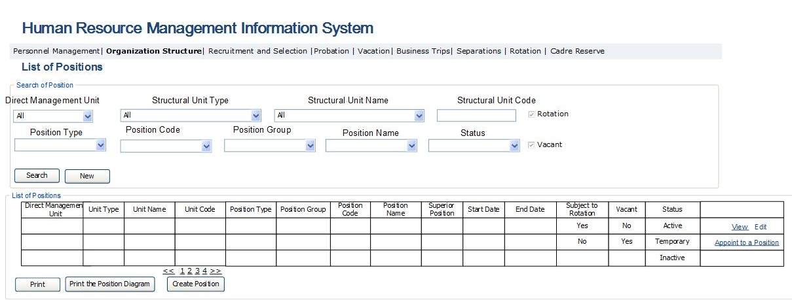

Table 26. Staff list administration form

Field |  | Type | Attributes |  | Initial value | Description
Search sector
Direct management unit | Dropdown |  | Not mandatory | All |  | Defines the direct management unit of the SRC structural unit for the particular position.
Type of structural unit | Dropdown |  | Not mandatory | All |  | Defines the list of the SRC structural unit types pertaining to the direct management unit as stated in the previous point.  Potential values are:  - All  - Headquarters  - Territorial body  - Territorial Tax Inspectorate  - Taxpayer Service Center  - Department  - Division  - Customs point  - Customs House
Name of structural unit | Dropdown |  |  |  |  | Field defines the name of structural unit for the particular position
Structural unit code | Dropdown |  |  |  |  | Field defines the structural unit code for the particular position
Rotation |  | Check box | Not Mandatory |  |  | Field defines the positions subject to rotation.
Vacant |  | Check box | Not Mandatory |  |  | Field defines vacant positions.
Position type |  | Dropdown | Not Mandatory |  | All | Field Defines the types of the SRC positions. The list contains the following values:  - All  - Discretionary positions  - Tax service  - Customs service  - Civil service  - Civil service contract-based  - Contract-based  The links of the position types, groups and the positions are created through the form entered in Table 33 and Fig. 31.
Position group |  | Dropdown | Not Mandatory |  | All | Field Defines the position groups of the position type as stated in the previous point. For the civil service, subgroups are displayed. In case of a contract-based position type, the types of contract-based positions are displayed. The list may contain the following values:  - All  - Top positions in Tax Service  - Chief positions in Tax Service  - Leading positions in Tax Service  - Junior positions in Tax Service  - Top positions in Customs Service  - Chief positions in Customs Service  - Leading positions in Customs Service  - Junior positions in Customs Service  - Contractual position groups  - Discretionary position groups  - Civil service subgroups  - Contractual position types
Position code |  | Dropdown | Not Mandatory |  | All | Field Defines the position code with the following structure:  [sequential number of tax/Customs Service]-[sequential number of department] - [sequential number of division] - [sequential number in the division staff list]
Position name |  | Dropdown | Not Mandatory |  | “All” | Defines the list of position names. It covers the positions pertaining to group stated in the previous point and “All” value.
Superior position |  | Dropdown | Not Mandatory |  | All | Defines the name of the position deemed as superior for the searched position. It covers the names of positions and “All” value.
Status |  | Dropdown | Not Mandatory |  | All | Defines the status of searched position. Potential values are:  - All  - Active  - Inactive  - Temporarily vacant  “Active” status pertains to the positions active at that moment.  “Inactive” status pertains to the positions that are inactive at that moment.  “Temporarily vacant” status pertains to the positions of such employees that are on “Pregnancy and maternity” and “Care for up to 3-year-old child” vacation. Contractual positions of “Replacement” type may be assigned to such positions.
Search |  | Button |  |  |  | Perform search
New |  | Button |  |  |  | Bring the search fields to the initial values
Table of positions
Direct management unit | Column |  |  |  |  | Field presents the name of the direct management unit of the structural unit for such position
Type of structural unit | Column |  |  |  |  | Field presents the structural unit type of the given position. Potential values are:  - All  - Headquarters  - Territorial body  - Territorial Tax Inspectorate  - Taxpayer Service Center  - Department  - Division  - Customs point  - Customs House
Name of the structural unit | Column |  |  |  |  | Field presents the structural unit name of the given position.
Structural unit code | Column |  |  |  |  | Field presents the structural unit code of the checked position
Position type |  | Column |  |  |  | Field displays the type of the given position. Potential values are:  - All  - Discretionary positions  - Tax service  - Customs service  - Civil service  - Civil service contract-based  - Contract-based  The links of position types, groups and the positions are defined through the form displayed in Table 33 and Fig. 31.
Position group |  | Column |  |  |  | Field displays the group, subgroup or type of the given position. For the civil service, subgroups are displayed. For the contractual type, the types of contractual positions are displayed. The list may contain the following values:  - Top positions in Tax Service  - Chief position in Tax Service  - Leading position in Tax Service  - Junior position in Tax Service  - Top position in Customs Service  - Chief position in Customs Service  - Leading position in Customs Service  - Junior position in Customs Service  - Types of contractual positions  - Groups of discretionary positions  - Civil service subgroups
Position name |  | Column |  |  |  | Field displays the name of the position
Position code |  | Column |  |  |  | Field displays the position code with the following structure:  [sequential number of Tax/Customs Service]- [sequential number of department] - [sequential number of division] - [sequential number in the division staff list]
Superior position |  | Column |  |  |  | Field displays the name of position being superior to the given position.
Position activation date |  | Column |  |  |  | Field displays the date of creation of the position.
Position inactivation date |  | Column |  |  |  | Field displays the end date of the position activation.
Vacant |  | Column |  |  |  | Field displays whether the position is vacant or filled.
Status |  | Column |  |  |  | Field displays the position status. Potential values are:  - Active  - Inactive  - Temporarily vacant  “Temporarily vacant” status pertains to the positions of such employees that are on vacation for “Pregnancy and maternity” and “Care for up to 3-year-old child”. It is possible to assign “Replacement” type contract- based positions to such positions.
Create position |  | Button |  |  |  | Clicking on the button, the page described in Table 23 opens, where selection of structural unit is conducted, following which the form for creation of a new position, as described in Table 26, opens. Once the changes made in the form are saved, the newly created position is displayed in the table.
Appoint to a position |  | Button |  |  |  | Button is active only for vacant positions and the positions with “Active” or “Temporarily vacant” status. Clicking on the button, the form described in Table 31 opens, where selection of employee is carried out for appointment to the position.
View |  | Button |  |  |  | Opens the window to view the information on the checked position in data view mode, with inactive fields and without editing option (Table 26).
Edit |  | Button |  |  |  | Opens the window to edit the information on the checked position (Table 26). The main data block described in Table 26 is suspended. To make changes in the main data block, it is necessary to enter the position inactivation date, so that the position status becomes “Inactive”. Thereafter, the new position should be created with the required data. The button is accessible only to the PMD employees.
Print |  | Button |  |  |  | Clicking on the button, the rows checked in the table are exported in the form of file in .xls format.
Print the diagram |  | Button |  |  |  | Clicking on the button, the system exports the structure of the checked position and the positions subordinate thereto in the form of a diagram. It is necessary to create an option for placing the diagram in the SRC website.

Fig. 29. Position creation/edition/view
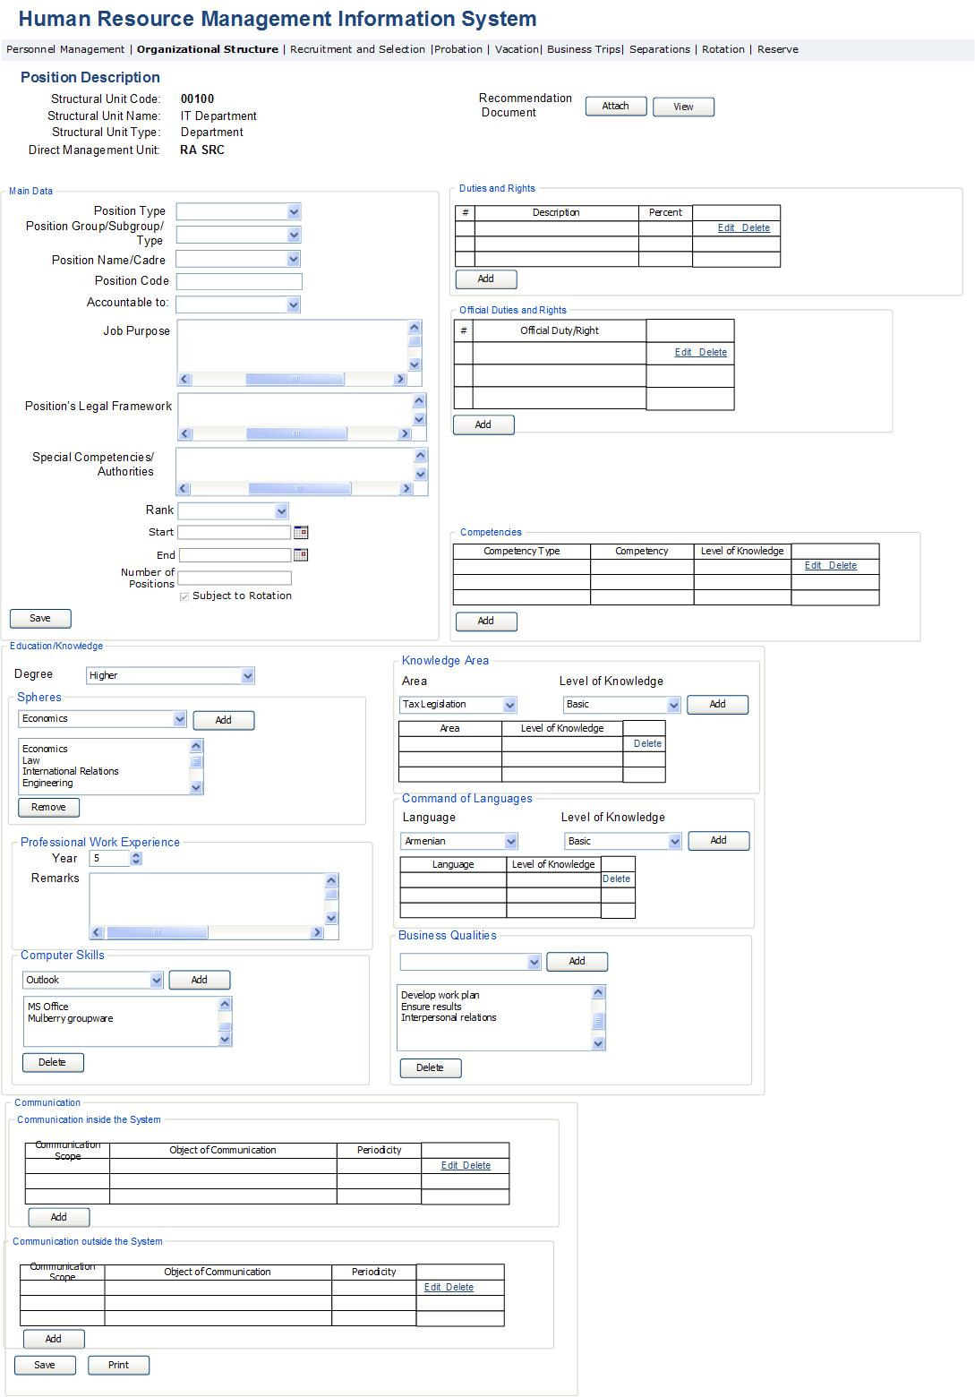

Table 27. Position creation/view/edition
Field |  | Type | Attributes |  |  |  | Initial value |  | Description
Main data block
Direct management unit | Label |  |  |  |  |  |  | Field displays the name of the direct management unit of the structural unit for such position.
Type of structural unit | Label |  |  |  |  |  |  | Field displays the structural unit type of the particular position. Potential values are:  - All  - Headquarters  - Territorial body  - Territorial Tax Inspectorate  - Taxpayer Service Center  - Department  - Division  - Customs point  - Customs House
Name of structural unit | Label |  |  |  |  |  |  | Field displays the structural unit name of the particular position.
Structural unit code | Label |  |  |  |  |  |  | Field displays the structural unit code of the position.
Position type | Drop Down |  |  |  |  |  |  |  | The type of the particular position is entered in the field. Potential values are:  - All  - Discretionary positions  - Tax service  - Customs service  - Civil service  - Civil service contract-based  - Contract-based  The links of the position types, groups and the positions are created through the form entered in Table 33 and Fig. 31.
Position group/subgroup/  type | Drop Down |  |  |  |  |  |  |  | The following are entered in the field: for Tax and Customs Service – the particular position group; for civil service – the subgroup; for contractual position - the type of contract-based position is displayed. Potential values are:  - All  - Top positions in Tax Service  - Chief positions in Tax Service  - Leading positions in Tax Service  - Junior positions in Tax Service  - Top positions in Customs Service  - Chief positions in Customs Service  - Leading positions in Customs Service  - Junior positions in Customs Service  - Civil service subgroups  - Types of contract-based employees  - Groups of discretionary positions
Position | Drop Down |  |  |  |  |  |  |  | The position name is entered in the field. While selecting the position name, the official duties for such position from the directories and the position legal framework fields should be automatically filled. Where position with the same name is available in the direct management unit of the structural unit, the data of the position passport in the same direct management unit created in the past with the same name are to be filled in the fields for the purpose of facilitating the entry of the new position passport. The button is accessible only to the PMD employees.
Position code | Text Box |  |  |  |  |  |  |  | Field displays the position code with the following structure:  [sequential number of Tax/Customs Service]- [sequential number of department] - [sequential number of division] - [sequential number in the division staff list]
Superior position | Drop Down |  |  |  |  |  |  |  | The name of the position deemed to be superior to the particular position is entered in the field.
Position activation date | Calendar Box |  |  |  |  |  |  |  | The date of the position creation is entered in the field.
Position inactivation date | Calendar Box |  |  |  |  |  |  |  | The date of the position inactivation is entered in the field.
Number of positions | Text box |  |  |  |  |  |  |  | The number of the particular position for the particular unit is entered in the field. In case if more than one position is created, the code of each next position is filled by a sequential number. See the description in “Position Code” field.
Subject to rotation | Check box |  |  |  |  |  |  |  | Once the field is checked, the position in question is checked as being subject to rotation. Once checked, the system exercises control whether or not the checked position is among the list of positions subject to rotation. Where 10 days are left until the expiration of the two-year period of appointment of a person to the position subject to rotation, he/she shall be displayed as an employee subject to rotation in the “Rotation Management” form under “Internal Transfers” module.
Rank | Drop Down |  |  |  |  |  |  |  | The maximum rank for the given position is entered in the field.
Purpose of job | Text box; multi-line |  |  |  |  |  |  |  | Free text box envisaged for entry of the job purpose.
Legal framework of position | Text box; multi-line |  |  |  |  |  |  |  | Free text box presenting the references to all legal acts related to the particular position.
Special competences | Text box; multi-line |  |  |  |  |  |  |  | Free text box, where special competencies are entered.
Recommendation document | Label |  |  |  |  |  |  |  | Field displays the recommendation document envisaged for creation of the particular position.
Attach | Button |  |  |  |  |  |  |  | Clicking on the button, the attachment page of the recommendation document for creation of the particular position opens in pdf format.
View | Button |  |  |  |  |  |  |  | Clicking on the button, page opens to view the recommendation document for creation of the particular position in pdf format.
Print | Button |  |  |  |  |  |  |  | Clicking on the button, the passport of the checked position is exported in doc format.
Save | Button |  |  |  |  |  |  |  | Clicking on the button, the changes made on this page are saved in the system. As per the inactivation date of the entered positions, the position status becomes “Active” or “Inactive. The form is closed and a newly created or modified position is displayed in the form described in Table 25.
Duty and right data block
Duty and right table
Description | Column |  |  |  |  |  |  |  | Field displays the description of duty.
Percent | Column |  |  |  |  |  |  |  | Field displays the percent value of the particular duty. The total of all duties should be 100%.
Add | Button |  |  |  |  |  |  |  | Clicking on the button, the window to edit the particular data block opens in add row mode (Table 27). The button is accessible only to the PMD employees.
Edit | Button |  |  |  |  |  |  |  | Clicking on the button, the window to edit the data block opens (Table 27). The button is accessible only to the PMD employees.
Delete | Button |  |  |  |  |  |  |  | Opens the inquiry window to receive authorization for deleting the checked row. If a positive answer is given to the inquiry, the row containing the checked duty is deleted. The button is accessible only to the PMD employees.
Official duties and rights data block
Official duties and rights table
# | Column |  |  |  |  |  |  |  | Displays the row number in the table.
Description | Column |  |  |  |  |  |  |  | Displays the description of official duty or the right.
Add | Button |  |  |  |  |  |  |  | Clicking on the button, window to edit the checked row in the particular table opens in add row mode (Table 28). The button is accessible only to the PMD employees.
Edit | Button |  |  |  |  |  |  |  | Clicking on the button, window to edit the checked row of the particular table opens (Table 28).  The button is accessible only to the PMD employees.
Delete | Button |  |  |  |  |  |  |  | Opens the inquiry window to receive authorization for deleting the checked row in the table. If a positive answer is given to the inquiry, the checked row is deleted. The button is accessible only to the PMD employees.
Communications data block
Table for communications inside the system
Communication scope | Column |  |  |  |  |  |  |  | Field displays the communication scopes. Potential values are:  - Inside the division and with direct supervisor  - With specialists and supervisors of another division
Object of the communication | Column |  |  |  |  |  |  |  | Field displays the description of given communication scope
Periodicity | Column |  |  |  |  |  | By request |  | Field displays the periodicity of the given communication scope. Potential values are:  - As applicable  - As per inquiry  - Daily  - Weekly  - Monthly  - Quarterly  - Triennially  - Biannually  - Annually
Add | Button |  |  |  |  |  |  |  | By clicking on the button, the window to edit the checked row in the given table opens in add row mode (Table 30). The button is accessible only to the PMD employees.
Edit | Button |  |  |  |  |  |  |  | Clicking on the button the window to edit the checked row in the particular table opens (Table 30).  The button is accessible only to the PMD employees.
Delete | Button |  |  |  |  |  |  |  | Opens the inquiry window to receive authorization for deleting the checked row. If a positive answer is given to the inquiry, the checked row is deleted. The button is accessible only to the PMD employees.
Table for communications beyond the system
Communication scope | Column |  |  |  |  |  |  |  | Field displays the communication scopes.
Object of the communication | Column |  |  |  |  |  |  |  | Field displays the description of given communication scope
Periodicity | Column |  |  |  |  |  | By request |  | Field displays the periodicity of the given communication scope. Potential values are:  - As applicable  - As per inquiry  - Daily  - Weekly  - Monthly  - Quarterly  - Triennially  - Biannually  - Annually
Add | Button |  |  |  |  |  |  |  | By clicking on the button, the window to edit the checked row in the given table opens in add row mode (Table 30). The button is accessible only to the PMD employees.
Edit | Button |  |  |  |  |  |  |  | Clicking on the button, the window to edit the checked row of the particular table opens (Table 30).  The button is accessible only to the PMD employees.
Delete | Button |  |  |  |  |  |  |  | Opens the inquiry window to receive authorization for deleting the checked row in the table. If a positive answer is given to the inquiry, the row containing the checked row is deleted. The button is accessible only to the PMD employees.
Competences data block
Type of competence | Column |  |  |  |  |  |  |  | Presents the type of competence. Potential values are:  - Knowledge  - Skill  - Capacity
Competence | Column |  |  |  |  |  |  |  | Filed displays the competence. Potential values are:  - Motivational assistance  - Team work  - Employees motivation  - Change management  - Efficiency management  - Paying attention to communication  - Oral speech  - Capacity to persuade own opinion  - Flexibility
Level of knowledge | Column |  |  |  |  |  |  |  | Presents the level of the competence knowledge in the row checked in table. Potential values are:  - Level 1  - Level 2  - Level 3  - Level 4  - Level 5  - Level 6
Add | Button |  |  |  |  |  |  |  | By clicking on the button, the window to edit the checked row in the given table opens in add row mode (Table 29). The button is accessible only to the PMD employees.
Edit | Button |  |  |  |  |  |  |  | Clicking on the button, the window to edit the row checked in the particular table opens (Table 29).  The button is accessible only to the PMD employees.
Delete | Button |  |  |  |  |  |  |  | Opens the inquiry window to receive authorization for deleting the checked row in the table. If a positive answer is given to the inquiry, the row containing the checked row is deleted. The button is accessible only to the PMD employees.
Education/Knowledge data block
Education subgroup
Level | Drop Down |  |  | Disabled |  |  |  |  | Field displays the level of education required to hold a particular position. Potential values are:  - Secondary  - Secondary vocational  - Higher
Edit | Button |  |  |  |  |  |  |  | By clicking on the button, the window to change the education level opens.
Sectors | List Box |  |  | Disabled |  |  |  |  | Presents such education sectors that are required for holding the particular position.
Add | Button |  |  |  |  |  |  |  | By clicking on the button, window to add a new row in the sectors list opens.
Remove | Button |  |  |  |  |  |  |  | Opens the inquiry window to receive authorization for removing the checked row in the sectors list. If a positive answer is given to the inquiry, the checked row is removed.
Professional work experience subgroup
Year | Text Box |  |  | Mandatory |  |  |  |  | Required work experience is entered in the field in digital form.
Remarks | Text box; multi-line |  |  |  |  |  |  |  | Additional conditions required for the work experience are entered in the field.
Computer skills subgroup
Computer skills | Drop Down |  |  |  |  |  |  |  | Field displays the list of software.  Potential values are: ՝  - MS Windows  - MS Office  - Mulberry  - Taxpayer  - Other
Computer skills | List Box |  |  |  |  |  |  |  | Field displays the list of knowledge of required software packages.
Add | Button |  |  |  |  |  |  |  | By clicking on the button, the checked row in “Computer skills” drop down is added in the computer skills list. The button is accessible only to the PMD employees.
Delete | Button |  |  |  |  |  |  |  | Opens the inquiry window to receive authorization for deleting the row checked in computer skills list. If a positive answer is given to the inquiry, the checked row is deleted. The button is accessible only to the PMD employees.
Knowledge area subgroup
Area | Drop Down |  |  |  |  |  |  |  | Field displays the list of knowledge area:  - Tax legislation  - Customs legislation  - Labour legislation  - Staff management
Level | Drop Down |  |  |  |  |  |  |  | Field displays the levels of knowledge:  - Basic  - Medium  - Advanced
Add | Button |  |  |  |  |  |  |  | By clicking on the button, the rows checked in “Knowledge area” and “Level of knowledge “drop down are added in the table. The button is accessible only to the PMD employees.
Delete | Button |  |  |  |  |  |  |  | Opens the inquiry window to receive authorization for deleting the checked row in the knowledge area list. If a positive answer is given to the inquiry, the checked row is deleted. The button is accessible only to the PMD employees.
Command of language subgroup
Language | Drop Down |  |  |  |  |  |  |  | Field displays the list of languages. Potential values are:  - Armenian  - Russian  - English
Level of knowledge | Drop Down |  |  |  |  |  |  |  | Field displays the list of languages. Potential values are:  - Basic  - Medium  - Advanced
Add | Button |  |  |  |  |  |  |  | By clicking on the button, rows checked in “Language” and “Level of Knowledge” dropdowns are added in the table. The button is accessible only to the PMD employees.
Delete | Button |  |  |  |  |  |  |  | Opens the inquiry window to receive authorization for deleting the row checked in the list for the command of languages. If a positive answer is given to the inquiry, the checked row is deleted. The button is accessible only to the PMD employees.
Business qualities subgroup
Standards of business qualities | Drop Down |  |  |  |  |  |  |  | Field displays the standards of the required business qualities: Potential values are:  - Team work  - Communication  - Interpersonal relations  - Mentality
Standards of business qualities | List Box |  |  |  |  |  |  |  | Field displays the standards of the required business qualities. Potential values are:  - Team work  - Communication  - Interpersonal relations  - Mentality
Add | Button |  |  |  |  |  |  |  | By clicking on the button, the row checked in dropdown for the standards of business qualities is added in the list of business qualities. The button is accessible only to the PMD employees.
Delete | Button |  |  |  |  |  |  |  | Opens the inquiry window to receive authorization for deleting the checked row in the business quality standards list. If a positive answer is given to the inquiry, the checked row is deleted. The button is accessible only to the PMD employees.

Fig. 30. Position passport data modification

Table 28. Editing/adding page for the data on duties and rights
Field | Type | Attributes | Initial value | Description
Duties and rights data block
# | Text box | Disabled |  | Displays the sequential number of checked row in the table.
Description | Text box; multi-line |  |  | Description of duties
Percent | Text box |  |  | Presents percentage value of the given duties. The sum of all duties should total 100%.
Save | Button |  |  | By clicking on the button, modifications made in this data block are saved. The form is closed, and the modifications are displayed in “Duties and Rights” data block of the form described in Table 26.

Table 29. Edit/add official duties
Field | Type | Attributes | Initial value | Description
Official duties editing page
# | Text box | Read Only |  | Presents the row number in the table.
Description | Text box; multi-line |  |  | Presents the description of official duty or right.
Save | Button |  |  | By clicking on the button, modifications made in the given data block are saved in data bank. The form is closed, and the modifications are displayed in “Official duties and Rights” data block of the form described in Table 26.

Table 30. Competency data editing/adding
Field | Type | Attributes |  | Initial value | Description
Competences data block
Type of competence | Drop Down |  |  |  | Presents the type of competence. Potential values are:  - Knowledge  - Skill  - Capacity
Competence | Drop Down |  |  |  | Presents the competence. Potential values are:  - Motivational assistance  - Team work  - Employee motivation  - Change management  - Efficiency management  - Paying attention to communication  - Oral speech  - Capacity to persuade own opinion  - Flexibility
Level of knowledge | Drop Down |  |  |  | Presents the level of knowledge of the competence in the checked row in table. Potential values are:  - Level 1  - Level 2  - Level 3  - Level 4  - Level 5  - Level 6
Save | Button |  |  |  | By clicking on the button, modifications made in the given data block are saved in data bank. The form is closed, and the modifications are displayed in “Competences” data block of the form described in Table 26.

Table 31. Editing/adding of data on communication inside/outside the organization
Field | Type | Attributes | Initial value |  | Description
Editing page for communications inside the system
Outside the system | Radio Button | Disabled |  | Communication scopes outside the system are entered. Field is checked when performing actions in regard to communications outside the system in Table 5.
Inside the system | Radio Button | Disabled |  | Communication scopes within the system are entered. Field is checked when performing actions in regard to communications inside the system in Table 26.
Communication scope | Drop Down |  |  | Communication scopes are entered. Potential values inside the system are:  - Inside the division and with the direct supervisor  - With specialists and supervisors of another division.
Object of communication | Text box; multi-line |  |  | Description of the given communication scope is entered.
Periodicity | Drop Down |  | By request | Periodicity of the given communication scope is entered. Potential values are:  - As applicable  - As per inquiry  - Daily  - Weekly  - Monthly  - Quarterly  - Triennially  - Biannually  - Annually
Save | Button |  |  | By clicking on the button, modifications made in the given data block are saved in data bank. The form is closed, and the modifications are displayed in “Communication scope” data block of the form described in Table 26.

Fig. 31. Selection of person to be appointed to a vacant position
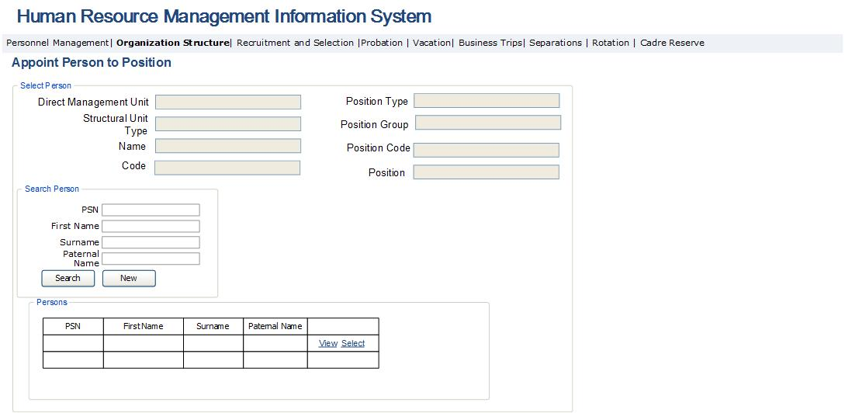

Table 32. Selection of person to be appointed to a vacant position
Field | Type |  | Attributes | Initial value |  | Description
Selection of person. Main data block
Direct management unit | Text box |  | Disabled |  | Field presents the name of the direct management unit of the structural unit for the selected vacant position.
Structural unit type | Text box |  | Disabled |  | Field presents the structural unit type of the selected vacant position.
Name | Text Box |  | Disabled |  | Field presents the name of structural unit of the selected vacant position.
Code | Text Box |  | Disabled |  | Field presents the code of structural unit of the selected vacant position.
Position type |  | Text Box | Disabled |  | Field displays the type of the selected vacant position.
Position group |  | Text Box | Disabled |  | Field displays the group of the selected vacant position, the subgroup in the event of civil service and the type in the event of contractual position.
Position name |  | Column |  |  | Field displays the name of selected vacant position.
Position code |  | Column |  |  | Field displays the code of selected vacant position.
People search block
PSN |  | Text box |  |  | Field Defines the PSN of the searched person.
First name |  | Text box |  |  | Field Defines the first name of the searched persons.
Surname |  | Text box |  |  | Field Defines the surname of the searched persons.
Paternal name |  | Text box |  |  | Field Defines the paternal name of the searched persons.
Search |  | Button |  |  | Clicking on the button, search is performed by the fields described above.
New |  | Button |  |  | By clicking on the button, all search fields are brought to their initial state.
Through people’s table
PSN |  | Text box |  |  | Field Defines the PSN of the searched persons.
First name |  | Text box |  |  | Field Defines the first name of the searched persons.
Surname |  | Text box |  |  | Field Defines the surname of the searched persons.
Paternal name |  | Text box |  |  | Field Defines the paternal name of the searched persons.
View |  | Button |  |  | By clicking on the button, the view page for the data of a particular person is displayed, which is described in Fig. 3 and Table 4 of the HRMIS Employee Data View module. By clicking on “Appoint to a position” button in that form, the form for appointing the checked person in the checked position opens, as described in Table 6 and Fig. 6 in “Module for appointing to a position” section.
Select |  | Button |  |  | By clicking on the button, the form for appointing the selected person to a selected position opens, which is described in Table 6 and Fig. 6 of “Module for appointing to a position” section.

Fig. 32. Links of the position types and groups and the positions
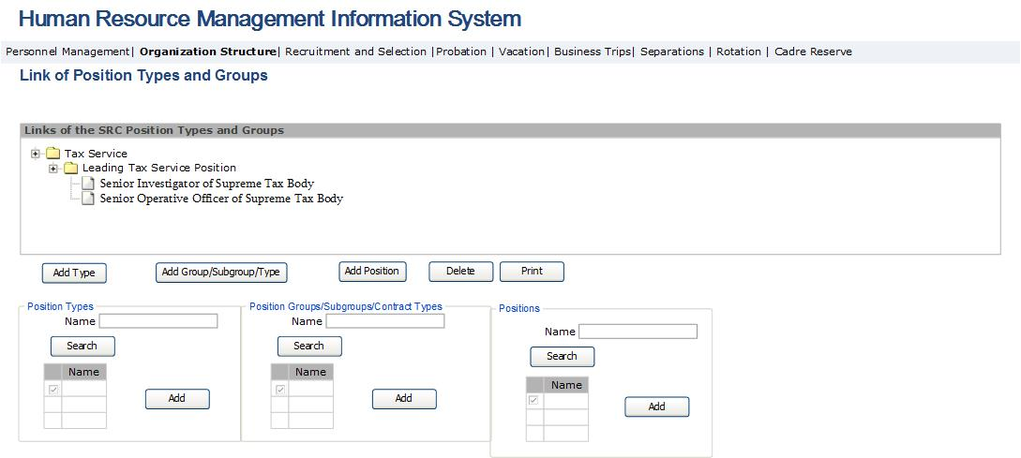

Table 33. Links of the position types and groups and the positions
Field | Type | Attributes | Initial value | Description
Links of the position types and groups
Links of the position types and groups | Tree View |  |  | Field displays the links of the types and groups of positions in the form of tree. The types, groups and position names are preliminarily entered in the system directory.
Add type | Button |  |  | By clicking on the button, the selection form for the position type opens. The button is active only when being located on the root level of tree.
Add group/subgroup/type | Button |  |  | By clicking on the button, the selection form of the position group opens, subgroup - in the event of civil service, and contract type - in the event of contract-based position. The button is active only when checking the type or group of any position, provided it is located on the first and second levels of tree.
Add position | Button |  |  | By clicking on the button, the selection form for the position name opens. The button is active only when checking any group or subgroup, provided it is located on the second and third levels of the tree.
Delete | Button |  |  | By clicking on the button, the checked node is removed from the tree once a positive answer is given to the question on removing.
Print | Button |  |  | By clicking on the button, the page for displaying the checked node and its sub nodes in the form of tree in pdf format opens.
Position types form
Search sector
Name | Text box |  |  | Defines the name of the position type.
Search | Button |  |  | When clicking on the button, search of the position type is performed by a selected criterion.
Table
Check box | Column |  |  | Field is envisaged for checking the row.
Name | Column |  |  | Displays the name list of position types from respective directory.
Add | Button |  |  | By clicking on the button, the checked rows in the table are added as sub nodes of the checked node in the tree.
Position groups/subgroups/contract types form
Search section
Name | Text box |  |  | Defines the name of the position group/subgroup
Search | Button |  |  | When clicking on the button, search of the position type is performed by a selected criterion.
Table
Check box | Column |  |  | Field is envisaged for checking the row.
Name | Column |  |  | Displays the list of position groups from respective directory.
Add | Button |  |  | By clicking on the button, the checked rows in the table are added as subnodes of the checked node in the tree.
Position form
Search section
Name | Text box |  |  | Defines the position name.
Search | Button |  |  | When clicking on the button, search of the position type is performed by selected criterion.
Table
Check box | Column |  |  | Field is envisaged for checking the row.
Name | Column |  |  | Displays the name list of positions from respective directory.
Add | Button |  |  | By clicking on the button, the rows checked in the table are added as subnodes of the checked node in the tree.

Vacation Management Module Implementation
This sub-module enables to create, view, edit and administer vacation applications and the schedule, as well as to create reports for the purpose of conducting analysis with such data. This sub-module constitutes a sub-module of the HRMIS and is accessible to the senior management and the PMD employees in terms of viewing vacation applications and schedule completed by all the SRC employees. Heads of units can approve, reject or send for review the vacation applications and schedules produced by the employees of their units. The PMD Head can approve, reject or send for review the vacation applications filed by all the SRC employees. The PMD officers can produce vacation decree for approved application and attach the decree signed by the Chairman of the SRC to the system. The main functionalities of the vacation management module are:
- Create an application on granting a vacation, for which the employee, by logging in the system and clicking on the “Vacation application” button in the vacation block of the employee data view module, fills application, signs and sends it for the approval by the head of unit.
- The system should enable the PMD officer to create a template of the decree on granting a vacation or returning from the vacation, in doc format, based on the data available in the application.
- The system should enable the employee or the PMD officer to make calculation of accrued vacation days and to exercise control of the granted vacation. In the event of registering vacation for incapacity, information about such employee must be sent to the separations management module provided the vacation exceeds a 4-month period throughout 1 year, and such employee should be displayed in the list of employees having a reason for being dismissed from job with “Overusing the days of disability” reason for separation.
- The system should enable to create the employee vacation schedule and conduct analysis thereon.
- Create reports for the purpose of analyzing the data available in the module. Examples of such reports are as follows:
- Annual vacation reports by various types of vacations;
- Vacation balances, by various structural units and management levels in the SRC;
- Reports on used vacation;
- Reports on unused vacations;
- Calculations of accrued vacation and granted vacation for each employee;
- Review of the vacation history;
- Compiling vacation plans on an annual basis and for other time periods.

- Send notifications throughout the vacation management process implementation. Where the application is approved, rejected or is sent for review by the head of unit, “Vacation application approved (rejected/sent for review)” message should be sent on the business email address of employee. In case the decree on granting a vacation signed by the Chairman is attached to the system, “Vacation granted” message should be sent on the business email address of the employee. In case if 3 days are left till the end of the vacation, “Report back to work [the date of the end of vacation]” message should be sent on the personal email address of the employee. In the event of sending the vacation application for the approval by the head of unit, “New vacation application” message should be sent on his/her email address.
Vacation management module is organized into three sub-modules as follows:
- Vacation application module, which is envisaged for producing vacation applications. The following vacation applications can be produced:
- Application on annual vacation;
- Application on pregnancy and maternity vacation;
- Application on vacation for temporary incapacity;
- Application on educational vacation;
- Application on unpaid vacation;
- Application on granting a vacation for the care for up to 3-year old child;
- Application on granting a vacation to fulfill State/social obligations;
- Application on return from vacation;
- Vacation administration module, where heads of units, the senior management and the PMD perform the administration of the filled vacation applications and the schedule.
- Vacation schedule creation module, where employees fill the vacation schedules.

3․5․1 Vacation Application Creation Module
Vacation administration module is envisaged for filling and approving applications on granting vacation and return from the vacation, as well as compiling, recording and registering vacation decrees. The process of filling the vacation application is contingent on the required vacation type.
The vacation application filling form is opened by clicking on “Vacation application” button in Vacation view section of the Labor Resource module. The types of vacations are as follows:
- Annual vacation. It is granted based on the completed application.
- Special vacation – for pregnancy and maternity. It is granted based on medical certificate for temporary incapacity.
- Special vacation: care for up to 3 year old child. It is granted based on an application.
- Special vacation: educational. It is granted based on a recommendation document filed by respective educational institution.
- Special vacation. Granted to fulfill State or social obligations. It is granted based on a notification received from respective organization.
- Special vacation – unpaid. It is granted based on application.
- Sick leave and temporary incapacity vacation. It is granted based on the medical certificate for temporary incapacity.
In addition, application on return from vacation is produced via this module that is performed by clicking on “Return from vacation” button in the Vacation view section of the Labor Resource module. This sub-module constitutes a sub-module of the HRMIS and is accessible to all the SRC employees. The SRC employees perform the processes of filling applications, as well as application data modifications when there is a need for review. The main functionalities of the Vacation Application Creation module are:
- Create application on granting a vacation, for which, by logging in the system and clicking on the “Vacation application” or “Return from vacation” button of the vacation block in the employee data view module, the employee fills the application, signs and sends it for approval by the head of unit. Once sent for approval, the option of making changes in the application data is disabled. Where the application is approved by the head of unit or the PMD, the option of creating the vacation decree is enabled. In case the application is sent for review by the head of unit, employee should be given an opportunity to make changes in the application data. In case of rejection, the process ends.
- While filling application, the system should make calculation of the accrued vacation days by the type of selected vacation, and where there are inconsistencies or mistakes in the number of filled days, it should display appropriate messages and request to change the application data.
- After opening the vacation application form, employee shall select the vacation type. The types can be as follows:
- Annual vacation
- Special vacation – pregnancy and maternity
- Special vacation – care for up to 3-year old child
- Special vacation – educational
- Special vacation – granted to fulfill State or social obligations;
- Special vacation - unpaid
- Sick leave and temporary incapacity vacation.

- In the event of selecting any vacation type, save for “pregnancy and maternity vacation” and “sick leave and temporary incapacity vacation”, the system checks the uninterrupted employment period for such employee, and should it be less than 6 months, “You are not eligible for applying for being granted the particular vacation” error message is displayed. Should that period be longer than 6 months, the system enables the application text boxes.
- Entering the number of vacation days in the appropriate field of application, the system should perform the following operations by the type of the selected vacation;
- when selecting “Annual vacation” type:
calculation of accrued annual vacation days is made by the following principle:
  - Define the following concepts:
A – the number of accrued annual vacation days
B – annual balance of vacation days
T₁ – the number of vacation days granted during the previous business year
T₂ – the number of vacation days granted during the first 6 months of the current business year
T – the number of vacation days granted during the current business year
H-the number of accrued vacation days
  - Define that A=24 days, of which 20 days are basic, and 4 – additional.
  - Calculate B = A - 4 – T1։
  - If vacation is granted during the first 6 months of the current business year, then H=24+(B-T2)
  - If vacation is granted during the last 6 months of the current business year, than
- If (B-T₂)>0, then H=24, and (B-T₂) value is saved in the computer as the number of unused annual vacation days .
- If (B-T₂) < 0, then H=24+(B-T)
  - If the number of entered days is bigger than the number of the accrued days, the system displays an error message reading “You are eligible for [the number of annual accrued vacation days] vacation days”.
- When selecting “Special vacation – pregnancy and maternity” type, the number of vacation days should be more than 69 days and less than 156 days.
- When selecting “Special vacation. Care for up to 3-year old child” type, the vacation days should not be checked.
- When selecting “Special vacation - educational” type, the vacation days should not be checked.
- When selecting “Special vacation – granted to fulfill State or social obligations” type, no check of the number of vacation days shall be performed.
- When selecting “Special vacation – unpaid” type, the system shall perform the following check:
- Regarding the husband of the woman who is on pregnancy and maternity vacation, as well as on vacation for the care for up to one-year-old child. The total duration of such vacation cannot exceed two months;
- Regarding disabled employee or employee sitting at bedside of a family member – within timeframes set by the medical report, which, nevertheless, shall not be more than 30 days per year;
- For marriage – three working days;
- In case of holding the funeral of deceased family member – not less than three days;
- Upon agreement between the SRC and the employees, the SRC employees can be granted an unpaid vacation throughout the duration of not more than thirty days per year.
- System deletes the number of entered vacation days and enables the field by providing an opportunity for employee to enter a new number.
- When selecting the sick leave and temporary incapacity vacation types, the system verifies as follows:
- If employee is a customs officer, the calculation of incapacity vacation days granted during the current year is made. Should the days of the incapacity vacation make up more than 120 consecutive days, or 140 days throughout the business year, the system should display “Overuse of the allowed days for incapacity” in “Separations management” module with the reason to be dismissed from the office.
- If employee is a tax officer, the calculation of incapacity vacation days granted during the current year is made. Should the days of the incapacity vacation make up more than 120 consecutive days, the system should display “Overuse of the allowed days for incapacity” in “Separations management” module with the reason to be dismissed from the office.
- When granting “Pregnancy and maternity” and “Care for up to 3 year old child” vacation, the employee status is change to “Temporarily passive” in the labor resource list module. The status of the position held by him/her is changed into “Temporarily vacant” status. An opportunity is created to appoint to such position a “Replacement” type employee for “Contract-based” type position. The status of the appointed employee becomes “Temporarily active”. In the event when employee comes back from “Pregnancy and maternity” and “Care for up to 3-year-old child” vacation, the status of her position is changed from “Temporarily vacant” status into “Active” status. In regard to the contract-based employee of “Replacement” type, being appointed to her position, the contract end date is entered, which is equal to the date of return of the employee holding such position. The status of the “Replacement” type employee is changed into “Inactive” status.
Vacation application creation module is comprised of the following forms:

Fig. 33. Application on granting vacation/return from vacation
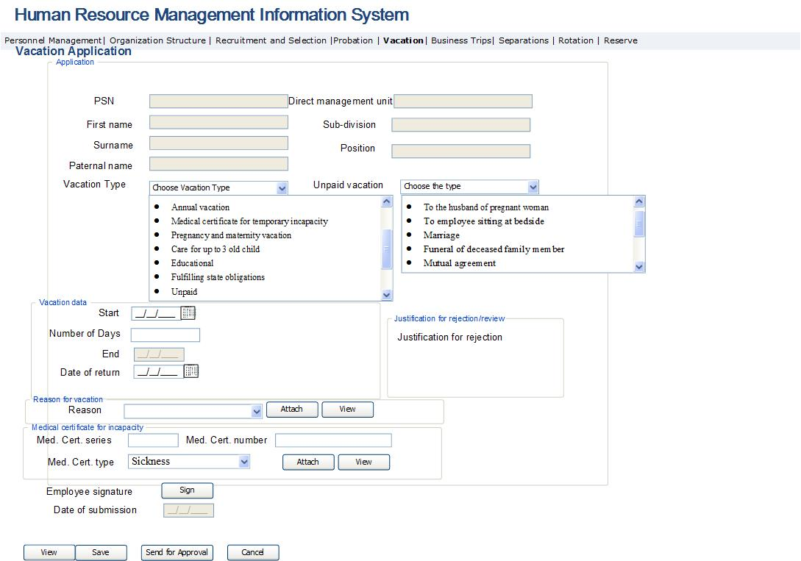

Fig. 34. Vacation application

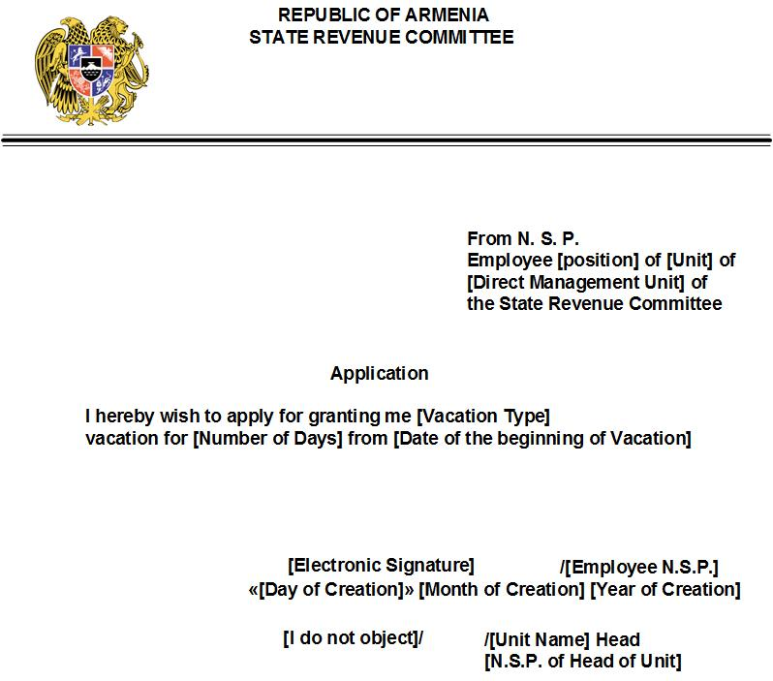

Fig. 35. Application on return from vacation
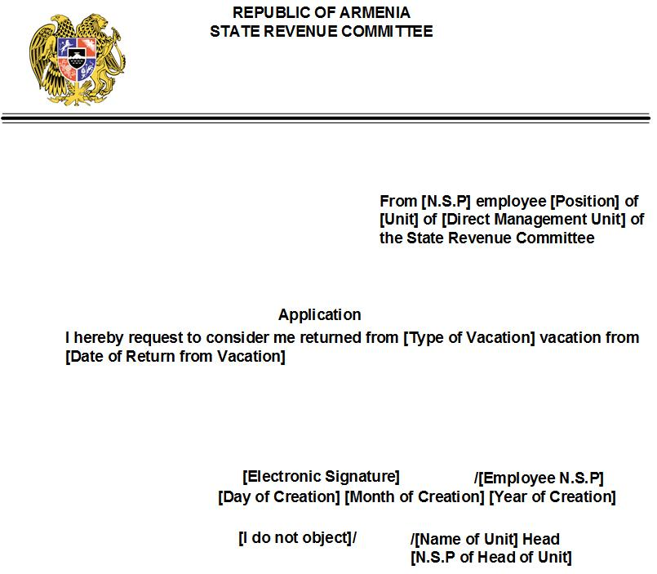

Table 34. Vacation application form
Field | Type | Attributes | Initial value | Description
Main data block
PSN | Text Box | Disabled |  | Displays employee’s PSN
Name of employee | Text Box | Disabled |  | Displays the first name of employee
Surname of employee | Text Box | Disabled |  | Displays the surname of employee
Paternal name of employee | Text Box | Disabled |  | Displays the paternal name of employee
Direct management unit | Text box | Disabled |  | Displays the direct management unit of the position held by employee
Unit | Text box | Disabled |  | Displays the unit of the position held by employee
Position | Text box | Disabled |  | Displays the position held by employee
Vacation type | Drop Down |  |  | Displays the vacation type list. Potential values are:  - Annual vacation  - Pregnancy and maternity vacation  - Vacation granted on the basis of incapacity certificate  - Care for up to 3-year-old child  - Educational  - For fulfilling State or social obligations  - Unpaid
Unpaid vacation type | Drop Down |  | Hidden | Displays the list of unpaid vacation types.  Field is displayed when selecting “Unpaid” vacation type from the previous point. Potential values are:  - To husband of the woman on maternity vacation  - Employee sitting at bedside  - Marriage  - Funeral of deceased family member  - On mutual consent
Employee signature | Label |  |  | Field displays the vacation application, in pdf format, filled by the electronic signature of the employee.
Sign | Button |  |  | By clicking on the button, the entry window for the employee’s electronic signature opens. The window is an application in pdf format, with an entry option for the employee electronic signature in the respective field. The report is presented in Fig. 32 and Fig. 33.
View | Button |  |  | Opens the view window for the application in pdf format in Fig. 32 and Fig. 33. Once the application is signed, the signed application is opened in pdf format after clicking on the button.
Send for approval | Button |  |  | By clicking on the button, the application is saved and sent for the approval by the head of unit of such employee. The application status becomes “Sent for approval”. The button is enabled only after the application is signed. After clicking on the button, the application fields become inactive, and there is no possibility to make any changes therein.
Save | Button |  |  | By clicking on the button, the application is saved in databank, but is not being sent for approval. Consequently, a new row is added in vacation application administration form as described in Table 34 and Fig. 34, and in “Vacation” block of the employee data view module.
Cancel | Button |  |  | By clicking on the button, the application is removed from the system. The button is enabled only for not signed application.
Vacation data block
Start | Calendar box | Required |  | The date of the Start of annual vacation is entered in the field.
End | Calendar box | Disabled |  | Calculation field. Displays the date of the end of the vacation based on the Start of the vacation and the number of vacation days.
Number of days | Text box | Required |  | The number of annual vacation days is entered in the field.
Date of submission | Calendar box | Disabled | Current Date | The date of clicking on “Sent for approval” button is automatically entered in the field.
Return date | Calendar box | Required |  | Field is displayed only upon availability of application on return from vacation. In this case, other fields of this block are not displayed. The data blocks for the reason for vacation and incapacity certificate are neither displayed.
Date of creation | Calendar box | Disabled | Current Date | The date of the document creation is automatically entered in the field.
Data block for the reason for vacation
Reason | Drop down |  |  | The reason for vacation is selected. Data block is displayed only for “Fulfill State or social obligations”, “Educational” and “Unpaid” vacations. The following values are possible: for vacation type – “Fulfill State or social obligations”  - exercising voting right;  - on the summon from investigation, preliminary investigation bodies, prosecutor and court;  - as a personnel representative to participate in court sessions;  - when performing duties of a donor;  - to perform conscription duties  - other  For educational vacation:  - to get prepared for and take current examinations  - to get prepared for and take pass-fail exams  - to perform laboratory works  - to get prepared and defend a graduation thesis  - to get prepared and take State (graduation) exam  For unpaid vacation:  - vacation granted to husband of the woman on pregnancy and maternity vacation or vacation for the care for up to 3 year old child;  - vacation granted to disabled employee or employee sitting at bedside;  - vacation granted for marriage;  - Vacation granted for the funeral of deceased family member.
Attach | Button |  |  | Opens the window to attach the document constituting the reason to the application in pdf format.
View | Button |  |  | Opens the window to view the document constituting the reason in pdf format.
Incapacity certificate data block. The data block is displayed only for vacation “Granted with medical certificate for incapacity” and “Pregnancy and maternity” vacation.
Certificate series and number | Text box | Required |  | The series and the numberof the medical certificate for incapacity are entered in the field.
Certificate type | Drop Down | Required |  | The type of the medical certificate for incapacity is entered in the field. Potential values are:  - Maternity (displayed only when selecting the pregnancy and maternity vacation. In this case, no other Potential values are displayed)  - Sickness (injury)  - Prosthesis  - Sanatorium therapy  - Sickness (injury) of a family member.
Attach | Button |  |  | By clicking on the button, the window to attach the medical certificate for incapacity in the form of file to the application is opened.
View | Button |  |  | By clicking on the button, the view window for the attached medical certificate for incapacity opens.
Rejection/Review justification data block
Rejection/review justification | Label |  |  | Field displays the justification for rejection/review in regard to the particular application.

3․5․2 Vacation Administration Module
Vacation administration module is envisaged for granting a vacation, approving applications on return from vacation and the vacation schedule, as well as compiling, recording and registering vacation decrees. Vacation application administration process is contingent on the required vacation type. In case of sick and incapacity vacations, no decree to grant vacation is produced, and the process is ended in the phase of approval or rejection of the application by the head of unit and the PMD based on the attached incapacity certificate. For other vacation types, the process is finalized, when the decree signed by the SRC Chairman is attached to the system.
This sub-module constitutes a sub-module of the HRMIS and is accessible to the senior management and the PMD department employees in terms of viewing all the SRC position data. Heads of units consider the applications produced by employees and perform the processes connected with their approval. The PMD department employees consider the approved applications and perform the processes of producing the decree and attaching the approved decree to the system. See below the main functionalities of the vacation administration module:
- System should enable the heads of units and the PMD officers to perform the operations of approving/rejecting/sending for review of application, and the PMD officers – to create the decree on granting vacation or return from vacation. Once the application is approved by the PMD, the option of creating vacation decree should be enabled. In case of rejection, the process is ended.
- System should enable the heads of units and the PMD officers to consider the vacation applications and the schedule filled by employees, and to conduct the required analysis.
Vacation administration module is comprised of the following forms.
Operations connected with applications are performed by the form presented in Table 35 and Figure 35. Here application and schedule management is performed by the head of unit and the PMD employee.
Fig. 36. Vacation application administration
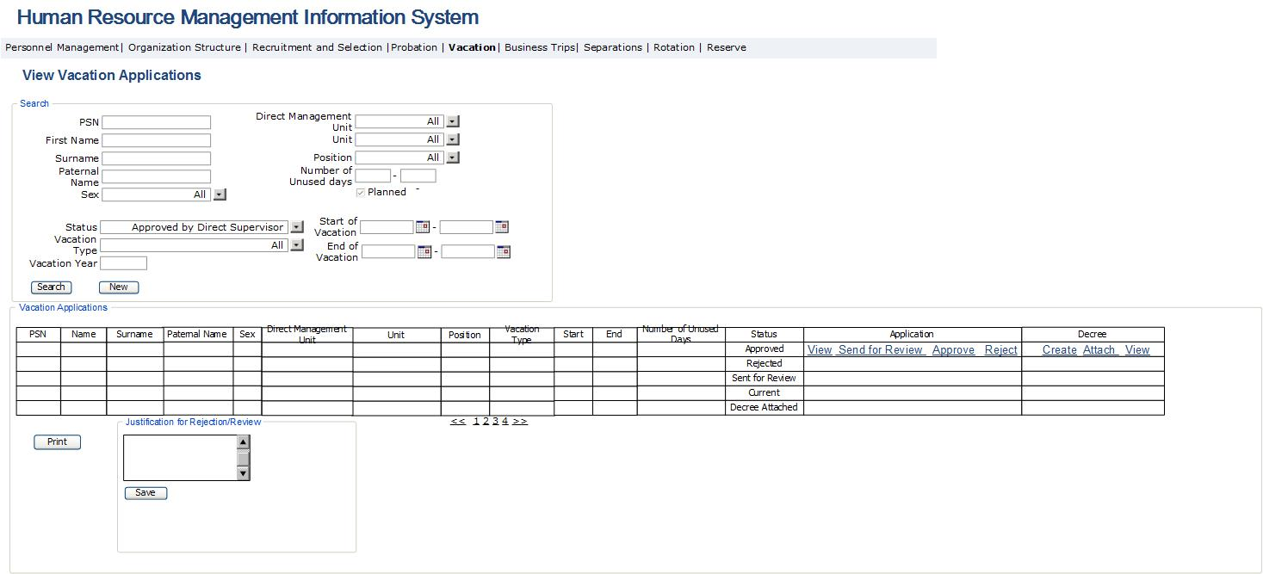
Fig. 37. Vacation decree report
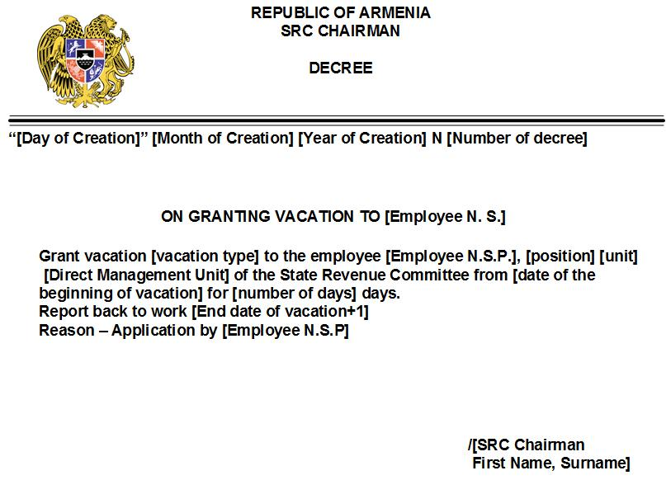

Fig. 38. Report of decree on return from vacation
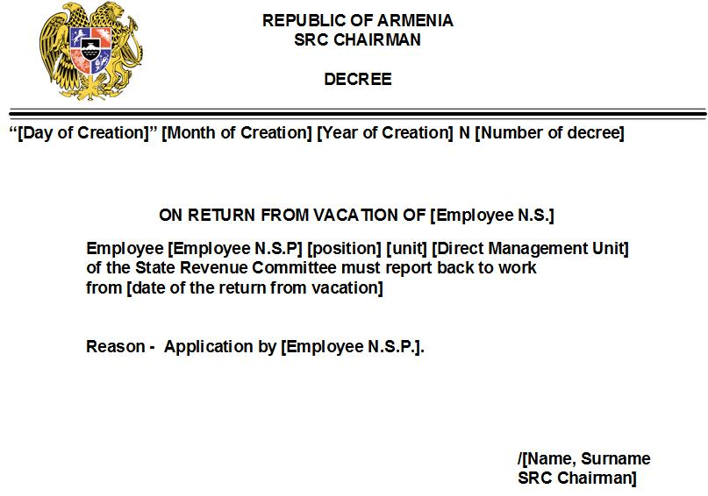

Table 35. Vacation application administration form
Field | Type | Attributes |  |  | Initial value | Description
Search sector
PSN | Text Box | Not mandatory |  |  | All | Defines the employee PSN
First Name | Text Box | Not mandatory |  |  | All | Defines the employee first name field
Surname | Text Box | Not mandatory |  |  | All | Defines the employee surname field
Paternal name | Text Box | Not mandatory |  |  | All | Defines the employee paternal name field
Sex | Dropdown | Not mandatory |  |  | All | Defines the employee sex. Contains the following values:  - All  - Male  - Female
Direct management unit | Dropdown | Not mandatory |  |  | All | Defines the list of such SRC units, which represent the direct management unit of the position held by the searched employee; it contains the name list and “All” value. As regard to the heads of units, only their subordinate units are displayed.
Unit | Dropdown | Not mandatory |  |  | All | Defines the list of the SRC units. It contains such name list and “All” value. As regard to the heads of units, only their subordinate units are displayed.
Position | Dropdown | Not mandatory |  |  | All | Defines the name list of employee positions. It contains the name list and “All” value.
Vacation type | Dropdown | Not mandatory |  |  | All | Defines the name list of vacation types; it contains the name list and “All” value. Potential values are:  - Annual  - Temporary incapacity  - Pregnancy and maternity vacation  - Educational  - Unpaid  - Care for up to 3-year-old child  - Fulfilling State or social obligations
Start of vacation | Calendar box | Not mandatory |  |  | Current date | Defines the date of the Start of vacation. For application on return from vacation, defines the date of return as stated in the application on return from vacation.
End of vacation | Calendar box | Not mandatory |  |  | Current date | Defines the date of the end of vacation.
Vacation year | Text box | Not mandatory |  |  | Current date | Defines the year of going on vacation.
Status | Drop Down | Not mandatory |  |  | All | Defines the status of vacation application. Potential values are:  - All  - New application  - Sent for approval  - Approved  - Rejected  - Sent for review  - Decree produced  - Decree approved  Newly created applications have “New application” status  Applications gains “Sent for approval” status when being sent by employee for approval  Applications approved by head of unit and the PMD Head have “Approved” status  Applications rejected by head of unit and the PMD Head have “Rejected” status  Applications sent by head of unit and the PMD Head for review have “Sent for review” status  Applications, regarding which vacation decree is produced by the PMD officer, have “Decree created” status  Decree approved by a PMD employee attached to applications has “Decree approved” status.
Number of unused days | Text box | Not mandatory |  |  | All | Field defines the number of vacation days unused by employee.
Planned | Check box | Not mandatory |  |  | All | Field defines the display of employee’s planned (entered through schedule) or actual vacation.
Find | Button |  |  |  |  | Perform search
New search | Button |  |  |  |  | Bring the search fields to initial values
Table
PSN | Column |  |  |  |  | Displays the employee’s PSN in the cadre management system
First name of employee | Column |  |  |  |  | Displays the first name of employee
Surname of employee | Column |  |  |  |  | Displays the surname of employee
Paternal name of employee | Column |  |  |  |  | Displays the paternal name of employee
Position | Column |  |  |  |  | Displays the position held by employee
Direct management unit | Column |  |  |  |  | Displays the direct management unit of the position held by employee
Unit | Column |  |  |  |  | Displays the unit of the position held by employee
Vacation type | Column |  |  |  |  |  | Field displays the vacation type. Potential values are: ՝  - Annual  - Temporary incapacity  - Pregnancy and maternity  - Educational  - Unpaid  - Care for up to 3-year-old child  - To perform State/social obligations
Start | Column |  |  |  |  |  | The Start of the vacation is displayed in the field.  In the event of availability of an application on return from vacation, sets the date as stated in the application on return from vacation
End | Column |  |  |  |  |  | The end of vacation is displayed in the field.  In the event of availability of an application on return from vacation, the field would be empty.
Number of unused vacation days | Column |  |  |  |  |  | Field displays the number of the unused remaining days as a consequence of taking such vacation by the particular employee.
Status | Column |  |  |  |  | Displays the status of the vacation application. Potential values are:  - All  - New application  - Sent for approval  - Approved  - Rejected  - Sent for review  - Decree produced  - Decree approved  Newly created applications have “New application” status  Applications gains “Sent for approval” status when being sent by employee for approval  Applications approved by head of unit and the PMD Head have “Approved” status  Applications rejected by head of unit and the PMD Head have “Rejected” status  Applications sent by head of unit and the PMD Head for review have “Sent for review” status  Applications, in regard to which vacation decree is produced by the PMD officer, have “Decree created” status  Decree approved by the PMD employee attached to applications has “Decree approved” status.
Application | Collumn |  |  |  |  | In the column, the application vacation and other documents attached thereto are displayed, as well as the processes of the application approval, rejection and sending for review are performed.
View | Button |  |  |  |  | By clicking on the button, at the top of the table on the same page, the filled and signed application in pdf format opens in the row checked by employees of the particular unit.
Send for review | Button |  |  |  |  | By clicking on the button, the checked application is sent for review. The button is accessible only to the PMD Head and head of unit. Once clicking on the button, the entry window for the reason for being sent for review opens. The status of the application becomes “Sent for review”. The option to make changes in the application fields is enabled for such employee. The reason for sending for review is displayed in an appropriate field of the vacation application form (Fig. 34 and Table 32). Employee is enabled to make changes in the application and once again sign and send the modified application for approval. The button is accessible only to the head of unit.
Approve | Button |  |  |  |  |  | By clicking on the button, the approval of application on granting a vacation or return from vacation by the head of unit and the PMD Head is given, being respectively stated with “I do not object” record in an appropriate field of the report, in pdf format (Fig. 33 and Fig. 34). After approval, the status of the application becomes “Approved”. The option of approval or rejection of the application by the PMD Head is enabled. Where the PMD Head approves the application, the option of creating the vacation decree is enabled. In regard to “Pregnancy and maternity” and “Temporary incapacity’ vacations, no decree is created. The button is accessible to the head of unit and the PMD Head.
Reject | Button |  |  |  |  | The button is accessible only to the head of unit and the Head of the PMD. By clicking on the button, the window to enter the reason for rejection opens. After finalizing and saving the entry, the application status becomes “Rejected”. The process is performed by the head of unit and the PMD Head. The button is accessible to the head of unit and the PMD Head. The reason for the entered rejection is displayed in the appropriate field of the vacation application module (Table 34 and Fig. 32).
Decree | Column |  |  |  |  | In regard to vacation application, the vacation decree is displayed, and attachment of the approved decree is executed in the column. As to the application on return from vacation, the column displays the decree on return from the vacation. The column is enabled in the event of approval of the application on vacation or return from vacation by the Head of PMD.
Create | Button |  |  |  |  | As regard to vacation application, the button is accessible only to PMD employee. The button is enabled once the application is approved by the PMD Head. By clicking on the button, the view page for the decree on granting the vacation opens in doc format. The form of the decree on granting vacation is presented in Fig. 37 and the form of the decree on return from vacation is presented in Fig. 38. The process of the decree approval is executed via Mulberry system.  In regard to the application on return from vacation, the button is accessible only to PMD employee. The button is enabled once the application is approved by the PMD Head. By clicking on the button, the view page for the decree on return from vacation opens in doc format. The button is accessible only to PMD employees.
Attach | Button |  |  |  |  | The button is enabled after creating the decree. By clicking on the button, the attachment window for the decree approved and signed by the SRC Chairman opens. If process is successfully finished, the status of application becomes “Decree approved”, and the view button for the decree in “Vacation” block of “Personal data” form in “Personnel Pool” module is enabled.  In regard to the application on return from vacation, the button is enabled after creating the decree. By clicking on the button, the attachment window for the decree approved and signed by the SRC Chairman opens. In case the process is successfully finished, the status of application becomes “Decree approved”. Once the decree is attached, in “Organization structure and positions management” module, the position gains “Active” status from “Temporarily vacant” status as of the date stated in the decree. The button is accessible only to PMD officer.
View | Button |  |  |  |  | The button is enabled once the process of attaching the decree, as stated in the previous point, is successfully finished. By clicking on the button, the view page for the decree signed by the SRC Chairman opens.
Print | Button |  |  |  |  | By clicking on the button, the rows displayed in the table are exported in the form of an Excel format file.
Sub window for entering the reason for rejection
Justification for rejection/review | Text box; multi line | Required |  |  |  | Field is displayed once clicking on the reject button. The reason for rejection is entered in the field. Once the reason for rejection is saved, it is displayed in “Justification for rejection/review” field in the application form (Fig. 34 and Table 32).
Save | Button |  |  |  |  | By clicking on the button, the reason for rejection is saved. Once the reason for rejection is saved, it is displayed in “Justification for rejection/review” field in the application form (Fig. 34 and Table 32).

3․5․3 Vacation Schedule Creation Module
The Vacation Schedule Creation Module is envisaged for completing the vacation schedule by the SRC staff. The completed schedule is displayed in the Vacation administration module form.
The form envisaged for completing the Vacation schedule opens in the vacation view section under the employee data view module by pressing the “Vacation planning” button. The types of planned vacations are as follows:
- Annual
- Maternity
- Child care for up to 3 years old children
- Learning
This is an HRMIS sub-module and is accessible for SRC employees, who perform data modification processes in case it is necessary to complete or review data of the schedule. The viewing and approval processes of the completed schedule are performed through vacation administration module. The main functionalities of this module are as follows.
- The system should enable the employee to create the vacation planning application, for which the employee should complete his/her application by entering the system and pressing the button of “Vacation planning” which is under the Vacation data block of Employee’s data review module. After saving the application, the possibility to make changes in the data of application will be disabled. If the application is sent back for reviewing after it has been viewed by the head of the sub-division, the employee should be able to make changes in the data of application. In case the application has been rejected, the process stops.
- When the application for vacation is completed, the system should count available days for the selected type of vacation and in case of discrepancies or if a wrong number of days have been entered in the application form, corresponding messages will appear to require modification of application data.
The vacation schedule module consists of the following forms:
The form for completion of Vacation Schedule is displayed when clicking the button “Vacation Planning” under the “Vacation” data block of the Employee’s data review module for planning new vacation, whereas for changing the planning data of the completed application for vacation, the form is displayed by pressing the button “Planning”.

Fig. 39. Entering vacation schedule
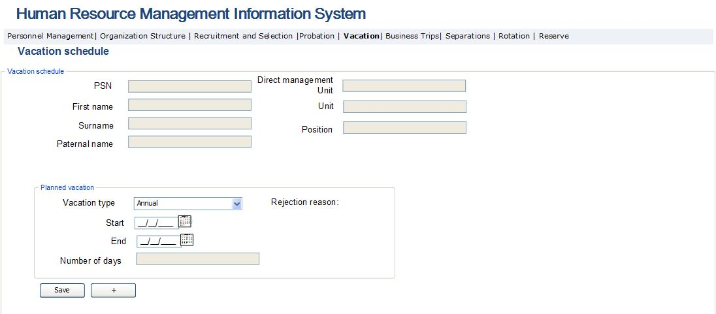

Table 36. Vacation schedule completion form
Field | Type | Attributes | Initial value |  | Description
Main data block
PSN | Text Box | Disabled |  | Displays employee’s PSN.
Name of employee | Text Box | Disabled |  |  | Displays employee’s name.
Surname of employee | Text Box | Disabled |  |  | Displays employee’s surname.
Paternal name of employee | Text Box | Disabled |  |  | Displays employee’s paternal name.
Direct management unit | Text box | Disabled |  |  | Displays direct management unit of employee’s position.
Sub-division | Text box | Disabled |  |  | Displays sub-division of employee’s position.
Position | Text box | Disabled |  |  | Displays employee’s position.
Vacation data block
Vacation type | Drop Down |  |  |  | The type of planned vacation is entered in the field:  Potential values:  - Annual  - Learning  - Maternity (if employee is female)  - Child care of up to 3 years old children (if employee is female)
Start | Calendar box |  |  |  | The start date of the planned vacation is entered in the field.
End | Calendar box |  |  |  | The end date of the planned vacation is entered in the field.
Number of days | Text box | Disabled |  |  | Calculation field. Displays the number of working days between the start and end of vacation.
Save | Button |  |  |  | By pressing the button, the changes made in the given field are saved in the database, and as a result, and a new row is added in the form of vacation applications administration described in Table 5 and Fig. 4 and in “Vacation” block of the form “Employee data” under the Module “Personnel pool”.
+ | Button |  |  |  | By pressing the button, the user is able to enter a newly planned vacation to be added in the vacation schedule.

Implementation of Business Trip Administration Module
This sub-module allows creating, viewing, editing and managing business trip requests, create the decree and certificate of a business trip and generate reports to make analyses of the data. This is a sub-module of HRMIS and is accessible to the management and staff of PMD to view the business trip requests completed by all SRC employees. The heads of units have the options to approve, reject or send the business trip request created by the staff of their units for revision. The PMD staff have the options to create business trip decree in case of the approval of the business trip request and attach the decree signed by the SRC Chairman in the system. Below are the main functionalities of the business trip management unit, which should be ensured by the system:
- The system should enable creating business trip request, for which, the employee entering the system and pressing the button “Business trip request” of Business trip block under the employees’ data view module, completes the report, signs and sends it to the approval of the head of Sub-division.
- The system must provide an option to the PMD staff to create the form of the business trip decree and report in doc format based on the data available in business trip request.
- The system must enable to create reports and make analyses on the available data.
- Send notifications during implementation of business trip management process. Upon signing of the request by the employee and sending it for approval, a notification reading “A business trip request is created for you” should be sent to the email address shown on the request form of the SRC employee. A notification reading “New business trip request” should be sent to the head of the sub-division of employee who has created the business trip request. After the approval or rejection of the head of sub-division, a notification reading “The business trip report has been approved/rejected” should be sent to the e-mail address of the SRC employee. In case of attaching the request initialed by the SRC Chairman to the system, a message reading “the business trip request has been initialed” is sent to official emails of SRC employees. When creating the business trip decree, approved by the SRC Chairman, a message reading “the business trip decree is attached” is sent to official emails of SRC employees. When PMD officer creates a business trip certificate for an employee, a message reading “business trip certificate is created” is sent to the official email of the employee.
The business trip administration module consists of two sub-modules, which are the following:
- Business trip requests and certificates creation module, where the SRC employees create business trip requests, and PMD officers create business trip certificates based on the data filled in the requests.
- Business trip administration module, where the heads of departments and divisions, PMD head and officers and SRC Chairman perform functions related to the administration of business trip requests, decrees and documents.

3․6․1 Business Trip Requests and Certificates
The business trip request and certificate creation module is envisaged for creation of business trip request by the employee, and business trip certificate by the PMD officer.
The form for completing those two documents opens when pressing the button “Business trip” or the button “Create” of the column “Business trip certificate”.
This is an HRMIS sub-module and is accessible to all SRC staff. SRC employees perform data modifications if necessary, fill in the business trip requests and review. Below are the main functionalities of the staff administration module.
- The system should enable the employee who completes the business trip request to view and add any SRC employee in the list of staff entitled to business trips. The staff included in the request have only a right to view the request. The right to make modifications is granted only to the employee who creates the request. After the approval by the head of the sub-division, it is exported from the system and sent for approval of the SRC Chairman or territorial authority head. Then, the request initialed by the PMD head is attached to the system, in a form described in business trips administration module.
- The PMD officer creates employee’s business trip certificate by this module. The certificate is created individually for each employee. When the certificate is saved, it is displayed in the column “certificate” of the Business trip table of Employee’s data view module.
The Business trip request and certificate creation module consist of the following forms:

Fig. 40. Business trip request, decree and certificate creation form
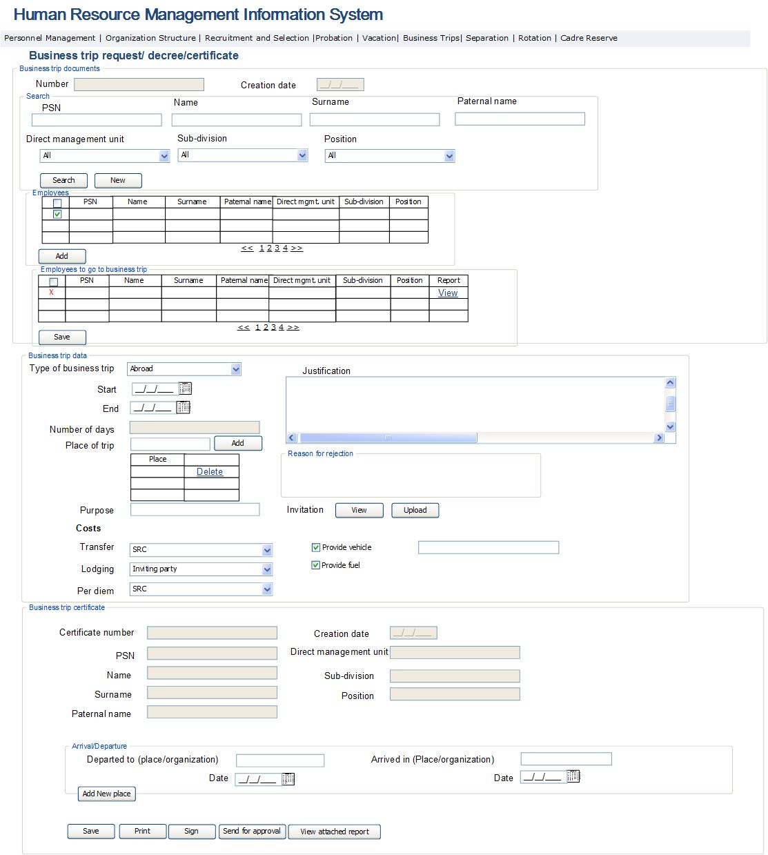

Fig. 41. Business trip request report
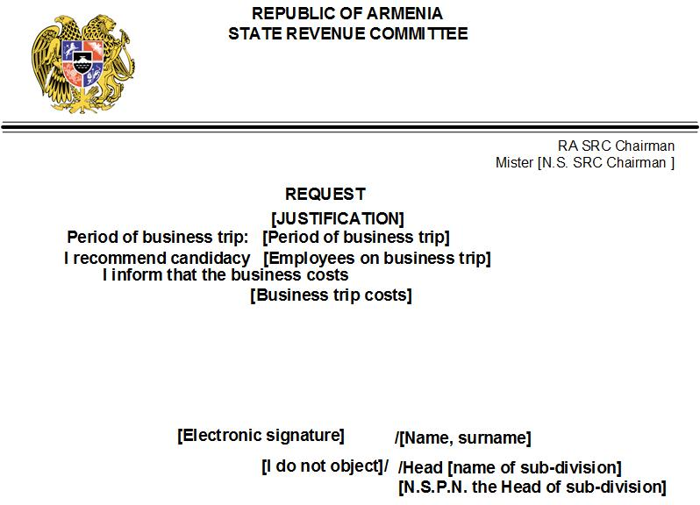

Fig. 42. Business trip certificate report
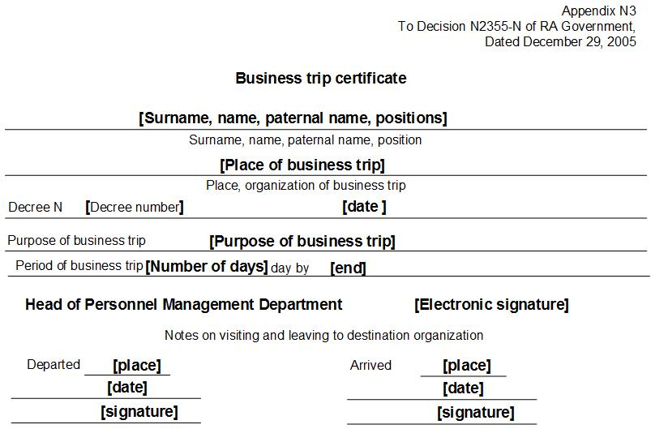

Table 37. Business trip request and certificate creation/view page
Field | Type | Attributes |  |  | Initial value |  | Description
Employee search section
PSN | Text Box | Not mandatory |  | All |  | Defines the PSN of employee.
Name | Text Box | Not mandatory |  | All |  | Defines the field of employee’s name.
Surname | Text Box | Not mandatory |  | All |  | Defines the field of employee’s surname.
Paternal name of employee | Text Box | Not mandatory |  | All |  | Defines the field of employee’s paternal name.
Direct management unit | Column |  |  | All |  | Defines the field of employee’s direct management unit.
Sub-division | Dropdown | Not mandatory |  | All |  | Defines the initial list of SRC sub-divisions. Contains the list of the units and the value “All”.
Position | Dropdown | Not mandatory |  | All |  | Defines the positions of employees, contains the list of positions and the value “All”.
Search | Button |  |  |  |  | Performs search.
New | Button |  |  |  |  | Converts the search field into initial values.
Employees’ Table
Check box | Column |  |  |  |  | The field is envisaged to select the line.
PSN | Column |  |  |  |  | Displays the PSN within the employee’s personnel management system.
Name of employee | Column |  |  |  |  | Displays employee’s name.
Surname of employee | Column |  |  |  |  | Displays employee’s surname.
Paternal name of employee | Column |  |  |  |  | Displays employee’s paternal name.
Direct management unit | Column |  |  |  |  | Displays direct management unit of employee’s position.
Sub-division | Column |  |  |  |  | Displays sub-division of employee’s position.
Position | Column |  |  |  |  | Displays employee’s position.
Add | Button |  |  |  |  |  | By pressing the button the employee included in the table is added in the below table of employees entitled to business trip.
Table of employees entitled to business trip
Check box | Column |  |  |  |  | This field is envisaged to delete the mentioned line from the list.
PSN | Column |  |  |  |  | Displays employee’s PSN within the personnel management system.
Name of employee | Column |  |  |  |  | Displays employee’s name.
Surname of employee | Column |  |  |  |  | Displays employee’s surname.
Paternal name of employee | Column |  |  |  |  | Displays employee’s paternal name.
Direct management unit | Column |  |  |  |  | Displays direct management unit of employee’s position.
Sub-division | Column |  |  |  |  | Displays sub-division of employee’s position.
Position | Column |  |  |  |  | Displays employee’s position.
Business trip certificate | Column |  |  |  |  | Displays employee’s position.
View | Column |  |  |  |  | The button activates once the business trip decree has been attached. By pressing the button, the data block of “business trip report” is displayed. The number of rows of the data block is equal to the number of destinations shown in the “Business trip destinations” table. The rows entered in “Business destination” table are displayed in the field “Departed” of the data block “Business trip report”.  In that case, the data block of business trip reports is displayed. Other fields are not displayed.
Save | Button |  |  |  |  |  | Saves the list of employees selected for the request
Data block of business trip documents
Number | Text Box | Disabled |  |  |  | Displays the subsequent number of the request or decree
Creation date | Calendar box | Disabled |  |  | Current Date |  | The document creation date is automatically displayed in the field
Business trip data block
Reason of rejection | Label |  |  |  |  | The reason for rejection is displayed when the head of the sub-division rejects the request
Type of business trip | Dropdown |  |  |  |  | The type of the business trip is entered here. Potential values:  - Direct management unit  - Within the country  - Outside the country
Start | Calendar box | Required |  |  |  |  | The start date of the business trips is entered in the filed
End | Calendar box | Required |  |  |  |  | The end date of the business trip is entered in the field
Number of days | Text box | Disabled |  |  |  |  | The number of business trip days is automatically calculated and displayed in the field
Justification | Text box; Multiline |  |  |  |  |  | The justification of the business trip is entered in the field
Purpose of the business trip | Text box |  |  |  |  |  | The purpose of the business trip is entered in the field
Expenditures of the business trip, transportation | Drop down; |  |  |  |  |  | The party covering the expenses of the business trip is entered in the field. Potential values are:  - State Revenue Committee  - Inviting Party
Business expenditures, accommodation | Drop down; |  |  |  |  |  | The party covering accommodation expenditures is entered here. Potential values are:  - State Revenue Committee  - Inviting Party
Business trip expenditures, per diem | Drop down; |  |  |  |  |  | The party covering perdiem shall be entered here. Potential values are։  - State Revenue Committee  - Inviting Party
Invitation, View | Button |  |  |  |  |  | By pressing the button, the invitation of the given business trip is opened in pdf format.
Invitation, upload | Button |  |  |  |  |  | By pressing the button, the page for uploading the given business trip invitation in pdf is opened.
Provision of a car | Check box |  |  |  |  |  | The permission to provide a car during the business trip is entered in the field. The field is not active in case of a business trip to a foreign country.
Provision of a car | Text box |  |  |  |  |  | The data of the car provided during the business trip is entered in the field. The field is activated when marking the previous field. The field is not active in case of out of country business trip.
Provide fuel | Text box |  |  |  |  |  | The data on the permission of providing fuel during the business trip is entered in the field. The field is activated when marking the previous field. The field is not active in case of out of country business trip.
Save | Button |  |  |  |  |  | By pressing the button, changes made in the relevant form are saved. In case of saving the request, it adds to the block “Business trips” of the “Personal data” form of “Personnel Resources” module and in the form described in Table 3 and Fig. 3 with a status “New request”. Only the employee who has created the request has a right to make changes in the report. When the certificate is saved for all employees, the status of the business trip converts to “Certificate is created”. After the completion of actions, the window is closed.
Print | Button |  |  |  |  | By pressing the button the view page of request, decree or certificate opens in doc format. In case of the signed report, the page of viewing the request signed electronically opens by pressing the print button. The forms of request are shown in Figures 2, 4 and 5.
Sign | Button |  |  |  |  | The button is displayed and active only when viewing the request. By pressing the button, the signature of the employee who has created the request is inserted in the proper place.
Send for approval | Button |  |  |  |  | By pressing the button, the request created by the employee is sent for approval. The status of the request converts to “Sent for approval” and the request becomes available in the form described in Table 3. When the business trip has a duration of up to 10 days, and its destination is not to the direct management unit, it’s approval is done by the head of the Territorial authority or the head of the SRC. In other cases, the approval is done by the head of the sub-division and the head of the direct management unit. When sending the request to the approval the options to make any changes in the request become blocked. The window closes after completion of actions.
View the attached report | Button |  |  |  |  | The button is activated by the PMD after attachment of the initialed request, which is implemented through Business trips administration module.
Business trip destination data block
Business trip destination | Text box |  |  |  |  |  | The destination of the business trip is entered here
Add | Button |  |  |  |  |  | By pressing the button the destination entered in the previous field is displayed in the below inserted table
Business trip destination table
Business trip destination | Column |  |  |  |  |  | The field displays the business trip destinations
Delete | Button |  |  |  |  |  | By pressing the button the business trip destination filled in the given row is deleted from the list
Business trip certificate data block. The data block is displayed in the table for Employees on Business trip when pressing the button “View”. The display of other data blocks is stopped.
PSN | Text box | Disabled |  |  |  | Displays employee’s PSN.
First name of employee | Text box | Disabled |  |  |  | Displays employee’s first name.
Surname of employee | Text box | Disabled |  |  |  | Displays employee’s surname.
Paternal name of employee | Text box | Disabled |  |  |  | Displays employee’s paternal name.
Creation date | Calendar box | Disabled |  |  |  | The certificate creation date is automatically entered in the field.
Direct management unit | Column |  |  |  |  | Displays direct management unit of employee’s position.
Sub-division | Column |  |  |  |  | Displays sub-division of employee’s position.
Position | Column |  |  |  |  | Displays employee’s position.
Business trip certificate data block: Arrival/departure
Departure place/organization | Text box |  |  |  |  | The destination place is entered in the field. The contents of the field and the number of arriving/departing rows are displayed automatically and completed based on the destination places as completed in the request.
Date | Calendar box |  |  |  |  | The date of departing from the destination place is entered in the field
Arrival place | Text box |  |  |  |  | The arrival place or organization are entered in the field.
Date | Calendar box |  |  |  |  | The date of arrival to the destination of the given field is entered here.

3․6․2 Business Trip Administration Module
The business trip administration module is envisaged to implement the processes of approval of business trip requests created by the employee, creation of business trip decrees and certificates by the PMD.
This is an HRMIS sub-module and is accessible to the managerial staff, heads of sub-divisions and PMD. The managerial staff is entitled to view the business trip data of all employees. The PMD employees are entitled to view and create the business trip decree and certificate of all SRC employees. The heads of Sub-divisions are entitled to view, approve or reject the business trips of employees within their Sub-divisions. Below are the main functionalities of personnel administration:
- The system should enable implementation of activities of approval or rejection of business trip requests by the heads of sub-divisions. In case of approval, the function of exporting the business trip request from the system by the PMD and sending to the SRC Chairman or head of the territorial authority for approval, is activated. When attaching the approved request in the system, the option of creating a Business trip decree shall activate.
- The system should enable the PMD officer to create the business trip decree and once it is attached to the system, the business trip certificate should be created. When saving the business trip certificate, it should become accessible to the employee, in the column Certificate of the Business trips table of Employees data view module.
The business trip administration module consists of the following forms:

Fig. 43. Business trip administration
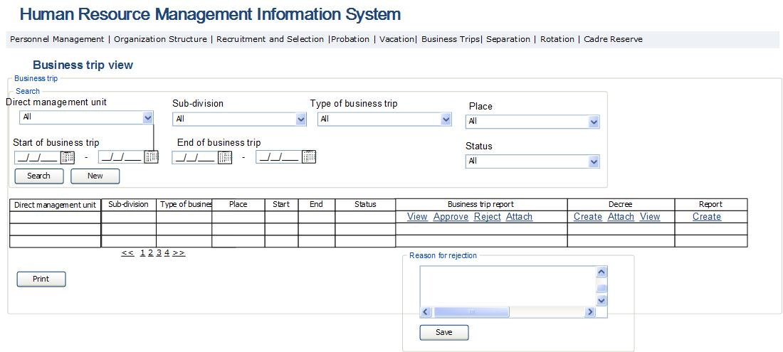

Fig. 44. Business trip decree report form
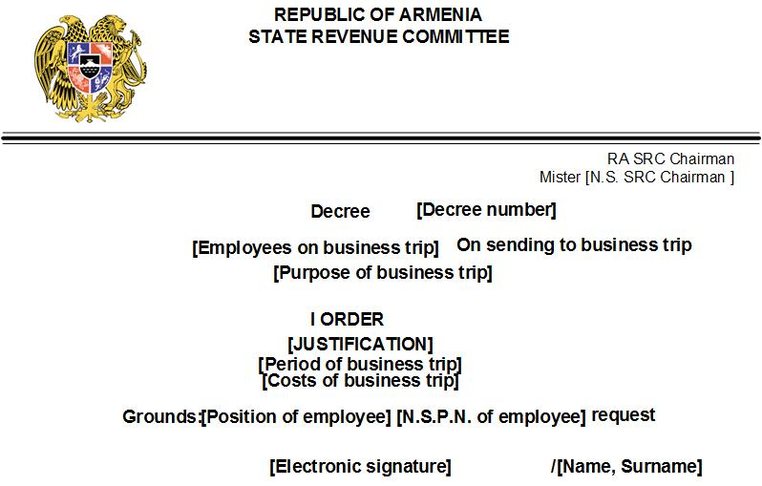

Table 38. Employees’ business trip administration
Field |  | Type | Attributes |  | Initial value | Description
Search section
Direct management unit |  | Dropdown | Not mandatory |  | All | Defines the direct management unit of SRC sub-division. Contains the list of all structural units and “All” value.
Sub-division |  | Dropdown | Not mandatory |  | All | Defines the list of sub-divisions of SRC. Contains the list of SRC sub-divisions and “All” value.
Type of business trip |  | Dropdown | Not mandatory |  | All | Defines the list of business trip types, contains the list of business trips types and “All” value.  Potential values are:  - All  - Direct management unit  - In country  - Out of country
Status |  | Dropdown | Not mandatory |  | All | Defines the list of business trips status, contains the list of statuses of business trips and “All” value.  Potential values:  - All  - New request  - Sent to approval  - Request is approved  - Decree is created  - Decree is approved  - Certificate is created  - Departed to a business trip  - Ended
Start |  | Calendar box | Not mandatory |  | Current date | Defines the start date of the business trip.
End |  | Calendar box | Not mandatory |  | Current date | Defines the end date of the business trip.
Search |  | Button |  |  |  | Perform search.
New search |  | Button |  |  |  | Bring the search fields into initial values.
Table
Direct management unit |  | Column |  |  |  | Displays the direct management of the position filled in by employee.
Sub-division |  | Column |  |  |  | Displays the sub-division of the position filled in by employee.
Type of business trip |  | Column |  |  |  |  | The field displays types of planned business trips.  Potential values:  - Direct management unit  - In country  - Out of country
Start |  | Column |  |  |  |  | The field displays the start date of the business trip.
End |  | Column |  |  |  |  | The field displays the end date of the business trip.
Status |  | Column |  |  |  | The field displays the business trip status:  - All  - New request  - Sent for approval  - Approved request  - Decree is created  - Decree is approved  - Certificate is created  - Departed to a business trip  - Ended  The newly created request has the status of “New request”.  The request that has been sent for approval has the status of “Sent for approval”.  The request approved by the head of sub-division has the status “Approved request”.  The request for which the decree of the business trip has been created has the status of “Decree is created”.  The request per which a business trip certificate has been created for all employees entitled to the business trip has the status of “Certificate is created".  The business trip, which has a start date smaller than or equal to the current date has the status of “Departed to a business trip”.  The business trip, which has an end date smaller than or equal to the current date has the status of “Ended”.
Request |  | Column |  |  |  |  | The field displays the request of the given business trip in pdf format. The form is described in Fig. 40.
View |  | Button |  |  |  |  | By pressing the button, the view page of the business trip request signed by the employee, opens in pdf format (Fig. 40)
Approve |  | Button |  |  |  |  | The button is accessible to the heads of units, heads of territorial and direct management units. If the employee is positioned in the territorial body and applies to a business trip with less than 10 days’ duration and the business trip is not to direct management unit, then the approval is provided by the head of territorial body. In other cases, including out of country business trips, the approval is provided by the head of sub-division or direct management unit.  By pressing the button, the request submitted by the employee is approved. The status of the request becomes as “Request is approved”. With the approval of the request the text, “Not against” appears on the report of the request (Fig. 40).
Reject |  | Button |  |  |  |  | The button is accessible to the head of the sub-division, heads of territorial and direct management units. If the employee is positioned in the territorial body and applies for a business trip for less than 10 days of duration and if the business trip is not to direct management unit, then the rejection is done by the head of territorial body. In other cases, including out of country business trips, the rejection is done by the head of sub-division or direct management unit.  By pressing the button, the form for filling in the reason for rejection opens, and after saving it, the status of the request becomes “Rejected”. The reason for rejection is displayed in the corresponding field of the form (Table 37, Fig. 39).
Attach |  | Button |  |  |  |  | The button is accessible to the PMD officer. The button is activated when the business trip request is approved. When pressing the button, the window for attaching to the system the business trip request initialed by the SRC Chairman, opens up in pdf format. When attaching, the button for creation of business trip decree activates.
Decree |  | Column |  |  |  |  | The decree of the given business trip is displayed in the field.
Create |  | Button |  |  |  |  | The button is accessible to PMD officer. The button activates when the business trip request of the previous column initialed by the SRC Chairman is attached to the system. By pressing the button, the page for viewing the business trip decree opens in doc format. The appearance of the report is presented in Fig. 43. Then, the business trip report is sent for SRC Chairman’s approval by mulberry system. The status of the business trip becomes as “Decree is created”. After creation of the decree a number is attached to it, which is generated automatically and represents a G format number - [for direct management unit] ․ [for sub-division]. [year]. [subsequent number in the course of the year ].
Attach |  | Button |  |  |  |  | The window for attaching the decree of the approved request by the SRC Chairman or head of territorial body opens by pressing the button. If the business trip’ is planned as “Out of the country” then the process stops here. The status of the business trip becomes as “Decree is approved”.
View |  | Button |  |  |  |  | By pressing the button, the page for viewing the business trip decree approved by the SRC Chairman is opened.
Certificate |  | Column |  |  |  |  | The field displays the form of the request for the given business trip, which is described in table 37 and Fig. 39. If the business trip is to take place “Out of country”, then the field is not active. The appearance of the report is shown in Fig. 41.
Create |  | Button |  |  |  |  | The button is accessible only to PMD officer. The button activates when attaching the business trip decree approved by the SRC Chairman. The form for creation of the business trip certificate opens by pressing the button, which is described in table 37 and Fig. 39. The form of the report is presented in Fig. 41. The business trip certificate is created individually for each employee to depart for a business trip. The status of the business trip becomes as “Certificate is created”.
Print |  | Button |  |  |  | By pressing the button, the rows of the table are exported in Excel format file.
 | Sub window for entering the reason for rejection
 | Reasoning for rejection / review | Text box; multi line | Required |  |  | The field is displayed when the rejection button is pressed. The reasons for rejection are entered in the field. If the reason for rejection is saved it is displayed in the corresponding field of the form of the request (Fig. 39 and table 37).
 | Save | Button |  |  |  | By pressing the button, the reason for rejection is saved in the system. If the reason for rejection is kept, it is displayed in the corresponding field of the report of the application (Fig. 39 and table 37).

Implementation of Internal Transfers Module
This sub-module enables to automate the rotations, staff internal transfers, position promotions and demotion processes implemented in SRC. This is an HRMIS sub-module and is accessible to the managerial staff and PMD employees to view the staff entitled to rotation, implement and manage the rotation, staff transfers, position demotions and position promotions of the staff. The heads of sub-divisions may only view the data of their staff and fill in recommendation documents for not implementing rotations, as well as to present recommendation documents for position promotions of employees. Below are the main functionalities for internal staff transfers:
- The system should enable to view the list of SRC staff entitled to rotations and the following corresponding activities should be implemented. If the feature “Rotation” is marked for the given position and the employee has been assigned to that position, then the duration for filling in the position is calculated and if it exceeds 2 years minus 10 days, then the system displays the given employee in the list of staff entitled to rotation. If a selection of rotation scheme is not implemented for the employee, then on the due date of his/her rotation, the date for a new rotation shall be calculated by adding 2 years minus 10 days to the previous period.
- The system must enable the PMD staff to create rotation implementation schemes with the purpose of viewing and approving those schemes by SRC Chairman.
- The system should enable to create reports and conduct data analyses of the available data.
- The form for selecting positions for rotation shall display the positions of employee’s subject to rotation and transfers are done among them. If the SRC Chairman approves the rotation scheme, but there is another employee assigned for the new position at that period for whom rotation has not been yet done, then the status of that employee will be changed to “Re-assignment” and he/she will not be associated with that position any further. When the rotation decree is approved for the employee, he/she will be registered in the new position and the status of the employee will change to the value “Active”.
- The system should send notifications when implementing internal transfers process. When the employee is assigned to a new position, an official notification is sent to the official email of employee reading “You have been assigned to a new position”.
The internal transfers module consists of two sub-modules:
- Rotation administration module, which is envisaged to implement the rotation process.
- Internal transfers administration module, which is envisaged for demotion, promotion and organizing internal transfers.
Below are descriptions of forms/pages and fields contained in them and the logic of related activities.

3․7․1 Rotation Administration Module
The rotation administration module is envisaged to view the employees entitled to rotation related activities, select rotation schemes, manage and implement rotation process.
This is an HRMIS sub-module and is accessible to managerial personnel and PMD officers to view all SRC employees entitled to rotation, selecting and approving the rotation schemes, creating rotation decree and appointing to a new position. Below are the main functionalities of staff administration module:
- The system should enable to view the employees entitled to rotation, make a selection of rotation scheme and once it is approved to assign the employees to new positions.
- The system should ensure the option of automatic creation of rotation scheme. The scheme is created taking into consideration the following criteria: the new direct management unit, sub-division and position should not be the same as the ones at the previous three rotations. The rotation should be implemented among the previously selected structural units. The system should allow editing automatically created rotation scheme.
Rotation administration module consists of the following forms.

Fig. 45. Rotation administration
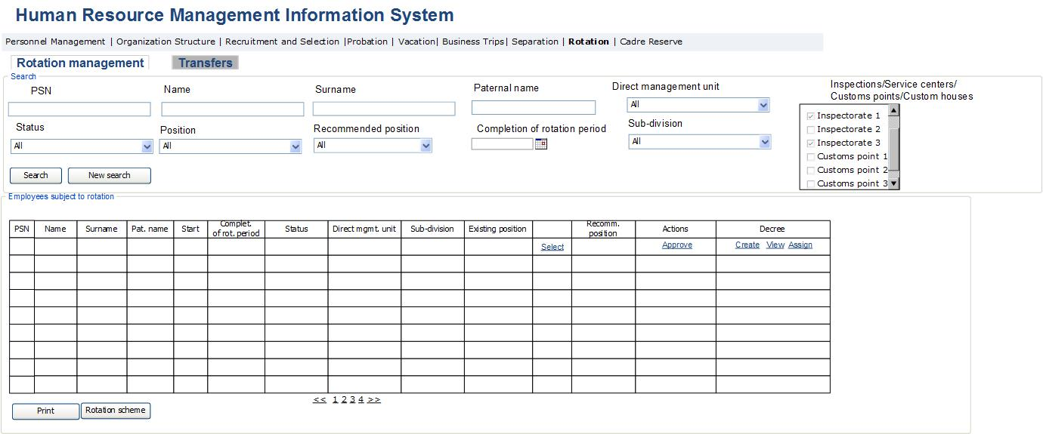

Table 39. Rotation administration
Field | Type |  | Attributes |  | Initial value | Description
Search
PSN | Text Box |  |  |  |  | Defines employee’s PSN.
First name of employee | Text Box |  |  |  |  | Defines employee’s first name.
Surname of employee | Text Box |  |  |  |  | Defines employee’s surname.
Paternal name of employee | Text Box |  |  |  |  | Defines employee’s paternal name.
Direct management unit | Drop Down |  |  |  |  | Defines the direct management unit of employee’s position  Potential values:  - All  - List of organization’s Sub-divisions
Sub-division | Drop Down |  |  |  |  | Defines the sub-division of employee’s position.  Potential values:  - All  - List of organization’s sub-divisions
Position | Drop down |  |  |  | All | Defines the position filled by employee.  The potential values are the list of available positions mentioned in the selected section of the previous point and the value “All”.
Recommended position | Drop down |  |  |  | All | Defines the new position proposed due to employee’s rotation. Potential values are: the list of organization’s positions subject to rotation and the value “All”.
Due date of rotation | Calendar box |  |  |  |  | Defines the due date of rotation of the employee subject to rotation.
Status | Drop down |  |  |  |  | Defines the status of the employee subject to rotation.  Potential values are:  - Entitled to rotation  - With selected scheme of rotation  - Approved  The employees whose rotation period ends in less than 10 days have the status of “Entitled to rotation”  The rows for whom selection of positions was done by the PMD have the status of “With selected scheme of rotation”  The employees for whom the Rotation scheme has been approved by the SRC Chairman have the status “Approved”. For them, the option of creating a Rotation decree is enabled.
Inspectorate/service center /customs check point/custom house | Check list box |  |  |  |  | The list defines the structural units selected for generating rotation scheme. The list displays the structural units “Inspectorate”, “Service Center”, “Customs check point”, “Custom-House”. When making selection in the list, the table displays only the employees subject to rotation in the selected structural units.
Search | Button |  |  |  |  | By pressing the button, the data mentioned in the previous clauses are searched and the results are displayed in the table.
New search | Button |  |  |  |  | When pressing the button, the search fields take their initial form.
Main table
PSN | Column |  |  |  |  | Displays the PSN of employee in the personnel management system.
Name of employee | Column |  |  |  |  | Displays the name of employee.
Surname of employee | Column |  |  |  |  | Displays surname of employee.
Paternal name of employee | Column |  |  |  |  | Displays paternal name of employee.
Start | Column |  |  |  |  | Displays the date of assigning the employee to the given position.
Rotation expiry | Column |  |  |  |  | Displays rotation expiry date for the given position.
Status | Column |  |  |  |  | Displays the status of employee to be rotated. Potential values:  - Subject to rotation  - Rotation scheme selected  - Approved  The status “Subject to rotation” is assigned to those employees whose rotation will expire in less than 10 days.  “Rotation scheme selected” status is assigned to those lines for which the PMD has performed selection of Recommended position.  The status “Approved” is assigned to those lines for which the SRC Chairman has “Approved rotation scheme”. For those lines the Rotation decree generation is enabled.
Direct management unit | Column |  |  |  |  | Displays direct management unit of employee’s position.
Sub-division | Column |  |  |  |  | Displays sub-division of employee’s position.
Position | Column |  |  |  |  | Displays most recent position of employee. The sub-division and position of employee is displayed in the field. If the same position is selected for another employee in the result of new rotation, then this field becomes link-button, which if pressed activates the line of the employee recommended for transferring to the given position.
Select | Column |  |  |  |  | The button is active if there is no recommendation for implementing approved rotation. By pressing the button, the module of assigning to position opens (table 5), from where the recommended position is selected. One of the positions of the employees entitled to rotation can be selected. When the position is selected, the line obtains the status “Rotation scheme selected”.
Recommended position | Column |  |  |  |  | Displays new position proposed to the employee resulting from rotation. Potential values are displayed from the position list. The field displays the sub-division and position. This field is a link-button, which if pressed activates that line of the table which displays Recommended position and the person occupying it.
Actions | Column |  |  |  |  | The column displays possible actions to be performed in respect to the given employee. The column is displayed only to the SRC Chairman.
Approve | Button |  |  |  |  | The button is active only for the SRC Chairman. By pressing the button, the selected rotation scհeme is approved and the rotation decree generation option is activated. The line now has the status “Approved”.
Decree | Column |  |  |  |  | The field displays rotation decree.
Create | Button |  |  |  |  | By pressing the button, the view page of rotation decree opens in doc format. The button activates when Rotation scheme is approved. The decree number is automatically entered in the decree file, which becomes sequential number of rotation decree entered in the system. The process of decree approval is implemented through Mulberry system. After the signed decree is received, it is entered by pressing the button “Appoint to position”.
View | Button |  |  |  |  | By pressing the button, the view page of rotation decree opens in doc format.
Appoint to position | Button |  |  |  |  | By pressing the button, the form described in table 6 on appointing to the position module opens, where respective actions in respect to appointing the employee to the new position are taken. Upon successful completion of the process of appointing to new position, the date of appointment is automatically entered as the end date of the previous position. If at the moment of appointment the given position is occupied by another employee, then the latter is given “Re-appointment” status and his/her link to that position is removed. The data are displayed in the block “Positions occupied in SRC” of the Employee data view module form.
Print | Button |  |  |  |  | By pressing the button, the lines displayed in the table are exported in the form of Excel file.
Rotation scheme | Button |  |  |  |  | By pressing the button, the automatic rotation scheme generation window opens (Fig. 45).

Fig. 46. Automatic rotation scheme generation page
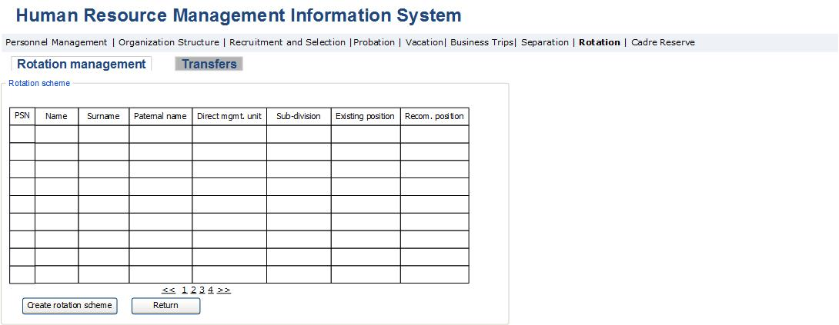

Table 40. Rotation scheme selection page
Field | Type |  | Attributes |  | Initial value | Description
Main data block
PSN | Column |  |  |  |  | Displays the PSN of employee.
Name of employee | Column |  |  |  |  | Displays the name of employee.
Surname of employee | Column |  |  |  |  | Displays surname of employee.
Paternal name of employee | Column |  |  |  |  | Displays paternal name of employee.
Direct management unit | Column |  |  |  |  | Displays direct management unit of employee’s position.
Sub-division | Column |  |  |  |  | Displays sub-division of employee’s position.
Position | Column |  |  |  |  | Displays most recent position of employee. The sub-division and position of employee is displayed in the field. If the same position is selected for another employee in the result of new rotation, then this field becomes link-button, which if pressed activates the line of the employee recommended for transferring to the given position.
Recommended position | Column |  |  |  |  | Displays new position proposed to the employee in the result of rotation. The field displays the sub-division and position. This field is a link-button, which if pressed activates that line of the table which displays Recommended position and the person occupying it.
Create rotation scheme | Button |  |  |  |  | By pressing the button, the system randomly selects one of the positions of the column “Position”. After random selection, the following condition is checked. The given employee shouldn’t have been appointed to the position in that management unit and sub-division over the last three rotations. Selected position is displayed in the column “Recommended position”.
Return | Button |  |  |  |  | By pressing the button, the form closes and the page described in Fig. 44 and Table 39 is displayed, where the field “Recommended position” displays the positions selected automatically in that form by the system.

3․7․2 Internal Transfers Administration Module
Internal transfers module is designed for viewing employees to be demoted, for administration and implementation of position change processes in the case of promotions, reductions and other reasons.
This is an HRMIS sub-module and is accessible to the managerial staff and PMD officers enabling them to view all SRC employees, to view and approve or reject the documents supporting their position change, to create the decree for position change and appoint to new position. Heads of units can have access to this module only in order to view their employees and create promotion recommendation. Below are the key functionalities of personnel pool administration module:
- The system should allow viewing employees with grounds for demotion, as well as performing promotion or changing their position for certain reasons and appointing them to new positions.
- When the “Demotion” penalty or commission decision is selected in the “Attestation” and “Desciplinary penalty” data block of the employee data view modul, employees with demotion grounds “Attestation result” and “Disciplinary result” are automatically displayed in this module. For these employees, the button “Create” is not active in the “Demotion grounds” column. By pressing the button “View”, the page of Fig. 47 is displayed and its fields automatically display the data entered in the employee data view module, and the option to change demotion ground is not active. The grounds for changing position “Other”, “Reduction”, “Official investigation with conclusion ‘Demotion’” and “Promotion” are entered with the help of internal transfers administration module by creating promotion recommendation or the ground for demotion.
The internal transfer administration module consists of the following forms:

Fig. 47. Internal transfers administration
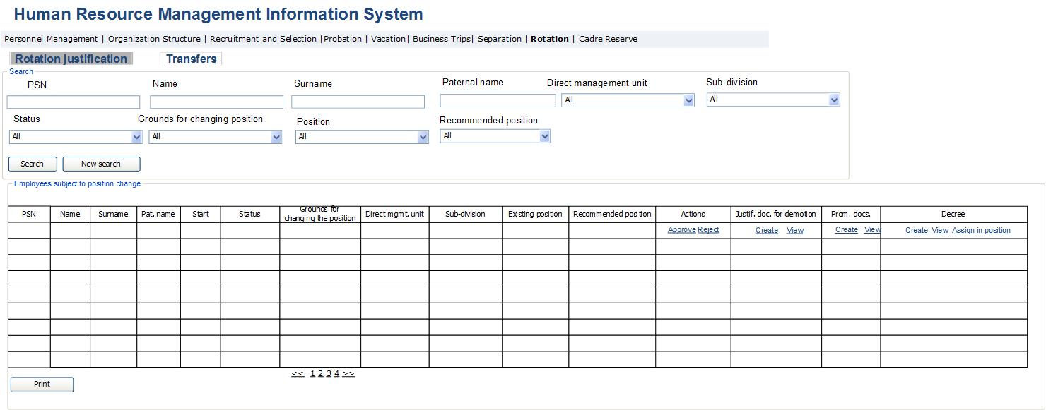
Table 41. Transfers administration
Field | Type |  | Attributes |  | Initial value |  |  | Description
Main data block
PSN | Text Box |  |  |  |  | Defines employee’s PSN.
First name of employee | Text Box |  |  |  |  | Defines employee’s name.
Surname of employee | Text Box |  |  |  |  | Defines employee’s surname.
Paternal name of employee | Text Box |  |  |  |  |  |  | Defines employee’s paternal name.
Direct management unit | Drop Down |  |  |  |  | Defines direct management unit of employee’s position. Potential values:  - All  - The list of structural units
Sub-division | Drop Down |  |  |  |  | Defines sub-division of employee’s position. Potential values:  - All  - The list of subordinate structural units of direct management unit
Position | Drop down |  |  |  | All |  |  | Defines employee’s position. The potential values are the list of positions stated in the section referred to in the preceding paragraph and “All” value.
Recommended position | Drop down |  |  |  | All |  |  | Defines the proposed new position as a result of the employee’s rotation. The potential values are the list of positions of organization and “All” value.
Status | Drop down |  |  |  |  |  |  | Defines the status of the employee whose position is subject to a change. Potential values:  - Current  - Ground created  - Approved  - Rejected  - Decree is created  The lines containing the basis for demotion or promotion have the status “Ground created”.  The lines containing approved basis for position change have the status “Approved”.  The lines on rejecting the position change, have “Rejected” status.  The lines, which create the decree for position change, have the “Decree created” status.
Ground for the change of position | Drop down |  |  |  |  |  |  | Dfines the basis for employee’s position change, if available. Potential values:  - All  - Other  - Attestation result  - Disciplinary penalty  - Reduction  - Official investigation with “Demotion” conclusion  - Official promotion
Search | Button |  |  |  |  |  |  | By pressing the button a search is done with the indicators reffered to in the preceding paragraph and the results are displayed in the table.
New search | Button |  |  |  |  |  |  | By pressing the button, the fields of search section are brought to the initial condition.
Main table
PSN | Column |  |  |  |  |  | Displays employee’s PSN in personnel management system.
First name of employee | Column |  |  |  |  |  | Displays employee’s name.
Surname of employee | Column |  |  |  |  |  | Displays employee’s surname.
Paternal name of employee | Column |  |  |  |  |  | Displays employee’s paternal name.
Start | Column |  |  |  |  |  | Displays the date of the employee’s appointment to the given position.
Status | Column |  |  |  |  |  | Displays the status of the employee whose position is subject to a change. Potential values:  - Current  - Ground created  - Approved  - Rejected  - Decree created  The lines where the basis for demotion or promotion of the position is completed, have “Ground created” status.  The lines with approval of the ground for position change, have “Approved” status.  The lines, which reject the position change, get the “Rejected” status.  The lines with decree creation for position change, have “Decree created” status.
Direct management unit | Column |  |  |  |  |  | Displays direct management unit of employee’s position.
Sub-division | Column |  |  |  |  |  | Displays sub-division of employee’s position.
Position | Column |  |  |  |  |  | Displays last position occupied by the employee. Potential values are displayed from the positions list. The field displays employee’s sub-division and position.
Ground for the change of position | Column |  |  |  |  |  |  | Displays the basis for the employee’s change of the position if available. Potential values:  - Other  - Attestation result  - Disciplinary penalty  - Reduction  - Official investigation with a conclusion “Demotion”  - Official promotion  In case of the first four values demotion is implemented.The fourth value is designed for promotion.
Recommended position | Column |  |  |  |  |  | Displays the proposed new position as a result of the employee’s change of position. The field displays the sub-division and the position.
Actions | Column |  |  |  |  |  | The column displays potential actions to be performed in respect to the given employee. The column is displayed only to the SRC Chairman. The field activates in the case of availability of grounds for position change.
Approve | Button |  |  |  |  |  | The button is active only for the SRC Chairman. By pressing the button, the grounds for demotion or promotion is approved and the possibility of decree creation is activated. The status of the line changes to the value “Approved”.
Reject | Button |  |  |  |  |  | The button is active only for the SRC Chairman. By pressing the button, the basis for the demotion or promotion of employee is rejected and the possibility of the decree creation is changed to a suspended status. The status of the line changes to the value “Rejected”.
Supporting document for demotion | Column |  |  |  |  |  | The field displays the document which is considered a basis for demotion.
Create | Button |  |  |  |  |  | By pressing the button, the entry form for the document considered as ground for demotion is opened at the top of the table, which is described in Table 42. In case of saving the ground, the line receives a “Ground created” status. In case the ground is approved by the Head of PMD, the status becomes “Ground approved”. By pressing the button, only records reading “Reduction”, “Other” or “Official investigation with “Demotion” conclusion”” can be created. Records with other grounds are displayed automatically in this form when appropriate data is entered in the employee’s data view module.
View | Button |  |  |  |  |  | By pressing the button, the view form of the document supporting demotion is opened at the top of the table on the same page, which is described in Table 42.
Promotion documents | Column |  |  |  |  |  | The field displays the form of promotion recommendation document.
Create | Button |  |  |  |  |  | By pressing the button, the form for entering promotion recommendation document opens at the top of the table on the same page, which is described in Table 43. The button is active only for the Head of sub-division. In case of saving the recommendation document, the line receives a “Ground created” status.
View | Button |  |  |  |  |  | By pressing the button, the view form of the promotion recommendation document opens at the top of the table on the same page, which is described in Table 6. The button is active for the Head of sub-division, Head of PMD and SRC Chairman.
Decree | Column |  |  |  |  |  | The field displays the decree for the change of position.
Create | Button |  |  |  |  |  | By pressing the button, the page for viewing the decree for the change of position in a doc format is opened. The button is activated when the SRC Chairman’s approves the ground for demotion or promotion. The number of decree is automatically entered into the decree file, and is considered serial number of the decree to an appointment to the position entered in the system. The process of decree approval is performed with Mulberry system. The status of the line changes to “Decree created”. After receiving the signed decree, it is entered by pressing the “Appoint to the position” button.
View | Button |  |  |  |  |  | By pressing the button, the page for viewing rotation decree in pdf format is opened.
Appoint to position | Button |  |  |  |  |  | By pressing the button, the form of employee’s appointment to the position described in Personnel Resource Module is opened, which is described in Table 5 of the Position Appointment Module. Selection of a new position is made, after which the appointment of the person to the given position is done with the help of the form described in Table 6 of the description of the same module. The field for the ground for change of position is filled automatically according to the ground of the change of position mentioned herein. In case of availability of Recommended position, the form described in Table 5 is opened by pressing the “Appoint to the position” button, where the fields of position and the grounds for change of position are filled in automatically.  Through that form the appointment of the person to the new position is made. In the case of successful accomplishment of the appointment process, the date of appointment to the new position is automatically entered as the end date of employment in the previous position. The data is displayed in the block “Occupied positions in SRC” of the “Personal data” form in Personnel Resource Module.
Print | Button |  |  |  |  |  | By pressing the button, the lines displayed in table are exported in the form of Excel file.

Fig. 48. Demotion justification form
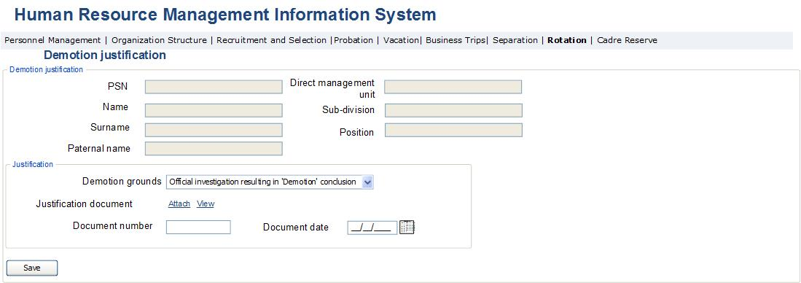

Table 42. Demotion justification form
Field | Type |  | Attributes |  | Initial Value | Description
Main Data Block
PSN | Text Box |  | Disabled |  |  | Displays employee’s PSN.
First name of employee | Text Box |  | Disabled |  |  | Displays employee’s name.
Surname of employee | Text Box |  | Disabled |  |  | Displays employee’s surname.
Paternal name of employee | Text Box |  | Disabled |  |  | Displays employee’s paternal name.
Direct management unit | Text box |  | Disabled |  |  | Displays direct management unit of employee’s position.
Sub-division | Text box |  | Disabled |  |  | Displays sub-division of employee’s position.
Position | Text box |  | Disabled |  |  | Displays employee’s position.
Justification data block
Grounds for demotion | Drop down |  |  |  |  | The field displays the ground for change of position. Potential values are:  - Other  - Reduction  - Attestation result  - Disciplinary penalty  - Official investigation with “Demotion” conclusion
Supporting document |  |  |  |  |  | The section displays supporting document.
View | Button |  |  |  |  | By pressing the button, the document view window is opened.
Upload | Button |  |  |  |  | By pressing the button, the window for uploading the document into the system is opened.
Number of document |  |  |  |  |  | The number of document considered as the ground is entered in the field.
Date of document |  |  |  |  |  | The date of creation of ground is entered in the field.
Save | Button |  |  |  |  | By pressing the button, the changes done in the form are saved. The status of the line becomes “Basis created”. After finishing all actions, the form is closed.

Fig. 49. Promotion form
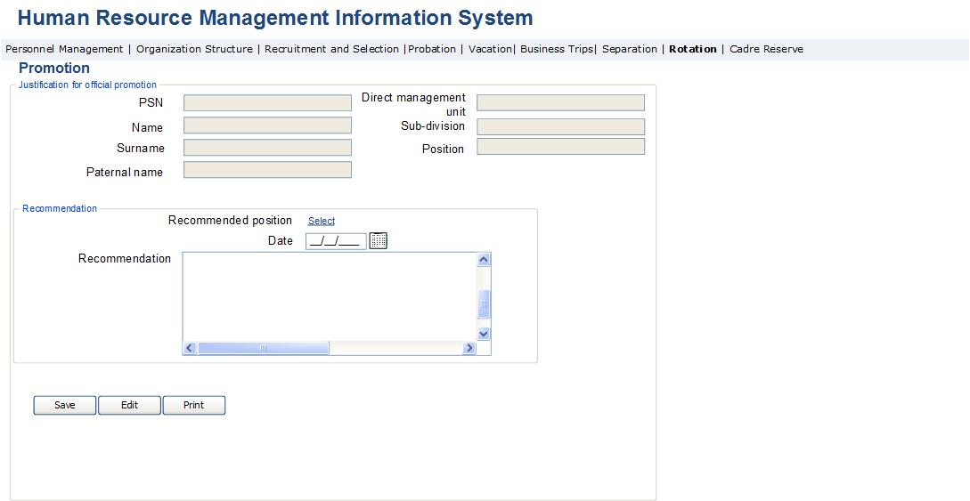

Fig. 50. Report on promotion recommendation document
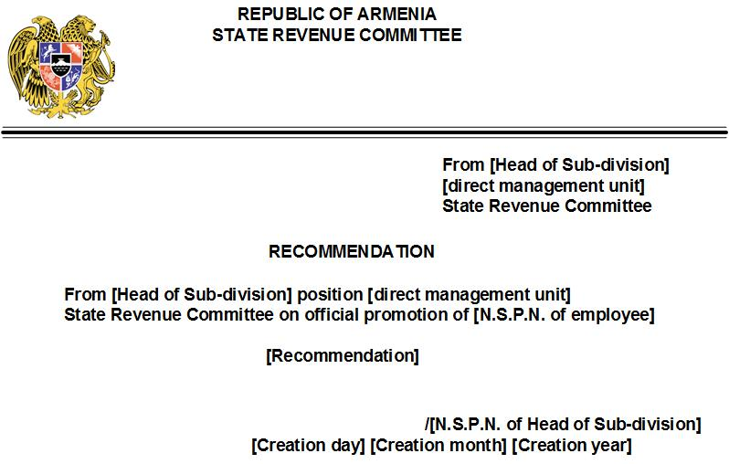

Table 43. Promotion documents view page
Field | Type | Attributes | Initial Value | Description
Main Data Block
PSN | Text Box | Disabled |  | Displays employee’s PSN.
First name of employee | Text Box | Disabled |  | Displays employee’s name.
Surname name of employee | Text Box | Disabled |  | Displays employee’s surname.
Paternal name of employee | Text Box | Disabled |  | Displays employee’s paternal name.
Direct management unit | Text box | Disabled |  | Displays direct management unit, sub-division of employee’s position.
Sub-division | Text box | Disabled |  | Displays sub-division of employee’s position.
Position | Text box | Disabled |  | Displays employee’s position.
Main Data Block
Recommended position | Label |  |  | The field displays the position proposed for promotion.
Select | Button |  |  | By pressing the button, the position selection form of the Position Appointment Module is opened.
Date | Calendar box |  |  | The date of creating the recommendation document is entered in the field.
Recommendation document | Text box; Multi line | Disabled |  | The text of promotion recommendation document is entered in the field. The field is active only for the Head of sub-division. The field is active when creating new recommendation document and is passive when viewing the created recommendation document.
Save | Button |  |  | By pressing the button, the changes done in the form are saved. The status of the line becomes “Ground created”. After finishing the actions, the form is closed.
Edit | Button |  |  | The button is displayed only in case of viewing available recommendation document. By pressing the button, the field “Recommendation document” becomes active and an option is created to make changes in the given field.
Print | Button |  |  | By pressing the button, the window for viewing recommendation document in word format is opened (Fig. 48a).

Implementation of Probation Administration Module
This sub-module enables to automate probation processes for the State Revenue Committee employees. This is an HRMIS sub-module and is accessible to the SRC Chairman and PMD staff with the options of viewing the reports on the probation produced by employees on probation, the memo completed by the probation supervisor and the conclusion completed by the head of sub-division, and to the SRC Chairman also with the option of evaluating probation. The heads of sub-divisions may only view the data of employees of their sub-divisions, to complete their probation conclusion and to evaluate employee’s probation. The employee appointed as probation supervisor has the option to complete the probation memo and evaluate the result of employee’s probation.
Below are the main functionalities of the Probation administration module:
- The system should enable to view the list of SRC employees on probation. The probation period is assigned by entering the period of probation in the required field of the form of Position appointment module. Due to entering the probation period, the employee must be displayed in the list of employees on probation. The list shall be accessible to the SRC Chairman and PMD with the option of viewing all SRC employees on probation, and to the heads of sub-divisions with the option of viewing only the employees on probation in their sub-divisions.
- It is necessary to enable the Head of sub-division to make a selection of probation supervisor for the employee on probation, who may be any of the experienced employees of the same sub-division. In the personal data view module of probation supervisor, the “Probation supervisor” data block should be activated. In this data block the employees, for whom the given employee has been appointed as the probation supervisor, shall be displayed. The probation supervisor should have the option to create a probation memo at the end of employee’s probation.
- The system should allow to create reports and make analysis using existing data.
- During the probation, a calculation of a period is done, after which the system shall activate the option of creating probation report, conclusion and memo in case 5 or less days are left to the end of probation. Moreover, the employee creates the report, the supervisor creates the memo and the head of sub-division creates the conclusion. The head of sub-division should have the option to create the document only in case of accessibility of the documents created by the employee and the head of his/her probation period.
- It is necessary to create an option in the system to view the report, conclusion and memo completed by the SRC Chairman and to assess the probation as satisfactory or unsatisfactory according to them. In the case of satisfactory score, the probation is considered completed. In the case of unsatisfactory score, the employee is displayed in “Separation management” module with the ground “Unsatisfactory score of probation” separation from work.
- The system should send notifications during the implementation of probation processes. In the case of probation assignment, “You are assigned to probation” notification must be sent to the employee’s business email. In the case of selection of probation supervisor by the head of the sub-division, the “Probation supervisor has been selected for You” notification shall be sent to the employee’s business email and “You were appointed as a probation supervisor” notification shall be sent to the employee appointed as a supervisor. When only 5 days are left to the end of employee’s probation, the notifications “5 days left to the end of Your probation period” and “5 days left to the end of the probation period of the employee of Your sub-division” shall be sent accordingly to the business emails of employee, probation supervisor and his/her sub-division head.
Probation administration module consists of two sub-modules, which are:
- Probation management module, which is envisaged for implementation of probation process.
- Probation document generation module, which is envisaged for creating the report, conclusion and memo of the probation.
Below is the description of the forms/pages that are used in those stages, the description of the fields displayed in them and the logic of their operation.

3․8․1 Probation Administration Module
Probation administration module is envisaged for viewing the employees and the reports completed by them, the memos created by the probation supervisor, for creating probation conclusions by the heads of sub-divisions and for probation evaluation by the SRC Chairman.
This is an HRMIS sub-module and is accessible to managerial staff and PMD officers to view all the SRC employees on probation. The SRC Chairman has the option to evaluate the probation by pressing the “Satisfactory” or “Unsatisfactory” buttons. The heads of sub-divisions have the option to view the employees of their Sub-divisions on probation and create a probation conclusion for the given employee in case that less than 5 days are left to the end of his/her probation. Below are the main functionalities of staff list management module:
- The system should enable to view the list of SRC employees on probation. The probation period is assigned by entering the period of probation in the required field of the form in Position appointment module. Due to entering the probation period, the employee shall be displayed in the list of employees on probation. The list shall be accessible to the SRC Chairman and PMD with the option to view all the SRC employees on probation and to the heads of sub-divisions with the option to view only the employees on probation in their sub-divisions.
- The head of sub-division should have the option to make a selection of a probation supervisor for the employee on probation. After selecting, the “Probation supervisor” data block should be activated in the module of viewing the personal data of the employee appointed as a probation supervisor. In this data block, should be displayed the employee, for whom the given employee has been appointed as the probation supervisor.
- It is necessary to create an option in the system to view the report, conclusion and memo completed by the SRC Chairman and to evaluate the probation satisfactory or unsatisfactory accordingly. In the case of satisfactory score, the probation is considered completed. In the event of unsatisfactory score, the employee is displayed in “Separation management” module on the grounds “Unsatisfactory score of probation” separation from work.
The Probation administration module consists of the following forms.
Fig. 51. Probation administration form
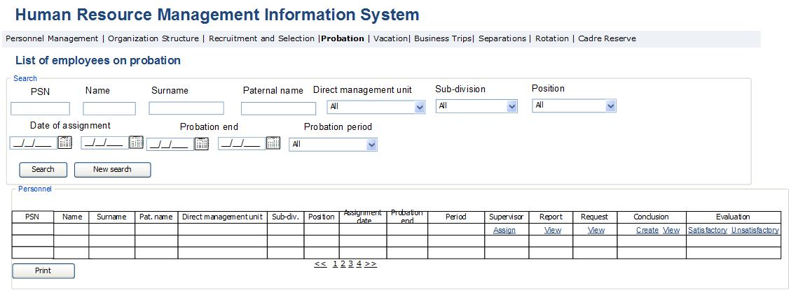
Table 44. Probation administration form
Field | Type |  | Attributes |  | Initial Value | Description
Search block
PSN | Text Box |  |  |  |  | Defines employee’s PSN.
First name of employee | Text Box |  |  |  |  | Defines employee’s name.
Surname of employee | Text Box |  |  |  |  | Defines employee’s surname.
Paternal name of employee | Text Box |  |  |  |  | Defines employee’s paternal name.
Direct management unit | Drop down |  |  |  | All | Defines direct management unit of employee’s position. The potential values are the list of structural units of SRC and “All” value.
Sub-division | Drop down |  |  |  | All | Defines Sub-division of employee’s position. The potential values are the list of Sub-divisions of SRC’s direct management unit mentioned in the preceding paragraph and “All” value.
Position | Drop down |  |  |  | All | Defines the employee’s position. The potential values are the list of positions of the Sub-division mentioned in the preceding paragraph and “All” value.
Date of appointment | Calendar Box |  |  |  |  | Defines the date of employee’s appointment to the position. The field is defined by the range.
End of probation period | Calendar Box |  |  |  |  | Defines the end date of employee’s probation period. The field is defined by the range.
Probation period, month | Drop down |  |  |  |  | Defines the terms of employee’s occupation of the last position in months. Potential values:  - All  - 1 month  - 2 month  - 3 month  - 4 month  - 5 month  - 6 month
Search | Button |  |  |  |  | By pressing the button, a data search with indicators mentioned in the previous paragraphs is done, and the results are displayed in the table.
New search | Button |  |  |  |  | By pressing the button, the fields of search section are brought to the initial condition.
Main Table
PSN | Column |  |  |  |  | Displays employee’s PSN.
First name of employee | Column |  |  |  |  | Displays employee’s name.
Surname of employee | Column |  |  |  |  | Displays employee’s surname.
Paternal name of employee | Column |  |  |  |  | Displays employee’s paternal name.
Direct management unit | Column |  |  |  |  | Displays direct management unit, sub-division of employee’s position.
Sub-division | Column |  |  |  |  | Displays sub-division of employee’s position.
Position | Column |  |  |  |  | Displays employee’s last position.
Date of appointment | Calendar Box |  |  |  |  | Displays the date of employee’s appointment to the position.
End of probation period | Calendar Box |  |  |  |  | Displays the date of the end of employee’s probation. Calculation field. Is being calculated based on the appointment date and probation period.
Term | Column |  |  |  |  | Displays the employee’s probation period.
Supervisor | Column |  |  |  |  | The field gives the option to choose or display the probation supervisor selected for the given employee.
Appoint | Button |  |  |  |  | By pressing the button, the form for the selection of the probation supervisor is opened at the top of the table on the same page, which is described in table 45 and Fig. 50.
Report | Column |  |  |  |  | The field displays the probation report created b the employee. The report is created by pressing the “Probation report” button of “Personal data view” module.
View | Button |  |  |  |  | By pressing the button, the page of viewing probation report in pdf format is opened ( Fig. 52)
Memo | Column |  |  |  |  | The field displays the memo created by the probation supervisor. The memo is created by pressing the “Probation memo” button of the “Probation Supervisor” block in “Personal data view” module.
View | Button |  |  |  |  | By pressing the button, the page of viewing probation memo in pdf format is opened ( Fig. 54)
Conclusion | Column |  |  |  |  | The field displays the probation memo created by the probation supervisor.
Create | Button |  |  |  |  | By pressing the button, the form for creating the probation memo is opened, which is described in “Probation documents” data block. The button is accessible only to the head of Sub-division. The button is activated only in case of availability of created and signed report and memo of probation.
View | Button |  |  |  |  | By pressing the button, the page of viewing probation conclusion in pdf format is opened ( Fig. 56)
Evaluation | Column |  |  |  |  | The field is accessible only to the SRC Chairman. The tools of probation valuation are displayed in the field.
Satisfactory | Button |  |  |  |  | By pressing the button, the probation is marked as “Satisfactory” which is displayed in the appropriate column of the line displaying the given position of “Positions occupied in SRC” section of employee’s data view module. The button is active in case of availability of signed conclusion of probation.
Unsatisfactory | Button |  |  |  |  | By pressing the button, the probation is marked as “Unsatisfactory” which is displayed in the appropriate column of the line displaying the given position of “Positions occupied in SRC” section of employee’s data view module. The employee who was scored unsatisfactory is also displayed in the list of employees of “Separations management” module on the grounds “Unsatisfactory probation score”. The button is active in case of availability of signed conclusion of probation.
Print | Button |  |  |  |  | B pressing the button, the lines displayed in the table are exported in the form of Excel file.

Fig. 52. Probation supervisor selection form
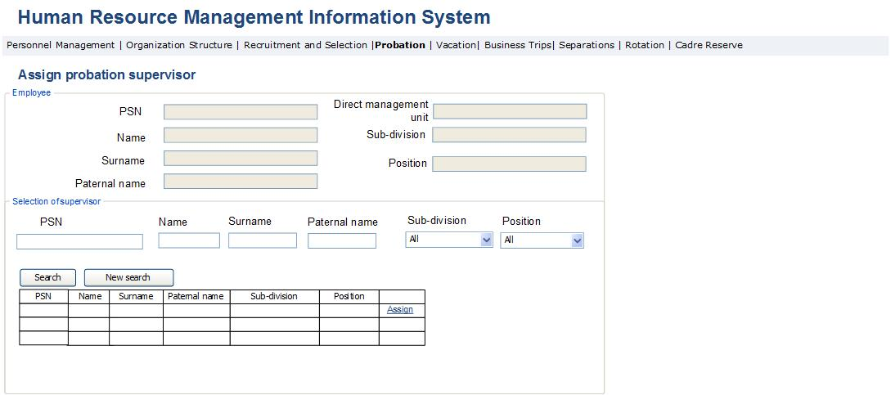

Table 45. Probation supervisor selection form
Field | Type |  | Attributes |  | Initial value | Description
Employee data block
PSN | Text Box |  | Disabled |  |  | Displays the PSN of employee for whom probation supervisor is selected.
First name of employee | Text Box |  | Disabled |  |  | Displays the name of employee for whom the selection of probation supervisor is made.
Surname of employee | Text Box |  | Disabled |  |  | Displays surname of employee for whom the selection of the probation supervisor is made.
Paternal name of employee | Text Box |  | Disabled |  |  | Displays paternal name of employee for whom the selection of the probation supervisor is made.
Direct management unit | Text Box |  | Disabled |  | All | Displays the direct management unit of employee for whom the selection of the probation supervisor is made.
Sub-division | Text Box |  | Disabled |  | All | Displays the sub-division of the employee’s position for whom the selection of the probation supervisor is made.
Position | Text Box |  | Disabled |  | All | Displays the position of employee for whom the selection of the probation supervisor is made.
Probation supervisor’s search block. The search is done only among other employees of the employee’s sub-division.
PSN | Text Box |  |  |  |  | Defines employee’s PSN.
First name | Text Box |  |  |  |  | Defines employee’s name.
Surname | Text Box |  |  |  |  | Defines employee’s surname.
Paternal name | Text Box |  |  |  |  | Defines employee’s paternal name.
Direct management unit | Drop down |  |  |  | All | Defines employee’s direct management unit. The potential values are the list of SRC’s structural units and “All” value.
Sub-division | Drop down |  |  |  | All | Defines employee’s sub-division. The potential values are the list of sub-divisions of SRC’s direct management unit mentioned in the preceding paragraph and “All” value.
Search | Button |  |  |  |  | By pressing the button, a search is done with the indicators reffered to in the preceding paragraph and the results are displayed in the table.
New search | Button |  |  |  |  | By pressing the button, the fields of search section are brought to the initial condition.
Probation supervisor selection table
PSN | Column |  |  |  |  | Displays employee’s PSN.
First name of employee | Column |  |  |  |  | Displays employee’s name.
Surname of employee | Column |  |  |  |  | Displays employee’s surname.
Paternal name of employee | Column |  |  |  |  | Displays employee’s paternal name.
Direct management unit | Column |  |  |  |  | Displays direct management unit, sub-division of employee’s position.
Sub-division | Column |  |  |  |  | Displays sub-division of employee’s position.
Position | Column |  |  |  |  | Displays employee’s last occupied position.
Appoint | Button |  |  |  |  | By pressing the button, the given employee is appointed as the probation supervisor. The “Probation supervisor” data block is activated in his/her employee’s data view module, and the person for whom the given employee has been appointed as the probation supervisor is displayed in the table of those data block with a separate line.

3․8․2 Probation Documents Creation Module
Probation documents creation module is envisaged for the creation of required documents for probation evaluation.
This sub-module is among the sub-module s of HRMIS system and is accessible to all employees with the option of creating their own probation report, to employees considered a probation supervisor with the option of creating a memo of probation and to heads of Sub-divisions with the option of creating the conclusion on probation of employees of their sub-divisions.
Below are the main functionalities of staff list management module:
- The system shall perform the calculation of the employee’s probation period and activate the option of creating a report, conclusion and memo of probation in the case that 5 or less days are left to the end of the probation. Moreover, the employee creates the report, the supervisor creates the memo and the head of Sub-division creates the conclusion. The head of Sub-division shall have the option to create the document only in case of availability of the documents created by the employee and his/her probation supervisor.
Probation documents module consists of the following forms.
Fig. 53. Probation report form
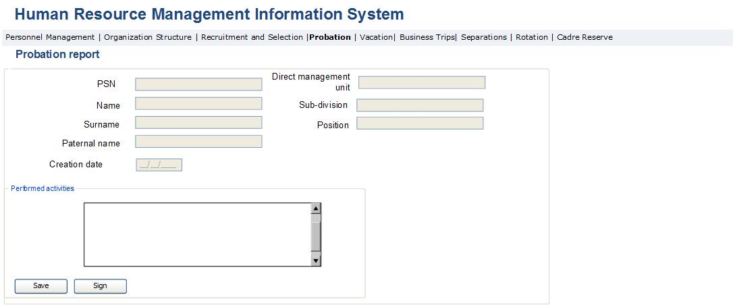

Fig. 54. Printable probation report form
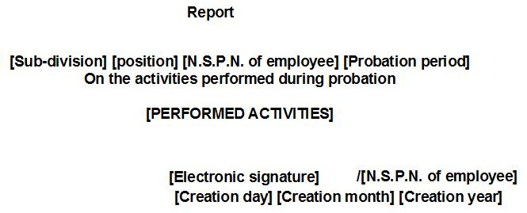

Table 46. Probation report form
Field | Type |  | Attributes |  | Initial Value | Description
Main Data Block
PSN | Text Box |  | Disabled |  |  | Displays employee’s PSN.
First name of employee | Text Box |  | Disabled |  |  | Displays employee’s name.
Surname of employee | Text Box |  | Disabled |  |  | Displays employee’s surname.
Paternal name of employee | Text Box |  | Disabled |  |  | Displays employee’s paternal name.
Direct management unit | Text box |  | Disabled |  |  | Displays direct management unit of employee’s position.
Sub-division | Text box |  | Disabled |  |  | Displays sub-division of employee’s position.
Position | Text box |  | Disabled |  |  | Displays employee’s position.
Date of creation | Text box |  | Disabled |  |  | Displays the date of creation of the document.
Main Data Block
Performed activities | Text box; Multiline |  |  |  |  | The text of the memo is entered in the field by the probation supervisor.
Sign | Button |  |  |  |  | By pressing the button, the electronic signature of the probation supervisor is placed in the field of report document ( Fig. 54) [electronic signature]
Save | Button |  |  |  |  | By pressing the button, the changes done in the form are saved in the system.

Fig. 55. Probation memo form
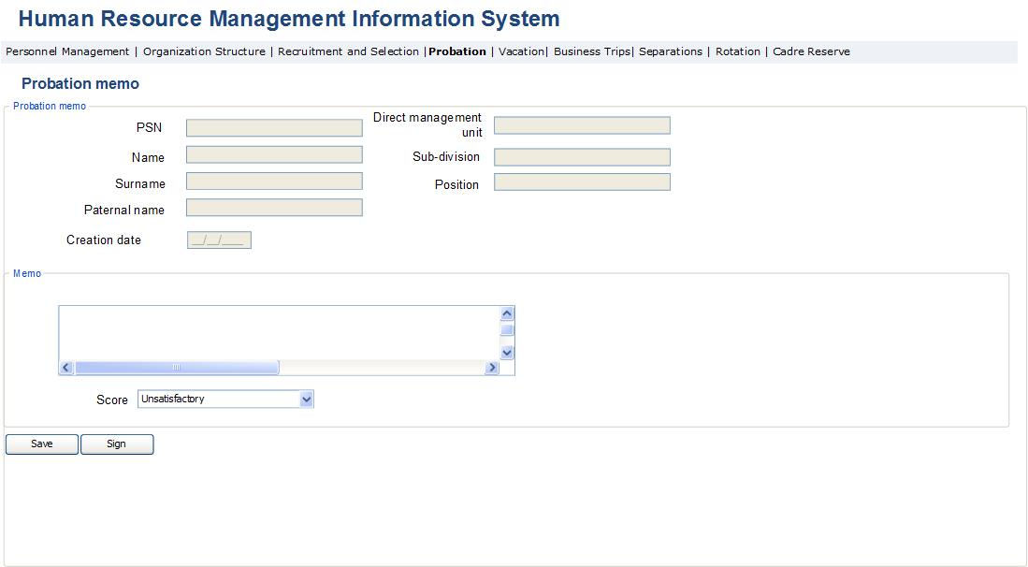

Fig. 56. Report on probation memo
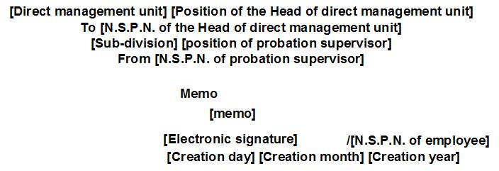

Table 47. Probation memo form
Field | Type |  | Attributes |  | Initial Value | Description
Main Data Block
PSN | Text Box |  | Disabled |  |  | Displays employee’s PSN.
First name of employee | Text Box |  | Disabled |  |  | Displays employee’s name.
Surname of employee | Text Box |  | Disabled |  |  | Displays employee’s surname.
Paternal name of employee | Text Box |  | Disabled |  |  | Displays employee’s paternal name.
Direct management unit | Text box |  | Disabled |  |  | Displays direct management unit of employee’s position.
Sub-division | Text box |  | Disabled |  |  | Displays sub-division of employee’s position.
Position | Text box |  | Disabled |  |  | Displays employee’s position.
Date of creation | Text box |  | Disabled |  |  | Displays the date of document creation.
Main Data Block
Memo | Text box; Multiline |  |  |  |  | The text of the memo is entered in the field by the probation supervisor.
Evaluation | Drop Down |  | Mandatory |  |  | The evaluation of the memo is entered in the field by the probation supervisor.  Potential values are:  - Satisfactory  - Unsatisfactory
Sign | Button |  |  |  |  | By pressing the button, the electronic signature of the probation supervisor is placed in the field of the report document ( Fig. 54) [electronic signature]
Save | Button |  |  |  |  | By pressing the button, the changes done in the form are saved in the system.

Fig. 57. Probation conclusion form
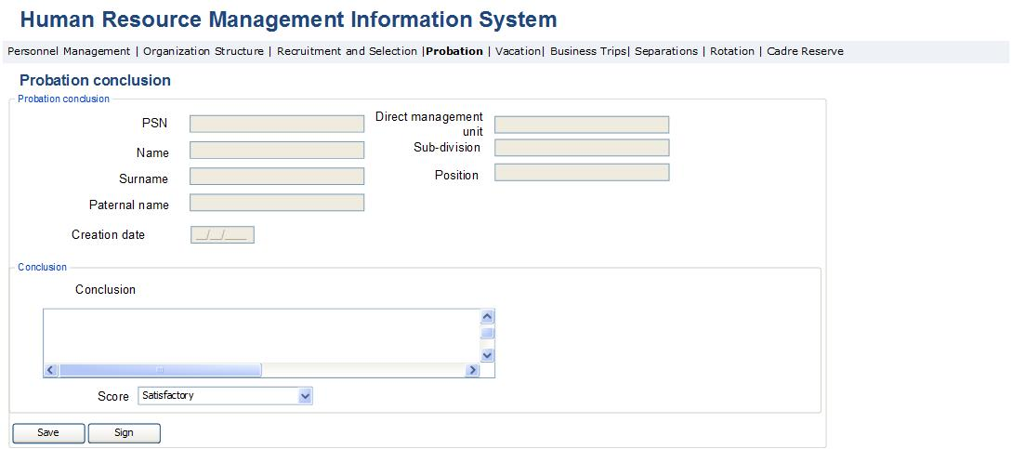

Fig. 58. Report on probation conclusion
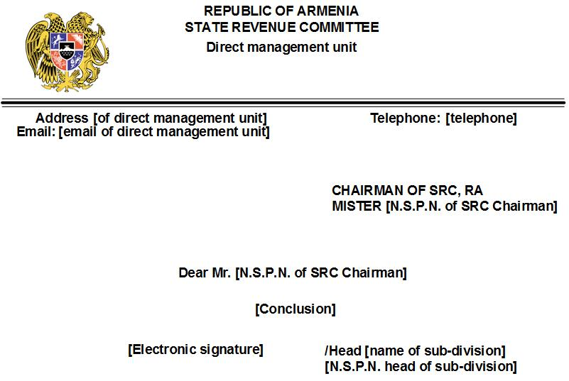

Table 48. Probation conclusion form
Field | Type |  | Attributes |  | Initial value | Description
Main data block
PSN | Text Box |  | Disabled |  |  | Displays employee’s PSN.
Name of employee | Text Box |  | Disabled |  |  | Displays the name of employee.
Surname of employee | Text Box |  | Disabled |  |  | Displays the surname of employee.
Paternal name of employee | Text Box |  | Disabled |  |  | Displays paternal name of employee.
Direct management unit | Text box |  | Disabled |  |  | Displays direct management unit of the position filled by employee.
Sub-division | Text box |  | Disabled |  |  | Displays the sub-division of the position filled by employee.
Position | Text box |  | Disabled |  |  | Displays the position filled by employee.
Date of creation | Text box |  | Disabled |  |  | Displays the date of creating the document.
Main data block
Conclusion | Text box; Multiline |  |  |  |  | The head of sub-division enters the conclusion text in the field.
Score | Drop Down |  | Mandatory |  |  | The head of sub-division enters the probation  Potential values:  - Satisfactory  - Unsatisfactory
Sign | Button |  |  |  |  | By pressing the button, electronic signature appears in the field of report document ( Fig. 56) [electronic signature]
Save | Button |  |  |  |  | By pressing the button, all changes to the form are saved in the system.

Implementation of Employee Separation Administration Module
This sub-module allows automating all processes of employee separation from the State Revenue Committee. This is an HRMIS sub-module and is accessible to SRC Chairman and PMD employees, which enables them to view the list of employees with grounds for separation, and all documents supporting the separation. The SRC Chairman is also authorized to approve or reject the grounds for separating the employee. Heads of structural units can only view the data of their unit personnel. Below are the key functionalities of internal transfers module:
- The system should allow viewing the list of SRC employees with grounds for separation. The employees should be automatically displayed in the list in the following cases: when they complete Employee separation application; when the SRC Chairman rejects the decision on demotion in Internal transfers module, in the case of decision on Separation from work made by the head of direct management due to attestation, or in the case of penalty “Separation from service”; when the contract is not extended; when the vacation is registered through incapacity certificate for more than 4 months throughout 1 year; in the case of retirement age (as a person turns 63); in the case probation is marked unsatisfactory. Where there is another reason for dismissal, it is necessary to search the employee through this module and manually fill in the required grounds for dismissal using the form described in this module.
- It is necessary to enable the Head of Sub-division to view the Separation application, which has been completed, signed and sent for his/her approval, and after making the decision to approve or reject it. In the case of approval, the PMD officer should be enabled to create Separation decree and perform further necessary actions.
- This module should allow creating Separation document once the signed Separation decree is attached to the system, and complete the document by performing mutually binding actions. Afterwards, it is necessary to enable export of the completed Separation document in pdf format for the purpose of performing further action.
- The system should allow generating reports and make analysis using data. Examples of reports:
- Staff turnover level, i.e. the number of employees, exiting SRC over a certain period, divided by the average number of labor force over the same period, in percentages;
- Staff turnover cost, i.e. what costs are made because of labor force turnover over a certain period, e.g. final settlements, severance payments, recruitment and training of new employees etc;
- Average turnover cost, i.e. the ratio of staff turnover cost to the number of exited employees, in percentages (indicates what expenses are required for separating one employee on average)
- Reasons for staff turnover, separately by those separated, e.g. X percent left the organization expecting to earn higher salary;
- Number of separated employees, i.e. the ratio of the number of separated employees over a certain period to the average number of labor force, in percentages. Moreover, the cases initiated by the SRC and by the employee himself/herself can be observed separately.
- Number of retiring employees in percentages.
- The following may serve as separation grounds: Application, Contract expiry, Unsatisfactory attestation score, Disciplinary penalty “Separation from service”, Unsatisfactory score of training, Exceeding number of days entitled for incapacity, Unsatisfactory probation score, Retirement, Death of employee, Reductions, Failure to observe restrictions, Termination of Armenian citizenship, Official investigation outcomes. The last 5 separation grounds are entered through this module. The rest is calculated and displayed automatically in the following principle: If the reason is “Application”, then it is displayed once the separation application is sent for approval by the employee. If the decision of direct management body “Separation from work”, which was made as a result of attestation, is registered in the “Attestation” table of “Personnel data view” module, the given employee should be displayed in the list of employees with separation grounds, where the ground is marked as “Unsatisfactory attestation score”. If the type of Penalty “Separation from service” is registered in the same module, the given employee with grounds for separation should be displayed under the grounds “Separation from service”. Where the contract is not extended, the employee is displayed under the grounds “Contract expiry period”. In the Vacation Administration module, if the vacation is registered with incapacity certificate for more than 4 months within 1 year, the employee should be displayed in this module under the grounds “Exceeding the number of incapacity leave”. As a person retires (turns 63), the employee should be displayed in the list under the ground “Retirement”. If the SRC Chairman qualifies the probation unsatisfactory in the module “Probation administration”, the employee is displayed in the list under the ground “Unsatisfactory probation score”.
- The system should send notification “New separation application” to the email of the Head of Sub-division in the case of preparing, signing and sending the Separation application for approval. If the Head of Sub-division approves or rejects the application, a notification with a content “Your Separation application is approved” or “Your Separation application is rejected” should be sent to the business email of employee. If the signed separation decree is attached in the system, a notification “You are separated from work” should be emailed to the employee on the day of employee separation. When the decree on including in cadre reserve is registered, the employee should should get a notification on his/her personal email with the content “You are included in Cadre reserve”. As the PMD Head signs the separation document, a notification should be sent to the SRC Settlement Department saying “Employee Separation document is signed”.
Employee Separations Administration module is comprised of the following two sub-modules:
- Separated Employee Administration module, designed for managing the Separations process, and
- Separation documents generation module, designed for creating the employee separation application, decree for separation, separation document and the decree on including in cadre reserve.
Below is the description of the forms/pages and the fields they contain, which are all used in the mentioned stages, and also the logic of their operation.

3․9․1 Employee Separation Administration Module
Separated employee administration module is designed for viewing SRC employees with grounds for separation or registering in the employee data list, if the separation grounds are received in hard copy, as well as performing other actions required for implementation of separation process.
This is a HRMIS sub-module. The form for viewing employees with separation grounds is accessible to management and PMD staff enabling to view all employees with separation grounds, as well as to search all SRC employees. The heads of sub-divisions can view the employees of their units with separation grounds and either approve or reject their separation application. The Separation document view form is accessible to the heads of sub-divisions stated in it. These are the Heads of employee’s sub-division and direct management unit, Head of IT Department, Head of Building Administration Department, Head of Secretariat, Head of Weapons’ Storage, Head of Financial Settlement Department and Head of PMD. In the separation document they can have access to only the field of their department:
- The systems should allow viewing the list of SRC employees with separation grounds and perform seach in all SRC employees. Employees must be automatically displayed in the list when the employee completes the Separation application, when the SRC Chairman rejects the decision on demoting the employee in “Internal transfers” module, if the direct management unit made a decision to “Separate from work” in the result of attestation or there is a Penalty “Dismiss from Service”, when the contract is not extended, when registering vacation with incapacity certificate in the “Vacation Administration” module for more than 4 months’ period or within a year or 3 months continually, in the case of retirement (when a person turns 63), in the case of unsatisfactory probation score. If there is another reason for separation, it is necessary to search the employee through this module and manually add the justification for separation in the form described in this module.
- The system should allow generating separation ground for any SRC employee attaching the supporting document and indicating the ground if it is not automatically displayed in this module after they enter respective records in the modules “Internal transfer administration” and “Employee data view”.
- The Head of Sub-division should be enabled to view, approve or decline the separation application prepared, signed and sent for approval by the employee.
- The list of employees with separation grounds should be accessible to the heads of units enabling them to view only the employees of their units. The PMD staff and SRC Chairman should be allowed viewing all SRC employees with separation grounds.
- The separation document form should be accessible to the Head of employee’s Sub-Division, Head of IT Department, Head of Building Administration Department, Head of Secretariat, Head of Weapons’ Storage, Head of Financial Settlement Department and Head of PMD enabling them to view it. The heads of mentioned units have the right to introduce changes only to the field indicating their units. The separation document form displays lines containing the attached separation decrees approved by the SRC Chairman.
The separation module is comprised of the following forms.
Fig. 59. List of employees with grounds for separation
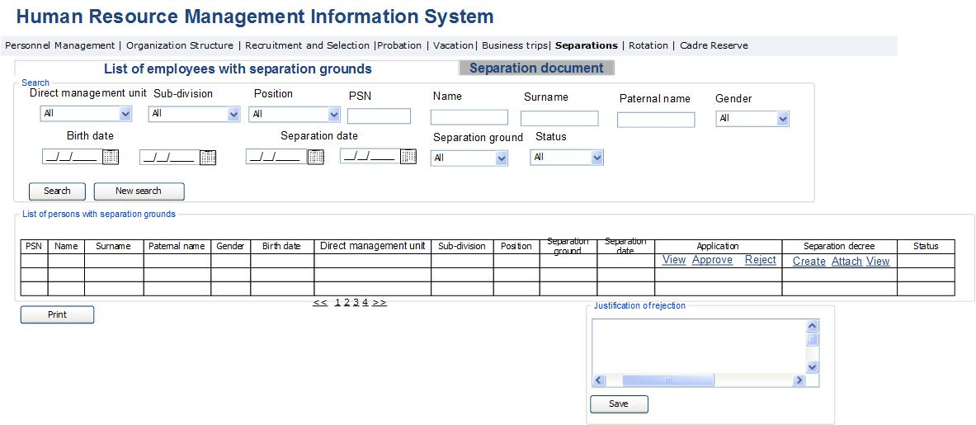

Table 49. Form of employee list with grounds for separation
Field | Type | Attributes |  | Initial value | Description
List of employees with grounds for separation | Button |  |  |  | By pressing the button, the form of employees with separation ground is displayed.
Employee separation certificate | Button |  |  |  | By pressing the button, the separation certificates list is displayed
Search section
Direct management unit | Dropdown | Non-mandatory |  | All | Defines direct management unit of employee, contains the list of structural units in SRC and “All” value.
Sub-division | Dropdown | Non-mandatory |  | All | Defines the employee’s position sub-division. Contains the list of SRC structural units and “All” value. When selecting Direct management unit, all respective Sub-divisions are displayed.
Position | Dropdown | Non-mandatory |  | All | Defines the position of employee. Contains list of SRC positions and “All” value.
PSN | Text Box | Non mandatory |  |  | Defines the PSN of employee.
Name | Text Box | Non mandatory |  |  | Defines the field of employee’s name.
Surname | Text Box | Non-mandatory |  |  | Defines the field of employee’s surname.
Paternal name | Text Box | Non-mandatory |  |  | Defines the field of employee’s paternal name.
Gender | Drop Down | Non-mandatory |  | All | Defines the gender of employee. Potential values:  - All  - Male  - Female
Date of birth | Calendar box | Non-mandatory |  |  | Defines employee’s date of birth. The field is entered in the form of range.
Date of separation | Calendar box | Non-mandatory |  | Current date | Defines the date of separation. The field is entered in the form of range.
Separation grounds | Dropdown | Non mandatory |  | All | Defines the list of Separation grounds, contains that list and “All” value.  Potential values:  - Application  - Contract termination period  - Unsatisfactory result of attestation  - Disciplinary penalty “Dismiss from service”  - Unsatisfactory result of training  - Exceeding the number of entitled incapacity days  - Unsatisfactory probation score  - Retirement  - Employee death  - Reduction  - Failure to observe restrictions  - Termination of RA citizenship  - Official investigation outcomes
Status | Drop Down | Non-mandatory |  | All | Defines Separation application status. Potential values:  - New application/separation ground  - Approved application  - Rejected application  - Generated decree  - Approved decree  - Generated separation document  - Separated
Find | Button |  |  |  | Perform search
New search | Button |  |  |  | Bring the search fields to initial value
Table
PSN | Column |  |  |  | Displays the employee PSN in the Cadre management system.
Name | Column |  |  |  | Displays employee’s name.
Surname | Column |  |  |  | Displays employee’s surname.
Paternal name | Column |  |  |  | Displays employee’s paternal name.
Direct management unit | Column |  |  |  | Displays employee’s most recent position’s direct management unit.
Sub-division | Column |  |  |  | Displays employee’s most recent position’s sub-division.
Position | Column |  |  |  | Displays employee’s most recent position.
Gender | Column |  |  |  | Displays employee’s gender.
Date of birth | Column |  |  |  | Displays employee’s date of birth.
Separation ground | Column |  |  |  | Displays employee’s separation ground:  Potential values:  - Application  - Contract expiry  - Unsatisfactory result of attestation  - Disciplinary penalty “Dismissal from Service”  - Unsatisfactory result of training  - Exceeding the number of entitled incapacity days  - Unsatisfactory probation score  - Retirement  - Employee death  - Reduction  - Failure to observe restrictions  - Termination of RA citizenship  - Official investigation outcomes  The last 5 grounds are entered in this module by creating separation gounds. Employees with all other listed grounds are displayed automatically, according to the principle referred to in the module.
Separation date | Column |  |  |  |  | Displays separation date in the field.
Status | Column |  |  |  | Displays status of separation application. Potential values:  - New application/Separation ground  - Approved application  - Rejected application  - Created decree  - Approved decree  - Separated  The lines on employees with separation grounds or applications send for approval have the status of “New application”  The lines with applications approved by the head of sub-division have the status of “Approved application”.  The lines with applications rejected by the head of sub-division have the status of “Rejected application”.  The lines for which a separation decree was created, have the status of “Created decree”.  The lines which contain attached separation decree signed by the SRC Chairman, have the status of “Approved decree”.  The line with a status “Approved decree” obtains the status “Separated” once the separation date is complete.
Separation decree | Column |  |  |  | The field displays the separation decree.
View | Button |  |  |  | By pressing the button on the upper part of the table in the same page, the view page of employee’s signed separation opens in pdf format (Figure 60).
Approve | Button |  |  |  | The button is accessible only to the head of sub-division. The button is accessible only to the head of sub-division. By pressing the button the separation application is approved and the status of line is changed to “Approved application”. This activates separation decree creation for the given line.
Reject | Button |  |  |  | The button is accessible only to the head of sub-division. By pressing the button the sub-window for entering rejection reason opens and after entering and saving the rejection reason, the application is rejected and line status is changed to “Rejected application”. Rejection reason is displayed in the respective field of rejection application. This line becomes disabled for creating separation decree.
Separation decree | Column |  |  |  | The field displays separation decree.
Create | Button |  |  |  | By pressing the button, the form of separation decree is opened in the upper part of the table in the same page (Fig. 59 and Table 51). When creating separation decree, only the last 5 grounds may be entered in “separation ground” field. For other grounds the mentioned field in the opening form is disabled. The button is accessible only to PMD employee. After creating the decree, the given line obtains the status of “Created decree”. The example of decree is presented in Fig. 61.
Attach | Button |  |  |  | By pressing the button, the window for attaching the separation decree signed by the SRC Chairman in the system, is opened. In the result of attaching the decree, the line presenting that employee is added in the Separation document form. When the decree is attached, the line status changes to “Decree approved”. The button is accessible only to PMD officer. The example of decree report is presented in Fig. 61. When the signed separation decree is attached in the system, on the day indicated in the field Separation date, the following actions are performed in the system: employee’s position becomes “Inactive”; the end date of occupied position is entered along with the start date; employee’s link to the position he/she occupied is removed; and the position field “Vacant” changes to value “Yes”.
View | Button |  |  |  | By pressing the button, the separation decree report for the said employee opens. The button is accessible only to PMD officer. The example of decree report is presented in Fig. 61.
Print | Button |  |  |  | By pressing the button, the lines displayed in table are exported in the form of Excel file.
Sub-window for entering rejection reason
Rejection reason | Text box; Multiline |  |  |  | The field is specified for entering the reason of separation application rejection.
Save | Button |  |  |  | By pressing the button, the reason for rejecting separation application is entered in the system. It is displayed in the relevant field of application form. Once the rejection rason is saved, the status of that line changes to “Rejected application” and the separation decree generation is disabled.

Fig. 60. Separation document view list
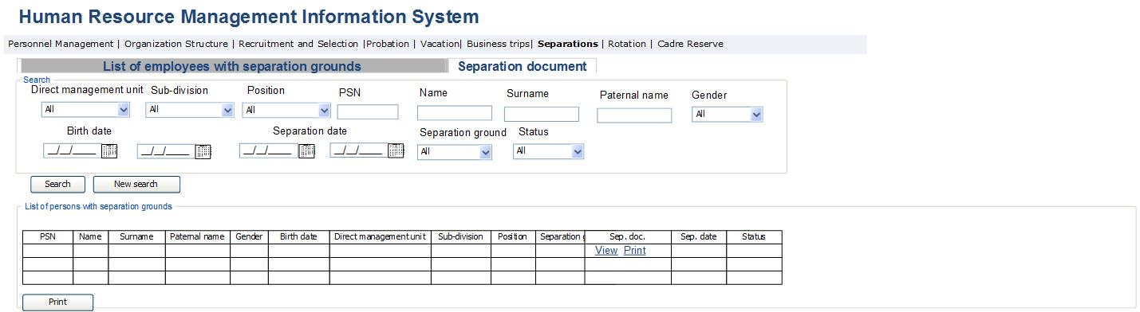

Table 50. Separation document list view form
Field | Type | Attributes |  | Initial value | Description
List of employees with separation grounds | Button |  |  |  | By pressing the button, the employee list form of employees with separation ground is displayed.
Separation document | Button |  |  |  | By pressing the button, the separation document list view form is displayed.
Search section
Direct management unit | Dropdown | Non-mandatory |  | All | Defines direct management unit of employee position. Contains the list of SRC structural units and value “All”.
Sub-division | Dropdown | Non-mandatory |  | All | Defines sub-division of employee’s position. Contain the list of SRTC structural units and value “All”. When choosing direct management unit, it displays all Sub-division.
Position | Dropdown | Non-mandatory |  | All | Defines employee’s position. Contains the list of SRC positions and value “All”.
PSN | Text Box | Non-mandatory |  |  | Defines employee’s PSN.
Name | Text Box | Non-mandatory |  |  | Defines employee’s name field.
Surname | Text Box | Non-mandatory |  |  | Defines employee’s surname field.
Paternal name | Text Box | Non mandatory |  |  | Defines employee’s paternal name field.
Gender | Drop Down | Non-mandatory |  | All | Defines employee’s gender. Potential values:  - All  - Male  - Female
Birth date | Calendar box | Non-mandatory |  |  | Defines employee’s birth date. The field is entered in the form of range.
Separation date | Calendar box | Non mandatory |  | Current date | Defines Separation date. The field is entered in the form of range.
Separation ground | Dropdown | Non-mandatory |  | All | Defines list of separation grounds and value “All”.  Potential values:  - Application  - Expired contract  - Unsatisfactory result of attestation  - Disciplinary penalty “Dismissal from Service”  - Unsatisfactory result of training  - Exceeding the number of entitled incapacity days  - Unsatisfactory probation score  - Retirement  - Employee death  - Reduction  - Failure to observe restrictions  - Termination of RA citizenship  - Official investigation outcomes
Status | Drop Down | Non-mandatory |  | All | Defines Separation application status. Potential values:  - New application/Separation ground  - Approved application  - Rejected application  - Created decree  - Approved decree  - Created separation document  - Separated
Find | Button |  |  |  | Perform search
New search | Button |  |  |  | Bring search fields to original values.
Table
PSN | Column |  |  |  | Displays employee’s PSN in personnel management system.
Name | Column |  |  |  | Displays employee’s name.
Surname | Column |  |  |  | Displays employee’s surname.
Paternal name | Column |  |  |  | Displays employee’s paternal name.
Direct management unit | Column |  |  |  | Displays direct management unit of employee’s most recent position.
Sub-division | Column |  |  |  | Displays sub-division of employee’s most recent position.
Position | Column |  |  |  | Displays employee’s most recent position.
Gender | Column |  |  |  | Displays employee’s gender.
Birth date | Column |  |  |  | Displays employee’s birth date.
Separation ground | Column |  |  |  | Displays employee’s separation ground.  Potential values:  - Application  - Expired contract  - Unsatisfactory result of attestation  - Disciplinary penalty “Dismissal from Service”  - Unsatisfactory result of training  - Exceeding the number of entitled incapacity days  - Unsatisfactory probation score  - Retirement  - Employee death  - Reduction  - Failure to observe restrictions  - Termination of RA citizenship  - Official investigation outcomes  The last five grounds are entered in this module by creating separation grounds. In respect to the rest of the grounds the employees are displayed automatically, according to the principle presented in module description.
Separation date | Column |  |  |  |  | The field displays separation date.
Status | Column |  |  |  | Displays separation application status. Potential values:  - New application/Separation ground  - Approved decree  - Rejected application  - Created decree  - Approved decree  - Separated  The lines on employees with separation grounds or applications send for approval have the status of “New application”  The lines with applications approved by the head of sub-division have the status of “Approved application”.  The lines with applications rejected by the head of sub-division have the status of “Rejected application”.  The lines for which a separation decree was created, have the status of “Created decree”.  The lines which contain attached separation decree signed by the SRC Chairman, have the status of “Approved decree”.  The line with a status “Approved decree” obtains the status “Separated” once the separation date is complete.
Separation document | Column |  |  |  | The field displays separation document.
View | Button |  |  |  | By pressing the button, the separation document form of that employee is opened in the upper part of table (Fig. 63, Table 52). The button is accessible to the heads of sub-division and direct management units and the PMD Head. The button is also accessible to those heads of sub-divisions, for whom the Organization structure administration module is tagged as “display in separation document”.
Print | Button |  |  |  | The button is accessible only to the PMD officer and SRC Financial Settlement Department staff. By pressing the button, the separation document report opens (Fig. 64).
Print | Button |  |  |  | By pressing the button, the lines displayed in the table are exported in the form of Excel file.

3․9․2 Separation Documents Generation Module
Separation documents generation module is designed for creating documents used in the process of employment separation. This is an HRMIS sub-module. The employment separation application/decree generation form is accessible to all SCR employees in terms of application-related fields. The form for completing the application is opened when the “Separation application” button in the personal data view form is pressed. Separation decree fields are accessible only to PMD staff. Separation decree window opens after pressing the button “Create” of the column “Decree” described in Table 49 and Fig. 57. Separation document form is accessible to the Head of Sub-division of employee, Head of IT Department, Head of Building Administration Department, Head of Secretariat, Head of Weapons’ Storage, Head of Financial Settlement Department and the Head of PMD with only view option. The mentioned heads of units can only introduce changes to the separation document lines in respect to their units.
- The system should allow the SRC employee to create the separation application only in the case when pressing the button “Separation application” in the employee’s data view module. When the application is signed, and sent for approval, all further related actions are performed in the Separation administration module.
- The system should enable the PMD officer to generate the separation decree indicating the grounds and attaching the supporting document.
- Separation document must be accessible to the Head of Sub-division of employee, Head of IT Deparment, Head of Building Administration Department, Head of Secretariat, Head of Weapons’ Storage, Head of Financial Settlement Department and the Head of PMD only with view option. The mentioned unit heads have the right to introduce changes to the separation document only in the fields related to their sub-division. The separation document displays the lines containing attached separations decrees which have been approved by the SRC Chairman.
The employment separation document generation module is comprised of the following forms.
Fig. 61. Separation application/decree
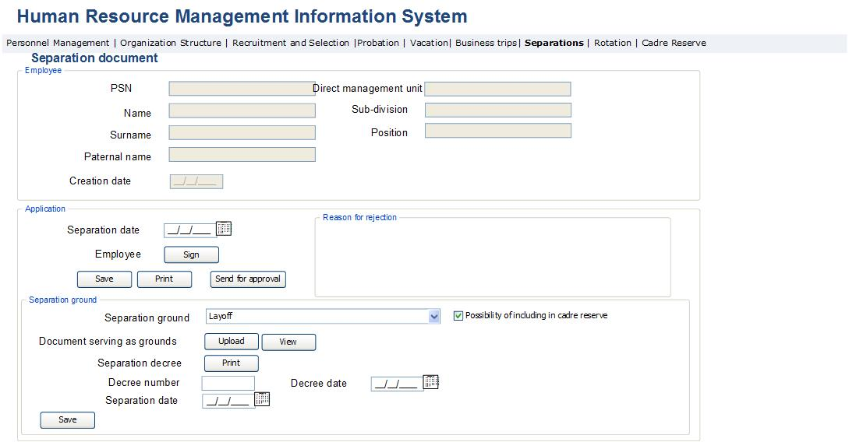
Fig. 62. Separation application report
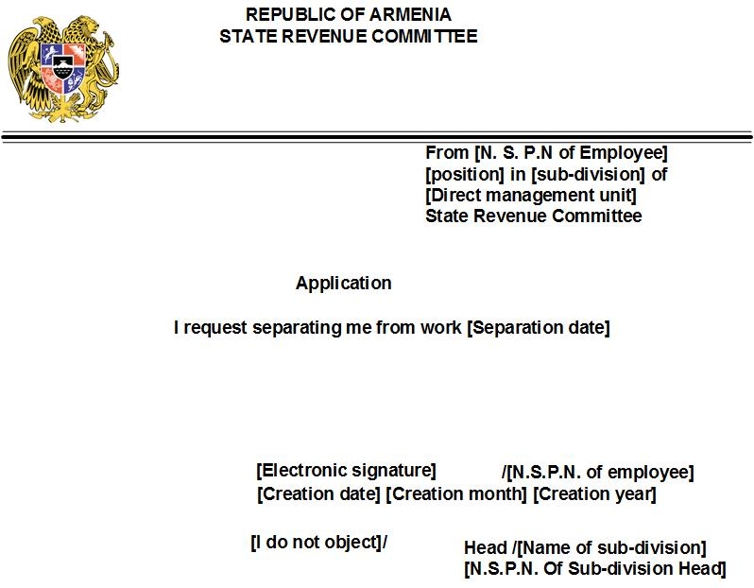

Fig. 63. Employee separation decree report
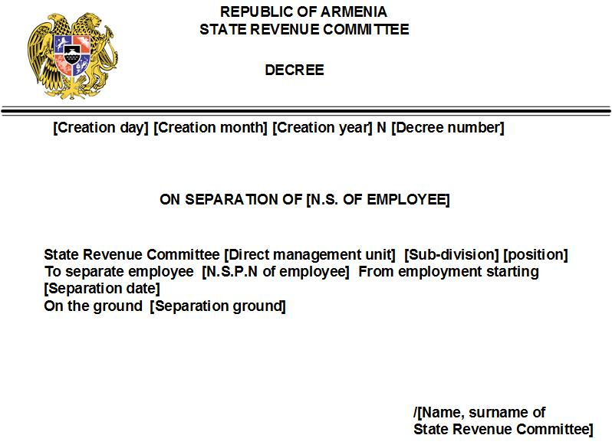

Table 51. Employee separation application and decree generation/view form
Field | Type |  | Attributes |  | Initial value | Description
Main data block
PSN | Text Box |  | Disabled |  |  | Displays employee’s PSN.
Employee name | Text Box |  | Disabled |  |  | Displays employee’s name.
Employee surname | Text Box |  | Disabled |  |  | Displays employee’s surname.
Employee paternal name. | Text Box |  | Disabled |  |  | Displays employee’s paternal name.
Direct management unit | Text box |  | Disabled |  |  | Displays direct management unit of employee's position.
Sub-division | Text box |  | Disabled |  |  | Displays sub-division of employee’s position.
Position | Text box |  | Disabled |  |  | Displays employee’s position.
Creation date | Calendar box |  | Disabled |  | Current Date | The date of creating the document is automatically displayed in the field.
Separation application data block. Displayed only when viewing or completing the separation application of SRC employee. The block is accessible to the SRC employee filing the application.
Separation date | Calendar box |  | Required |  |  | The officer enters the needed separation date.
Sign | Button |  |  |  |  | By pressing the button, the electronic signature of employee appears in the respective field of separation application (Fig. 60).
Save | Button |  |  |  |  | By pressing the button, all changes made to the application data block are saved.
Print | Button |  |  |  |  | By pressing the button, the separation application view page opens in pdf format (Fig. 60).
Send for approval | Button |  |  |  |  | The button activates after the application is signed. By pressing the button, the application is sent for approval. The application is added in the new line of separated employees view module.
Separation ground data block. The block is displayed only after the separation decree is generated. The block is accessible only to PMD officers.
Separation ground | Drop Down |  | Required |  |  | The separation ground is entered or displayed in the field.  Potential values:  - Application (displays in case there is an separation application sent to that employee automatically for approval)  - Expired contract (is displayed automatically when the contract of that employee expires and it’s not extended)  - Unsatisfactory attestation result (displayed automatically when entering the decision of direct management unit “Separate from work” in “Attestation” block of the “Personal Data View” module)  - Disciplinary penalty “Dismiss from service” (displayed automatically when entering the penalty “Separation from service” in the data block “Disciplinary penalties” of “Personal Data View” module)  - Unsatisfactory training result (displayed automatically in the “Training” data block of “Personal Data View” module if scoring lower than 80%, provided the decision of Attestation Commission “Send to Training” is active)  - Exceeding the number of entitled incapacity days (displayed automatically in the “Vacation” data block of “Personal Data View” module, if the vacation provided under the incapacity certificate is over 4 months or 3 months non-stop within one year)  - Unsatisfactory probation score (displayed automatically in case the SRC Chairman scores unsatisfactory the given employee in the “Probation administration” module)  - Retirement (displayed automatically once the employee turns 63)  - Death of employee (entered manually when other grounds are missing)  - Reduction (entered manually when other grounds are missing)  - Failure to observe restrictions (entered manually when other grounds are missing)  - Termination of RA citizenship (entered manually when other grounds are missing)  - Official investigation outcome (entered manually when other grounds are missing)
Separation date | Calendar box |  | Required |  |  | The required date of employee separation is entered in the field.
Possibility to include in Cadre reserve | Check box |  |  |  |  | This field is active only when in the case of “Reduction”. When the field is selected, on the day mentioned in the Separation date, the following actions are perfomed: The status of employee is changed to “Passive” in the “Personnel resources list” module. The line displaying the employee is added to the list of cadre reserve in the “Cadre Reserve” module.
Supporting document | Label |  |  |  |  | The supporting document is displayed in or attached to the field.
View | Button |  |  |  |  | By pressing the button, the view page of the supporting document of separation opens.
Upload | Button |  |  |  |  | By pressing the button, the upload page of the supporting document of separation opens.
Save | Button |  |  |  |  | By pressing the button, all changes made to the given data block fields are saved in the system.
Decree | Label |  |  |  |  | The field displays the separation decree report.
Decree number | Text box |  |  |  |  | The decree number is entered in the field.
Decree date | Calendar box |  |  |  |  | The date of creating separation decree is entered in the field.
Print | Button |  |  |  |  | By pressing the button, the decree view form opens in pdf format (Fig. 61).

Fig. 64. Separation document
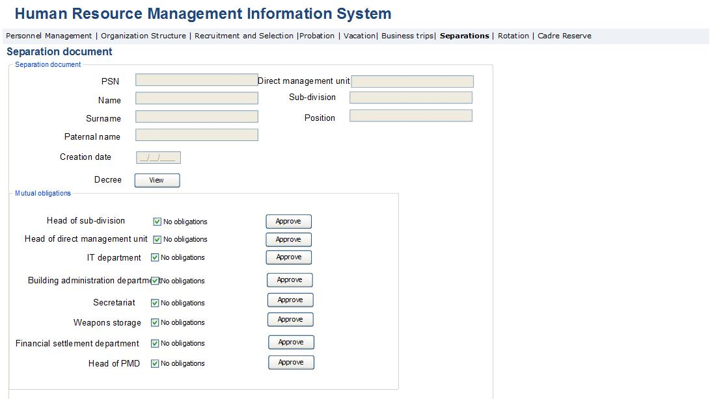
Fig. 65. Separation document report
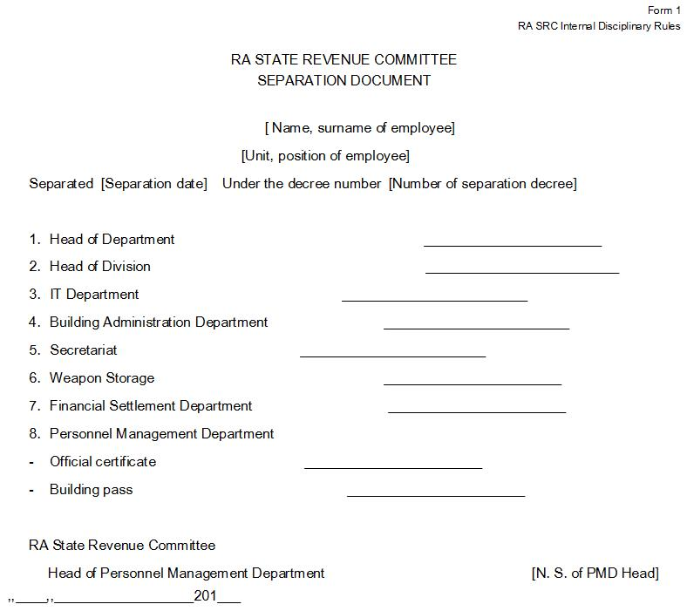

Table 52. Separation document page
Field | Type |  | Attributes |  | Initial value | Description
Separated employee data block
PSN | Text Box |  | Disabled |  |  | Displays employee’s PSN.
Name of employee | Text Box |  | Disabled |  |  | Displays employee’s name.
Surname of employee | Text Box |  | Disabled |  |  | Displays employee’s surname.
Paternal name of employee | Text Box |  | Disabled |  |  | Displays employee’s paternal name.
Direct management unit | Text box |  | Disabled |  |  | Displays direct management unit of employee’s position.
Sub-division | Text box |  | Disabled |  |  | Displays the sub-division of employee’s position.
Position | Text box |  | Disabled |  |  | Displays employee’s position.
Date of generation | Calendar box |  | Disabled |  | Current Date | Document generation date is automatically entered in the field.
Decree | label |  |  |  |  | The Separation decree signed by the SRC Chairman is displayed in the field.
View | Button |  |  |  |  | By pressing the button, the view page of separation decree signed by the SRC Chairman in pdf format is opened.
Mutual obligations data block
Sub-divisions included in the separation document | Label |  |  |  |  | This data block reflects those units, for which are marked “Show in Separation document” in the organization structure management module. Apart from these structural units, the sub-division and other structural units representing the direct management unit are also displayed. In the case of repetitions, only one line indicating the given structural unit is displayed. Only the said head of sub-division has access to modify in every line.
No obligations | Check Box |  |  |  |  | A note is made in the field certifying that the separated person has no obligations towards the given sub-division. The check boxes representing each sub-division is accessible only to the mentioned head of sub-division for making notes. The field is disabled for other units. The field of PMD Head “No obligations” becomes active only after all heads of sub-divisions presented in the list have selected and confirmed the field “No obligations”.
Approve | Button |  |  |  |  | The button is activated by pressing “No obligations” in the respective line. Once the button is pressed, the sub-division indicated in that line confirms the fact that the separated employee doesn’t bear any obligations, and in the relevant line of separation document report the electronic signature of the head of sub-division is entered (Fig. 64).

Administration
This module of the system is designed for defining the parameters underlying the operation of HRMIS. This page will be accessible to the employees of PMD and IT department. The Administration page should be regularly reviewed by the PMD staff to make sure that the system parameters comply with the requirements of the laws. Below are the key functionalities of administration module:
- The parameters presented in the page are grouped according to logical groups. Each group has a separate accessibility.
- All fields of the page are initially opened with the status of View. By pressing the button “Change” for some group, all fields of that group become changeable.
Below are the definitions of Administration page fields:

Fig. 66. Administration
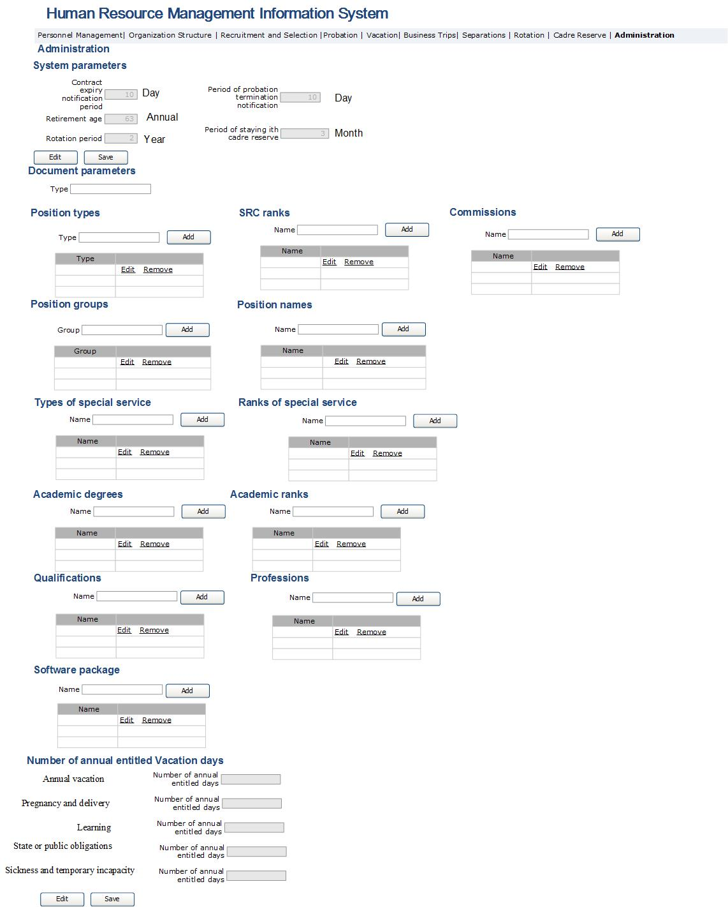

Table 53. Administration page
Field | Type |  | Attributes |  | Initial value | Description
System parameter
Period of contract expiry notification | Text Box |  | Disabled |  |  | Defines how many days before contract expiry does the system send notifications.
Retirement age | Text Box |  | Disabled |  |  | Defines retirement age of employee.
Rotation period | Text Box |  | Disabled |  |  | Defines position rotation periods by years.
Period of probation termination notification | Text Box |  | Disabled |  |  | Defines how many days before probation termination does the system send notifications.
Period of stayng with cadre reserve | Text box |  | Disabled |  |  | Defines how long was the employee kept with cadre reserve.
Edit | Button |  |  |  |  | By pressing the button, all block fields become Enabled and allow changing field values.
Save | Button |  |  |  |  | By pressing the button, the changes made to the given data block fields are entered in the system and the fields are Disabled.
All data blocks
Add | Button |  |  |  |  | By pressing the button in the field Text box of this data block, the entered value is added to that data block list. By pressing the button, the value entered in the text box of the given data block is added to that data block list.
Edit | Button |  |  |  |  | By pressing the button, the possibility of making changes for the given line is enabled. When making changes, the button is replaced by the button “Save”, which if pressed, saves all modifications in the system.
Remove | Button |  |  |  |  | By pressing the button, a question on removing that line appears, which if answered positively, deletes the line from the system.
SRC ranks
SRC rank | Text box |  |  |  |  | The name of SRC rank is entered in the field.
SRC ranks | Column |  |  |  |  | The list of SRC ranks is displayed in the field.
Position types
Type | Text box |  |  |  |  | The added type of position is entered in the field.
Types | Column |  |  |  |  | The list of position types is displayed in the field.
Position groups
Group | Text box |  |  |  |  | The added position group is entered in the field.
Groups | Column |  |  |  |  | The list of position groups is displayed in the field.
Position names
Name | Text box |  |  |  |  | The name of added position is entered in the field.
Names | Column |  |  |  |  | The list of positions names is displayed in the field.
Name
Name | Text box |  |  |  |  | The name of added commission is entered in the field.
Names | Column |  |  |  |  | The list of commissions names is displayed in the field.
Types of special service
Name | Text box |  |  |  |  | The name of added special service is entered in the field.
Names | Column |  |  |  |  | The list of names of RA special services is displayed in the field.
Special service ranks
Name | Text box |  |  |  |  | The name of added special services ranks is entered in the field.
Names | Column |  |  |  |  | The list of ranks appointed in the RA special services is displayed in the field.
Academic grades
Name | Text box |  |  |  |  | The name of added academic grades is entered in the field.
Names | Column |  |  |  |  | The list of academic grades is displayed in the field.
Academic ranks
Name | Text box |  |  |  |  | The name of added academic rank is entered in the field.
Names | Column |  |  |  |  | The list of academic ranks is displayed in the field.
Qualifications
Name | Text box |  |  |  |  | The name of qualification approved by the RA Ministry of Education and Science is entered in the field.
Names | Column |  |  |  |  | The list of qualifications approved by the RA Ministry of Education and Science is displayed in the field.
Professions
Name | Text box |  |  |  |  | The name of the added profession approved by the RA Ministry of Education and Science is entered in the field.
Names | Column |  |  |  |  | The list of professions approved by the RA Ministry of Education and Science is displayed in the field.
Software packages
Name | Text box |  |  |  |  | The name of added software package is entered in the field.
Names | Column |  |  |  |  | The list of software packages is displayed in the field.
Number of entitled annual vacation days
Annual vacation | Label |  |  |  |  | The number of annual entitled vacation days is displayed in the field.
Number of entitled annual vacation days | Text box |  | Disabled |  |  | The number of annual entitled vacation days is entered in the field.
Pregnancy and delivery | Label |  |  |  |  | The number of entitled annual pregnancy and delivery leave days is displayed in the field.
Number of entitled annual vacation days | Text box |  | Disabled |  |  | The number of entitled annual pregnancy and delivery leave days is entered in the field.
Learning | Label |  |  |  |  | The number of entitled annual learning vacation days is displayed in the field.
Number of entitled annual vacation days | Text box |  | Disabled |  |  | The number of entitled annual learning vacation days is entered in the field.
Perform state or public duties | Label |  |  |  |  | The number of entitled annual state or public duties’ vacation days is displayed in the field.
Number of entitled annual vacation days | Text box |  | Disabled |  |  | The number of entitled annual state or public duties’ vacation days is entered in the field.
Sickness and temporary incapacity | Label |  |  |  |  | The number of entitles annual sickness and temporary incapacity days is displayed in the field.
Number of entitled annual vacation days | Text box |  | Disabled |  |  | The number of entitles annual sickness and temporary incapacity days is entered in the field.
Edit | Button |  |  |  |  | By pressing the button, the given data block fields become Enabled and allow modifying field values.
Save | Button |  |  |  |  | By pressing the button, the modifications to the given data block fields are entered in the system and the fields are Disabled.

Implementation of Cadre Reserve Module
Cadre reserve module is envisaged for viewing personal data in Cadre reserve, running Cadre reserve, and based on certain search criteria, create lists of persons included in Cadre reserve. The view window for viewing personal data of persons in Cadre reserve should be the duplicate of the personal file view window.
SRC employees are included in the Cadre reserve when an employee is separated as a result of staff reduction in the tax service, or s/he has been recognized competition winner, but was not appointed to the position. In the case of customs service, apart from the above mentioned grounds, election in selected bodies and failure to go to work as a result of temporary incapacity, when the allowed number of days is expired, ca also serve as grounds for employee separation.
Deregistration of persons from Cadre reserve takes place in the following cases:
- From tax service Cadre reserve: retirement age, appointment to vacant position of tax service, termination of Armenian citizenship, emergence of grounds referring to breach of requirements to restrictions for tax officers, application for delisting from Cadre reserve, termination of period for staying with Cadre reserve;
- From customs service Cadre reserve: retirement age, appointment to vacant position of customs service, termination of Armenian citizenship, emergence of grounds referring to breach of requirements to restrictions for tax officers and his/her appointment, decision made by higher management customs body on separation based on respective application, termination of period for staying with Cadre reserve;
The maximum period for staying with Cadre reserve is three months.
Key functions of Cadre reserve module are the following:
- Electronic Cadre reserve database creation and administration;
- Perform searches/inquiries based on defined criteria in the database, e.g. based on service years, or any specific skill and knowledge, and preparation of lists for respective persons;
- Definition and estimation of Cadre reserve-related indicators and analytical activities;
- Drow lists of candidates based on searches/inquiries made in Cadre reserve for filling vacancy;
- Appointment of the candidate selected from Cadre reserve to vacant position.

Cadre Reserve/Candidate Pool List Module
This sub-module of the system allows to view employee list contained in Cadre reserve and Candidate pool and make searches in the list. It is an HRMIS sub-module and is accessible to the senior managers and PMD employees to view data of persons. PMD employees are also enabled to add new records and edit the data displayed in this module. Main functionalities of Cadre reserve/Candidate pool list module are listed below:
  - View Cadre reserve/Candidate pool list and perform searches based on various criteria;
  - It should allow to recommend and appoint the employee selected in the result of search to contractual position.
The view form of Cadre reserve/Candidate pool list and description of each field is presented below:
Fig. 67․ Cadre reserve/Candidate pool list
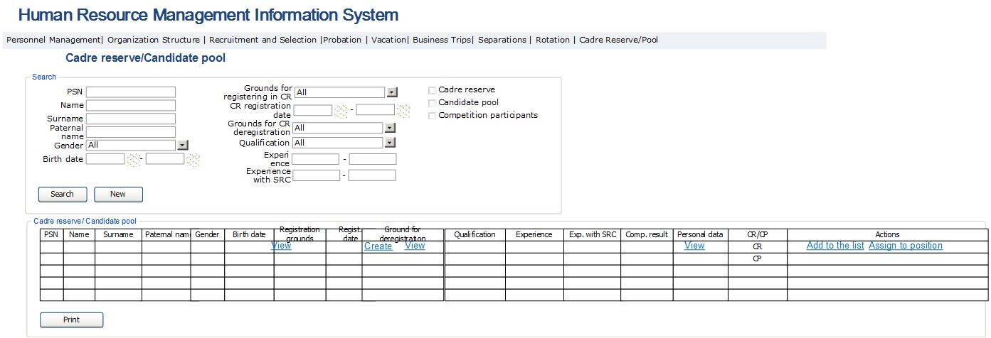

Table 54․ Cadre reserve/Candidate pool list
Field |  | Type | Attributes | Initial value | Description
Search section
PSN |  | Text Box | Non mandatory | All | Defines public services number of person.
Name |  | Text Box | Non mandatory | All | Defines person’s name field.
Surname |  | Text Box | Non mandatory | All | Defines person’s surname field.
Paternal name |  | Text Box | Non mandatory | All | Defines person’s paternal name field.
Gender |  | Dropdown | Non mandatory | All | Defines person’s gender field.  Potential values are:  - All  - Male  - Female
Birth date |  | Calendar box | Non mandatory |  | Defines person’s birth date interval.
Registration date |  | Calendar box | Non mandatory | All | Defines cadre reserve registration date.
Registration grounds |  | Drop Down | Non mandatory | All | Defines the grounds for registering in Cadre reserve. Potential values are:  - All  - Staff reduction  - The candidate not recognized as competition winner  - Temporary incapacity to work  - Election in Election bodies
Grounds for deregistering from Cadre reserve |  | Drop Down | Non mandatory | All | Defines the grounds for deregistering from Cadre reserve. Potential values are:  - All  - Retirement age  - Termination of RA citizenship  - Emergence of grounds referring to breach of requirements to restrictions for officer and his/her appointment  - Application
 | Qualification | Drop Down | Non mandatory | All | Defines the person’s qualification acquired in particular educational institution. Potential values are:  in accordance to the list of the Professions and Qualifications of the RA higher education, as well as “All” value.
 | Work experience | Text box | Non mandatory |  | Defines the total number of years of service outside the SRC system.
 | Work experience in SCR | Text box | Non mandatory |  | Defines the total number of years of service within the SRC system.
 | Cadre reserve | Check box | Non mandatory |  | Defines person’s search only in Cadre reserve.
 | Candidate pool | Check box | Non mandatory |  | Defines person’s search only in Candidate pool.
 | Competition participants | Check box | Non mandatory |  | Defines the search of only those participating in competitions.
Search |  | Button |  |  | Perform search.
New |  | Button |  |  | Bring search field to initial value.
Table
PSN |  | Column |  |  | Displays public services number of employee.
Name |  | Column |  |  | Displays person’s name.
Surname |  | Column |  |  | Displays employee’s surname.
Paternal name |  | Column |  |  | Displays person’s paternal name.
Birth date |  | Column |  |  | Displays person’s birth date.
Gender |  | Column |  |  | Displays person’s gender.
Registration grounds |  | Column |  |  | Displays grounds for including in Cadre reserve.
View |  | Button |  |  | By pressing the button, the form described in Table 55 and Figure 68 opens, displaying only the Registration grounds section of Cadre reserve.
Registration date |  | Column | Non mandatory | All | The field displays the date when employee was registered in Cadre reserve.
Cadre reserve deregistration grounds |  | Column |  |  | The field displays the grounds for deregistering from Cadre reserve (CR). In the case of persons newly registered in CR the given field looks like a row with “View” and “Create” buttons. In the case of deregistered persons, the field is a text which displays the grounds for deregistration.
View |  | Button |  |  | By pressing the button, the form described in Table 55 and Figure 68 opens in view regime to display only the section on removing from CR.
Create |  | Button |  |  | By pressing the button, the form described in Table 55 and Figure 68 opens in entry regime to display only the section on grounds for removing from CR.
 | Qualification | Column |  |  | Displays employee’s qualifications.
 | Work experience | Column |  |  | Displays the total number of years of service outside the SRC system.
 | Work experience in SRC | Column |  |  | Displays the total number of years of service within the SRC system.
 | Competition result | Column |  |  | The field displays most recent total interview and test score received by the given person for the vacancy in SRC.
 | Personal data | Column |  |  | Displays personal data of a person.
 | View | Button |  |  | By pressing the button, personal data view form opens, which in the case of CR is the form described in Employee personal data view model (Figure 70, Table 57). In the case of Candidate pool (CP) the form described in Candidate data view module opens (Figure 70-Figure 73 of this document).
 | CR/CP | Column |  |  | Displays whether particular person is in the CR or CP.
Actions |  | Button |  |  | The field displays the buttons used to perform actions in respect to particular person.
Assign to position |  | Button |  |  | By pressing the button, the form described in Figure 71 and Table 58 of Position assignment module opens, where only contractual positions, or position,s for which the recruitment application was approved, but no competition was announced yet, can be searched.
Add to the list |  | Button |  |  | By pressing the button, the particular person in added to the list of candidates selected for recruitment for a vacancy of Recruitment and Selection module. The form is described in Figure 77 and Table 64.
Print |  | Button |  |  | By pressing the button, the displayed rows are exported from the system in xls format.

Fig.68․ Cadre reserve documents view
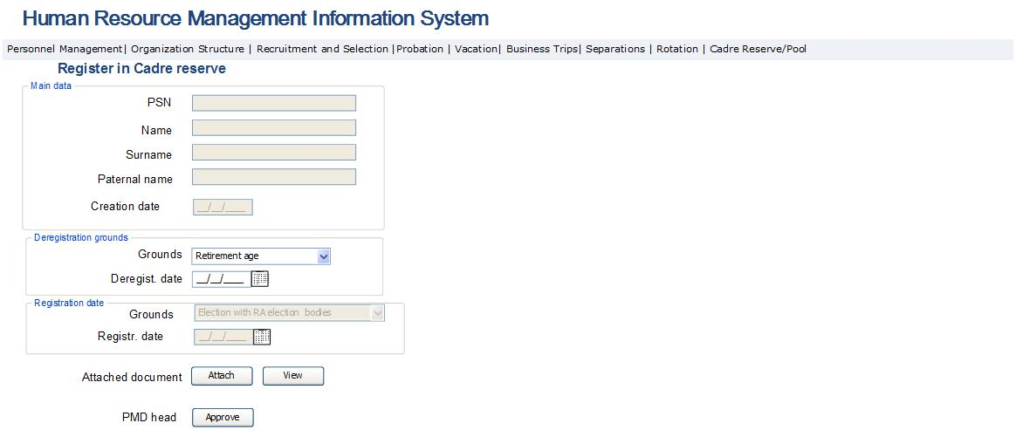
Table 55․ Cadre reserve documents view
Field | Type | Attributes | Initial value | Description
Key data block
PSN | Text Box | Disabled |  | Displays the person’s PSN.
Name | Text Box | Disabled |  | Displays the person’s name.
Surname | Text Box | Disabled |  | Displays the person’s surname.
Paternal name | Text Box | Disabled |  | Displays the person’s paternal name.
Creation date | Text box | Disabled |  | Displays the date of creating the document.
Attached document | Label |  |  | The section displays the decree on registering in Cadre reserve when viewing CR registeration documents, and displays deregistration grounds in case of viewing Cadre reserve deregistration grounds.
Attach | Button |  |  | By pressing the button, the window for attaching pdf document opens in the given form.
View | Button |  |  | By pressing the button, the window for viewing pdf document opens in the given form.
PMD Head | Label |  |  | This field is displayed when deregistering from CR and viewing registration grounds; it is active only for PMD Head, and is designed for approving the grounds for deregistration from CR.
Approve | Button |  |  | This button is only displayed when deregistering from CR and viewing registration grounds, it is active only for PMD Head. When Deregistration grounds data block is displayed, by pressing it on the date mentioned in Deregistration grounds data block, the particular person is removed from CR and his/her data are transferred to CP. When Registration grounds data block is displayed, by pressing the button on the day mentioned in Registration date field that person is registered in CR. In no other cases are the person’s data registered in CR. The data of that person are transferred to CP.
Deregistration grounds data block
Deregistration grounds | Drop Down | Required |  | Deregistration grounds are entered in this field.  Potential values are:  - Retirement age  - Termination of RA citizenship  - Emergence of grounds referring to breach of requirements to restrictions for officer and his/her appointment  - Application
Deregistration date | Calendar box |  |  | Deregistration date is entered in this field. After that date, the system removes the particular employee from CR to CP.
Registration grounds data block
Registration grounds | Drop Down | Disabled |  | The field displays the grounds for registering a person in CR. It is entered in “Separation management” module when creating the decree on registering in CR.  Potential values are:  - Staff reduction  - Passed the competition, but not recognized as winner  - Temporary incapacity  - Election in Election bodies
Registration date | Calendar box |  |  | The field displays CR registration date, which is entered in “Separation management” module when creating the decree on registering in CR.

Implementation of Candidate Pool Module
This module is envisaged for registering all candidate data and information and applying for the vacancy through SRC website. It should be accessible both within SRC and in the SRC website for the purpose of filling the application on internet and including in Candidate pool. This module helps entering personal data, information on education, work experience, knowledge of languages and computer literacy, as well as contact information. Apart from these, it should also enable to attach candidate’s CV and other necessary documents. The lists of candidates entered through that module should be used for selecting a candidate to fill the vacancy in Recruitment and Selection module. This module should also enable to remove the registration on candidate from Candidate pool.
To get included in Candidate pool (CP), the candidates’ data should meet certain defined criteria on competencies, work experience, restrictions for position. In the result, the pool structure is established according to defined competencies, work experience and other criteria.
It has to also enable to seach candidates based on certain competency or any other criteria.
Increased CP efficiency is only possible through high quality data coordination and maintaining their integrity, as well as fast search functional capacities.

Candidate data completion module
This sub-module of the system allows to fill the person’s data in CP to use for the purposes of appointing in contractual or other position. This module should be accessible from the SRC website so that the applicant can fill in his/her data personally and include in CP, as well as within SRC for PMD officers. The latter should be able to enter the hard copy of candidate data into HRMIS through the mentioned module. The module should enable:
      - To register necessary data in the system through SRC website and within HRMIS.
      - Perform entered data accuracy checks.
      - After the registration process through website is finished, the system should send a notification to the registered person’s email with the following content: “Your data is included in SRC Candidate Pool.”
      - When the SRC PMD identifies errors in the registered data registered, s/he should press the button “reject” to remove the records from the system and sends a notification to the registered person’s email with the following content: “Your inclusion in SRC Candidate Pool is rejected.”
The following forms are designed for performing the above-mentioned actions.

Fig. 69․ Candidate registration in the pool: alerts
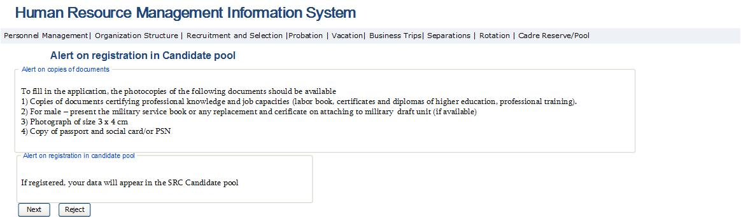

Table 56․ Candidate registration in the pool: alerts
Field | Type | Attributes | Initial value | Description, ratification rules
Key data block
Alert on availability of document copies | Label |  |  | Field displays the need for filling in copies of documents during the completion of application. When opening the form, in the beginning only this alert is displayed.
Alert on registration in pool | Label | Hidden |  | Field displays an alert of registration in pool. The field is displayed when pressing the button Next after displaying the first alert.
Next | Button |  |  | By pressing the button, next step is made. When pressing the first time, the alert is displayed. In case the button is pressed the second time, the form described in Figure 70 opens.
Reject | Button |  |  | By pressing the button, the mentioned form closes.

Fig. 70․ Candidate registration in the pool: personal data
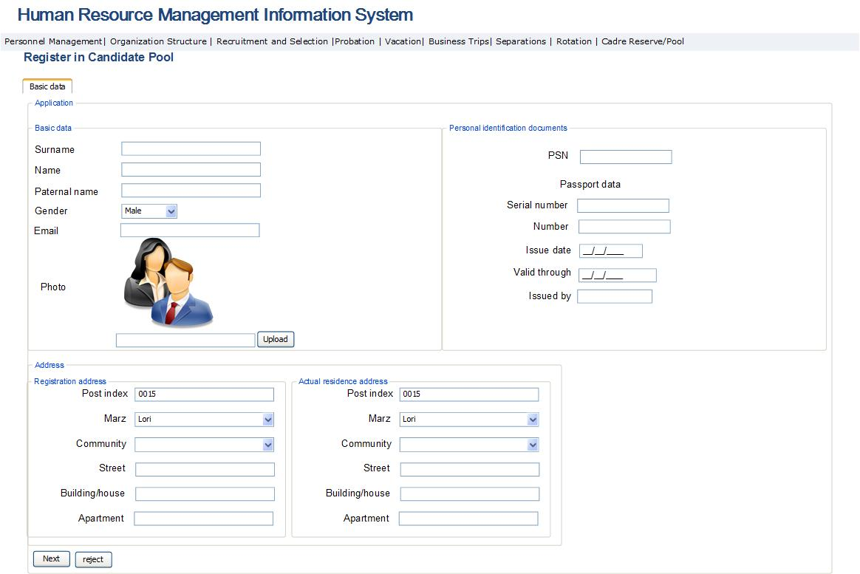

Table 57․ Candidate registration in the pool: personal data page
Field | Type |  | Attributes |  | Initial value | Description, ratification rules
Key data block
Surname | Text Box |  | Mandatory |  |  | The applicant’s surname is entered.
Name | Text Box |  | Mandatory |  |  | The applicant’s name is entered.
Paternal name | Text Box |  | Mandatory |  |  | The applicant’s paternal name is entered.
Photo | Image box |  | Mandatory |  |  | The applicant’s photo is entered.
Upload | Button |  |  |  |  | By pressing the button, a form in jpg format for uploading applicant’s photo opens.
Gender | Dropdown |  | Mandatory |  |  | The applicant’s gender is entered. In case of male, the data block “Service in RA Special Services” opens.  Potential values are:  - Male  - Female
Email | Text box |  | Mandatory |  |  | The email address of applicant is entered in the field.
Identification documents data block
PSN | Textbox |  | Mandatory |  |  | The public services number of the applicant is entered.
Serial number | Textbox |  | Mandatory |  |  | The serial number of the applicant’s ID is entered.
Number | Textbox |  | Mandatory |  |  | The number of the applicant’s ID is entered.
Issued by | Textbox |  | Mandatory |  |  | The issuing body of the applicant’s ID is entered.
Issue date | Calendar box |  | Mandatory |  |  | The issue date of the applicant’s ID is entered.
Validity | Calendar box |  | Mandatory |  |  | The validity period body of the applicant’s ID is entered.
Address data block
Employee registration address data sub-group
Postal index | Text Box |  |  |  |  | Displays the postal index of applicant’s registration address.
Marz | Dropdown |  | Mandatory |  |  | Displays Marz of applicant’s registration address. Potential values are:  - Aragatsotn  - Ararat  - Armavir  - Gegharkunik  - Yerevan  - Lori  - Kotayk  - Shirak  - Syunik  - Vayots Dzor  - Tavush
Community | Dropdown |  | Mandatory |  |  | Displays applicant’s registration address community. The content of the list depends on the selected Marz. The list of communities is registered according to the RA Law on Territorial Division.
Street | Text Box |  | Mandatory |  |  | Displays applicant’s registration address street.
House | Text Box |  | Mandatory |  |  | Displays house number of applicant’s registration address.
Apartment | Text Box |  |  |  |  | Displays apartment number of applicant’s registration address.
Employee actual residence address data sub-group
Postal index | Text Box |  |  |  |  | Displays actual residence postal index of employee.
Marz | Dropdown |  |  |  |  | Displays actual residence Marz of employee. Potential values are:  - Aragatsotn  - Ararat  - Armavir  - Gegharkunik  - Yerevan  - Lori  - Kotayk  - Shirak  - Syunik  - Vayots Dzor  - Tavush
Community | Dropdown |  |  |  |  | Displays the community of actual address. The content of the list depends on the selected Marz. The list of communities is registered according to the RA Law on Territorial Division.
Street | Text Box |  |  |  |  | Actual residence street is displayed.
House | Text Box |  |  |  |  | Actual residence house number is displayed.
Apartment | Text Box |  |  |  |  | Actual residence apartment number is displayed.
Postal index | Text Box |  |  |  |  | Actual residence postal index of the applicant is displayed.
Marz | Dropdown |  |  |  |  | The marz of applicant’s registration address is entered. Potential values are:  - Aragatsotn  - Ararat  - Armavir  - Gegharkunik  - Yerevan  - Lori  - Kotayk  - Shirak  - Syunik  - Vayots Dzor  - Tavush
Community | Dropdown |  |  |  |  | The community of actual address is entered. The content of the list depends on the selected Marz. The list of communities is registered according to the RA Law on Territorial Division.
Street | Text Box |  |  |  |  | Actual residence street is entered.
House | Text Box |  |  |  |  | Actual residence house number is entered.
Apartment | Text Box |  |  |  |  | Actual residence apartment number is entered.
Next | Button |  |  |  |  | By pressing the button, the information entered in the given form is checked. If no mistakes are found, shift to the form described in Figure 71 is made. If mistakes are found, the system displays respective alerts next to each entered field.
Reject |  | Button |  |  |  | The button is displayed only for PMD staff. By pressing it, the application is removed from the system and the applicant receives “Your inclusion in SRC Candidate Pool is rejected by the SRC” note on his/her email.

Fig. 71․ Candidate registration in the pool: education data block
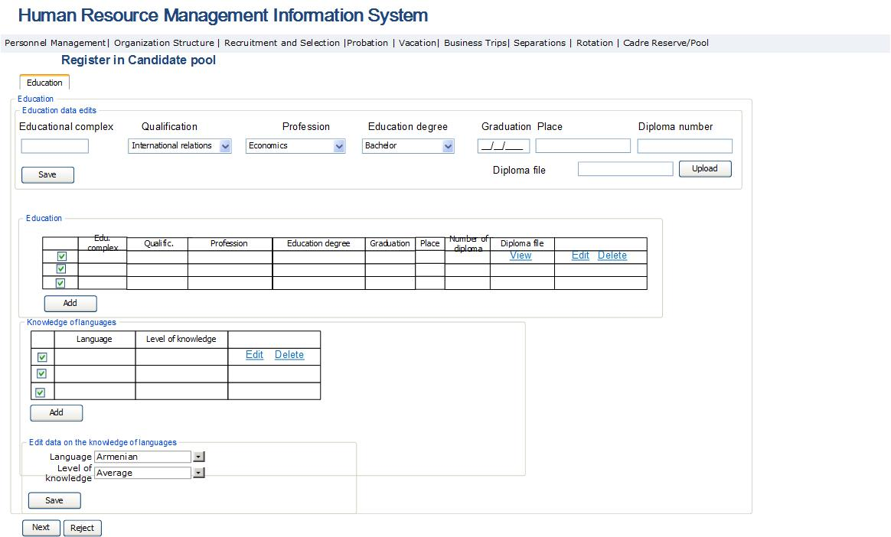

Table 58․ Candidate registration in the pool: education data
Field | Type | Attributes | Initial value | Description, ratification rules
Applicant education data block
Applicant education table
# | Column |  |  | This field is a Checkbox Type field designed for selecting the row.
Educational complex | Column |  |  | Educational complex name is displayed.
Qualification | Column |  |  | Displays the qualification the applicant obtained in that educational complex. Potential values: by the list of specialties and qualifications of the RA vocational education.
Specialty | Column |  |  | Displays the main specialty acquired by employee in the particular educational institution. Potential values: by the list of specialties and qualifications of the RA vocational education.
Degree | Column |  |  | Displays the degree obtained by the particular applicant in that educational complex. Potential values are:  - Specialist with diploma  - Bachelor  - Masters  - Candidate of Sciences  - Doctor of Sciences
End | Column |  |  | Displays the date of graduating from the particular educational institution.
Place | Column |  |  | Displays the address of the particular educational complex.
Diploma number | Column |  |  | Display the diploma number.
Diploma file | Column |  |  | Displays the diploma copy file in pdf format.
View | Column |  |  | By pressing the button, the view form of diploma copy opens in pdf format.
Edit | Button |  |  | The applicant’s education table editing block opens in edit mode.
Delete | Button |  |  | By pressing the button, a permission to delete the given row opens, and when answered positively the selected row is removed from the system.
Add | Button |  |  | By pressing the button, the table data edit row opens in new data entry mode.
Applicant’s education table editing block. Displayed in the case of adding a new row or editing existing row in the table.
Educational complex | Text Box | Required |  | The name of educational complex is entered.
Qualification | Dropdown | Required |  | The qualification the applicant obtained in that educational complex is entered. Potential values: by the list of specialties and qualifications of the RA vocational education.
Specialty | Dropdown | Required |  | The main specialty acquired by employee in the particular educational institution is entered. Potential values: by the list of specialties and qualifications of the RA vocational education.
Degree | Dropdown | Required |  | The degree obtained by the particular applicant in that educational complex is entered. Potential values are:  Specialist with diploma  Bachelor  Masters  Candidate of Sciences  Doctor of Sciences
End | Calendar box | Required |  | The date of graduating from the particular educational institution is entered.
Place | Text box | Required |  | The address of the particular educational complex is entered.
Diploma number | Text box | Required |  | The diploma number is entered.
Diploma file | File box | Required |  | The diploma copy file is entered.
Upload | Button |  |  | By pressing the button, the diploma copy file is uploaded in the system.
Save | Button |  |  | By pressing the button, the data entered in the fields is saved.
Language knowledge data block
# | Column |  |  | The field is a Checkbox Type field designed for selecting the row.
Language | Column |  |  | Displays the name of necessary language comprised of the following items:  - Armenian  - Russian  - English
Level of knowledge | Column |  |  | Displays the level of language level. Potential values are:  - Basic  - Average  - Advanced
Edit | Button |  |  | Opens applicant’s language knowledge table editing block and the selected row in edit mode.
Delete | Button |  |  | By pressing the button, a permission to delete the given row opens, and when answered positively the selected row is removed from the system.
Add | Button |  |  | By pressing the button, the table data edit row opens in new data entry mode.
Editing the language knowledge data block
Language | Drop down |  |  | The name of necessary language comprised of the following items is entered:  - Armenian  - Russian  - English
Level of knowledge | Drop down |  |  | The language knowledge level is entered. Potential values are:  - Basic  - Average  - Advanced
Save | Button |  |  | By pressing the button, the table data editing row is opened in data entry mode.
Next | Button |  |  | By pressing the button, the information entered in the given form is checked. If no mistakes are found, shift to the form described in Figure 72 is made. If mistakes are found, the system displays respective alerts next to each entered field. The error check is the following: each table should contain at least one row entered.
Reject | Button |  |  | The button is displayed only for PMD staff. By pressing it, the particular application is removed from the system and the applicant receives “Your inclusion in SRC Candidate Pool is rejected by the SRC” note on his/her email.

Fig. 72․ Candidate registration in the pool: work experience
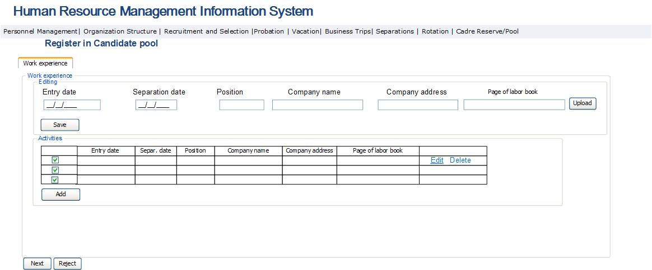

Table 59․ Candidate registration in the pool: work experience

Field | Type | Attributes | Initial value |  |  | Description, ratification rules
Job activity data block
Job activity table
# | Column |  |  |  |  | The field is a Checkbox Type field designed for selecting the row.
Entry date | Column |  |  |  |  | Entry date to the given company is entered.
Separation date | Column |  |  |  |  | Separation date from the given company is entered.
Position | Column |  |  |  |  | Occupied position is entered.
Company name | Column |  |  |  |  | Company name is entered.
Company address | Column |  |  |  |  | Company address is entered.
Employment record book | Column |  |  |  |  | The page confirming the given employment is uploaded.
Edit | Button |  |  |  |  | The job activity table editing block is opened in edit mode.
Delete | Button |  |  |  |  | By pressing the button, a permission to delete the given row opens, and when answered positively the selected row is removed from the system.
Add | Button |  |  |  |  | Opens table data editing block in add mode.
Job activity table editing block
Entry date | Calendar box | Required |  |  |  | Entry date to the given company is entered.
Spetaration date | Calendar box | Required |  |  |  | Separation date from the given company is entered.
Position | Text box | Required |  |  |  | Occupied position is entered.
Company name | Text box | Required |  |  |  | Company name is entered.
Company address | Text box multi-row | Required |  |  |  | Company address is entered.
Employment record book file | File Box |  |  |  |  | The page confirming the given employment is uploaded.
Next | Button |  |  |  |  | By pressing the button, the information entered in the given form is checked. If no mistakes are found, shift to the form described in Figure 73 is made. If mistakes are found, the system displays respective alerts next to each entered field. The error check is the following: each table should contain at least one row entered.
Reject | Button |  |  |  |  | The button is displayed only for PMD staff. By pressing it, the particular application is removed from the system and the applicant receives “Your inclusion in SRC Candidate Pool is rejected by the SRC” note on his/her email.

Fig. 73․ Candidate registration in the pool: service in RA Armed Forces
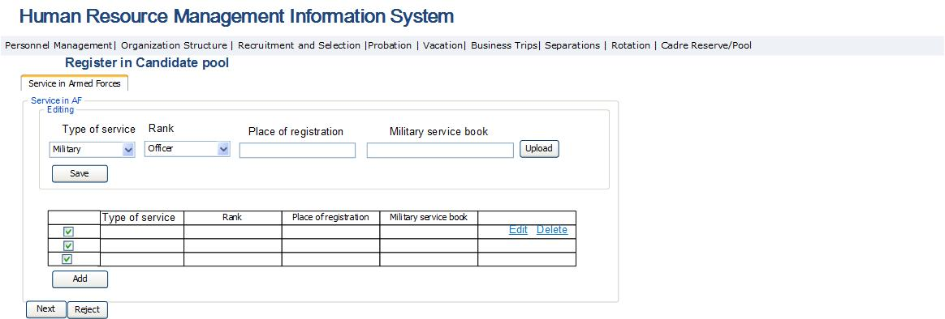

Table 60․ Candidate registration in the pool: service in RA Armed Forces
Field | Type | Attributes | Initial value |  |  | Description, ratification rules
Service in RA Armed Forces data block
Service in RA Armed Forces table
# | Column |  |  |  |  | The field is a Checkbox Type field designed for selecting the row.
Type of service | Column |  |  |  |  | The applicant’s special service type is entered. Potential values are:  - Police service  - National Security Service  - Military service
Rank | Column |  |  |  |  | Special service rank of applicant is entered. Potential values are:  - Warrant Officer  - Senior Warrant Officer  - Junior Lieutenant  - Lieutenant  - Senior Lieutenant  - Captain  - Major  - Lieutenant Colonel  - Colonel  - Major General  - General-Lieutenant  - General-Colonel
Place of military registration | Column |  |  |  |  | The place of military registration is entered.
Military service book file | Column |  |  |  |  | Military service book file is entered in pdf format.
Edit | Button |  |  |  |  | The Service in RA Armed Forces table edit block is opened with the selected row in edit mode.
Delete | Button |  |  |  |  | By pressing the button a permission to delete the given row opens, and when answered positively the selected row is removed from the system.
Add | Column |  |  |  |  | Table data editing block opens in Add mode.
Service in RA Armed Forces table data editing block
Type of service | Dropdown |  |  |  |  | The applicant’s special service type is entered. Potential values are:  - Police service  - National Security Service  - Military service
Rank | Dropdown |  |  |  |  | Special service rank of applicant is entered. Potential values are:  - Warrant Officer  - Senior Warrant Officer  - Junior Lieutenant  - Lieutenant  - Senior Lieutenant  - Captain  - Major  - Lieutenant Colonel  - Colonel  - Major General  - General-Lieutenant  - General-Colonel
Place of military registration | Text box |  |  |  |  | The place of military registration is entered.
Military service book file | File box |  |  |  |  | Military service book file is entered in pdf format.
Save | Button |  |  |  |  | Saves changes made to the editing block fields of Service in Armed Forces.
Next | Button |  |  |  |  | By pressing the button, the information entered in the given form is checked. If no mistakes are found, shift to the form described in Figure 74 is made. If mistakes are found, the system displays respective alerts next to each entered field. The error check is the following: each table should contain at least one row entered.
Reject | Button |  |  |  |  | The button is displayed only for PMD staff. By pressing it, the particular application is removed from the system and the applicant receives “Your inclusion in SRC Candidate Pool is rejected by the SRC” note on his/her email.

Fig. 74․ Candidate registration in the pool: CV and other documents
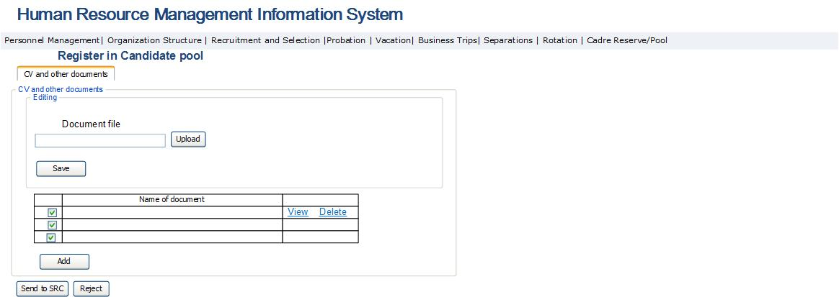

Table 61․ Candidate registration in the pool: CV and other documents
Field | Type | Attributes | Initial value |  |  | Description, ratification rules
Attached documents data block
Attached documents table
# | Column |  |  |  |  | The field is a Checkbox Type field designed for selecting the row.
Document name | Column |  |  |  |  | The field displays document fine name.
View | Button |  |  |  |  | By pressing the button, the document file uploaded in pdf format is displayed.
Delete | Button |  |  |  |  | By pressing the button a permission to delete the given row opens, and when answered positively the selected row is removed from the system.
Add | Column | File box |  |  |  | Table data editing block opens in Add mode.
Editing block of attached documents table
Document file | Column |  |  |  |  | Field displays document file.
Upload | Button |  |  |  |  | By pressing the button, the form for uploading the document file in pdf format opens.
Save | Button |  |  |  |  | By pressing the button, all changes made are saved in the system.
Send to SRC | Button |  |  |  |  | By pressing the button, the information entered in the particular form is checked. In case no errors were found, the data entered in Figure 70 - Figure 74 is sent to the SRC HRMIS for registering in the Candidate pool. When the system saves the data in the system, the applicant receives “Your data are included in the SRC Candidate pool” note on his/her email. If mistakes are found, the system displays respective alerts next to each entered field. The error check is the following: each table should contain at least one row entered.
Reject | Button |  |  |  |  | The button is displayed only for PMD staff. By pressing it, the particular application is removed from the system and the applicant receives “Your inclusion in SRC Candidate Pool is rejected by the SRC” note on his/her email.

Implementation of Selection and Recruitment Module
This module is designed for automation of recruitment process. The module should include the following functions:
- Creation and confirmation of vacancy selection and recruitment;
- Enable selecting candidates from Cadre Reserve (CR) and Candidate Pool (CP);
- In case no candidate is selected, create competition announcement and start the competition process;
- Collection of necessary documents from competition participants through SRC website and HRMIS Recruitment and Selection module;
- Process and check of received data, selection of competition participants;
- In the stage of tests and interviews, exchange of data with automated testing system;
- Selection of competition winner;
- Appointment of the winner in the position.
The recruitment and selection process is implemented in the following sequence:
- Selection and recruitment application is created by the head of sub-division (in the case of sub-divisions under the SRC Deputy Chairmen – to agree with them). After that, the recruitment application should be approved by the SRC Chairman.
- In case the recruitment application is approved, the PMD provides the list of candidates to the SRC Chairman, which are developed based on the personal data registered in CR and CP. When the SCR Chairman makes the selection, the module should allow selecting the candidate to appoint to the vacant position.
- In case the candidate is not selected, the module should enable creating the competition announcement for filling the vacancy.
- After the competition is announced, the module should contain forms in order to register and control the documents received from the participants. The candidates should also be enabled to file necessary data and documents through the SRC website.
- The module should allow selecting competition participants in the result of processing obtained data and arrange data exchange with automated testing system to incorporate the test and interview results in the system and select the winner based on the obtained data.
- In case a competition winner is selected, the system should allow appointing the winner to the vacant position.

The module should enable genering report of the following types (can be mentioned with the Armenian letters)

- Duration of recruitment cycle
- Recruitment level
- Average performance score of new employees
- Average weight of employees separated within the first year based on their application (voluntarily)
- Average weight of employees dismissed within the first year
- Cadre flow/turnover cost for the first year
- Satisfaction of manager with the performance of new employees
- Satisfaction of sub-division heads with recruitment and selection process
- Average weight of selection sources (public sector, tax and customs services, private sector)
The processes implemented in Selection and Recruitment module are divided into four sub-stages, which are as follows:
- Recruitment process launch sub-module: in this module, after the PMD officers receive the requests created for filling the vacancy and approved by the Chairman, they attach it within the system. A candidate list is prepared for these positions, which includes candidates from CR, CP and/or personnel database. In case no selection is made from that list within fifteen days’ time, or in case the Chairman makes respective decision, the option of holding a competition is activated. It is then processed, approved and published on the SRC website with related documents. After the publication, the process moves to the next module.
- Application registration and responding sub-module: in this module the applications are received, processed, checked, and for each applicant a personal file is developed with respective documents, the documents are discussed by the Commission members resulting in the applicant being permitted or prohibited to participate in the competition, after which each applicant is notified about his/her participation in the competition.
- Final selection and appointment to the position sub-module, which implements data exchange with the automated testing system, and based on received data, selection of winner and appointment to the relevant vacancy.

3․13.1 Recruitment Process Launch Sub-Module
In this sub-module a candidate list is developed for the purpose of filling the vacancies available in the recruitment application, which includes persons from CR, HR pool and/or in the personnel database. If the SRC Chairman doesn’t make a selection from that list, the Competition Commission makes a decision on holding a competition, based on which the competition announcement is generated and published.
This sub-module is an HRMIS sub-module and is accessible to the management personnel and PMD Department staff to view data of SRC vacancies. Key functionalities of vacation management module are presented below:
- The system should enable the PMD officers to view the vacancies in recruitment requests and create candidate lists for each position.
- The system should allow the SRC Chairman to view the candidate lists created by the PMD and select a candidate to fill the vacancy.
- The system should allow creating competition announcement if no candidate was selected.
- The vacancy table displays the vacancies with and without attached requests.
- In case the Chairman sends the Recruitment request or approves the Recruitment request, within 15 days’ time if no candidate is selected by the Chairman, a Request should be sent to the email of PMD respective unit officer saying “[Direct management unit] [Sub-division][type of position][position] to declare competition for vacancy”. “Hold a competition” button is activated for the given vacancy.
- During the creation of competition announcement in the system as the documents are uploaded in the system, the latter should perform checks of the name and content of the document. Only the following can be attached to the competition announcement:
- Competition test questionnaire
- List of legal acts used to develop the questionnaire
- Application to the Competition and Attestation Commission (form)
- Applicant’s announcement (form) on restrictions or conditions prescribed by the law (related person, health condition etc)
- Description of tax or customs service vacancy
Recruitment process launch sub-module consists of the following figures: The forms described in Figure 75 -77 are accessible only to the PMD, while the one pictures in Figure 78 is accessible only to SRC Chairman.

Fig. 75․ List of SRC vacant positions
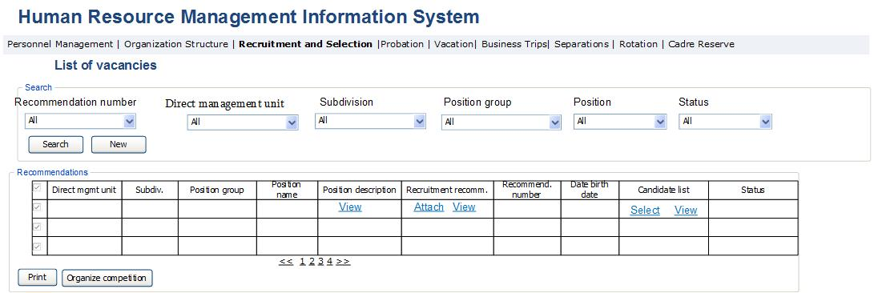

Table 62․ List of SRC vacant positions
Field | Type | Attributes | Initial value | Description, ratification rules
Search section
Number of request | Dropdown | Not Mandatory | All | Field defines sequential number of recruitment application. Contains entered requests numbers and value “All”.
Direct management unit | Dropdown | Not Mandatory | All | Defines the list of direct management units of SRC sub-divisions. The list contains all SRC sub-divisions and “All” value.
Sub-division | Dropdown | Not Mandatory | All | Defines the list of sub-divisions. ների ցանկը։ The list contains all SRC sub-divisions and “All” value.
Position group | Dropdown | Not Mandatory | All | Defines the list of positions group. The list contains all SRC sub-divisions and “All” value.
Position name | Drop Down | Not Mandatory | All | Defines the list of positions' names. Includes the positions of the group mentioned in the previous clause and “All” value.
Status | Drop Down | Not Mandatory | All | Defines the information status list of the given table. Potential values are:  - All  - Vacant  - Request approved  - Candidate list created  - Candidate list approved  - Candidate selected  - Sent for holding competition  - Competition launched
Search | Button |  |  | Perform search.
New | Button |  |  | Bring search fields to intitial values. Bring search fields to intitial values.
Recruitment application view page
# | Column |  |  | The field is a Checkbox Type field designed for selecting the row.
Number of request | Column |  |  | The field displays the number of request.
Recruitment request date | Column |  |  | Displays requestion creation date.
Direct management unit | Column |  |  | Displays direct management unit of vacancy.
Sub-division | Column |  |  | Displays sub-division of vacancy.
Position group | Column |  |  | Displays position group of vacancy.
Position name | Column |  |  | Displays the name of vacancy.
Position description | Column |  |  | Displays the description of the given vacancy.
View | Button |  |  | Opens the view window of the given position description, which is described in “SRC staff management module” section.
Request | Column |  |  | Displays the request for filling the given vacancy.
Attach | Button |  |  | Opens the form for attaching the request in the system. The form is described in Table 63 and Figure 76. After pressing that button and attaching the request, the status of vacancy changes to “Request approved”.
View | Button |  |  | Opens the window of viewing the recruitment request file in pdf format.
Status | Column |  |  | Displays the information status of the given table. Potential values are:  - Vacant  - Request approved  - Candidate list created  - Candidate list approved  - Candidate selected  - Sent for holding competition  - Competition launched  Vacant positions have the status “Vacant”.  Vacancies attached to approved recruitment requests have the status “Request approved”.  Those vacant positions, for which candidate list was developed through Figure 75,77 and Table 62,64, have the status “Candidate list created”.  Those vacant positions, for which candidate list was created and approved by the PMD through Figures 75,77 and Tables 62,64 have the status “Candidate list approved”.  Those vacant positions, for which the SRC Chairman has selected a candidate through Figure 78 and Table 65 have the status “Candidate selected”.  Those vacant positions, for which the SRC Chairman requested to hold competition, or those vacancies for which no candidate was selected within 15 day period after the approval of the Request, shall have the status “Sent for holding competition”.  Those vacant positions, for which competition was announced have the status “Competition launched”.
Candidate list | Column |  |  | Displays the list of candidates selected for filling the vacancy.
Select | Button |  |  | The button is activated for the SRC Chairman to attached the approved the Recruitment request. By pressing the button, Candidate selection form described in Figure 77 and Table 64 to select candidates for filling the vacancy. The button is active only in case the Recruitment request is available. The button is accessible only for PMD staff. After the candidate is selected and the list is approved, the button “Send for Chairman’s approval” activates.
View | Button |  |  | By pressing the button, the form for selecting a person from candidate list described in Figure 74 and Table 61 opens. The button is activated only in the case of availability of candidates selected under the previous clause. The button is active only in the case of availability of candidates selected under the previous clause. The button is accessible only to the SRC Chairman.
Print | Button |  |  | By pressing the button, the rows displayed in the table are exported in xls format.
Review | Button |  |  | The button is activated in the result of creating candidate list. The button is accessible only to the SRC Chairman. By pressing the button, the Candidate list is enabled to change, for which the “Select” button of Candidate list column is activated, and the View button is disabled.
Hold competition | Button |  |  | By pressing the button, the option to create competition announcement is activated. The form described in Figure 79 and Table 66 opens. The button is activated parallel with the activation of requests button “Sent for holding competition”.

Fig. 76․ Recruitment request
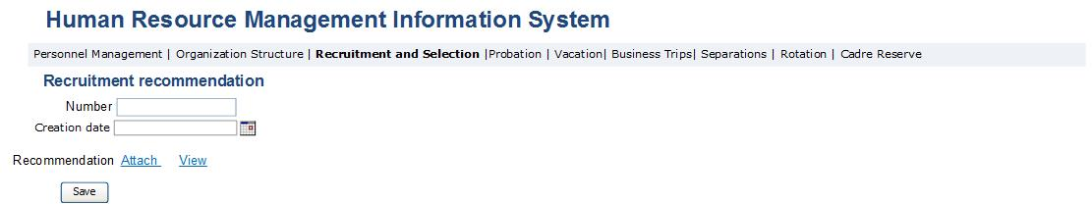

Table 63․ Recruitment request
Field | Type | Attributes | Initial value | Description, ratification rules
Number | Text box | Mandatory |  | Sequential number of request is entered in the field.
Date | Calendar box | Mandatory | Current Date | Request creation date is entered in the field.
Request | Label |  |  | Request file is uploaded and displayed in the field in pdf format.
Attach | Button |  |  | By pressing the button, the window for uploading the request file in pdf format opens.
View | Button |  |  | By pressing the button, the window for viewing the request file in pdf format opens.
Save | Button |  |  | By pressing the button, the form of filled in request is saved in the database.

Fig. 77․ Candidate selection form
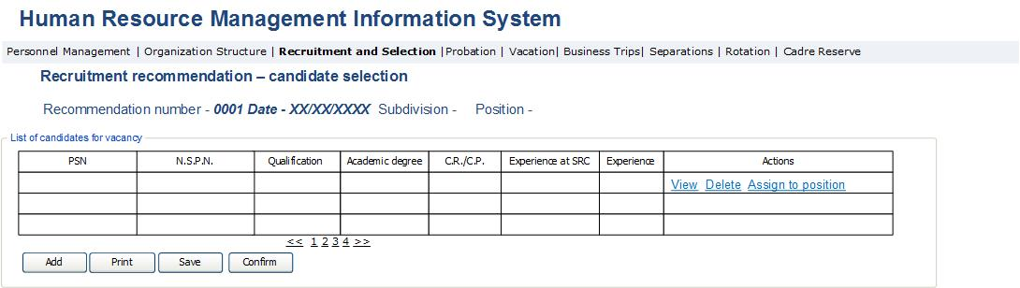

Table 64․ Candidate selection form
Field | Type | Attributes |  | Initial value |  | Description, ratification rules
Request data section
Number of request | Label |  |  |  |  | Displays recruitment request number.
Date | Label |  |  |  |  | Displays the date of creating the recruitment request.
Sub-division | Label |  |  |  |  | Displays the sub-division of vacancy.
Position | Label |  |  |  |  | Displays the title of vacancy.
Print | Button |  |  |  |  | By pressing the button, the rows displayed in the table are exported in xls format.
Vacancy candidate list section
PSN | Column |  |  |  |  | Field displays the PSN of the candidate for vacancy.
N.S.PN | Column |  |  |  |  | Field display the name, surname and paternal name of the candidate for vacancy.
Qualification | Column |  |  |  | Field displays the qualification of the candidate for vacancy.
Academic degree | Column |  |  |  | Field displays academic degree of the candidate for vacancy.
CR/CP | Column |  |  |  | Field displays the source of the candidate for vacancy. Values:  - CR – in the case of CR  - CP – in the case of CP
Work experience in SRC | Column |  |  |  | Displays the total number of years of service within the SRC system.
Work experience | Column |  |  |  | Displays the total number of years of service outside the SRC system.
Actions | Column |  |  |  |  | Displays personal data of person.
View | Button |  |  |  |  | By pressing the button, personal data view form opens, which in the case of Cadre reserve is the form describles in personal data view module (Figure 70, Table 57). In the case of Candidate pool, the form described in candidate data view module opens (Figure 70-74) of this document)
Delete | Button |  |  |  |  | By pressing the button, the selected row in the given table is removed from the list.
Appoint | Button |  |  |  |  | The button is activated in case the SRC Chairman selects a specific person. It is active only for candidates with the status “Candidate selected”. By pressing the button, the form described in section “Appointment to position module” opens for appointing him/her to the given position.
Add | Button |  |  |  |  | By pressing the button, the form described in Figure 67 and Table 1 opens to add candidates in the table. By pressing the button described in Figure 67 and Table 54, that person is added to the table as a selected candidate for filling the vacancy.
Print | Button |  |  |  |  | By pressing the button, the rows displayed in the table are exported in xls format.
Save | Button |  |  |  |  | By pressing the button, the list of candidates for vacancy is saved in the system.
Confirm | Button |  |  |  |  | By pressing the button, the option to make changes is suspended, for which the Add and Delete buttons of this form are suspended. In Figure 78 and Table 65, the view option in the candidate list is activated.

Fig. 78․ Candidate selection/Recruitment application approval: SCR Chairman form
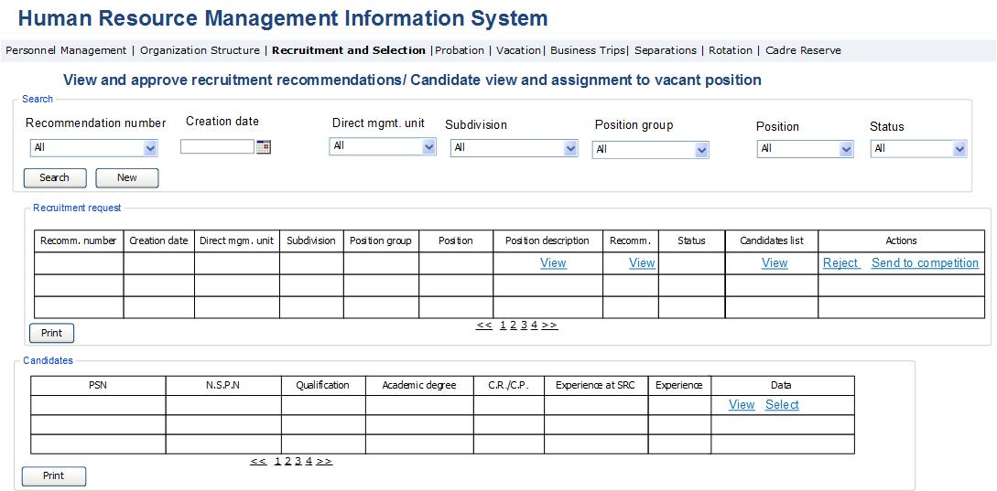

Table 65․ Candidate selection/Recuitment application approval: SCR Chairman form
Field | Type | Attributes |  | Initial value |  | Description, ratification rules
Search section
Number of request | Drop Down | Not Mandatory |  | All |  | Field defines the recruitment request number. Potential values are: “All” value and request numbers entered in the system.
Creation date | Text Box | Not Mandatory |  | Current Date |  | Defines request creation date.
Direct management unit | Dropdown | Not Mandatory |  | “All” |  | Defines direct management unit of vacancy. The list contains the list of all SRC sub-divisions and “All” value.
Sub-division | Dropdown | Not Mandatory |  | “All” |  | Defines the list of direct management unit sub-divisions. The list contains the list of all SRC sub-divisions and “All” value.
Position group | Dropdown | Not Mandatory |  | “All” |  | Defines vacant position group. The list contains all SRC sub-divisions and “All” value.
Position | Drop Down | Not Mandatory |  | “All” |  | Defines name of vacancy. Contains all vacancies of the previously mentioned group and “All” value.
Status | Drop Down | Not Mandatory |  | “All” |  | Defines the information status list of the given table. Potential values are:  - All  - Vacant  - Request approved  - Candidate list created  - Candidate list approved  - Sent for holding competition  - Candidate selected  - Competition launched
Search | Button |  |  |  |  | Perform search.
New search | Button |  |  |  |  | Bring search fields to intitial values.
Recruitment request section
Request number | Column |  |  |  |  | Field displays recruitment request number.
Creation date | Column |  |  |  |  | Displays creation date of request.
Direct management unit | Column |  |  |  |  | Displays direct management unit of vacancy.
Sub-division | Column |  |  |  |  | Displays sub-division of vacancy.
Position group | Column |  |  |  |  | Displays vacant position group.
Position | Column |  |  |  |  | Displays name of vacancy.
Position figure | Column |  |  |  |  | Displays the description of position.
View | Button |  |  |  |  | The view form of the given job passport opens, which is described in “SRC Staff List Administration” module.
Request | Column |  |  |  |  | Displays the recruitment application for the given vacancy.
View | Button |  |  |  |  | Opens the application form.
Status | Column |  |  |  |  | Displays the status of information available in the given table. Potential values are:  - Vacancy  - Request approved  - Candidate list created  - Candidate list approved  - Candidate selected  - Sent for holding competition  - Competition launched  Vacancies have the status “Vacant”.  Vacant positions attached to the recruitment requests have the status “Request approved”.  Those positions, for which a candidate list was developed through Figures 75,77 and Table 62,64 have the status “Candidate list created”.  Those positions, for which a candidate list was developed and approved by the PMD through Figures 75,77 and Table 62,64 have the status “Candidate list approved”.  Those vacancies for which the SCR Chairman has selected a candidate through Figure 78 and Table 65, have the status “Candidate selected”.  Those positions, for which the SRC Chairman instructed to hold competition, or those vacancies, for which no candidate was selected within 15 days’s time after the request was approved, have the status “Sent for holding competition”.  Those vacancies, for which competitions has been announced, have the status “Competition launched”.
List of candidates | Column |  |  |  |  | Displays the list of candidates selected and approved by the PMD for filling the vacancy.
View | Button |  |  |  |  | The button is activated only when the PMD approves the candidate list. By pressing the button, the Candidate section of the given form opens, which shows the candidates selected by PMD for the given vacancy.
Actions | Column |  |  |  |  | The column displays actions made to the given request.
Reject | Button |  |  |  |  | By pressing the button, the recruitment request selected in the table is rejected, it is removed from the system and the status of the given row becomes “Vacant”.
Send for competition | Button |  |  |  |  | By pressing the button, the status of the was becomes “Sent for holding competition”.
Print | Button |  |  |  |  | By pressing the button, the rows selected in the table are exported in xls format.
Candidate section
PSN | Column |  |  |  |  | Field displays the PSN of vacancy candidate.
N.S.P.N | Column |  |  |  |  | Field displays the name, surname and paternal name of vacancy candidate.
Qualification | Column |  |  |  | Field displays the qualification of vacancy candidate.
Degree | Column |  |  |  | Field displays the degree held by the vacancy candidate.
CR/CP | Column |  |  |  | Field displays the source of vacancy candidate. Values:  - CR – in the case of cadre reserve  - CP – in the case of candidate pool
Work experience | Column |  |  |  | Displays the total sum of years of service outside the SRC.
Work experience in SRC | Column |  |  |  | Displays the total sum of years of service within the SRC.
Data | Column |  |  |  |  | Displays personal data of the given person.
View | Button |  |  |  |  | By pressing the button, personal data view form opens, which is the form described in employee personal data view module in the case of Cadre reserve (Figure 70, Table 57). In the case of Candidate pool, the form described in candidate data view module opens (Figure 70-Figure 74).
Select | Button |  |  |  |  | By pressing the button, the button “Assign to position” is activated in Figure 77 and Table 64, and the status of that recruitment request turns into “Candidate selected”.
Print | Button |  |  |  |  | By pressing the button, the rows displayed in the table are exported in xls format.

Fig. 79․ Competition announcement creation form
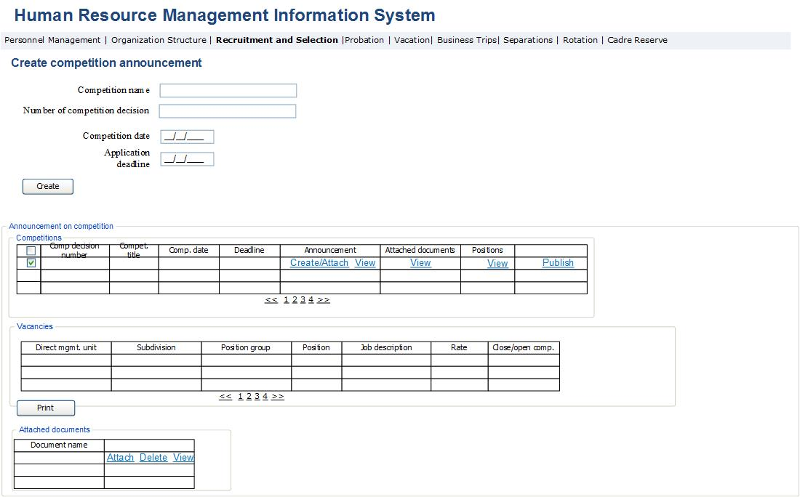

Table 66․ Competition announcement creation form
Field | Type | Attributes | Initial value | Description, ratification rules
General section
Competition name | Text Box | Mandatory |  | The competition name is displayed in the field.
Competition decision number | Text Box | Mandatory |  | The competition decision number is entered in the field.
Competition date | Text Box | Mandatory |  | The competition date is entered in the field.
Application deadline | Calendar box | Mandatory |  | The application deadline is entered in the field.
Create | Button |  |  | By pressing the button, respective record for selected positions is generated in competition announcement section.
Competition announcement section
Competition decision number | Column |  |  | The field displays competition decision number.
Competition name | Column |  |  | The field displays competition name.
Competition date | Column |  |  | The field displays competition date.
Application deadline | Column |  |  | The field displays application deadline for that competition.
Announcement | Column |  |  | Displays competition announcement file in pdf format.
Upload | Button |  |  | By pressing the button, the form for attaching the competition announcement file in pdf format to the system opens.
View | Button |  |  | By pressing the button, the view form for viewing the competition announcement file in pdf format opens.
Attached documents | Column |  |  | Displays other documents required for competition.
View | Button |  |  | By pressing the button, the data block of attached documents of this form is displayed.
Positions | Column |  |  | Vacancies selected for competition is displayed.
View | Button |  |  | By pressing the button, the data block of Vacancies of this form is displayed.
Prepare announcement | Button |  |  | By pressing the button, the competition announcement report described in Figure 14 opens.
Send for publication | Button |  |  | By pressing the button, a document package based on competition announcement and attached documents is prepared and sent to the email of the person servicing the SRC website, which is stated in SRC website.  The list of documents includes:  - Competition announcement  - Competition test questionnaire  - List of legal acts used for questionnaire  - Application to the Competition and Attestation Commission (form)  - Applicant’s announcement (form) of restrictions or conditions specified by the law (related person, health condition etc.)  - Description of tax or customs service vacant position
Vacancy data block
Direct management unit | Column |  |  | Displays direct management unit of vacancy.
Sub-division | Column |  |  | Displays sub-divisions of vacancy.
Position group | Column |  |  | Displays vacant position group.
Position | Column |  |  | Displays the name of vacant position.
Position’s job description | Column |  |  | Field displays job description from position passport.
Work hours | Column |  |  | Field displays the work hours mentioned in the positions description.
Closed/Open competition | Column |  |  | Field displays the type of competition announced. Closed competition is held for leading and chief positions. Open competition is held for junior positions group.
Print | Button |  |  | By pressing the button, the rows displayed in the table are exported in xls format.
Attached documents data block
Document name | Column |  |  | Field displays attached document file name. The following documents are attached to the announcement:  - Competition test questionnaire  - List of legal acts used for questionnaire  - Application to the Competition and Attestation Commission (form)  - Applicant’s announcement (form) of restrictions or conditions specified by the law (related person, health condition etc.)
Attach | Calendar box |  |  | By pressing the button, the form for attaching the competition announcement related document in pdf format opens.
Delete | Button |  |  | By pressing the button, the file displayed in the same row is removed from the system, after which the mentioned row is removed from the system.
View | Button |  |  | By pressing the button, the form for viewing the uploaded file in pdf format opens.

Fig. 80․ Competition announcement report

3․13. 2 Application Registration and Respond Submodule
Application registration and respond sub-module is designed for viewing the competitions held in SRC for vacancies, and to receive, process the participants’ documents, and to notify them on permission to participate in these competitions. This sub-module is accessible only to SRC PMD officers. Key functionalities of this module are the following:
  - The sub-module should allow receive applicants’ documents electronically, and to do so, the Competition announcement page of the SRC website should contain a link which if pressed, will open the forms of documents (referred in Figure 84 - Figure 91) to be sent to the PMD department. The module should enable entering the application electronically in the system both using the SRC website, as well as inside the HRMIS so that the hard copies of application can be entered in the system by PMD officers.
  - In the case of pressing the link of electronic application contained in the announcement posted on the website, the vacancy selection option must be suspended, and show the vacancy next to the link instead. When opening the electronic application from other links, the position selection option should be active.
  - When the deadline for applications is over, the system should stop receiving further applications for the given vacancy and show the message “Application deadline over” to the applicants.
  - In case the applicant registered personal data, sent to the SRC and registered in the SRC pool successfully, the system should deliver a notification to the applicant’s email address saying “Your data has been delivered to the SRC PMD”. After the SRC PMD reviews the application and approves it, the applicant should receive a notification “Your application for the given vacancy has been accepted by the SRC”. In case the PMD rejects the application, an email should be sent with the content “You’re application for the vacancy in SRC is rejected.”
  - Sub-module should enable creating police inquiry to be sent to the RA Police to perform applicants’ conviction history check. In the future this data exchange with the Police should be made electronically.
  - The system should enable exchanging the data with the Police electronically. By sending the requested information, the system should receive information on conviction history and register it in the sytem.
  - In case of receiving or not receiving the permission to participate in the competition, the system should send a notification to the applicant’s email saying “You are allowed to participate in the competition of [position][direct management unit][sub-division]” or “You are not allowed to participate in the competition of [position] [direct management unit] [sub-division]”.
  - When holding the competition in the sub-module, in certain cases it must enable cancelling the competition. The cases are the following:
- The number of applicants allowed to participate in the competition = 0
- The number of applicants passing the test = 0
- The number of applicants passing the interview = 0
- No competition winner selected
  - The data of applicants forbidden to participate in the competition should be removed from the HRMIS.
Application registration and respond sub-module consists of the forms described below. The forms displayed in Figure 81 and Table 67 is accessible only to PMD staff.

Fig. 81․ Competition view form
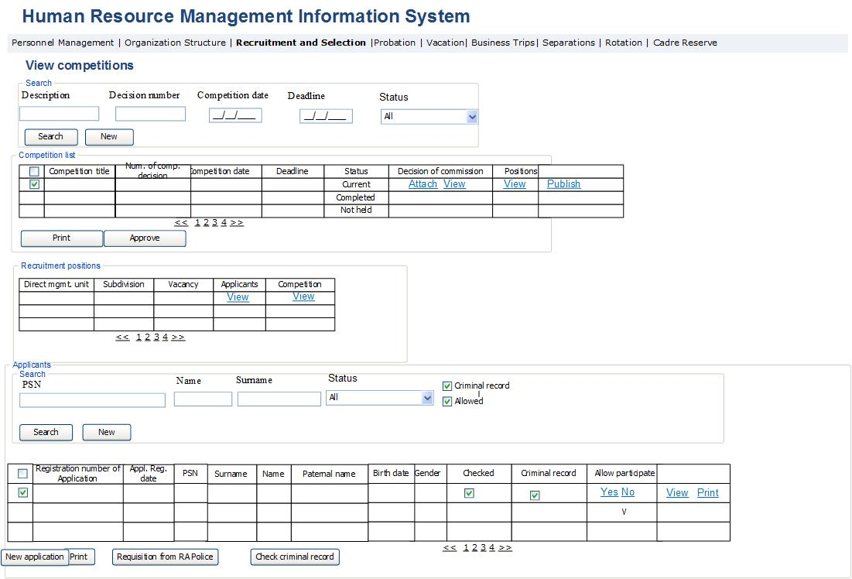
Table 67․ Competition view form
Field | Type | Attributes |  | Initial value | Description
Search section
Competition name | Text Box |  |  |  | Defines competition name.
Competition decision number | Text Box |  |  |  | Defines competition decision number.
Competition date | Calendar box |  |  |  | Defines decision date.
Deadline | Calendar box |  |  |  | Defines competition application deadline.
Vacancy | Drop Down |  |  |  | Defines the vacancy name included in the competition.
Status | Drop Down |  |  |  | Defines competition status. Potential values are:  - All  - Competition announced  - Receive applicants’ documents  - Applicant’s documents checked  - Testing  - Interview  - Rejected  Those competitions for which the applicants have sent respective document package, have the status “Receipt of applicants documents”.  Those competitions where the PMD staff has checked the document received from applicants, have the status “Applicants’ documents checked”.  Those competitions which are at the stage of testing, have the status “Testing”.  Those competitions which are at the stage of interviews, have the status “Interviews”.  Those competitions for which winner was selected, have the status “Completed”.  Those competitions which were canceled have the status “Canceled”.
Competition list Table
# | Column |  |  |  |  | The field is a Checkbox Type field designed for selecting the row.
Competition name | Text Box |  |  |  | Competition name is displayed.
Competition decision number | Column |  |  |  | Displays the number of decision on competition. The button is a reference field, which when pressed displays “Recruitment positions” data block for the given competition.
Competition date | Column |  |  |  | Displays the competition date.
Deadline | Calendar box |  |  |  | Displays competition application deadline. If the current date is higher than the date registered in Deadline field, then the system stops registering applications for the given competition. If the number of applications at that moment is 0, then the option of attaching the competition decision “Not held” activates, in case the applications are registered, but no one is allowed to participate, then apart from the action mentioned previously, the data of mentioned applicants is registered in Candidate pool.
Status | Column |  |  |  | Displays competition status.
Commission decision | Column |  |  |  | The field displays Commission decision in pdf format.
Attach | Button |  |  |  | By pressing the button, the page for attaching Commission decision opens, which is displayed in Figure 82 and Table 68.
View | Button |  |  |  | By pressing the button, the view form of Commission decision file opens in pdf format.
Print | Button |  |  |  | By pressing the button, the rows displayed in the table are exported in xls format.
Approve | Button |  |  |  | By pressing the button, the particular competition is approved.
Stop the competition | Button |  |  |  | The button is activated if there are grounds for canceling the competition. By pressing the button, the competition status changes to “Canceled” and any actions in respect to that competition are suspended.
Publish | Column |  |  |  | By pressing the button, the competition decision, the list of allowed and disallowed participants is sent to the email of the person servicing the SRC website. The link is active only when the View link of the Competition column in Recruitment positions table has been activated.
Recruitment positions data block
# | Column |  |  |  |  | The field is a Checkbox Type field designed for selecting the row.
Direct management unit | Column |  |  |  | The field displays direct management unit of the vacancy included in the given competition.
Sub-division | Column |  |  |  | The field displays the sub-division included in the given competition.
Vacancy | Column |  |  |  | The field displays the name of the vacancy included in the given competition.
Applicants | Column |  |  |  | The field displays the data of persons applying for the given vacancy.
View | Button |  |  |  | By pressing the button, the Applicants data block opens to display the data of applicants.
Competition results | Column |  |  |  | The field displays the form showing the results of competition held for the given vacancy.
View | Button |  |  |  | By pressing the button, the form displayed in Table 77 and Figure 92 showing the competition results. The link becomes active only when the column “allow participation” has been completed for all applicants.
Applicant data block Search section
PSN | Textbox |  |  |  | The field defines applicant’s PSN.
Name | Textbox |  |  |  | The field defines applicant’s name.
Surname | Textbox |  |  |  | The field defines applicant’s surname.
Checked | Checkbox |  |  |  | Defines the display of only those applicants in the table, whose documents have been checked.
Conviction | Checkbox |  |  |  | Defines the display of only those applicants in the table, who have conviction records.
Allowed | Checkbox |  |  |  | Defines the display of only those applicants in the table, who have been allowed to participate in the competition.
Applicant data block table
Application registration number | Column |  |  |  | The field displays the application registration number automatically generated by the system.
Application registration date | Column |  |  |  | The field displays application registration date.
PSN | Column |  |  |  | The field displays applicant’s PSN.
Name | Column |  |  |  | The field displays applicant’s name.
Surname | Column |  |  |  | The field displays applicant’s surname.
Paternal name | Column |  |  |  | The field displays applicant’s paternal name.
Birth date | Column |  |  |  | The field displays applicant’s birth date.
Gender | Column |  |  |  | The field displays applicant’s gender.
Status | Column |  |  |  | The field displays applicant’s status. Potential values are:  - Application received  - Checked  - Sent for review  - Allowed to participate  - Rejected  Newly created applications have the status “Application received”.  Those applications, for which the field “Checked” was filled, have the status “Checked”.  Those applications, where errors were found and they were sent for review, have the status “Sent for review”.  Those applications, for which the field “Allowed to participate” was entered, Those applications, for which the field “Checked” was entered, but the field “Allowed to participate” wasn’t, have the status “Rejected”. The status changes to “Rejected” 2 days before the testing stage.
Checked | Column |  |  |  | When no errors are found in the application, this field is checked.
Conviction | Column |  |  |  | The field is entered after the Police reply to the inquiry is received.
Allow to participate | Column |  |  |  | The field is entered according to the data of Competition Commission decision. In the case of pressing “Yes” or “No” button, this row no longer displays those buttons, instead showing the signs “V” or “-”.
Yes | Button |  |  |  | By pressing the button, the applicant receives a notification on his/her email saying “You are allowed to participate in the competition announced for [direct management unit][sub-division][position]”. The person is displayed in the “Final Selection and Appointment” module form.
No | Button |  |  |  | By pressing the button, the applicant receives a notification on his/her email saying “You are not allowed to participate in the competition announced for [direct management unit][sub-division][position]”. That applicant’s data are removed from this form. The person gets registered in Candidate pool and his/her data is displayed in Cadre reserve/Candidate pool list module.
View | Button |  |  |  | By pressing the button, the application filled in by that applicant and other documents open in view form.
Print | Button |  |  |  | By pressing the button, the application filled in by that applicant and other documents open in view form in pdf format.
New application | Button |  |  |  | By pressing the button, the application creation form opens to generate new application, which is described in Figure 84 and Table 68. The button is accessible only to PMD officers and is used to enter the hard copy of application in the system.
Send for review | Button |  |  |  | The button is activated in case any of the table rows are selected. By pressing the button, the applicant is sent a letter on the errors discovered in his/her application.
Notify | Button |  |  |  | By pressing the button, based on the application status, the applicant receives a notification on his/her email. The button is activated 2 days before the testing stage. The notification is sent based on the field “Allowed to participate”.
Print | Button |  |  |  | By pressing the button, the table content is exported in xls format.
Create Police inquiry | Button |  |  |  | By pressing the button, a Police inquiry is created for applicants mentioned in the table, which is displayed in Figure 83.
Check conviction history | Button |  |  |  | By pressing the button, the system makes conviction checks for the given person. To this end, the system sends necessary information to the RA Police, including the PSN, passport data, name, surname, paternal name and as a reply receives a message from the Police referring that person’s conviction history, which is then automatically entered in the system.

Fig. 82․ Form for attaching Commission decision
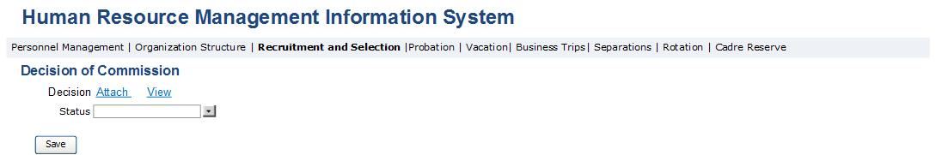
Table 68․ Form for attaching Commission decision
Field | Type | Attributes | Initial value | Description, ratification rules
Key data block
Decision | Label |  |  | The field displays Competition Commission decision in pdf format.
Attach | Button |  |  | By pressing the button, Commission decision form opens in pdf format to attach to the system.
Status | Drop down |  |  | The decision status is entered in the field. Potential values are:  - Competition completed  - Competition not held
Save | Button |  |  | By pressing the button, the data entered in the form are saved in the system and the given form closes.

Fig. 83․ Police inquiry

Fig. 84․ Filling in application: alerts
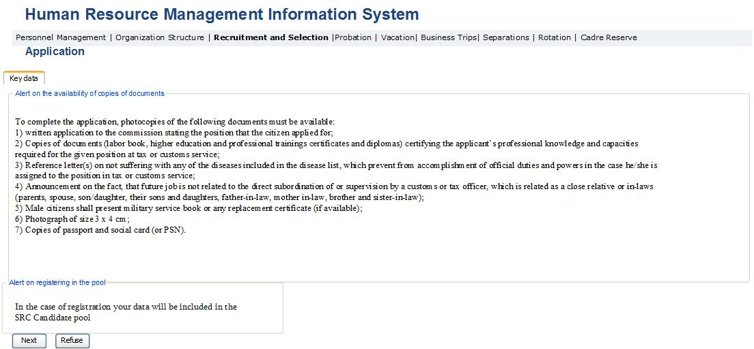
Table 69․ Filling in application: alerts
Field | Type | Attributes | Initial value | Description, ratification rules
Key data block
Alert on availability of documents copies | Label |  |  | The field displays the need for presenting photocopies of required documents. When opening the form first this alert is displayed only.
Next | Button |  |  | By pressing the button it moves to the next step. In the beginning the second alert is displayed, after which when pressing that button the form described in Figure 85 is displayed.
Reject | Button |  |  | By pressing the button, the form closes.

Fig. 85․ Application completion: selection for vacancy
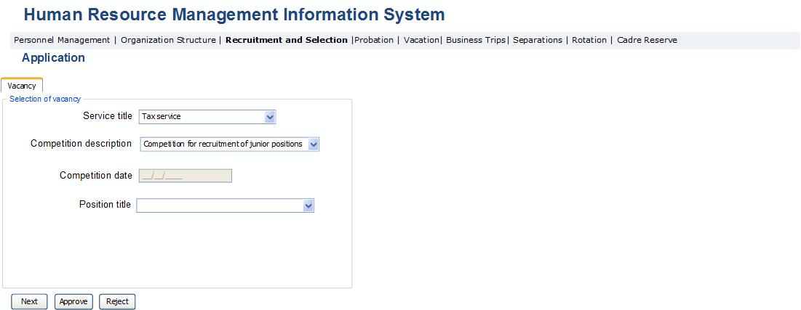

Table 70․ Application completion: selection for vacancy
Field | Type |  | Attributes | Initial value | Description, ratification rules
Vacancy selection data block
Name of service | Dropdown |  | Mandatory |  | The name of higher management of the vacancy is entered. Potential values are:  - Tax service  - Customs service  The fields described in the given form are suspended, when the application is opened by pressing the link posted in the competition announcement. In those cases, the vacant position mentioned in the competition is mentioned in the fields.
Competition name | Dropdown |  | Mandatory |  | The list of open competitions announced for the service stated in the previous field is entered.
Competition date | Calendar Box |  | Mandatory |  | Displays the date of creating competition selected in the previous stage.
Position name | Dropdown |  | Mandatory |  | Displays the list of vacancies included in the competition entered in the previous field.
Next | Button |  |  |  | By pressing the button, the information entered in the given form is checked. If no errors are found, a shift is made to the form described in Figure 86. If errors are found, the system displays respective alerts next to each wrongly entered field.
Accept | Button |  |  |  | The button is displayed only for PMD staff. By pressing it, the application is saved in the system and the applicant receives a message on his/her email saying “Your application for the vacancy is accepted by the SRC”.
Reject | Button |  |  |  | The button is displayed only for PMD staff. By pressing it, the application is removed from the system and the applicant receives a message on his/her email saying “Your application for the vacancy is rejected by the SRC”.

Fig. 86․ Application completion: personal data
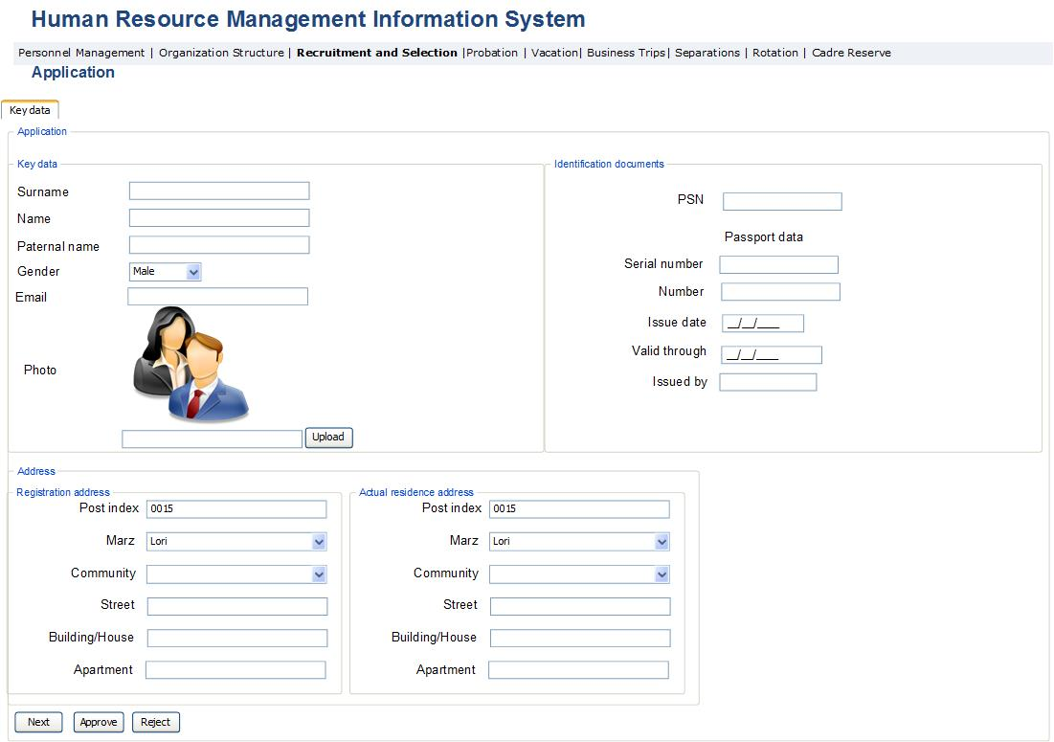

Table 71․ Application completion: personal data page
Field | Type | Attributes |  | Initial value | Description, ratification rules
Key data block
Surname | Text Box | Mandatory |  |  | Applicant’s surname is entered.
Name | Text Box | Mandatory |  |  | Applicant’s name is entered.
Paternal name | Text Box | Mandatory |  |  | Applicant’s paternal name is entered.
Photo | Image box | Mandatory |  |  | Applicant’s photo is entered.
Upload | Button |  |  |  | By pressing the button, the form for uploading the applicant’s photo in the system in jpg format opens.
Gender | Dropdown | Mandatory |  |  | The applicant’s gender is entered. In the case of the applicant’s gender is entered. In case of male, the data block “Service in RA Special Services” opens.  Potential values are:  - Male  - Female
Email | Text box | Mandatory |  |  | Applicant’s email is entered in the field.
Identification document data block
PSN | Textbox | Mandatory |  |  | Public Services Number is entered.
Serial number | Textbox | Mandatory |  |  | Serial number of applicant’s ID is entered.
Number | Textbox | Mandatory |  |  | Number of applicant’s ID is entered.
Issued by | Textbox | Mandatory |  |  | The issuing body of applicant’s ID is entered.
Issue date | Calendar box | Mandatory |  |  | The issue date of applicant’s ID is entered.
Validity period | Calendar box | Mandatory |  |  | The validity period of applicant’s ID is entered.
Address data block
Employee registration address data sub-group
Postal index | Text Box |  |  |  | Displays the postal index of employee’s registration address.
Marz | Dropdown | Mandatory |  |  | Displays the Marz of employee’s registration address. Potential values are:  - Aragatsotn  - Ararat  - Armavir  - Gegharkunik  - Yerevan  - Lori  - Kotayk  - Shirak  - Syunik  - Vayots Dzor  - Tavush
Community | Dropdown | Mandatory |  |  | The community of registration address of employee is registered; the content of the list depends on the selected marz. The list of communities is registered according to the RA Law on Territorial Division.
Street | Text Box | Mandatory |  |  | Displays employee's registration address street.
House | Text Box | Mandatory |  |  | Displays the number of house of employee's registration address.
Apartment | Text Box |  |  |  | Displays the number of apartment of employee's registration address.
Employee actual residence address data sub-group
Postal index | Text Box |  |  |  | Displays actual residence postal index of employee.
Marz | Dropdown |  |  |  | Displays actual residence Marz of employee. Potential values are:  - Aragatsotn  - Ararat  - Armavir  - Gegharkunik  - Yerevan  - Lori  - Kotayk  - Shirak  - Syunik  - Vayots Dzor  - Tavush
Community | Dropdown |  |  |  | The community of actual residence address of employee is registered; the content of the list depends on the selected marz. The list of communities is registered according to the RA Law on Territorial Division.
Street | Text Box |  |  |  | Actual residence street is displayed.
House | Text Box |  |  |  | Actual residence house number is displayed.
Apartment | Text Box |  |  |  | Actual residence apartment number is displayed.
Postal index | Text Box |  |  |  | Actual residence postal index of the applicant is displayed.
Marz | Dropdown |  |  |  | The marz of applicant’s registration address is entered. Potential values are:  - Aragatsotn  - Ararat  - Armavir  - Gegharkunik  - Yerevan  - Lori  - Kotayk  - Shirak  - Syunik  - Vayots Dzor  - Tavush
Community | Dropdown |  |  |  | The applicant’s registration community is entered. The content of the list depends on the selected marz. The list of communities is registered according to the RA Law on Territorial Division.
Street | Text Box |  |  |  | The street of applicant’s registration address is entered.
House | Text Box |  |  |  | The house number of applicant’s registration address is entered.
Apartment | Text Box |  |  |  | The apartment number of applicant’s registration address is entered.
Next | Button |  |  |  | By pressing the button, the information entered in the given form is checked. If no mistakes are found, the information entered in that form is checked. If no mistakes are found, then shift is made to the form described in Figure 87. If errors are found, the system displays respective alerts next to each wrongly entered field.
Approve | Button |  |  |  | The button is displayed only for PMD staff. By pressing it, the application is temporarily saved in the system and the the applicant receives a message to his/her email saying “Your application for the vacancy is accepted by the SCR”.
Reject | Button |  |  |  | The button is displayed only for PMD staff. By pressing it, the particular application is removed from the system and the applicant receives a message on his/her email saying “Your application for the vacancy is rejected by the SRC”.

Fig. 87․ Application completion: education data block
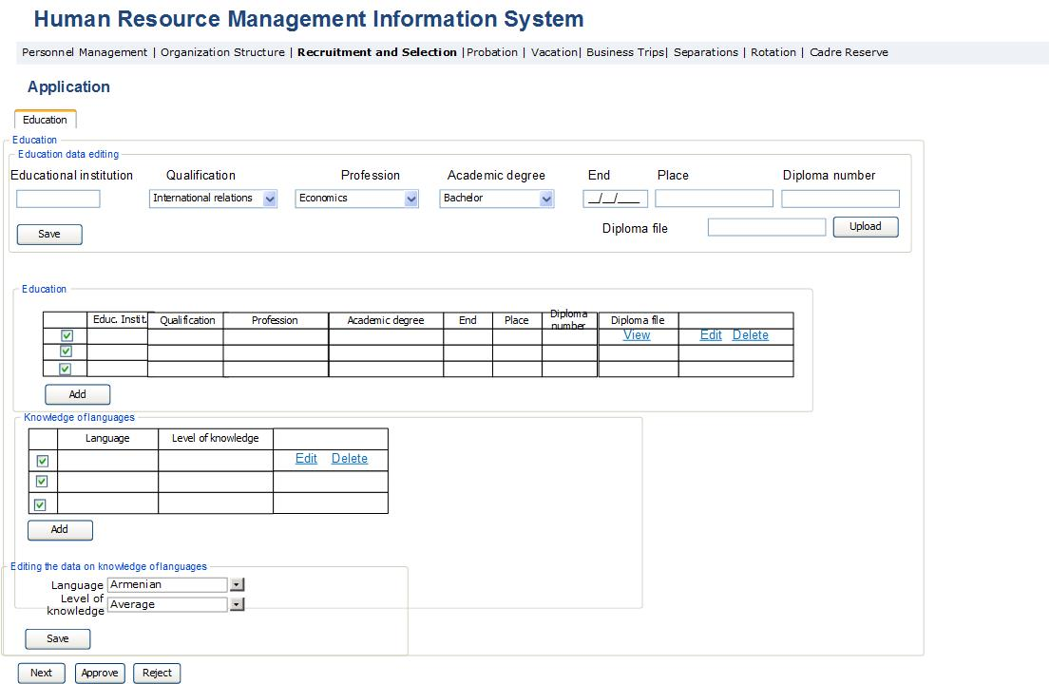

Table 72․ Application completion: education data
Field | Type | Attributes | Initial value | Description, ratification rules
Applicant’s education data block
Applicant’s education table
# | Column |  |  | The field is a Checkbox Type field designed for selecting the row.
Educational complex | Column |  |  | Displays the name of educational complex.
Qualification | Column |  |  | Displays the qualification of applicant obtained in that educational complex. Potential values: in accordance to the list of the Professions and Qualifications of the RA higher education.
Specialty | Column |  |  | Displays the specialty of applicant obtained in that educational complex. Potential values: in accordance to the list of the Professions and Qualifications of the RA higher education.
Degree | Column |  |  | Displays the degree of applicant obtained in that educational complex.  Potential values are:  Specialist with diploma  Bachelor  Masters  Candidate of Sciences  Doctor of Sciences
End | Column |  |  | Displays the graduation date of applicant.
Place | Column |  |  | Displays the address of the particular educational complex.
Diploma number | Column |  |  | Displays the given diploma number.
Diploma file | Column |  |  | Displays the the diploma copy file in pdf format.
View | Column |  |  | By pressing the button, the diploma copy file opens in pdf format in view form.
Edit | Button |  |  | The education table edit block opens with the selected row in edit mode.
Delete | Button |  |  | By pressing the button, a permission to delete the given row opens, and when answered positively the selected row is removed from the system.
Add | Button |  |  | By pressing the button, the table data edit row opens in new data entry mode.
Applicant’s education table editing block. Displayed in case of adding new row or editing existing row in the table.
Educational complex | Text Box | Required |  | The name of educational complex is entered.
Qualification | Dropdown | Required |  | The qualification of applicant obtained in that educational complex is entered. Potential values: in accordance to the list of the Professions and Qualifications of the RA higher education.
Specialty | Dropdown | Required |  | The specialty of applicant obtained in that educational complex is entered. Potential values: in accordance to the list of the Professions and Qualifications of the RA higher education.
Degree | Dropdown | Required |  | The degree of applicant obtained in that educational complex is entered. Potential values are:  Specialist with diploma  Bachelor  Masters  Candidate of Sciences  Doctor of Sciences
End | Calendar box | Required |  | The graduation date of applicant is entered.
Place | Text box | Required |  | The adddress of particular educational complex is entered.
Diploma number | Text box | Required |  | The respective diploma number is entered.
Diploma file | File box | Required |  | The file of respective diploma copy is entered.
Upload | Button |  |  | By pressing the button, the copy of diploma file is entered in the system.
Save | Button |  |  | By pressing the button, the data entered in the fields is saved.
Knowledge of languages data block
# | Column |  |  | The field is a Checkbox Type field designed for selecting the row.
Language | Column |  |  | Displays the name of necessary language, which is comprised of the following items:  - Armenian  - Russian  - English
Level of knowledge | Column |  |  | The level of language knowledge is displayed. Potential values are:  Basic  Average  Advanced
Edit | Button |  |  | The language knowledge table edit block opens with the selected row in editing mode.
Delete | Button |  |  | By pressing the button a permission to delete the given row opens, and when answered positively the selected row is removed from the system.
Add | Button |  |  | By pressing the button, the table data edit row opens in new data entry mode.
Language knowledge data block editing
Language | Drop down |  |  | The name of necessary language is entered comprised of the following items:  - Armenian  - Russian  - English
Level of knowledge | Drop down |  |  | The level of language knowledge is entered. Potential values are:  - Basic  - Average  - Advanced
Save | Button |  |  | By pressing the button, the table data edit row opens in new data entry mode.
Next | Button |  |  | By pressing the button the information entered in that form is checked. If no mistakes are found, a shift is made to the form described in Figure 88. If errors are found, the system displays respective alerts next to each wrongly entered field.: The error check is the following: each table should contain at least one entered row.
Approve | Button |  |  | The button is displayed only for PMD staff. By pressing it, the application is saved in the system and the applicant receives a message on his/her email saying “Your application for the vacancy is accepted by the SRC”.
Reject | Button |  |  | The button is displayed only for PMD staff. By pressing it, the particular application is removed from the system and the applicant receives a message on his/her email saying “Your application for the vacancy is rejected by the SRC”.

Fig. 88․ Application completion: work experience
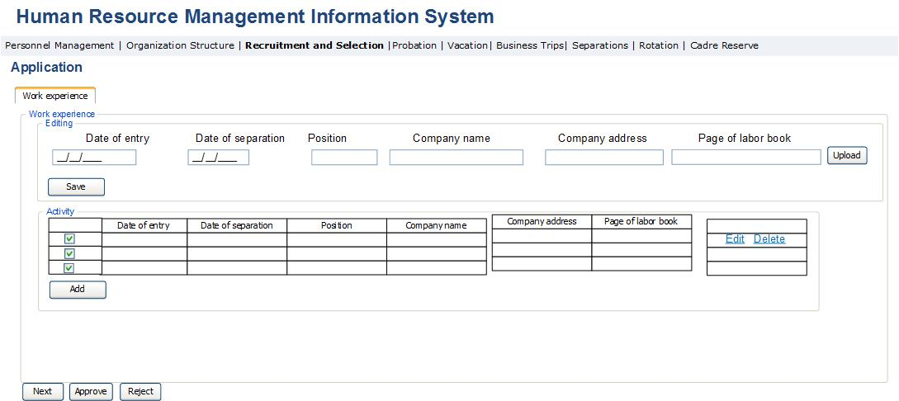

Table 73․ Application completion: work experience
Field | Type |  | Attributes | Initial value |  |  | Description, ratification rules
Work activity data block
Work activity table
# | Column |  |  |  |  |  | The field is a Checkbox Type field designed for selecting the row.
Entry date | Column |  | Text box |  |  |  | Entry date to the given company is entered.
Spetaration date | Column |  | Text Box |  |  |  | The separation date from the given company is entered.
Position | Column |  | Text Box |  |  |  | The occupied position in the given company is entered.
Company name | Column |  | Text Box |  |  |  | The company name is entered.
Company address | Column |  | Text box; multi-row |  |  |  | The company address is entered.
Employment record book file | Column |  | File Box |  |  |  | The page confirming the given employment is uploaded.
Edit | Button |  |  |  |  |  | The job activity table editing block is opened in edit mode.
Delete | Button |  |  |  |  |  | By pressing the button a permission to delete the given row opens, and when answered positively the selected row is removed from the system.
Add | Button |  |  |  |  |  | Table data editing block opens in Add mode.
Work activity table edit block
Entry date | Calendar box |  | Required |  |  |  | Entry date to the given company is entered.
Spetaration date | Calendar box |  | Required |  |  |  | Separation date from the given company is entered.
Position | Text box |  | Required |  |  |  | The occupied position in the given company is entered.
Company name | Text box |  | Required |  |  |  | The company name is entered.
Company address | Text box multi-row |  | Required |  |  |  | The company address is entered.
Employment record book file | File Box |  |  |  |  |  | The page confirming the given employment is uploaded.
Next |  | Button |  |  |  |  | By pressing the button, the information entered in that form is checked. If no mistakes are found, a shift is made to the form described in Figure 89. If errors are found, the system displays respective alerts next to each wrongly entered field. The error check is the following: each table should contain at least one entered row.
Approve |  | Button |  |  |  |  | The button is displayed only for PMD staff. By pressing it, the application is saved in the system and the applicant receives a message on his/her email saying “Your application for the vacancy is accepted by the SRC”.
Reject |  | Button |  |  |  |  | The button is displayed only for PMD staff. By pressing it, the particular application is removed from the system and the applicant receives a message on his/her email saying “Your application for the vacancy is rejected by the SRC”.

Fig. 89․ Application completion: service in RA Armed Forces
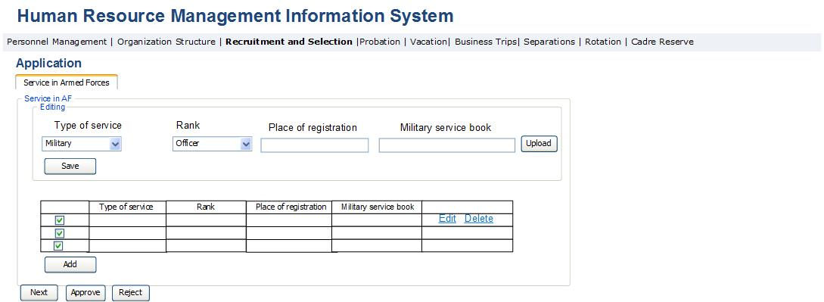

Table 74․ Application completion: service in RA Armed Forces
Field | Type | Attributes | Initial value |  |  | Description, ratification rules
Service in the RA Armed Forces data block
Service in the RA Armed Forces table
# | Column |  |  |  |  | The field is a Checkbox Type field designed for selecting the row.
Type of service | Column | Dropdown |  |  |  | The special type of service of applicant is entered. Potential values are:  - Police service  - National Security Service  - Military service
Rank | Column | Dropdown |  |  |  | Special service rank of applicant is entered. Potential values are:  - Warrant Officer  - Senior Warrant Officer  - Junior Lieutenant  - Lieutenant  - Senior Lieutenant  - Captain  - Major  - Lieutenant Colonel  - Colonel  - Major General  - General-Lieutenant  - General-Colonel
Place of registration | Column | Text box |  |  |  | The place of military registration is entered.
Military service book | Column | File box |  |  |  | Military service book file is entered in pdf format.
Edit | Button |  |  |  |  | The Service in RA Armed Forces table edit block is opened with the selected row in edit mode.
Delete | Button |  |  |  |  | By pressing the button a permission to delete the given row opens, and when answered positively the selected row is removed from the system.
Add | Column | File box |  |  |  | Table data editing block opens in Add mode.
Service in RA Armed Forces table data edit block
Type of service | Dropdown |  |  |  |  | The special type of service of applicant is entered. Potential values are:  - Police service  - National Security Service  - Military service
Rank | Dropdown |  |  |  |  | Special service rank of applicant is entered. Potential values are:  - Warrant Officer  - Senior Warrant Officer  - Junior Lieutenant  - Lieutenant  - Senior Lieutenant  - Captain  - Major  - Lieutenant Colonel  - Colonel  - Major General  - General-Lieutenant  - General-Colonel
Place of registration | Text box |  |  |  |  | The place of military registration is entered.
Military service book file | File box |  |  |  |  | Military service book file is entered in pdf format.
Save | Button |  |  |  |  | Saves the changes made to the AF edit block fields.
Next | Button |  |  |  |  | By pressing the button the information entered in that form is checked. If no mistakes are found, a shift is made to the form described in Figure 90. If errors are found, the system displays respective alerts next to each wrongly entered field. The error check is the following: each table should contain at least one entered row.
Approve | Button |  |  |  |  | The button is displayed only for PMD staff. By pressing it, the application is saved in the system and the applicant receives a message on his/her email saying “Your application for the vacancy is accepted by the SRC”.
Reject | Button |  |  |  |  | The button is displayed only for PMD staff. By pressing it, the particular application is removed from the system and the applicant receives a message on his/her email saying “Your application for the vacancy is rejected by the SRC”.

Fig. 90․ Application completion: medical certificates
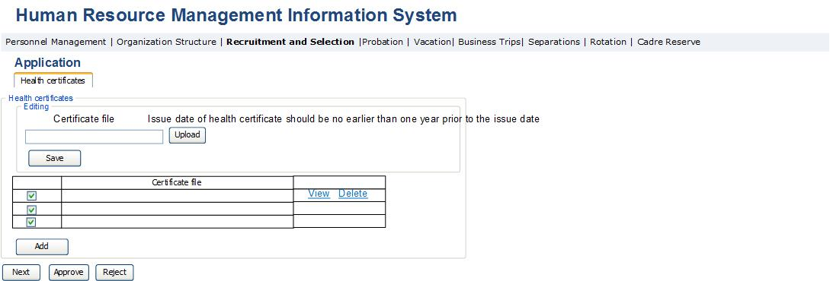

Table 75․ Application completion: medical certificates
Field | Type | Attributes | Initial value |  | Description, ratification rules
Health certificates data block
Health certificates table
# | Column |  |  |  | The field is a Checkbox Type field designed for selecting the row.
Certificate file | Column |  |  |  | The field displays the certificate file.
View | Button |  |  |  | By pressing the button, the uploaded file of medical certificate in pdf format is displayed.
Delete | Button |  |  |  | By pressing the button a permission to delete the given row opens, and when answered positively the selected row is removed from the system.
Add | Column | File box |  |  | Table data editing block opens in Add mode.
Health certificates table edit block
Certificate file | Column |  |  |  | The field displays the certificate file.
Upload | Button |  |  |  | By pressing the button, the medical certificate file in pdf format is opened for uploading in the system.
Alert | Label |  |  |  | Display the following message “The issue date of medical certificate should be no earlier than one year before the mentioned date”.
Save | Button |  |  |  | By pressing the button, all changes made are saved in the system.
Next | Button |  |  |  | By pressing the button the information entered in that form is checked. If no mistakes are found, a shift is made to the form described in Figure 91. If errors are found, the system displays respective alerts next to each wrongly entered field. The error check is the following: each table should contain at least one entered row.
Approve | Button |  |  |  | The button is displayed only for PMD staff. By pressing it, the application is saved in the system and the applicant receives a message on his/her email saying “Your application for the vacancy is accepted by the SRC”.
Reject | Button |  |  |  | The button is displayed only for PMD staff. By pressing it, the particular application is removed from the system and the applicant receives a message on his/her email saying “Your application for the vacancy is rejected by the SRC”.

Fig. 91․ Application completion: attached documents
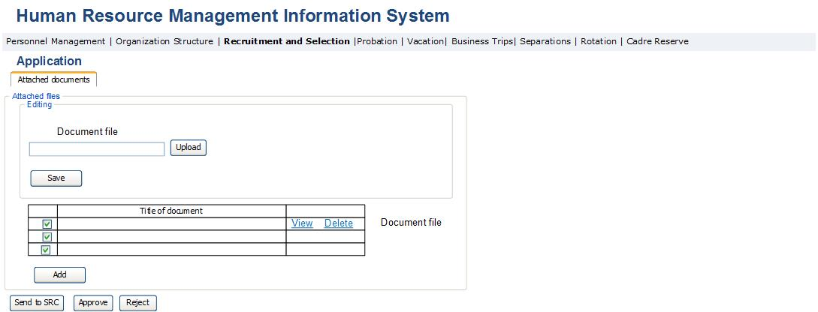

Table 76․ Application completion: attached documents
Field | Type | Attributes | Initial value |  |  | Description, ratification rules
Attached documents data block
Attached documents Table
# | Column |  |  |  |  | The field is a Checkbox Type field designed for selecting the row.
Document name | Column |  |  |  |  | The field displays the name of document file.
View | Button |  |  |  |  | By pressing the button the uploaded document file in pdf format is displayed.
Delete | Button |  |  |  |  | By pressing the button a permission to delete the given row opens, and when answered positively the selected row is removed from the system.
Add | Column | File box |  |  |  | Table data editing block opens in Add mode.
Attached documents table edit block
Document file | Column |  |  |  |  | The field displays the document file.
Upload | Button |  |  |  |  | By pressing the button the form for uploading the document file in pdf format opens.
Save | Button |  |  |  |  | By pressing the button, all changes made are saved in the system.
Sent to SRC | Button |  |  |  |  | By pressing the button the information entered in that form is checked. If no mistakes are found, the data entered in Figure 85-Figure 91 are sent to the SRC HRMIS. In case the data are successfully saved in the system, the applicant receives an email saying “Your data is sent to the SRC PMD”. If errors are found, the system displays respective alerts next to each wrongly entered field. The error check is the following: each table should contain at least one entered row.
Approve | Button |  |  |  |  | The button is displayed only for PMD staff. By pressing it, the application is saved in the system and the applicant receives a message on his/her email saying “Your application for the vacancy is accepted by the SRC”.
Reject | Button |  |  |  |  | The button is displayed only for PMD staff. By pressing it, the particular application is removed from the system and the applicant receives a message on his/her email saying “Your application for the vacancy is rejected by the SRC”.

3․13. 3 Final Selection and Appointment Sub-module
Final selection and appointment sub-module, where the tests, interviews, selection and appointment of the winner takes place. It is a HRMIS sub-module and is accessible to the higher management and PMD staff to view the data of all SRC employees. Key functionalities of this sub-module are the following:
- HRMIS should exchange data with automated testing system sending it the name, surname, paternal name, PSN and passport data of the applicant, competition name, competition date, vacancy name and in return receive the applicant’s test and interview scores where available.
- If the applicant’s test and interview scores are received from the automated testing system, HRMIS doesn’t request the given applicant’s score provided the field “Appealed” is not selected.
- After receiving the test scores, the interview data exchange and other actions are active only for those applicants, whose test scores are higher than 89% for customs service, and 79% for tax service.
- After the interview scores are received, the winner selection and appointment should be enabled to to for those applicants with interview score higher than 74%.
- After the competition is over, the system should allow to send the data of applicants who passed the interview and test but were not selected as winner, to the Cadre reserve.
- After the competition is over, the system should allow to sent the data of all applicants, apart from the case mentioned above, to the Candidate pool.
Final selection and appointment sub-module is comprised of the following forms.
Fig. 92․ Competition result view
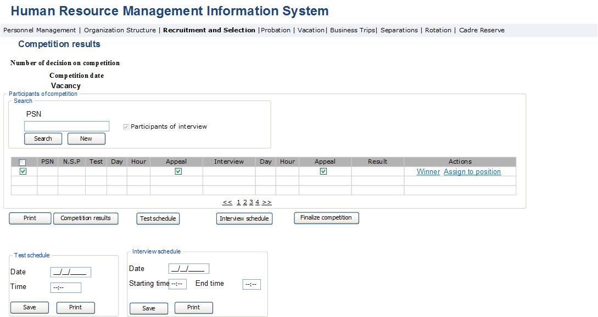

Table 77․ Competition result view
Field | Type | Attributes | Initial value | Description, ratification rules
Competition data
Competition decision number | Label |  |  | Displays the number of decision on competition.
Competition date | Label |  |  | Displays the competition date.
Vacancy | Label |  |  | Displays the vacancy for which recruitment competition was held.
Search of competition participants
PSN | Text Box |  |  | Defines applicant’s PSN.
Search | Button |  |  | Perform search.
New | Button |  |  | Return the fields to initial value.
Table of competition participants
# | Column |  |  | The field is a Checkbox Type field designed for selecting the row.
PSN | Column |  |  | Displays applicant’s PSN.
N.S.P.N. | Column |  |  | Name, surname and paternal name of applicant is displayed.
Test | Column |  |  | Displays the applicant’s test scores.
Day | Column |  |  | Displays the applicants test day.
Time | Column |  |  | Displays the applicants test hour.
Appealed | Column |  |  | The score received in the result of appealed test is entered or not. When selecting this field, in case the button “Competition results” is pressed, the system checks the appealed score and the new score is entered in the system if it was changed.
Interview | Column |  |  | The interview scores of applicant is displayed.
Day | Column |  |  | The interview day of applicant is displayed.
Time | Column |  |  | Displays interview hour; the hour is displayed in the form of interval.
Appealed | Column |  |  | The score received in the result of appealed interview is entered or not. When selecting this field, in case the button “Competition results” is pressed, the system checks the appealed score and the new score is entered in the system if it was changed.
Result | Column |  |  | The algebraic sum of the interview and test scores is displayed.
Actions | Column |  |  | The list of actions performed with the given row is displayed.
Winner | Button |  |  | The button is accessible only to the SRC Chairman. By pressing the button, the winner is selected. The button is active only when the test score is 80% and the interview score is 75% for tax service vacant positions, and when the test score is 90% and the interview score is 75% for customs service vacant positions. When the button is pressed, the button “Appoint to the position” activates.
Assign to position | Button | Disabled |  | The button is accessible for PMD staff. The button is activated only in case the action stated in the previous clause is performed. By pressing the button, the form described in “Appointment module” section opens with already selected the given vacancy for competitions and the applicant. The appointment of the winning participant is done through this form. After this action is completed, the data of those applicants mentioned in the table whose test scores are higher than 79% for tax service, and 89% for customs service, and the interview scores are higher than 74%, but they were not selected winners of competition and were not appointed, shall be sent for registration in the Cadre reserve on the grounds of “Passing the interview but not recognized as winner”.  The data of all those competition participants who didn’t get sufficient scores at tests or interviews shall be sent to Candidate pool on the grounds of “Competition participant”.
Print | Button |  |  | By pressing the button, the table rows are exported in xls format.
Competition results | Button |  |  | By pressing the button, the HRMIS sends the applicant’s name, surname, paternal name, PSN, passport data, competition name and date, vacancy name to the automated test system, and receives the test and interview score of the given applicant, if available. The interview score is requested only for those applicants, whose test scores are higher than 79% for tax service competitions, and 89% for customs service competitions. During the next data exchange, the HRMIS makes an inquiry of the data for applicant with a score only when the score field is marked as “Appealed”.
Test schedule | Button |  |  | The button is accessible only for PMD staff. The button is activated in case of selecting any of table rows. By pressing it, the Test schedule data block is displayed, and after the fields are entered and that block is saved, the test day and hour for the applicants stated in table is entered.
Interview schedule | Button |  |  | The button is accessible only for PMD staff. The botton is activated for those completed test results rows containing 80% and more value when one of these rows are selected in the table. By pressing it, the Interview schedule data block is displayed, and after the fields are entered and that block is saved, the interview day and hour for the applicants stated in table is entered.
Finish the competition | Button |  |  | The button is accessible only for PMD staff. By pressing the button, the final competition reports are displayed. The button is active only in case competition winner is selected.
Test schedule
Date | Calendar box |  |  | The test day for the mentioned competition participants is entered.
Hour | Calendar box |  |  | The test hour for the mentioned competition participants is entered.
Save | Button |  |  | By pressing the button, the test day and hour entered in this data block are entered in the Test day and Test hour columns of the selected rows of the Table.
Print the list | Button |  |  | By pressing the button the test schedule report is displayed.
Test schedule
Date | Calendar box |  |  | Test day for competition participants is entered.
Start | Calendar box |  |  | The interview start hour for competition participants is entered.
End | Calendar box |  |  | The interview end hour for competition participants is entered.
Save | Button |  |  | By pressing the button, the interview day and time entered in this data block are entered in the interview day and interview hour columns in the indicated rows of the table.
Print the list | Button |  |  | By pressing the button, the report on interview schedule is displayed.

Infrastructure, Implementation and Resource Requirements

Implementation Requirements

Number of users: Approximately 4000

Frequency of ussage: Editing-monthly, viewing – daily

The number of users corresponds to the number of SRC employees, where apart from the Personnel Department staff, others have only the right to view data. The personnel unit staff is the only unit entitled to edit data. Based on the volume of data and big number of users, the performance of data base and system servers should be at an appropriate level. System reliability and easy handling become key requirement.

Existing Implementation Methodology Infrastructure at SRC
Presentation Layer
- Web Browser: Mozilla Firefox 3.6.3
- PDF Reader: Adobe Reader 9.3
- Program package of electronic signature: Co-sign
Application Layer
- Web Server: Apache HTTTP server 2.2
- Database Serving the Web Server: MySQL 5.1
- Service module for JSP web server and Java Servlet software solutions: Apache Tomcat 8
- Specifications of JSP and Java Servlet software solutions development language: JDK 1.8
Business Logic Layer
- Business logic software environment: Wildfly 8
- Specification for business logic environment software language: JDK 1.8
Data Layer
- Database: Oracle Database 11g

